Table of Contents

UNITED STATES
SECURITIES AND EXCHANGE COMMISSION
WASHINGTON, DC 20549
FORM 10-Q
(Mark One)
☒ |  |  | QUARTERLY REPORT PURSUANT TO SECTION 13 OR 15(d) OF THE SECURITIES EXCHANGE ACT OF 1934
For the quarterly period ended June 30, 2025
OR
☐ |  |  | TRANSITION REPORT PURSUANT TO SECTION 13 OR 15(d) OF THE SECURITIES EXCHANGE ACT OF 1934
For the transition period from to
Commission File Number: 001-35518
SUPERNUS PHARMACEUTICALS, INC.
(Exact name of registrant as specified in its charter)
Delaware |  |  |  |  |  |  |  |  |  | 20-2590184
(State or other jurisdiction of  incorporation or organization) |  |  |  |  |  |  |  |  |  | (I.R.S. Employer  Identification No.)
9715 Key West Avenue |  |  | Rockville |  |  | MD |  |  |  | 20850
(Address of principal executive offices) |  |  |  |  |  |  |  |  |  | (Zip Code)
(301) 838-2500
(Registrant's telephone number, including area code)
Indicate by check mark whether the registrant: (1) has filed all reports required to be filed by Section 13 or 15(d) of the Securities Exchange Act of 1934 during the preceding 12 months (or for such shorter period that the registrant was required to file such reports), and (2) has been subject to such filing requirements for the past 90 days. ☒ Yes ☐ No
Indicate by check mark whether the registrant has submitted electronically every Interactive Data File required to be submitted pursuant to Rule 405 of Regulation S-T (§232.405 of this chapter) during the preceding 12 months (or for such shorter period that the registrant was required to submit such files).
☒ Yes No ☐
Indicate by check mark whether the registrant is a large accelerated filer, an accelerated filer, a non-accelerated filer, a smaller reporting company, or an emerging growth company. See the definitions of "large accelerated filer," "accelerated filer," "smaller reporting company," and "emerging growth company" in Rule 12b-2 of the Exchange Act.
Large accelerated filer |  |  | ☒ |  |  |  | Accelerated filer |  |  | ☐
Non-accelerated filer |  |  | ☐ |  |  |  | Smaller reporting company |  |  | ☐
 |  |  |  |  |  |  | Emerging growth company |  |  | ☐
If an emerging growth company, indicate by check mark if the registrant has elected not to use the extended transition period for complying with any new or revised financial accounting standards provided pursuant to Section 13(a) of the Exchange Act. o
Indicate by check mark whether the registrant is a shell company (as defined in Rule 12b-2 of the Exchange Act). ☐ Yes ☒ No
Securities registered pursuant to Section 12(b) of the Exchange Act
Title of each class |  |  |  |  |  | Outstanding at July 29, 2025 |  |  |  |  |  | Trading Symbol |  |  |  |  |  | Name of each exchange on which registered
Common Stock, $0.001 par value per share |  |  |  |  |  | 56,073,088 |  |  |  |  |  | SUPN |  |  |  |  |  | The Nasdaq Global Market

1
Table of Contents

SUPERNUS PHARMACEUTICALS, INC.
FORM 10-Q — QUARTERLY REPORT
FOR THE QUARTERLY PERIOD ENDED June 30, 2025
 |  |  | Page No.
PART I — FINANCIAL INFORMATION
Item 1. Unaudited Condensed Consolidated Financial Statements
Condensed Consolidated Balance Sheets |  |  | 3
Condensed Consolidated Statements of Earnings |  |  | 4
Condensed Consolidated Statements of Comprehensive Earnings |  |  | 5
Condensed Consolidated Statements of Changes in Stockholders' Equity |  |  | 6
Condensed Consolidated Statements of Cash Flows |  |  | 8
Notes to Condensed Consolidated Financial Statements |  |  | 9
Item 2. Management's Discussion and Analysis of Financial Condition and Results of Operations |  |  | 25
Item 3. Quantitative and Qualitative Disclosures about Market Risk |  |  | 35
Item 4. Controls and Procedures |  |  | 35
PART II — OTHER INFORMATION
Item 1. Legal Proceedings |  |  | 36
Item 1A. Risk Factors |  |  | 42
Item 2. Unregistered Sales of Equity Securities and Use of Proceeds |  |  | 42
Item 3. Defaults Upon Senior Securities |  |  | 42
Item 4. Mine Safety Disclosures |  |  | 42
Item 5. Other Information |  |  | 43
Item 6. Exhibits |  |  | 44
SIGNATURES |  |  | 45

2
Table of Contents

PART I — FINANCIAL INFORMATION

Supernus Pharmaceuticals, Inc.
Condensed Consolidated Balance Sheets
(in thousands, except share data)
 |  |  | June 30, |  |  |  |  |  | December 31,
 |  |  | 2025 |  |  |  |  |  | 2024
 |  |  | (unaudited)
Assets
Current assets
Cash and cash equivalents |  |  | $ | 144,711 |  |  |  |  | $ | 69,331
Marketable securities |  |  | 377,885 |  |  |  |  |  | 384,281
Accounts receivable, net |  |  | 140,831 |  |  |  |  |  | 142,077
Inventories, net |  |  | 44,023 |  |  |  |  |  | 54,293
Prepaid expenses and other current assets |  |  | 31,416 |  |  |  |  |  | 36,088
Total current assets |  |  | 738,866 |  |  |  |  |  | 686,070
Property and equipment, net |  |  | 11,069 |  |  |  |  |  | 11,545
Intangible assets, net |  |  | 481,307 |  |  |  |  |  | 521,912
Goodwill |  |  | 117,019 |  |  |  |  |  | 117,019
Deferred income tax assets, net |  |  | 6,181 |  |  |  |  |  | —
Other assets |  |  | 27,963 |  |  |  |  |  | 31,527
Total assets |  |  | $ | 1,382,405 |  |  |  |  | $ | 1,368,073
Liabilities and stockholders' equity
Current liabilities
Accounts payable and accrued liabilities |  |  | $ | 77,739 |  |  |  |  | $ | 76,352
Accrued product returns and rebates |  |  | 180,916 |  |  |  |  |  | 168,705
Contingent consideration, current portion |  |  | — |  |  |  |  |  | 47,340
Other current liabilities |  |  | 27,705 |  |  |  |  |  | —
Total current liabilities |  |  | 286,360 |  |  |  |  |  | 292,397
Operating lease liabilities, long-term |  |  | 24,383 |  |  |  |  |  | 27,382
Deferred income tax liabilities, net |  |  | — |  |  |  |  |  | 4,961
Other liabilities |  |  | 7,762 |  |  |  |  |  | 7,600
Total liabilities |  |  | 318,505 |  |  |  |  |  | 332,340
Commitments and contingencies (Note 15)
Stockholders' equity
Common stock, $0.001 par value; 130,000,000 shares authorized; 56,119,360 and 55,743,095 shares issued and outstanding as of June 30, 2025 and December 31, 2024, respectively |  |  | 56 |  |  |  |  |  | 56
Additional paid-in capital |  |  | 496,946 |  |  |  |  |  | 479,440
Accumulated other comprehensive loss, net of tax |  |  | (200) |  |  |  |  |  | (189)
Retained earnings |  |  | 567,098 |  |  |  |  |  | 556,426
Total stockholders' equity |  |  | 1,063,900 |  |  |  |  |  | 1,035,733
Total liabilities and stockholders' equity |  |  | $ | 1,382,405 |  |  |  |  | $ | 1,368,073

See accompanying notes.

3
Table of Contents
Supernus Pharmaceuticals, Inc.
Condensed Consolidated Statements of Earnings
(in thousands, except share and per share data)

 |  |  | Three Months Ended  June 30, |  |  |  |  |  |  |  |  |  |  |  | Six Months Ended  June 30,
 |  |  | 2025 |  |  |  |  |  | 2024 |  |  |  |  |  | 2025 |  |  |  |  |  | 2024
 |  |  | (unaudited) |  |  |  |  |  |  |  |  |  |  |  | (unaudited)
Revenues
Net product sales |  |  | $ | 157,995 |  |  |  |  | $ | 162,538 |  |  |  |  | $ | 299,983 |  |  |  |  | $ | 300,999
Royalty, licensing and other revenues |  |  | 7,458 |  |  |  |  |  | 5,787 |  |  |  |  |  | 15,294 |  |  |  |  |  | 10,970
Total revenues |  |  | 165,453 |  |  |  |  |  | 168,325 |  |  |  |  |  | 315,277 |  |  |  |  |  | 311,969
Costs and expenses
Cost of goods sold(a) |  |  | 16,827 |  |  |  |  |  | 17,916 |  |  |  |  |  | 32,590 |  |  |  |  |  | 34,225
Research and development |  |  | 22,115 |  |  |  |  |  | 26,183 |  |  |  |  |  | 49,042 |  |  |  |  |  | 51,113
Selling, general and administrative |  |  | 93,551 |  |  |  |  |  | 85,904 |  |  |  |  |  | 183,495 |  |  |  |  |  | 172,420
Amortization of intangible assets |  |  | 20,819 |  |  |  |  |  | 20,108 |  |  |  |  |  | 40,605 |  |  |  |  |  | 40,245
Contingent consideration loss (gain) |  |  | — |  |  |  |  |  | (4,355) |  |  |  |  |  | 7,660 |  |  |  |  |  | (5,450)
Total costs and expenses |  |  | 153,312 |  |  |  |  |  | 145,756 |  |  |  |  |  | 313,392 |  |  |  |  |  | 292,553
Operating earnings |  |  | 12,141 |  |  |  |  |  | 22,569 |  |  |  |  |  | 1,885 |  |  |  |  |  | 19,416
Other income (expense)
Interest and other income, net |  |  | 4,528 |  |  |  |  |  | 3,733 |  |  |  |  |  | 8,953 |  |  |  |  |  | 7,129
Total other income (expense), net |  |  | 4,528 |  |  |  |  |  | 3,733 |  |  |  |  |  | 8,953 |  |  |  |  |  | 7,129
Earnings before income taxes |  |  | 16,669 |  |  |  |  |  | 26,302 |  |  |  |  |  | 10,838 |  |  |  |  |  | 26,545
Income tax expense (benefit) |  |  | (5,830) |  |  |  |  |  | 6,386 |  |  |  |  |  | 166 |  |  |  |  |  | 6,505
Net earnings |  |  | $ | 22,499 |  |  |  |  | $ | 19,916 |  |  |  |  | $ | 10,672 |  |  |  |  | $ | 20,040
Earnings per share
Basic |  |  | $ | 0.40 |  |  |  |  | $ | 0.36 |  |  |  |  | $ | 0.19 |  |  |  |  | $ | 0.37
Diluted |  |  | $ | 0.40 |  |  |  |  | $ | 0.36 |  |  |  |  | $ | 0.19 |  |  |  |  | $ | 0.36
Weighted average shares outstanding
Basic |  |  | 56,024,771 |  |  |  |  |  | 54,978,781 |  |  |  |  |  | 55,945,434 |  |  |  |  |  | 54,890,265
Diluted |  |  | 56,643,189 |  |  |  |  |  | 55,724,283 |  |  |  |  |  | 56,688,754 |  |  |  |  |  | 55,675,474
_____________________________
(a) Excludes amortization of acquired intangible assets

See accompanying notes.

4
Table of Contents
Supernus Pharmaceuticals, Inc.
Condensed Consolidated Statements of Comprehensive Earnings
(in thousands)

 |  |  | Three Months Ended  June 30, |  |  |  |  |  |  |  |  |  |  |  | Six Months Ended  June 30,
 |  |  | 2025 |  |  |  |  |  | 2024 |  |  |  |  |  | 2025 |  |  |  |  |  | 2024
 |  |  | (unaudited) |  |  |  |  |  |  |  |  |  |  |  | (unaudited)
Net earnings |  |  | $ | 22,499 |  |  |  |  | $ | 19,916 |  |  |  |  | $ | 10,672 |  |  |  |  | $ | 20,040
Other comprehensive gain (loss)
Unrealized gain (loss) on marketable securities, net of tax |  |  | (41) |  |  |  |  |  | 162 |  |  |  |  |  | (11) |  |  |  |  |  | 221
Other comprehensive gain (loss) |  |  | (41) |  |  |  |  |  | 162 |  |  |  |  |  | (11) |  |  |  |  |  | 221
Comprehensive earnings |  |  | $ | 22,458 |  |  |  |  | $ | 20,078 |  |  |  |  | $ | 10,661 |  |  |  |  | $ | 20,261

See accompanying notes.

5
Table of Contents

Supernus Pharmaceuticals, Inc.
Condensed Consolidated Statements of Changes in Stockholders' Equity
(unaudited, in thousands, except share data)

j |  |  | Common Stock |  |  |  |  |  |  |  |  |  |  |  | Additional  Paid-in Capital |  |  |  |  |  | Accumulated Other  Comprehensive  Earnings (Loss) |  |  |  |  |  | Retained  Earnings |  |  |  |  |  | Total  Stockholders'  Equity
 |  |  | Shares |  |  |  |  |  | Amount
Balance, December 31, 2024 |  |  | 55,743,095 |  |  |  |  |  | $ | 56 |  |  |  |  | $ | 479,440 |  |  |  |  | $ | (189) |  |  |  |  | $ | 556,426 |  |  |  |  | $ | 1,035,733
Share-based compensation expense related to employee stock purchase plan and share-based awards |  |  | — |  |  |  |  |  | — |  |  |  |  |  | 8,068 |  |  |  |  |  | — |  |  |  |  |  | — |  |  |  |  |  | 8,068
Issuance of common stock related to employee stock purchase plan and share-based awards, net of taxes withheld |  |  | 246,153 |  |  |  |  |  | — |  |  |  |  |  | (1,299) |  |  |  |  |  | — |  |  |  |  |  | — |  |  |  |  |  | (1,299)
Net loss |  |  | — |  |  |  |  |  | — |  |  |  |  |  | — |  |  |  |  |  | — |  |  |  |  |  | (11,827) |  |  |  |  |  | (11,827)
Unrealized gain on marketable securities, net of tax |  |  | — |  |  |  |  |  | — |  |  |  |  |  | — |  |  |  |  |  | 30 |  |  |  |  |  | — |  |  |  |  |  | 30
Balance, March 31, 2025 |  |  | 55,989,248 |  |  |  |  |  | $ | 56 |  |  |  |  | $ | 486,209 |  |  |  |  | $ | (159) |  |  |  |  | $ | 544,599 |  |  |  |  | $ | 1,030,705
Share-based compensation expense related to employee stock purchase plan and share-based awards |  |  |  |  |  |  |  |  | — |  |  |  |  |  | 7,507 |  |  |  |  |  | — |  |  |  |  |  | — |  |  |  |  |  | 7,507
Issuance of common stock related to employee stock purchase plan and share-based awards, net of taxes withheld |  |  | 130,112 |  |  |  |  |  | — |  |  |  |  |  | 3,230 |  |  |  |  |  | — |  |  |  |  |  | — |  |  |  |  |  | 3,230
Net earnings |  |  | — |  |  |  |  |  | — |  |  |  |  |  | — |  |  |  |  |  | — |  |  |  |  |  | 22,499 |  |  |  |  |  | 22,499
Unrealized loss on marketable securities, net of tax |  |  | — |  |  |  |  |  | — |  |  |  |  |  | — |  |  |  |  |  | (41) |  |  |  |  |  | — |  |  |  |  |  | (41)
Balance, June 30, 2025 |  |  | 56,119,360 |  |  |  |  |  | 56 |  |  |  |  |  | 496,946 |  |  |  |  |  | (200) |  |  |  |  |  | 567,098 |  |  |  |  |  | 1,063,900

See accompanying notes.
6
Table of Contents

Supernus Pharmaceuticals, Inc.
Condensed Consolidated Statements of Changes in Stockholders' Equity
(unaudited, in thousands, except share data)
 |  |  | Common Stock |  |  |  |  |  |  |  |  |  |  |  | Additional  Paid-in Capital |  |  |  |  |  | Accumulated Other  Comprehensive  Earnings (Loss) |  |  |  |  |  | Retained  Earnings |  |  |  |  |  | Total  Stockholders'  Equity
 |  |  | Shares |  |  |  |  |  | Amount
Balance, December 31, 2023 |  |  | 54,723,356 |  |  |  |  |  | $ | 55 |  |  |  |  | $ | 439,493 |  |  |  |  | $ | (593) |  |  |  |  | $ | 482,561 |  |  |  |  | $ | 921,516
Share-based compensation expense related to employee stock purchase plan and share-based awards |  |  | — |  |  |  |  |  | — |  |  |  |  |  | 5,897 |  |  |  |  |  | — |  |  |  |  |  | — |  |  |  |  |  | 5,897
Issuance of common stock related to employee stock purchase plan and share-based awards, net of taxes withheld |  |  | 241,960 |  |  |  |  |  | — |  |  |  |  |  | 1,570 |  |  |  |  |  | — |  |  |  |  |  | — |  |  |  |  |  | 1,570
Net earnings |  |  | — |  |  |  |  |  | — |  |  |  |  |  | — |  |  |  |  |  | — |  |  |  |  |  | 124 |  |  |  |  |  | 124
Unrealized gain on marketable securities, net of tax |  |  | — |  |  |  |  |  | — |  |  |  |  |  | — |  |  |  |  |  | 59 |  |  |  |  |  | — |  |  |  |  |  | 59
Balance, March 31, 2024 |  |  | 54,965,316 |  |  |  |  |  | $ | 55 |  |  |  |  | $ | 446,960 |  |  |  |  | $ | (534) |  |  |  |  | $ | 482,685 |  |  |  |  | $ | 929,166
Share-based compensation expense related to employee stock purchase plan and share-based awards |  |  | — |  |  |  |  |  | — |  |  |  |  |  | 6,552 |  |  |  |  |  | — |  |  |  |  |  | — |  |  |  |  |  | 6,552
Issuance of common stock related to employee stock purchase plan and share-based awards, net of taxes withheld |  |  | 80,733 |  |  |  |  |  | — |  |  |  |  |  | 1,658 |  |  |  |  |  | — |  |  |  |  |  | — |  |  |  |  |  | 1,658
Net earnings |  |  | — |  |  |  |  |  | — |  |  |  |  |  | — |  |  |  |  |  | — |  |  |  |  |  | 19,916 |  |  |  |  |  | 19,916
Unrealized gain on marketable securities, net of tax |  |  | — |  |  |  |  |  | — |  |  |  |  |  | — |  |  |  |  |  | 162 |  |  |  |  |  | — |  |  |  |  |  | 162
Balance, June 30, 2024 |  |  | 55,046,049 |  |  |  |  |  | 55 |  |  |  |  |  | 455,170 |  |  |  |  |  | (372) |  |  |  |  |  | 502,601 |  |  |  |  |  | 957,454

See accompanying notes.

7
Table of Contents

Supernus Pharmaceuticals, Inc.
Condensed Consolidated Statements of Cash Flows
(in thousands)
 |  |  | Six Months Ended June 30,
 |  |  | 2025 |  |  |  |  |  | 2024
 |  |  | (unaudited)
Cash flows from operating activities
Net earnings |  |  | $ | 10,672 |  |  |  |  | $ | 20,040
Adjustments to reconcile net earnings to net cash provided by operating activities:
Depreciation and amortization |  |  | 41,741 |  |  |  |  |  | 41,467
Amortization of premium/discount on marketable securities |  |  | (1,106) |  |  |  |  |  | 1,531
Change in fair value of contingent consideration |  |  | 7,660 |  |  |  |  |  | (5,450)
Share-based compensation expense |  |  | 15,575 |  |  |  |  |  | 12,449
Deferred income tax benefit |  |  | (11,152) |  |  |  |  |  | (13,597)
Inventory valuation write-down |  |  | 1,467 |  |  |  |  |  | 2,022
Payment of contingent consideration |  |  | (4,900) |  |  |  |  |  | —
Other noncash adjustments, net |  |  | 3,779 |  |  |  |  |  | 4,601
Changes in operating assets and liabilities:
Accounts receivable |  |  | 1,246 |  |  |  |  |  | (8,339)
Inventories |  |  | 9,618 |  |  |  |  |  | 8,015
Prepaid expenses and other assets |  |  | 4,870 |  |  |  |  |  | (6,789)
Accrued product returns and rebates |  |  | 12,211 |  |  |  |  |  | 20,845
Accounts payable and other liabilities |  |  | (2,547) |  |  |  |  |  | (2,770)
Net cash provided by operating activities |  |  | 89,134 |  |  |  |  |  | 74,025
Cash flows from investing activities
Purchases of marketable securities |  |  | (259,113) |  |  |  |  |  | (317,680)
Maturities of marketable securities |  |  | 266,605 |  |  |  |  |  | 217,774
Purchases of property and equipment |  |  | (782) |  |  |  |  |  | (312)
Net cash provided by (used in) investing activities |  |  | 6,710 |  |  |  |  |  | (100,218)
Cash flows from financing activities
Proceeds from issuance of common stock |  |  | 5,318 |  |  |  |  |  | 4,569
Employee taxes paid related to net share settlement of equity awards |  |  | (3,387) |  |  |  |  |  | (1,341)
Payment of contingent consideration |  |  | (22,395) |  |  |  |  |  | —
Net cash provided by (used in) financing activities |  |  | (20,464) |  |  |  |  |  | 3,228
Net change in cash and cash equivalents |  |  | 75,380 |  |  |  |  |  | (22,965)
Cash and cash equivalents at beginning of year |  |  | 69,331 |  |  |  |  |  | 75,054
Cash and cash equivalents at end of period |  |  | $ | 144,711 |  |  |  |  | $ | 52,089
Supplemental cash flow information
Cash paid for income taxes |  |  | $ | 12,697 |  |  |  |  | $ | 20,762

See accompanying notes.

8
Table of Contents

Supernus Pharmaceuticals, Inc.
Notes to Condensed Consolidated Financial Statements (unaudited)

1. Business Organization
Supernus Pharmaceuticals, Inc. (the Company, see Consolidation in Note 2, Summary of Significant Accounting Policies) is a biopharmaceutical company focused on developing and commercializing products for the treatment of central nervous system (CNS) diseases. The Company's diverse neuroscience portfolio includes approved treatments for attention-deficit hyperactivity disorder (ADHD), dyskinesia in Parkinson's Disease (PD) patients receiving levodopa-based therapy, hypomobility in PD, epilepsy, migraine, cervical dystonia, and chronic sialorrhea. The Company is developing a broad range of novel CNS product candidates including new potential treatments for epilepsy, depression, and other CNS disorders.
The Company has eight commercial products that it markets: Qelbree®, GOCOVRI®, Oxtellar XR®, Trokendi XR®, APOKYN®, XADAGO®, MYOBLOC® and ONAPGOTM (formerly known as SPN-830). In February 2025, the FDA approved ONAPGO (apomorphine hydrochloride) injection as the first and only subcutaneous apomorphine infusion device for the treatment of motor fluctuations in adults with advanced PD. ONAPGO was launched in April 2025.
Acquisition of Sage Therapeutics, Inc.
On June 13, 2025, the Company entered into an Agreement and Plan of Merger (Merger Agreement) to acquire Sage Therapeutics, Inc. (Sage). The acquisition closed on July 31, 2025. See Note 16, Subsequent Event.
Sage was a commercial-stage pharmaceutical company with a portfolio of therapies to address a range of neurological diseases. Sage's commercialized medicine, ZURZUVAE® (zuranolone) capsules CIV, is the first and only FDA-approved oral medicine indicated for the treatment of postpartum depression in adults. As of July 31, 2025, Sage is a wholly-owned subsidiary of the Company.

2. Summary of Significant Accounting Policies
Basis of Presentation
The Company's unaudited condensed consolidated financial statements have been prepared in accordance with the requirements of the U.S. Securities and Exchange Commission (SEC) for interim financial information. As permitted under Generally Accepted Accounting Principles in the United States (U.S. GAAP), certain notes and other information have been omitted from the interim unaudited condensed consolidated financial statements presented in this Quarterly Report on Form 10-Q. Therefore, these unaudited condensed consolidated financial statements should be read in conjunction with the Company's most recent Annual Report on Form 10-K, for the year ended December 31, 2024, filed with the SEC.
In management's opinion, the unaudited condensed consolidated financial statements include all normal and recurring adjustments necessary for a fair presentation of the Company's financial position, results of operations, and cash flows. The results of operations for any interim period are not necessarily indicative of the Company's future quarterly or annual results.
The Company, which is primarily located in the U.S., operates in one operating segment.
Reclassifications
The prior year amounts related to the caption Inventory valuation write-down in the condensed consolidated statements of cash flows has been reclassified to conform to current year presentation. The reclassification did not affect the other condensed consolidated financial statements.
Consolidation
The Company's unaudited condensed consolidated financial statements include the accounts of Supernus Pharmaceuticals, Inc. and its wholly owned subsidiaries. These are collectively referred to herein as "Supernus" or "the Company." Supernus Pharmaceuticals, Inc. and each of its subsidiaries are distinct legal entities. All material intercompany transactions and balances have been eliminated in consolidation.
The unaudited condensed consolidated financial statements reflect the consolidation of entities in which the Company has a controlling financial interest. In determining whether there is a controlling financial interest, the Company considers if it has a majority of the voting interests of the entity, or if the entity is a variable interest entity (VIE) and if the Company is the primary beneficiary. In determining the primary beneficiary of a VIE, the Company evaluates whether it has both: the power to direct the
9
Table of Contents

activities of the VIE that most significantly impact the VIE's economic performance; and the obligation to absorb losses of, or the right to receive benefits from the VIE that could potentially be significant to that VIE. The Company's judgment with respect to its level of influence or control of an entity involves the consideration of various factors, including the form of an ownership interest; representation in the entity's governance; the size of the investment; estimates of future cash flows; the ability to participate in policymaking decisions; and the rights of the other investors to participate in the decision making process, including the right to liquidate the entity, if applicable. If the Company is not the primary beneficiary of the VIE, and an ownership interest is maintained in the entity, the interest is accounted for under the equity or cost methods of accounting, as appropriate.
The Company continuously assesses whether it is the primary beneficiary of a VIE as changes to existing relationships or future transactions may affect its conclusions.
Use of Estimates
The Company bases its estimates on: historical experience; forecasts; information received from its service providers; information from other sources, including public and proprietary sources; and other assumptions that the Company believes are reasonable under the circumstances. Actual results could differ materially from the Company's estimates. The Company periodically evaluates the methodologies employed in making its estimates.
Advertising Expense
Advertising expense includes the cost of promotional materials and activities, such as printed materials and digital marketing, marketing programs and speaker programs. The cost of the Company's advertising efforts is expensed as incurred.
The Company incurred $25.3 million and $51.4 million in advertising expense for the three and six months ended June 30, 2025 and $23.5 million and $47.9 million for the three and six months ended June 30, 2024, respectively. These expenses are recorded as a component of Selling, general and administrative expenses in the unaudited condensed consolidated statements of earnings.
Insurance Recoveries
The Company has several policies with third-party insurers that provide for the recovery of certain costs incurred by the Company. The Company records its rights to insurance recoveries as a receivables when the respective costs are reimbursable under applicable insurance policies, it is probable that such costs will be reimbursed, and reimbursement can be reasonably estimated. As such, the Company estimates the percentage of costs that will be reimbursed by the insurance provider to determine the proper amount to record for the insurance recovery receivable.
Insurance recoveries recognized in fiscal year 2025 were recorded as a reduction to Selling, general and administrative expenses. The Company had $1.0 million and $5.4 million of insurance recoveries during the three and six months ended June 30, 2025. There were no insurance recoveries during the three and six months ended June 30, 2024. Insurance recovery receivable was $5.4 million and $4.0 million as of June 30, 2025 and December 31, 2024, respectively.
Recently Issued Accounting Pronouncements
Accounting Pronouncements Adopted
On January 1, 2024, the Company adopted Accounting Standards Update (ASU) 2023-07, Improvements to Reportable Segment Disclosures (Topic 280). The new standard improves reportable segment disclosure requirements, primarily through enhanced disclosures about significant segment expenses that are regularly provided to the chief operating decision maker. ASU 2023-07 also clarifies that entities with a single reportable segment are subject to both new and existing reporting requirements under Topic 280. See Note 13, Segment Reporting.
New Accounting Pronouncements Not Yet Adopted
ASU 2023-09, Improvements to Income Tax Disclosures (Topic 740) - The new standard, issued in December 2023, requires entities to disclose additional information with respect to the effective tax rate reconciliation and to disclose the disaggregation by jurisdiction of income tax expense and income taxes paid. The standard is effective with annual periods beginning after December 15, 2024, with early adoption permitted. The standard is to be applied on a prospective basis, although optional retrospective application is permitted. The Company plans to adopt the guidance for the fiscal year ending December 31, 2025. The Company expects ASU 2023-09 to require additional disclosures in the notes to its consolidated financial statements. The Company is currently evaluating the effects the adoption of this guidance will have on the consolidated financial statements.
10
Table of Contents

ASU 2024-03, Disaggregation of Income Statement Expenses (Topic 220) - The new standard, issued in November 2024, requires additional disclosure in tabular format, about the nature of specific types of expense captions presented on the face of the income statement as well as disclosures about selling expenses. The new standard does not change the requirements for the presentation of expenses on the face of the income statement. The standard is effective with annual periods beginning after December 15, 2026. Early adoption and retrospective application are permitted. The Company plans to adopt the guidance for the fiscal year ending December 31, 2027. We expect ASU 2024-03 to require additional disclosures in the notes to our consolidated financial statements. The Company is currently evaluating the effects adoption of this guidance will have on the consolidated financial statements.

3. Disaggregated Revenues

The following table provides information regarding total revenues (dollars in thousands):
 |  |  | Three Months Ended  June 30, |  |  |  |  |  |  |  |  |  |  |  | Six Months Ended  June 30,
 |  |  | 2025 |  |  |  |  |  | 2024 |  |  |  |  |  | 2025 |  |  |  |  |  | 2024
 |  |  | (unaudited) |  |  |  |  |  |  |  |  |  |  |  | (unaudited)
Net product sales
Qelbree |  |  | $ | 77,547 |  |  |  |  | $ | 59,395 |  |  |  |  | $ | 142,292 |  |  |  |  | $ | 104,499
GOCOVRI |  |  | 36,660 |  |  |  |  |  | 31,703 |  |  |  |  |  | 67,349 |  |  |  |  |  | 58,265
APOKYN |  |  | 12,820 |  |  |  |  |  | 17,295 |  |  |  |  |  | 27,796 |  |  |  |  |  | 33,944
Trokendi XR |  |  | 11,193 |  |  |  |  |  | 17,086 |  |  |  |  |  | 23,994 |  |  |  |  |  | 33,075
Oxtellar XR |  |  | 11,637 |  |  |  |  |  | 29,516 |  |  |  |  |  | 21,835 |  |  |  |  |  | 56,459
ONAPGO |  |  | 1,604 |  |  |  |  |  | — |  |  |  |  |  | 1,604 |  |  |  |  |  | —
Other(1) |  |  | 6,534 |  |  |  |  |  | 7,543 |  |  |  |  |  | 15,113 |  |  |  |  |  | 14,757
Total net product sales |  |  | 157,995 |  |  |  |  |  | 162,538 |  |  |  |  |  | 299,983 |  |  |  |  |  | 300,999
Royalty, licensing and other revenues |  |  | 7,458 |  |  |  |  |  | 5,787 |  |  |  |  |  | 15,294 |  |  |  |  |  | 10,970
Total revenues |  |  | $ | 165,453 |  |  |  |  | $ | 168,325 |  |  |  |  | $ | 315,277 |  |  |  |  | $ | 311,969
___________________________________________
(1) Includes net product sales of MYOBLOC, XADAGO and Osmolex ER.
In the second quarter of 2025, the Company continued to have favorable actual returns experience for Qelbree. As such, the Company changed its estimated provision for product returns based on the most recent experience. Provision for product returns related to prior year sales for the six months period ended June 30, 2025 is approximately 4% of net product sales primarily attributable to Qelbree. Provision for product returns related to prior year sales for the six months period ended June 30, 2024 was approximately 1% of net product sales.

4. Investments
Marketable Securities
Unrestricted available-for-sale marketable securities held by the Company are as follows (dollars in thousands):
 |  |  | June 30, 2025 |  |  |  |  |  | December 31, 2024
 |  |  | (unaudited)
Corporate, U.S. government agency and municipal debt securities
Amortized cost |  |  | $ | 378,087 |  |  |  |  | $ | 384,481
Gross unrealized gains |  |  | 16 |  |  |  |  |  | 89
Gross unrealized losses |  |  | (218) |  |  |  |  |  | (289)
Total fair value |  |  | $ | 377,885 |  |  |  |  | $ | 384,281
As of June 30, 2025, all of the Company's unrestricted available-for-sale marketable securities have contractual maturities of one year or less.
As of June 30, 2025, there was no impairment due to credit loss on any available-for-sale marketable securities.

11
Table of Contents

5. Fair Value of Financial Instruments
The fair value of an asset or liability represents the price that would be received to sell an asset or paid to transfer a liability in an orderly transaction between unrelated market participants.
The Company reports the fair value of assets and liabilities using a three level measurement hierarchy that prioritizes the inputs used to measure fair value. Fair value hierarchy consists of the following three levels:
•Level 1—Valuations based on unadjusted quoted prices in active markets that are accessible at measurement date for identical assets.
•Level 2—Valuations based on quoted prices for similar assets or liabilities in active markets, quoted prices for identical or similar assets or liabilities in markets that are not active and model-based valuations in which all significant inputs are observable in the market, either directly or indirectly (e.g., interest rates; yield curves).
•Level 3—Valuations using significant inputs that are unobservable in the market and inputs that reflect the Company's own assumptions. These are based on the best information available, including the Company's own data.
Financial Assets and Liabilities Recorded at Fair Value
The Company's financial assets and liabilities that are required to be measured at fair value on a recurring basis are as follows (dollars in thousands):
 |  |  | Fair Value Measurements as of June 30, 2025 (unaudited)
 |  |  | Total |  |  |  |  |  | Level 1 |  |  |  |  |  | Level 2 |  |  |  |  |  | Level 3
Assets:
Cash and cash equivalents
Cash |  |  | $ | 53,557 |  |  |  |  | $ | 53,557 |  |  |  |  | $ | — |  |  |  |  | $ | —
Money market funds |  |  | 91,154 |  |  |  |  |  | 91,154 |  |  |  |  |  | — |  |  |  |  |  | —
Marketable securities
Corporate debt securities |  |  | 367,895 |  |  |  |  |  | — |  |  |  |  |  | 367,895 |  |  |  |  |  | —
U.S government agency securities |  |  | 9,990 |  |  |  |  |  | — |  |  |  |  |  | 9,990 |  |  |  |  |  | —
Other noncurrent assets
Marketable securities - restricted (SERP) |  |  | 660 |  |  |  |  |  | 24 |  |  |  |  |  | 636 |  |  |  |  |  | —
Total assets at fair value |  |  | $ | 523,256 |  |  |  |  | $ | 144,735 |  |  |  |  | $ | 378,521 |  |  |  |  | $ | —
Liabilities:
Contingent consideration |  |  | $ | — |  |  |  |  | $ | — |  |  |  |  | $ | — |  |  |  |  | $ | —
Total liabilities at fair value |  |  | $ | — |  |  |  |  | $ | — |  |  |  |  | $ | — |  |  |  |  | $ | —
 |  |  | Fair Value Measurements as of December 31, 2024
 |  |  | Total |  |  |  |  |  | Level 1 |  |  |  |  |  | Level 2 |  |  |  |  |  | Level 3
Assets:
Cash and cash equivalents
Cash |  |  | $ | 37,830 |  |  |  |  | $ | 37,830 |  |  |  |  | $ | — |  |  |  |  | $ | —
Money market funds |  |  | 31,501 |  |  |  |  |  | 31,501 |  |  |  |  |  | — |  |  |  |  |  | —
Marketable securities
Corporate debt securities |  |  | 355,201 |  |  |  |  |  | — |  |  |  |  |  | 355,201 |  |  |  |  |  | —
U.S. government agency debt securities |  |  | 29,080 |  |  |  |  |  | — |  |  |  |  |  | 29,080 |  |  |  |  |  | —
Other noncurrent assets
Marketable securities - restricted (SERP) |  |  | 635 |  |  |  |  |  | 21 |  |  |  |  |  | 614 |  |  |  |  |  | —
Total assets at fair value |  |  | $ | 454,247 |  |  |  |  | $ | 69,352 |  |  |  |  | $ | 384,895 |  |  |  |  | $ | —
Liabilities:
Contingent consideration |  |  | $ | 47,340 |  |  |  |  | $ | — |  |  |  |  | $ | — |  |  |  |  | $ | 47,340
Total liabilities at fair value |  |  | $ | 47,340 |  |  |  |  | $ | — |  |  |  |  | $ | — |  |  |  |  | $ | 47,340
12
Table of Contents

Other Financial Instruments
The carrying amounts of other financial instruments, including accounts receivable, accounts payable, and accrued expenses approximate fair value due to their short-term maturities.

6. Contingent Consideration
The following table sets forth the contingent consideration for the USWM Acquisition and Adamas Acquisition (as defined below) (dollars in thousands):
 |  |  | June 30, 2025 |  |  |  |  |  | December 31, 2024
 |  |  | (unaudited)
Reported under the following captions in the consolidated balance sheets:
Contingent consideration, current portion |  |  | $ | — |  |  |  |  | $ | 47,340
Total |  |  | $ | — |  |  |  |  | $ | 47,340
The Company's contingent consideration liabilities are related to the USWM Acquisition in 2020 and the Adamas Acquisition in 2021. The contingent consideration liabilities are measured at fair value using either a Monte Carlo simulation or the income approach. The Company classifies contingent consideration liabilities as Level 3 fair value measurements in the period where significant unobservable inputs were used to estimate fair value. These reflect the inputs and assumptions the Company believes would be made by market participants. Changes in any of those inputs together or in isolation may result in significantly lower or higher fair value measurement. The change in fair value is reported on the condensed consolidated statement of earnings in Contingent consideration loss (gain).
USWM Contingent Consideration
On June 9, 2020 (the USWM Closing Date), the Company completed its acquisition of all the outstanding equity of USWM Enterprises, LLC (USWM Enterprises) (USWM Acquisition). The USWM Acquisition included potential additional contingent consideration payments for regulatory and development milestones and sales-based milestones. In February 2025, the Company paid the $25 million milestone related to the FDA's approval of ONAPGO in February 2025. ONAPGO was launched in April 2025 and the $30 million milestone payment related to the commercial launch of ONAPGO, subject to certain holdbacks as permitted under the Sale and Purchase Agreement Relating to USWM Enterprises, LLC, dated April 28, 2020, by and between US WorldMeds Partners, LLC and Supernus Pharmaceuticals, Inc., (the "USWM Sale and Purchase Agreement") became due and payable. Of the $30 million, the Company paid $2.3 million and $27.7 million was held back in the second quarter of 2025. The amount held was reclassified to Other current liabilities in the condensed consolidated balance sheet as of June 30, 2025 as the milestone had been met but payment remains subject to certain holdbacks permitted under the USWM Sale and Purchase Agreement. During the third quarter of 2025 USWorldsMeds Partners, LLC filed a complaint in the Superior Court of the State of Delaware seeking to compel the Company to release the held back amount of the milestone payment.
Adamas Contingent Consideration
On November 24, 2021 (the Adamas Closing Date), the Company completed its acquisition of all the outstanding equity of Adamas (Adamas Acquisition). The Adamas Acquisition included payment of two non-tradable contingent value rights (CVRs) each of which represents the contractual right to receive a contingent payment upon the achievement of the applicable aggregate worldwide net product sales of GOCOVRI.
Each CVR represents the contractual right to receive a contingent payment of $0.50 per share in cash, less any applicable withholding taxes and without interest, upon the achievement of the applicable milestone (each such amount, a Milestone Payment) in accordance with the terms of a Contingent Value Rights Agreement entered into between the Company and American Stock Transfer & Trust Company, LLC, as rights agent, as further defined in the CVR agreement. Achievement of the first milestone did not occur, and accordingly the first Milestone Payment did not become payable. As of June 30, 2025, only one of the CVR remains. The remaining Milestone Payment is payable (subject to certain terms and conditions) upon the first occurrence of the achievement of aggregate worldwide net sales of GOCOVRI in excess of $225 million during any consecutive 12-month period ending on or before December 31, 2025 (2025 Milestone). The 2025 Milestone may only be achieved once.
As of June 30, 2025, the possible outcomes for the remaining 2025 Milestone contingent consideration is $0 or $25.0 million on an undiscounted basis. As of June 30, 2025, the probability of achievement of 2025 Milestone is remote. The fair
13
Table of Contents

value of the contingent consideration liability related to the 2025 Milestone was $0 as of June 30, 2025 and December 31, 2024. The Company classified the contingent consideration liability as Level 3 fair value measurements as of June 30, 2025 and December 31, 2024.
The key assumptions considered in estimating the fair value of the Adamas sales-based milestones include the estimated revenue projections and probability of achievement of milestone.
Change in the Fair Value of Contingent Consideration
The following tables provide a reconciliation of the beginning and ending balances related to the contingent consideration for the USWM Acquisition and Adamas Acquisition (dollars in thousands):
 |  |  | USWM Acquisition |  |  |  |  |  | Adamas Acquisition |  |  |  |  |  | Total
Balance at December 31, 2024 |  |  | $ | 47,340 |  |  |  |  | $ | — |  |  |  |  | $ | 47,340
Change in fair value recognized in earnings |  |  | 7,660 |  |  |  |  |  | — |  |  |  |  |  | 7,660
Milestone payments |  |  | (27,295) |  |  |  |  |  | — |  |  |  |  |  | (27,295)
Reclassification to Other Current Liabilities |  |  | (27,705) |  |  |  |  |  |  |  |  |  |  |  | (27,705)
Balance at June 30, 2025 (unaudited) |  |  | $ | — |  |  |  |  | $ | — |  |  |  |  | $ | —
 |  |  | USWM Acquisition |  |  |  |  |  | Adamas Acquisition |  |  |  |  |  | Total
Balance at December 31, 2023 |  |  | $ | 46,400 |  |  |  |  | $ | 7,050 |  |  |  |  | $ | 53,450
Change in fair value recognized in earnings |  |  | (1,170) |  |  |  |  |  | (4,280) |  |  |  |  |  | (5,450)
Balance at June 30, 2024 (unaudited) |  |  | $ | 45,230 |  |  |  |  | $ | 2,770 |  |  |  |  | $ | 48,000
The Company recorded the following changes in fair value of the contingent consideration liability for the USWM milestones:
•The Company recorded a $7.7 million expense due to the change in fair value of contingent consideration liabilities for the USWM milestones for the six months ended June 30, 2025. No expense was recorded during the three months ended June 30, 2025. The Company recorded a $1.9 million gain and a $1.2 million gain due to the change in the fair value of the contingent consideration liabilities for the USWM milestones for the three and six months ended June 30, 2024, respectively. The change in fair value of contingent consideration was primarily due to accretion to the full milestone payment amount with the achievement of the milestones. ONAPGO was approved by the FDA in February 2025 and was launched in April 2025.
The Company recorded the following changes in fair value of the contingent consideration liabilities for the Adamas CVRs:
•The Company recorded a $2.5 million gain and a $4.3 million gain due to the change in fair value of the contingent consideration liabilities for the Adamas CVRs for the three and six months ended June 30, 2024. The change in fair value of contingent consideration was primarily due to passage of time.

14
Table of Contents

7. Intangible Assets, Net
The following table sets forth the gross carrying amounts and related accumulated amortization of intangible assets (dollars in thousands):
 |  |  | June 30, 2025 |  |  |  |  |  |  |  |  |  |  |  |  |  |  |  |  |  |  |  |  |  |  |  | December 31, 2024
 |  |  | (unaudited)
 |  |  | Remaining Weighted  Average Life (Years) |  |  |  |  |  | Carrying Amount, Gross |  |  |  |  |  | Accumulated Amortization |  |  |  |  |  | Carrying Amount, Net |  |  |  |  |  | Carrying Amount, Gross |  |  |  |  |  | Accumulated Amortization |  |  |  |  |  | Carrying Amount, Net
Acquired in-process research and development |  |  |  |  |  |  |  |  | $ | — |  |  |  |  | $ | — |  |  |  |  | $ | — |  |  |  |  | $ | 124,000 |  |  |  |  | $ | — |  |  |  |  | $ | 124,000
Intangible assets subject to amortization:
Acquired developed technology and product rights |  |  | 6.5 |  |  |  |  |  | 785,311 |  |  |  |  |  | (304,004) |  |  |  |  |  | 481,307 |  |  |  |  |  | 661,311 |  |  |  |  |  | (263,399) |  |  |  |  |  | 397,912
Capitalized patent defense costs |  |  | — |  |  |  |  |  | 43,820 |  |  |  |  |  | (43,820) |  |  |  |  |  | — |  |  |  |  |  | 43,820 |  |  |  |  |  | (43,820) |  |  |  |  |  | —
Total intangible assets |  |  | 6.5 |  |  |  |  |  | $ | 829,131 |  |  |  |  | $ | (347,824) |  |  |  |  | $ | 481,307 |  |  |  |  | $ | 829,131 |  |  |  |  | $ | (307,219) |  |  |  |  | $ | 521,912
Amortization expense for intangible assets was $20.8 million and $40.6 million for the three and six months ended June 30, 2025, and $20.1 million and $40.2 million for the three and six months ended June 30, 2024, respectively.
In February 2025, the FDA approved ONAPGO and as such, the research and development efforts for the Company's acquired in-process research and development asset is considered complete. As of the FDA approval date, the ONAPGO intangible asset is a definite-life intangible asset subject to amortization and has a useful life of 10 years.
U.S. patents covering Trokendi XR and Oxtellar XR will expire no earlier than 2027. The Company entered into settlement agreements that allowed third parties to enter the Trokendi XR market on January 1, 2023. The Company entered into settlement and license agreements that allowed a third party to enter the Oxtellar XR market in September 2024.
The Company entered into settlement and license agreements that allows third parties to enter the XADAGO market in December 2027, or sooner under certain conditions.

8. Debt
Uncommitted Demand Secured Line of Credit
On February 8, 2023, the Company entered into a credit line agreement with UBS (the Credit Line). The Credit Line provides for a revolving line of credit of up to $150 million, which can be drawn at any time. Any fixed rate borrowing will bear interest at a fixed interest rate, equal to the sum of (i) the UBS Fixed Funding Rate (as defined in the Credit Line) plus (ii) the applicable Percentage Spread established in the Credit Line. Any variable rate borrowing will bear interest at a variable interest rate, equal to the sum of (i) the UBS Variable Rate (as defined in the Credit Line) plus (ii) the applicable Percentage Spread established in the Credit Line.
The Credit Line is secured by a first priority lien and security interest in certain of the Company's assets, including each account of the Company at UBS Financial Services Inc. (the Collateral Account), and other such collateral (collectively, the Collateral), as further defined in the Credit Line. The Company may be required to post additional collateral if the value of the Collateral declines below the required collateral maintenance requirements.
Upon certain customary events of default, all amounts due under the Credit Line will become immediately due and payable without demand, and UBS has the right, in its discretion, to liquidate, transfer, withdraw or sell all or any part of the Collateral and apply the proceeds to repay any borrowings pursuant to the Credit Line.
The Company has the right to repay any variable rate advance under the Credit Line at any time, in whole or in part, without penalty. The Company may repay any fixed rate advance in whole, but may not repay any fixed rate advance in part. In its discretion and without cause, UBS has the right at any time to demand full or partial payment of amounts borrowed pursuant to the Credit Line and terminate the Credit Line.
As of June 30, 2025 and December 31, 2024, there was no outstanding debt under the Credit Line.

15
Table of Contents

9. Share-Based Payments
Share-based compensation expense is as follows (dollars in thousands):
 |  |  | Three Months Ended  June 30, |  |  |  |  |  |  |  |  |  |  |  | Six Months Ended  June 30,
 |  |  | 2025 |  |  |  |  |  | 2024 |  |  |  |  |  | 2025 |  |  |  |  |  | 2024
 |  |  | (unaudited) |  |  |  |  |  |  |  |  |  |  |  | (unaudited)
Research and development |  |  | $ | 1,479 |  |  |  |  | $ | 1,231 |  |  |  |  | $ | 2,891 |  |  |  |  | $ | 2,596
Selling, general and administrative |  |  | 6,028 |  |  |  |  |  | 5,321 |  |  |  |  |  | 12,684 |  |  |  |  |  | 9,853
Total |  |  | $ | 7,507 |  |  |  |  | $ | 6,552 |  |  |  |  | $ | 15,575 |  |  |  |  | $ | 12,449
Stock Option
The following table summarizes stock option activities:
 |  |  | Number of  Options |  |  |  |  |  | Weighted  Average  Exercise Price |  |  |  |  |  | Weighted  Average  Remaining  Contractual  Term (in years)
Outstanding, December 31, 2024 |  |  | 6,719,073 |  |  |  |  |  | $ | 30.44 |  |  |  |  | 5.9
Granted |  |  | 1,081,220 |  |  |  |  |  | $ | 33.82
Exercised |  |  | (175,748) |  |  |  |  |  | $ | 23.01
Forfeited |  |  | (97,131) |  |  |  |  |  | $ | 34.37
Outstanding, June 30, 2025 (unaudited) |  |  | 7,527,414 |  |  |  |  |  | $ | 31.04 |  |  |  |  | 6.1
As of June 30, 2025 (unaudited):
Vested and expected to vest |  |  | 7,527,414 |  |  |  |  |  | $ | 31.04 |  |  |  |  | 6.1
Exercisable |  |  | 4,800,080 |  |  |  |  |  | $ | 30.16 |  |  |  |  | 4.6
As of December 31, 2024:
Vested and expected to vest |  |  | 6,719,073 |  |  |  |  |  | $ | 30.44 |  |  |  |  | 5.9
Exercisable |  |  | 4,137,283 |  |  |  |  |  | $ | 29.54 |  |  |  |  | 4.4
Restricted Stock Units
The following table summarizes restricted stock unit (RSU) activities:
 |  |  | Number of  RSUs |  |  |  |  |  | Weighted Average  Grant Date Fair Value per Share
Nonvested, December 31, 2024 |  |  | 378,165 |  |  |  |  |  | $ | 32.48
Granted |  |  | 172,725 |  |  |  |  |  | $ | 33.50
Vested |  |  | (136,673) |  |  |  |  |  | $ | 32.33
Forfeited |  |  | (9,262) |  |  |  |  |  | $ | 32.30
Nonvested, June 30, 2025 (unaudited) |  |  | 404,955 |  |  |  |  |  | $ | 32.97

16
Table of Contents

Performance Share Units
The following table summarizes performance share unit (PSU) activities:
 |  |  | Performance-Based Units |  |  |  |  |  |  |  |  |  |  |  | Market-Based Units |  |  |  |  |  |  |  |  |  |  |  | Total PSUs
 |  |  | Number of PSUs |  |  |  |  |  | Weighted  Average  Grant Date Fair Value per Share |  |  |  |  |  | Number of PSUs |  |  |  |  |  | Weighted  Average  Grant Date Fair Value per Share |  |  |  |  |  | Number of PSUs |  |  |  |  |  | Weighted  Average  Grant Date Fair Value per Share
Nonvested, December 31, 2024 |  |  | 324,685 |  |  |  |  |  | $ | 28.80 |  |  |  |  | 20,000 |  |  |  |  |  | $ | 28.63 |  |  |  |  | 344,685 |  |  |  |  |  | $ | 28.79
Granted |  |  | 246,496 |  |  |  |  |  | $ | 32.84 |  |  |  |  | — |  |  |  |  |  | $ | — |  |  |  |  | 246,496 |  |  |  |  |  | $ | 32.84
Vested |  |  | (114,415) |  |  |  |  |  | $ | 30.52 |  |  |  |  | — |  |  |  |  |  | $ | — |  |  |  |  | (114,415) |  |  |  |  |  | $ | 30.52
Forfeited |  |  | (37,550) |  |  |  |  |  | $ | 30.42 |  |  |  |  | — |  |  |  |  |  | $ | — |  |  |  |  | (37,550) |  |  |  |  |  | $ | 30.42
Nonvested, June 30, 2025 (unaudited) |  |  | 419,216 |  |  |  |  |  | $ | 30.56 |  |  |  |  | 20,000 |  |  |  |  |  | $ | 28.63 |  |  |  |  | 439,216 |  |  |  |  |  | $ | 30.47

10. Earnings per Share

The following table sets forth the computation of basic and diluted earnings per share for the three and six months ended June 30, 2025 and 2024 (dollars in thousands, except share and per share amounts):
 |  |  | Three Months Ended  June 30, |  |  |  |  |  |  |  |  |  |  |  | Six Months Ended  June 30,
 |  |  | 2025 |  |  |  |  |  | 2024 |  |  |  |  |  | 2025 |  |  |  |  |  | 2024
 |  |  | (unaudited) |  |  |  |  |  |  |  |  |  |  |  | (unaudited)
Numerator:
Net earnings |  |  | $ | 22,499 |  |  |  |  | $ | 19,916 |  |  |  |  | $ | 10,672 |  |  |  |  | $ | 20,040
Denominator:
Weighted average shares outstanding, basic |  |  | 56,024,771 |  |  |  |  |  | 54,978,781 |  |  |  |  |  | 55,945,434 |  |  |  |  |  | 54,890,265
Effect of dilutive securities:
Stock options and stock awards |  |  | 618,418 |  |  |  |  |  | 745,502 |  |  |  |  |  | 743,320 |  |  |  |  |  | 785,209
Weighted average shares outstanding, diluted |  |  | 56,643,189 |  |  |  |  |  | 55,724,283 |  |  |  |  |  | 56,688,754 |  |  |  |  |  | 55,675,474
Earnings per share, basic |  |  | $ | 0.40 |  |  |  |  | $ | 0.36 |  |  |  |  | $ | 0.19 |  |  |  |  | $ | 0.37
Earnings per share, diluted |  |  | $ | 0.40 |  |  |  |  | $ | 0.36 |  |  |  |  | $ | 0.19 |  |  |  |  | $ | 0.36
The following table sets forth the common stock equivalents of outstanding stock-based awards excluded in the calculation of diluted earnings per share, because their inclusion would be anti-dilutive:
 |  |  | Three Months Ended  June 30, |  |  |  |  |  |  |  |  |  |  |  | Six Months Ended  June 30,
 |  |  | 2025 |  |  |  |  |  | 2024 |  |  |  |  |  | 2025 |  |  |  |  |  | 2024
 |  |  | (unaudited) |  |  |  |  |  |  |  |  |  |  |  | (unaudited)
Stock options and stock awards |  |  | 588,422 |  |  |  |  |  | 971,683 |  |  |  |  |  | 836,462 |  |  |  |  |  | 799,798

11. Income Tax Expense (Benefit)
The following table provides information regarding the Company's income tax expense (benefit) for the three and six months ended June 30, 2025 and 2024 (dollars in thousands):
 |  |  | Three Months Ended  June 30, |  |  |  |  |  |  |  |  |  |  |  | Six Months Ended  June 30,
 |  |  | 2025 |  |  |  |  |  | 2024 |  |  |  |  |  | 2025 |  |  |  |  |  | 2024
 |  |  | (unaudited) |  |  |  |  |  |  |  |  |  |  |  | (unaudited)
Income tax expense (benefit) |  |  | $ | (5,830) |  |  |  |  | $ | 6,386 |  |  |  |  | $ | 166 |  |  |  |  | $ | 6,505
Effective tax rate |  |  | (35.0) |  | % |  |  |  | 24.3 |  | % |  |  |  | 1.5 |  | % |  |  |  | 24.5 |  | %

17
Table of Contents

Income tax benefit was $5.8 million ((35.0)% effective tax rate)) and income tax expense was $0.2 million (1.5% effective tax rate) for the three and six months ended June 30, 2025, as compared to an income tax expense of $6.4 million (24.3% effective tax rate) and $6.5 million (24.5% effective tax rate) for the three and six months ended June 30, 2024. The change in both periods was primarily due to decreased pre-tax book income for the three and six months ended June 30, 2025 as compared to the same period in 2024.

The Company's effective income tax rate for the three and six months ended June 30, 2025 was lower compared to the same period in 2024 primarily due to a benefit for a state tax refund received during the quarter. The Company's effective income tax rates for the three and six months ended June 30, 2025 vary from the statutory federal tax rate in the United States (U.S. federal tax rate) of 21% primarily due to state taxes, offset by tax benefits related to research and development tax credits and the benefit of a state tax refund received during the quarter. The Company's effective income tax rates for the three and six months ended June 30, 2024 vary from the statutory U.S. federal tax rate primarily due to state taxes, offset by tax benefits related to research and development tax credits.

The annual forecasted earnings represent the Company's best estimate as of June 30, 2025 and 2024, are subject to change and could have a material impact on the effective tax rate in subsequent periods. Accounting Standard Codification 740, Income Taxes (ASC 740), requires the Company to estimate the annual effective income tax rate for the full year and apply it to pre-tax income (loss) for each interim period, taking into account year-to-date amounts and projected results for the full year.

On July 4, 2025, H.R.1, also referred to as the One Big Beautiful Bill Act (OBBBA), was signed into law in the U.S. The OBBBA includes changes to U.S. federal tax law, including extending and modifying certain key Tax Cuts and Jobs Act of 2017 provision, and provisions allowing accelerated tax deductions for qualified property and research expenditures. As the legislation was signed into law after June 30, 2025, any impact of the OBBA is not reflected in our condensed consolidated financial statements. The Company is currently evaluating the impact on its consolidated financial statements.

12. Leases
Operating lease assets and lease liabilities as reported on the condensed consolidated balance sheets are as follows (dollars in thousands):

 |  |  | Balance Sheet Classification |  |  |  |  |  | June 30, 2025 |  |  |  |  |  | December 31, 2024
 |  |  |  |  |  |  |  |  | (unaudited)
Assets
Operating lease assets |  |  | Other assets |  |  |  |  |  | $ | 21,881 |  |  |  |  | $ | 24,477
Total lease assets |  |  |  |  |  |  |  |  | $ | 21,881 |  |  |  |  | $ | 24,477
Liabilities
Operating lease liabilities, current portion |  |  | Accounts payable and accrued liabilities |  |  |  |  |  | $ | 7,391 |  |  |  |  | $ | 6,889
Operating lease liabilities, long-term |  |  | Operating lease liabilities, long-term |  |  |  |  |  | 24,383 |  |  |  |  |  | 27,382
Total lease liabilities |  |  |  |  |  |  |  |  | $ | 31,774 |  |  |  |  | $ | 34,271

Supplemental cash flow information related to leases is as follows (dollars in thousands):
 |  |  |  |  |  | Six Months Ended June 30,
 |  |  |  |  |  | 2025 |  |  |  |  |  | 2024
Cash paid for operating leases |  |  |  |  |  | $ | 7,290 |  |  |  |  | $ | 8,138
Lease assets obtained for new operating leases |  |  |  |  |  | 900 |  |  |  |  |  | 3,525

18
Table of Contents

13. Segment Reporting

The Company operates in one operating segment and therefore has only one reportable segment. The Company derives revenue primarily from sales of its commercial products in the U.S.

The Company's chief operating decision maker (CODM) is the chief executive officer. The Company manages the business activities on a consolidated basis. The CODM assesses performance of the Company, decides how to allocate resources based on net earnings (loss), which is reported in the condensed consolidated statement of earnings (loss) as net earnings (loss), and allocates resources on a consolidated basis. The CODM uses net earnings (loss) to decide whether to reinvest profits into the Company's current products or into other research and development initiatives for the Company's product candidates. Net earnings (loss) is also used to monitor budget versus actual results.

The measure of the reportable segment assets is reported on the balance sheet as total assets.
The following table shows the segment revenue, significant segment expenses and net earnings (dollars in thousands):
 |  |  | Three Months Ended  June 30, |  |  |  |  |  |  |  |  |  |  |  | Six Months Ended  June 30,
 |  |  | 2025 |  |  |  |  |  | 2024 |  |  |  |  |  | 2025 |  |  |  |  |  | 2024
 |  |  | (unaudited) |  |  |  |  |  |  |  |  |  |  |  | (unaudited)
Total revenues |  |  | $ | 165,453 |  |  |  |  | $ | 168,325 |  |  |  |  | $ | 315,277 |  |  |  |  | $ | 311,969
Less: Significant segment expenses:
Cost of goods sold |  |  | 16,827 |  |  |  |  |  | 17,916 |  |  |  |  |  | 32,590 |  |  |  |  |  | 34,225
Selling |  |  | 44,398 |  |  |  |  |  | 39,094 |  |  |  |  |  | 87,012 |  |  |  |  |  | 78,108
Marketing |  |  | 20,732 |  |  |  |  |  | 19,710 |  |  |  |  |  | 41,396 |  |  |  |  |  | 40,263
General and administrative |  |  | 28,421 |  |  |  |  |  | 27,100 |  |  |  |  |  | 55,087 |  |  |  |  |  | 54,049
Research and development expenses

External development program expenses:
ONAPGO |  |  | 789 |  |  |  |  |  | 309 |  |  |  |  |  | 1,261 |  |  |  |  |  | 1,093
SPN-820 |  |  | 2,199 |  |  |  |  |  | 6,604 |  |  |  |  |  | 6,962 |  |  |  |  |  | 13,342
SPN-817 |  |  | 3,446 |  |  |  |  |  | 1,898 |  |  |  |  |  | 7,017 |  |  |  |  |  | 3,020
Qelbree |  |  | 2,224 |  |  |  |  |  | 3,880 |  |  |  |  |  | 6,637 |  |  |  |  |  | 5,931
Early-stage programs and other expenses |  |  | 3,479 |  |  |  |  |  | 4,158 |  |  |  |  |  | 6,692 |  |  |  |  |  | 8,173
Total external development program expenses |  |  | 12,137 |  |  |  |  |  | 16,849 |  |  |  |  |  | 28,569 |  |  |  |  |  | 31,559
Internal employee-related expenses |  |  | 9,978 |  |  |  |  |  | 9,334 |  |  |  |  |  | 20,473 |  |  |  |  |  | 19,554
Total research and development expenses |  |  | 22,115 |  |  |  |  |  | 26,183 |  |  |  |  |  | 49,042 |  |  |  |  |  | 51,113
Other segment items(a) |  |  | 10,461 |  |  |  |  |  | 18,406 |  |  |  |  |  | 39,478 |  |  |  |  |  | 34,171
Net earnings |  |  | $ | 22,499 |  |  |  |  | $ | 19,916 |  |  |  |  | $ | 10,672 |  |  |  |  | $ | 20,040
(a) Other segment items include amortization of intangible assets, intangible asset impairment charges, contingent consideration gain or loss, net interest and other income, interest expense, and income tax expense, whose amounts are disclosed in the condensed consolidated statement of earnings.

19
Table of Contents

14. Composition of Other Balance Sheet Items
The following details the composition of other balance sheet items (dollars in thousands for amounts in tables):

Inventories, Net
 |  |  | June 30,  2025 |  |  |  |  |  | December 31,  2024
 |  |  | (unaudited)
Raw materials |  |  | $ | 8,419 |  |  |  |  | $ | 11,127
Work in process |  |  | 15,650 |  |  |  |  |  | 26,725
Finished goods |  |  | 19,954 |  |  |  |  |  | 16,441
Total |  |  | $ | 44,023 |  |  |  |  | $ | 54,293

Property and Equipment, Net
 |  |  | June 30,  2025 |  |  |  |  |  | December 31,  2024
 |  |  | (unaudited)
Lab equipment and furniture |  |  | $ | 13,959 |  |  |  |  | $ | 13,370
Leasehold improvements |  |  | 14,023 |  |  |  |  |  | 14,023
Software |  |  | 883 |  |  |  |  |  | 883
Computer equipment |  |  | 1,183 |  |  |  |  |  | 1,112
Subtotal |  |  | 30,048 |  |  |  |  |  | 29,388
Less accumulated depreciation and amortization |  |  | (18,979) |  |  |  |  |  | (17,843)
Property and equipment, net |  |  | $ | 11,069 |  |  |  |  | $ | 11,545
Depreciation and amortization expense on property and equipment was approximately $0.5 million and $1.1 million for the three and six months ended June 30, 2025 and $0.6 million and $1.2 million for the three and six months ended June 30, 2024, respectively.

Accounts Payable and Accrued Liabilities
 |  |  | June 30,  2025 |  |  |  |  |  | December 31,  2024
 |  |  | (unaudited)
Accounts payable |  |  | $ | 8,215 |  |  |  |  | $ | 4,587
Accrued compensation, benefits, & related accruals |  |  | 20,463 |  |  |  |  |  | 21,225
Accrued sales & marketing |  |  | 15,960 |  |  |  |  |  | 11,007
Accrued manufacturing expenses |  |  | 7,953 |  |  |  |  |  | 11,652
Accrued R&D expenses |  |  | 3,293 |  |  |  |  |  | 5,898
Operating lease liabilities, current portion (1) |  |  | 7,391 |  |  |  |  |  | 6,889
Accrued royalties (2) |  |  | 5,127 |  |  |  |  |  | 8,105
Other accrued expenses |  |  | 9,337 |  |  |  |  |  | 6,989
Total |  |  | $ | 77,739 |  |  |  |  | $ | 76,352
_______________________________
(1) Refer to Note 12, Leases.
(2) Refer to Note 15, Commitments and Contingencies.

20
Table of Contents

Accrued Product Returns and Rebates
 |  |  | June 30,  2025 |  |  |  |  |  | December 31,  2024
 |  |  | (unaudited)
Accrued product rebates |  |  | $ | 134,892 |  |  |  |  | $ | 115,330
Accrued product returns |  |  | 46,024 |  |  |  |  |  | 53,375
Total |  |  | $ | 180,916 |  |  |  |  | $ | 168,705

15. Commitments and Contingencies
Product Licenses
The Company has obtained exclusive licenses from third parties for proprietary rights to support the product candidates in the Company's CNS portfolio. Under these license agreements, the Company may be required to pay certain amounts upon the achievement of defined milestones. If these products are ultimately commercialized, the Company is also obligated to pay royalties to third parties, computed as a percentage of net product sales, for each respective product under a license agreement.
Through the USWM Acquisition, the Company acquired licensing agreements with other pharmaceutical companies for APOKYN, ONAPGO, XADAGO, and MYOBLOC. The Company is obligated to pay royalties to third parties, computed as a percentage of net product sales, for each of the products under the respective license agreements. The royalty expense incurred for these acquired products is recognized as Cost of goods sold in the condensed consolidated statements of earnings.
Navitor Development Agreement
In April 2020, the Company entered into a development agreement (Development Agreement) with Navitor Pharmaceuticals, Inc. (Navitor Inc.). The Company can terminate the Development Agreement upon 30 days' notice. Under the terms of the Development Agreement, the Company and Navitor Inc. will jointly conduct a Phase II clinical program for NV-5138 (SPN-820) for treatment-resistant depression. The Company agreed to bear certain Phase I and Phase II development costs incurred by either party, up to a maximum of $50 million, which amount could be increased under the terms of the Development Agreement upon Navitor's request and the Company's consent. In 2020, the Company paid a one-time, nonrefundable, and non-creditable fee of $10 million for the option to acquire or license NV-5138 (SPN-820) (Purchase Option) and made a $15 million equity investment representing approximately 13% ownership in Navitor Inc. There are also certain additional payments which could be incurred by the Company that are contingent upon Navitor Inc. achieving defined milestones. These payments include an additional license or acquisition fee depending on whether the Company ultimately licenses or acquires NV-5138 (SPN-820), and subsequent clinical, regulatory and sales milestone payments. The total payments, exclusive of the royalty payments on net sales of NV-5138 (SPN-820) and development costs paid by the Company under the agreement, have the potential to reach $410 million to $475 million, which includes an aggregate upfront payment of $25 million paid in 2020 for the option to acquire or license NV-5138 (SPN-820) and the equity investment, an additional license or acquisition fee depending on whether the Company ultimately licenses or acquires NV-5138 (SPN-820), and subsequent clinical, regulatory and sales based milestone payments. The Company also will have the first right of refusal for any compound with a similar mechanism of action to NV-5138 (SPN-820) on mTORC1 in the central nervous system.
In addition to entering into the Development Agreement in April 2020, as above mentioned, the Company acquired Series D Preferred Shares of Navitor Inc. (the Navitor Shares), an equity investment representing an approximately 13% ownership position in Navitor Inc. As part of a legal restructuring in March 2021, the Company's Navitor Inc. Shares were exchanged for membership interests in Navitor Pharmaceutics LLC (Navitor LLC), which became the sole shareholder of Navitor Inc. The Company has determined that although Navitor LLC is a VIE, the Company does not consolidate the results of this VIE into its financial results because the Company lacks the power to direct the activities that most significantly impact Navitor's economic performance.
In the second quarter of 2024, the Company consented to payment of additional Phase II development costs for NV-5138 (SPN-820) as they are incurred, but reserves the right to terminate payment of future development costs at its discretion.
21
Table of Contents

On May 5, 2025, the Company entered into a binding memorandum of understanding (MOU) with Navitor Inc. Under the MOU, the Company agreed to conduct further development activities at its own cost and Navitor Inc. agreed to waive its right to receive the $100 million Initial Acquisition Fee under the Development Agreement. In addition, pursuant to the MOU the Company exercised the Purchase Option to purchase all assets of Navitor and its affiliates pursuant to the Development Agreement, subject to, among other things, completion of satisfactory due diligence by the Company, and negotiation and execution of a definitive Purchase Agreement.
The maximum exposure to losses related to Navitor LLC includes the approximately $50 million for Phase I and Phase II development of NV-5138 (SPN-820) already paid by the Company, plus the cost of other development and formulation activities provided by the Company and additional Phase II development costs the Company agreed to pay pursuant to the Development Agreement.
Other than as described herein, no additional equity investment has been made or financing has been provided to Navitor Inc. or Navitor LLC.
USWM Enterprise Commitments Assumed
As part of the USWM Acquisition, the Company assumed the remaining commitments of USWM Enterprises and its subsidiaries, which are discussed below.
The Company assumed the annual minimum purchase requirement of MYOBLOC, amounting to an estimated €3.0 million annually, under the contract manufacturing agreement with Merz for manufacture and supply. An amendment to the contract manufacturing agreement with Merz was executed in July 2025. Amendments to the contract manufacturing agreement included among other things, the removal of the annual minimum purchase requirement of MYOBLOC, and the Company's agreement to pay a nonrefundable annual fee of €3.0 million to cover general maintenance and reservation costs for the manufacturing facilities.
MDD US Operations, LLC (formerly US WorldMeds, LLC) and its subsidiary, Solstice Neurosciences, LLC (US) (collectively, the MDD Subsidiaries) entered into a Corporate Integrity Agreement (CIA) with the Office of Inspector General of the U.S. Department of Health and Human Services which was effective in April 2019. Under the CIA, the MDD Subsidiaries agreed to and paid $17.5 million to resolve U.S. Department of Justice allegations that it violated the False Claims Act and committed to the establishment and ongoing maintenance of an effective compliance program. The fine was paid by the MDD Subsidiaries prior to closing of the USWM Acquisition. As part of the USWM Acquisition, the Company assumed the obligations of the CIA and could become liable for payment of certain stipulated monetary penalties in the event of any CIA violations. In addition, the Company continues to maintain a broad array of processes, policies and procedures necessary to comply with the CIA and submitted its final report during the second quarter of 2024. The Company received an official notification of release from the Office of the Inspector General in April 2025 and thus no longer remains subject to its obligations under the CIA.
Claims and Litigation
From time to time, any of Supernus Pharmaceuticals, Inc. or one or more of its subsidiaries may be involved in various claims, litigation and legal proceedings. These matters may involve patent litigation, product liability and other product-related litigation, commercial and other matters, and government investigations, among others. On a quarterly basis, the Company reviews the status of each significant matter and assesses its potential financial exposure. If the potential loss from any claim, asserted or unasserted, or legal proceeding is considered probable and the amount can be reasonably estimated, the Company will accrue a liability for the estimated loss. Because of uncertainties related to claims, legal proceedings and litigation, accruals will be based on the Company's best estimates based on available information. The Company may reassess the potential liability related to these matters and may revise these estimates. The process of resolving matters through litigation or other means is inherently uncertain and it is possible that an unfavorable resolution of these matters will adversely affect the Company, its results of operations, financial condition and cash flows.
NAMENDA XR/Namzaric Qui Tam Litigation
On April 1, 2019, Adamas was served with a complaint filed in the United States District Court for the Northern District of California (the District Court) (Case No. 3:18-cv-03018-JCS) against it and several Allergan entities alleging violations of federal and state false claims acts (FCA) in connection with the commercialization of NAMENDA XR and Namzaric by Allergan. The lawsuit is a qui tam complaint brought by an individual, asserting rights of the federal government and various state governments. The lawsuit was originally filed in May 2018 under seal, and Adamas became aware of the lawsuit when it was served. The complaint alleges that patents held by Allergan and Adamas covering NAMENDA XR and Namzaric were procured through fraud on the United States Patent and Trademark Office and that these patents were asserted against potential generic manufacturers of NAMENDA XR and Namzaric to prevent the generic manufacturers from entering the market, thereby
22
Table of Contents

wrongfully excluding generic competition resulting in an artificially high price being charged to government payors. Adamas' patents in question were licensed exclusively to Forest Laboratories Holdings Limited. The complaint includes a claim for damages of "potentially more than $2.5 billion dollars," treble damages and statutory penalties. To date the federal and state governments have declined to intervene in this action. This case is currently stayed pending Adamas's and Allergan's interlocutory appeal of the District Court's December 11, 2020 order denying Adamas's and Allergan's motion to dismiss the complaint. The appeal is pending in the United States Court of Appeals for the Ninth Circuit (Case No. 21-80005). Argument was held on January 10, 2022. On August 25, 2022, the Ninth Circuit sided with the defendants by reversing the District Court's public disclosure bar rulings and remanding the case back to the District Court to decide certain issues in the first instance. On October 11, 2022, the plaintiff filed a petition for rehearing with the Ninth Circuit which was denied on November 3, 2022. On December 23, 2022, the defendants filed renewed motions to dismiss directed to the remaining unresolved issue. On March 20, 2023, the District Court entered an order and final judgement dismissing with prejudice the FCA claim while declining to exercise supplemental jurisdiction over the state false claims act claims which were dismissed without prejudice. On April 19, 2023, the plaintiff appealed the District Court's dismissal of the Federal False Claims Act claim. On February 20, 2024, the plaintiff filed a motion for an indicative ruling and to set aside the judgment in the District Court, based on the same arguments raised in his appeal. That motion was fully briefed and the District Court determined that the motion for an indicative ruling was suitable for determination without a hearing. On May 7, 2024, the District Court denied the plaintiff's motion for an indicative ruling. The appeal is fully briefed, and the Ninth Circuit has set oral argument for November 21, 2024. On January 29, 2025, the Ninth Circuit affirmed the District Court's order dismissing the litigation. On March 31, 2025, the plaintiff filed a petition for rehearing by the Ninth Circuit, but the Ninth Circuit denied the Petition on April 15, 2025. The plaintiff opted not to seek review from the U.S. Supreme Court. It remains to be seen whether the plaintiff will attempt to refile any of his state-law FCA claims. The Company intends to defend itself vigorously. However, the Company can offer no assurances that it will be successful in a litigation.
APOKYN Litigation
On October 3, 2022, Sage Chemical, Inc. and TruPharma, LLC filed a lawsuit in the United States District Court for the District of Delaware (Case No.22-cv-1302) alleging that Supernus Pharmaceuticals, Inc., Britannia Pharmaceuticals Limited and US WorldMeds Partners, LLC violated state and federal antitrust law in connection with APOKYN. On October 16, 2022, Plaintiffs amended their complaint to add additional defendants MDD US Enterprises, LLC, MDD US Operations, LLC (each a subsidiary of Supernus Pharmaceuticals, Inc.), USWM, LLC, and individual defendants Paul Breckinridge Jones, Sr., Herbert Lee Warren, Jr., Henry Van Den Berg, and Kristin L. Gullo. On January 10, 2023, Defendants filed an Omnibus Motion to Dismiss the Amended Complaint seeking dismissal of each of Plaintiffs' claims and the lawsuit in its entirety and US WorldMeds with USWM, Britannia, and the group of individual defendants each filed separate motions to dismiss. On March 12, 2024, following oral argument before the Court on the afternoon of March 11, 2024, the Court issued an Oral Order granting Defendants' motion to stay depositions until the court resolved Defendants' motions to dismiss. On May 9, 2024, and May 28, 2024, respectively, the Court denied the Defendants' omnibus motion and the Britannia motion to dismiss. The Court lifted the stay on fact depositions, which are now mostly completed. The time period for completion of fact discovery concluded in February 2025, but Plaintiffs continue to seek depositions from two US WorldMeds’ executives, including its former CEO. Briefing on this dispute has been completed and a hearing is scheduled for August 4, 2025. Plaintiffs also are seeking to take international depositions of a Britannia employee and a former Britannia employee. Plaintiffs also are actively pursuing additional document production from the Company to which the Company objects. On May 31, 2024, and June 4, 2024, respectively, the Court granted the individual defendants' motion to dismiss and the US WorldMeds and USWM motion to dismiss. On August 29, 2024, the Court entered an Order that revived the claims against US WorldMeds Partners, LLC and USWM, LLC on December 5, 2024. On December 6, 2024, Plaintiffs filed a second amended complaint, which added US WorldMeds and USWM back to the case. US WorldMeds Partners, LLC and USWM, LLC have filed a Motion for Leave to File an Early Summary Judgment Motion. This Motion has been briefed but the Court has not made a ruling to date. On November 4, 2024, the Court issued a scheduling order that provides for a Pretrial Conference on December 10, 2025, and a jury trial beginning on January 5, 2026. On January 3, 2025, the Court issued an Oral Order requiring the parties to "engage in in-person mediation in good faith" and jointly select an agreed-upon mediator. The parties agreed jointly to a mediator and mediation was held in April 2025 that did not result in settlement for any of the parties.
On May 12, 2025, after expert reports have been exchanged but prior to the start of the majority of expert depositions, Plaintiffs moved to strike or limit the testimony of seven of Defendant's ten experts. On same day, the parties jointly submitted a stipulation to suspend the operative Scheduling Order as to all dates related to discovery, dispositive motions, and Daubert motions. The Court approved this stipulation in its entirety on May 13, 2025 by issuance of an Oral Order reading "SO ORDERED" and listing the docket number for the stipulation. The parties did not explicitly stipulate to suspending pre-trial deadlines or the scheduled trial dates, which are currently set for two weeks beginning on January 5, 2026. In the stipulation, the parties jointly committed to submitting a proposed Amended Scheduling Orders as to all remaining deadlines, including trial, within ten business days of the Court's decision on the motion to strike. Briefing has concluded on the motion to Strike and the
23
Table of Contents

parties are awaiting a ruling from the Court. The Company intends to defend itself vigorously. However, the Company can offer no assurances that it will be successful in a litigation.

16. Subsequent Event
Acquisition of Sage Therapeutics, Inc.
On June 13, 2025, the Company entered into a Merger Agreement to acquire Sage. Under the terms of the Merger Agreement, the Company will commence a tender offer to acquire all outstanding shares of Sage, par value $0.001 per share (the "Shares" and each, a "Share"), at an offer price of (i) $8.50 per share in cash, less any applicable withholding taxes and without interest (the "Cash Amount"; an aggregate of approximately $561 million), plus (ii) one contingent value right per Share (the "CVR"; an aggregate of approximately $234 million, subject to the achievement of specific contingencies), which represents the right to receive up to $3.50, which is governed by the terms of a contingent value rights agreement entered into between the Company and Equiniti Trust Company, LLC (the "CVR Agreement"), in cash, less any applicable withholding taxes and without interest (the Cash Amount plus the CVR, collectively; or any higher amount per Share paid pursuant to the Offer, the "Offer Price").
Subject to the terms of the CVR Agreement, (1) $1.00 per share would be payable if in any calendar year between closing and end of 2027, annual net sales (as defined in the CVR Agreement) of ZURZUVAE allocable to Supernus or any of its affiliates reach $250 million or more in the U.S., (2) $1.00 per share would be payable if in any calendar year between closing and end of 2028, annual net sales (as defined in the CVR Agreement) of ZURZUVAE allocable to Supernus or any of its affiliates reach $300 million or more in the U.S., (3) $1.00 per share would be payable if in any calendar year between closing and end of 2030, annual net sales (as defined in the CVR Agreement) of ZURZUVAE allocable to Supernus or any of its affiliates reach $375 million or more in the U.S., and (4) $0.50 per share would be payable upon the first commercial sale in Japan to a third-party customer after regulatory approval for ZURZUVAE for the treatment of major depressive disorder (MDD) in Japan by June 30, 2026. The maximum amount payable with respect to a CVR issued in respect to each Share is $3.50. The transaction closed and the Company completed the acquisition of Sage on July 31, 2025.

24
Table of Contents

Item 2. Management's Discussion and Analysis of Financial Condition and Results of Operations
Management's Discussion and Analysis of Financial Condition and Results of Operations is intended to help the reader understand the results of operations and the financial condition of Supernus Pharmaceuticals, Inc. The interim condensed consolidated financial statements included in this report and this Management's Discussion and Analysis of Financial Condition and Results of Operations should be read in conjunction with our audited consolidated financial statements and notes thereto for the year ended December 31, 2024 and the related Management's Discussion and Analysis of Financial Condition and Results of Operations, both of which are contained in our Annual Report on Form 10-K, filed with the Securities and Exchange Commission on February 25, 2025.
In addition to historical information, this Quarterly Report on Form 10-Q contains forward-looking statements within the meaning of Section 27A of the Securities Act of 1933, as amended, and Section 21E of the Securities Exchange Act of 1934, as amended, which are intended to be covered by the safe harbors created thereby. These forward-looking statements may include declarations regarding the Company's belief or current expectations of management, such as statements including the words "budgeted," "anticipate," "project," "forecast," "estimate," "expect," "may," "believe," "potential," and similar statements or expressions, which are intended to be among the statements that are forward-looking statements, as such statements reflect the reality of risk and uncertainty that is inherent in our business. Actual results may differ materially from those expressed or implied by such forward-looking statements. Readers are cautioned not to place undue reliance on these forward-looking statements, which are made as of the date this report was filed with the Securities and Exchange Commission. Our actual results and the timing of events could differ materially from those discussed in our forward-looking statements because of many factors, including those set forth under the "Risk Factors" section of our Annual Report on Form 10-K and elsewhere in this report as well as in other reports and documents we file with the Securities and Exchange Commission from time to time. Except as required by law, we undertake no obligation to update any forward-looking statements to reflect events or circumstances occurring after the date of this Quarterly Report on Form 10-Q.
Unless the content requires otherwise, the words "Supernus," "we," "our" and "the Company" refer to Supernus Pharmaceuticals, Inc. and/or one or more of its subsidiaries, as the case may be. These terms are used solely for the convenience of the reader. Supernus Pharmaceuticals, Inc. and each of its subsidiaries are distinct legal entities. For example, MDD US Operations, LLC, a wholly-owned indirect subsidiary of Supernus Pharmaceuticals, Inc., is the exclusive licensee and distributor of APOKYN and ONAPGO in the United States and its territories. Adamas Operations, LLC, a wholly-owned indirect subsidiary of Supernus Pharmaceuticals, Inc., wholly owns the patents and patent applications related to GOCOVRI and Osmolex ER and has a license agreement with Supernus Pharmaceuticals, Inc., granting Supernus Pharmaceuticals, Inc. rights to market and sell GOCOVRI and Osmolex ER.
Solely for convenience, in this Quarterly Report on Form 10-Q, the trade names are referred to without the TM symbols and the trademark registrations are referred to without the circled R, but such references should not be construed as any indicator that the Company will not assert, to the fullest extent under applicable law, our rights thereto.

25
Table of Contents

Overview
We are a biopharmaceutical company focused on developing and commercializing products for the treatment of central nervous system (CNS) diseases. Our diverse neuroscience portfolio includes approved treatments for attention-deficit hyperactivity disorder (ADHD), dyskinesia in Parkinson's Disease (PD) patients receiving levodopa-based therapy, hypomobility in PD, epilepsy, migraine, cervical dystonia, and chronic sialorrhea. We are developing a broad range of novel CNS product candidates including new potential treatments for epilepsy, depression, and other CNS disorders.
Acquisition of Sage Therapeutics, Inc.
On June 13, 2025, the Company entered into a Merger Agreement to acquire Sage. Under the terms of the Merger Agreement, the Company will commence a tender offer to acquire all outstanding shares of Sage, par value $0.001 per share (the "Shares" and each, a "Share"), at an offer price of (i) $8.50 per share in cash, less any applicable withholding taxes and without interest (the "Cash Amount"; an aggregate of approximately $561 million), plus (ii) one contingent value right per Share (the "CVR"; an aggregate of approximately $234 million, subject to the achievement of specific contingencies), which represents the right to receive up to $3.50, which is governed by the terms of a contingent value rights agreement entered into between the Company and Equiniti Trust Company, LLC (the "CVR Agreement"), in cash, less any applicable withholding taxes and without interest (the Cash Amount plus the CVR, collectively; or any higher amount per Share paid pursuant to the Offer, the "Offer Price").
Prior to the time at which Purchaser accepted the Shares tendered in the Offer for purchase, the Company and Equiniti Trust Company LLC, as rights agent, entered into a CVR Agreement to allow for the payment of milestones pursuant to the CVR. Subject to the terms of the CVR Agreement, (1) $1.00 per share would be payable if in any calendar year between closing and end of 2027, annual net sales (as defined in the CVR Agreement) of ZURZUVAE allocable to Supernus or any of its affiliates reach $250 million or more in the U.S., (2) $1.00 per share would be payable if in any calendar year between closing and end of 2028, annual net sales (as defined in the CVR Agreement) of ZURZUVAE allocable to Supernus or any of its affiliates reach $300 million or more in the U.S., (3) $1.00 per share would be payable if in any calendar year between closing and end of 2030, annual net sales (as defined in the CVR Agreement) of ZURZUVAE allocable to Supernus or any of its affiliates reach $375 million or more in the U.S., and (4) $0.50 per share would be payable upon the first commercial sale in Japan to a third-party customer after regulatory approval for ZURZUVAE for the treatment of major depressive disorder (MDD) in Japan by June 30, 2026. The maximum amount payable with respect to a CVR issued in respect to each Share is $3.50. The tender offer was consummated on July 31, 2025. Following consummation of the tender offer, on July 31, 2025, Purchaser merged with and into Sage upon the terms set forth in the Agreement, with Sage continuing as the surviving corporation and becoming a wholly-owned subsidiary of the Company.
Sage is a commercial-stage pharmaceutical company with a portfolio of therapies to address a range of neurological diseases. Sage's commercialized medicine, ZURZUVAE® (zuranolone) capsules CIV, is the first and only FDA-approved oral medicine indicated for the treatment of postpartum depression in adults.
Beginning in the third quarter, the Company expects the acquisition and integration of Sage will result in: increase in net product sales as a result of sales of ZURZUVAE, integration costs, including from severance payments and professional fees, other increases in selling, general and administrative expenses, and an increase in amortization of intangible assets primarily related to ZURZUVAE® (zuranolone). The Company is also expecting a reduction in Other Income (Expense) driven by lower interest income due to the overall decrease in marketable securities as a portion were sold to fund the acquisition of Sage.
In connection with the Merger Agreement and Sage's Board of Directors' (the "Sage Board") recommendation to Sage shareholders to tender their shares pursuant to the tender offer, two purported Sage shareholders filed complaints in state court against Sage and each member of the Sage Board. Among other things, the complaints assert claims for negligent misrepresentation and concealment and negligence under New York common law. Sage has also received certain demand letters from other purported shareholders with similar allegations to those contained in the complaints. Additional demand letters may be received by Sage and additional complaints may be filed against Sage, the Sage Board, Supernus and Purchaser in connection with the Merger Agreement and tender offer. In addition, prior to entering into the Agreement, a purported federal securities class action lawsuit and three derivative complaints were commenced against Sage and certain of its current and former officers and directors alleging, among other things, violations of federal securities laws and seeking unspecified damages and equitable relief. Sage is also cooperating with the Enforcement Division of the U.S. Securities and Exchange Commission, which has requested documents and information related to the new drug application for zuranolone for the treatment of major depressive disorder. The outcome of the matters described above cannot be predicted with certainty.

26
Table of Contents

Commercial Products
•Qelbree® (viloxazine) extended-release capsules is a novel non-stimulant product indicated for the treatment of ADHD in adults and pediatric patients 6 years and older. The United States Food and Drug Administration (FDA) approved Qelbree for the treatment of ADHD in pediatric patients 6 to 17 years of age in April 2021, and in adult patients in April 2022. The Company launched Qelbree for pediatric patients in May 2021 and for adult patients in May 2022 in the United States (U.S.). In January 2025, the FDA approved an expanded label update for Qelbree to include new data on the pharmacodynamics and use in breastfeeding mothers.
•GOCOVRI® (amantadine) extended-release capsules is the first and only FDA approved medicine indicated for the treatment of dyskinesia in patients with PD receiving levodopa-based therapy, with or without concomitant dopaminergic medications, and as an adjunctive treatment to levodopa/carbidopa with PD experiencing "OFF" episodes.
•Oxtellar XR® (oxcarbazepine) is indicated as therapy for the treatment of partial onset seizures in patients 6 years of age and older. It is also the first once-daily extended-release oxcarbazepine product indicated for the treatment of epilepsy in the U.S. market.
•APOKYN® (apomorphine hydrochloride injection) is a product indicated for the acute, intermittent treatment of hypomobility, "OFF" episodes ("end-of-dose wearing off" and unpredictable "ON/OFF" episodes) in patients with advanced PD.
•Trokendi XR® (topiramate) is the first once-daily extended-release topiramate product indicated for the treatment of epilepsy in patients 6 years of age and older in the U.S. market. It is also indicated for the prophylaxis of migraine headache in adults and adolescents 12 years and older.
•XADAGO® (safinamide) is a once-daily product indicated as adjunctive treatment to levodopa/carbidopa in patients with PD experiencing "OFF" episodes.
•MYOBLOC® (rimabotulinumtoxinB injection) is a product indicated for the treatment of cervical dystonia and chronic sialorrhea in adults. It is the only botulinum toxin type B available on the market.
•ONAPGOTM (apomorphine hydrochloride) injection is the first and only subcutaneous apomorphine infusion device for the treatment of motor fluctuations in adults with advanced PD. ONAPGO was approved by the FDA in February 2025. ONAPGO was launched in April 2025.
27
Table of Contents

Research and Development
We are committed to the development of innovative product candidates in neurology and psychiatry, including the following:
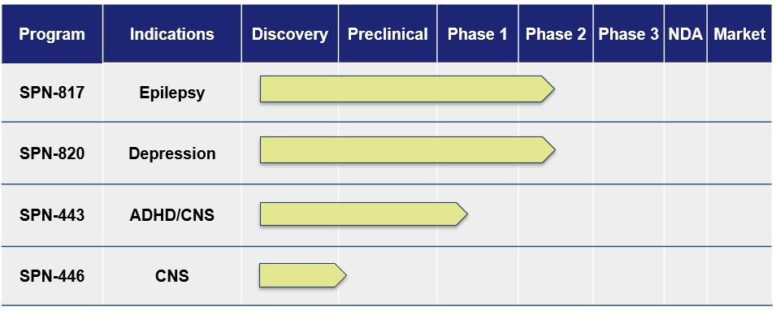
SPN-817 (huperzine A)
SPN-817 represents a novel mechanism of action (MOA) for an anticonvulsant. SPN-817 is a novel synthetic form of huperzine A, whose MOA includes potent acetylcholinesterase inhibition, with pharmacological activities in CNS conditions such as epilepsy. The development will initially focus on the drug's anticonvulsant activity, which has been shown in preclinical models to be effective for the treatment of partial seizures and Dravet Syndrome. SPN-817 is in clinical development and has received Orphan Drug Designation for several epilepsy indications from the FDA.
SPN-820 (NV-5138)
SPN-820 is a first-in-class, orally active small molecule that increases the brain mechanistic target of rapamycin
complex 1 (mTORC1) mediated synaptic function intracellularly. SPN-820 does not bind to or modulate any cell surface receptors and therefore is unlikely to have abuse potential given its lack of binding to targets implicated in drug abuse. In addition, unlike leucine, it is not incorporated into proteins during protein synthesis, and therefore, it is more available at the target site in the brain than leucine.
In February 2025, the Company reported topline results from a randomized double-blind placebo-controlled Phase 2b study of SPN-820 in adults with treatment-resistant depression (TRD). The study did not demonstrate a statistically significant improvement on the primary and secondary endpoints. The safety profile of SPN-820 was consistent with previous clinical trials, showing few adverse events.
SPN-443 – Novel stimulant for the treatment of ADHD/CNS
The Company completed a Phase 1 single dose study in healthy adults in 2024 following submission of an Investigational New Drug Application. The study was a first in human, pilot pharmacokinetic study of two oral formulations of SPN-443 in healthy adults. The primary objective of the study was to assess safety and tolerability. This molecule, along with its major metabolites, is an inhibitor of norepinephrine, dopamine and serotonin, also known as a triple reuptake inhibitor. Both formulations of SPN-443 showed adequate bioavailability and were well tolerated.
Commercial Highlights

•Total IQVIA prescriptions for Qelbree were 225,254 for the second quarter 2025, an increase of 23% compared to the same period in the prior year. Qelbree continues to expand its base of prescribers, with approximately 36,000 prescribers in the second quarter of 2025, up by 23% compared to the same period last year.

28
Table of Contents

•In April 2025, the Company launched ONAPGO, the first and only subcutaneous apomorphine infusion device for the treatment of motor fluctuations in adults with advanced Parkinson's disease. ONAPGO demand is exceeding the Company's expectations, with more than 750 enrollment forms submitted by more than 300 prescribers through the end of the second quarter of 2025.
Product Pipeline Update
SPN-817 – Novel first-in-class highly selective AChE inhibitor for epilepsy
•The Phase 2b randomized, double-blind, placebo-controlled study of 3mg and 4mg twice daily doses is ongoing with a targeted enrollment of approximately 258 adult patients with treatment resistant focal seizures.

SPN-820 – Novel first-in-class molecule that increases mTORC1 mediated synaptic function for depression

•The Company plans to initiate a follow-on Phase 2b multi-center, randomized, double-blind, placebo-controlled trial in approximately 200 adults with major depressive disorder (MDD). The study will examine the safety and tolerability of SPN-820 2400 mg given intermittently (twice weekly) as an adjunctive treatment to the current baseline antidepressant therapy, as well as assess the rapid onset of improvement in depressive symptoms. The Company expects to initiate the Phase 2b study by the end of 2025.
SPN-443 – Novel stimulant for ADHD/CNS
•The Company completed a Phase 1 pharmacokinetic study of two oral formulations in healthy adults. Both formulations of SPN-443 showed adequate bioavailability and were well tolerated. The Company expects to disclose a lead indication for the product candidate by the end of 2025.

Critical Accounting Policies and the Use of Estimates
A summary of our significant accounting policies is included in Note 2, Summary of Significant Accounting Policies of our audited consolidated financial statements included in the Annual Report on Form 10-K for the year ended December 31, 2024. There were no significant changes to the disclosures with respect to our critical accounting policies in our Annual Report on Form 10-K for the year ended December 31, 2024.

29
Table of Contents

Results of Operations
Comparison of the Three and Six Months ended Months Ended June 30, 2025 and 2024
Revenues
Revenues consist primarily of net product sales of our commercial products in the U.S., supplemented by royalty and licensing revenues from our collaborative licensing arrangements. The following table provides information regarding our revenues during the three and six months ended months ended June 30, 2025 (dollars in thousands):
 |  |  | Three Months Ended June 30, |  |  |  |  |  |  |  |  |  |  |  | Change |  |  |  |  |  |  |  |  |  |  |  | Six Months Ended  June 30, |  |  |  |  |  |  |  |  |  |  |  | Change
 |  |  | 2025 |  |  |  |  |  | 2024 |  |  |  |  |  | Amount |  |  |  |  |  | Percent |  |  |  |  |  | 2025 |  |  |  |  |  | 2024 |  |  |  |  |  | Amount |  |  |  |  |  | Percent
Net product sales
Qelbree |  |  | $ | 77,547 |  |  |  |  | $ | 59,395 |  |  |  |  | $ | 18,152 |  |  |  |  | 31% |  |  |  |  |  | $ | 142,292 |  |  |  |  | $ | 104,499 |  |  |  |  | $ | 37,793 |  |  |  |  | 36%
GOCOVRI |  |  | 36,660 |  |  |  |  |  | 31,703 |  |  |  |  |  | 4,957 |  |  |  |  |  | 16% |  |  |  |  |  | 67,349 |  |  |  |  |  | 58,265 |  |  |  |  |  | 9,084 |  |  |  |  |  | 16%
APOKYN |  |  | 12,820 |  |  |  |  |  | 17,295 |  |  |  |  |  | (4,475) |  |  |  |  |  | (26)% |  |  |  |  |  | 27,796 |  |  |  |  |  | 33,944 |  |  |  |  |  | (6,148) |  |  |  |  |  | (18)%
Trokendi XR |  |  | 11,193 |  |  |  |  |  | 17,086 |  |  |  |  |  | (5,893) |  |  |  |  |  | (34)% |  |  |  |  |  | 23,994 |  |  |  |  |  | 33,075 |  |  |  |  |  | (9,081) |  |  |  |  |  | (27)%
Oxtellar XR |  |  | 11,637 |  |  |  |  |  | 29,516 |  |  |  |  |  | (17,879) |  |  |  |  |  | (61)% |  |  |  |  |  | 21,835 |  |  |  |  |  | 56,459 |  |  |  |  |  | (34,624) |  |  |  |  |  | (61)%
ONAPGO |  |  | 1,604 |  |  |  |  |  | — |  |  |  |  |  | 1,604 |  |  |  |  |  | 100 |  | % |  |  |  | 1,604 |  |  |  |  |  | — |  |  |  |  |  | 1,604 |  |  |  |  |  | 100 |  | %
Other(1) |  |  | 6,534 |  |  |  |  |  | 7,543 |  |  |  |  |  | (1,009) |  |  |  |  |  | (13)% |  |  |  |  |  | 15,113 |  |  |  |  |  | 14,757 |  |  |  |  |  | 356 |  |  |  |  |  | 2%
Total net product sales |  |  | 157,995 |  |  |  |  |  | 162,538 |  |  |  |  |  | (4,543) |  |  |  |  |  | (3)% |  |  |  |  |  | 299,983 |  |  |  |  |  | 300,999 |  |  |  |  |  | (1,016) |  |  |  |  |  | —%
Royalty, licensing and other revenues |  |  | 7,458 |  |  |  |  |  | 5,787 |  |  |  |  |  | 1,671 |  |  |  |  |  | 29% |  |  |  |  |  | 15,294 |  |  |  |  |  | 10,970 |  |  |  |  |  | 4,324 |  |  |  |  |  | 39%
Total revenues |  |  | $ | 165,453 |  |  |  |  | $ | 168,325 |  |  |  |  | $ | (2,872) |  |  |  |  | (2)% |  |  |  |  |  | $ | 315,277 |  |  |  |  | $ | 311,969 |  |  |  |  | $ | 3,308 |  |  |  |  | 1%
___________________________________________
(1) Includes net product sales of MYOBLOC, XADAGO and Osmolex ER.
Net Product Sales
Net product sales were $158.0 million and $162.5 million for the three months ended June 30, 2025 and 2024, respectively. Net product sales were $300.0 million and $301.0 million for the six months ended June 30, 2025 and 2024, respectively. The decrease in both periods was primarily due to the decline in net product sales of APOKYN due to lower volume and decline in net product sales of Oxtellar XR and Trokendi XR due to generic erosion, partially offset by the increases in net product sales from Qelbree and GOCOVRI due to higher volume and higher price, and ONAPGO which was launched in the second quarter of 2025.
Adjustments related to prior year sales for the six months period ended June 30, 2025 is approximately 4% of net product sales. The majority of the adjustments is attributable to Qelbree, reflecting favorable actual returns experienced in 2025. As a result, the Company changed its estimated provision for product returns based on the most recent experience. Adjustments related to prior year sales for the six months period ended June 30, 2024 was approximately 2% of net product sales. Refer to discussion Sales Deductions and Related Accruals below.
Sales Deductions and Related Accruals
We record accrued product returns and accrued product rebates as current liabilities in Accrued product returns and rebates, on our condensed consolidated balance sheets. We record sales discounts as a reduction against Accounts receivable, net on the unaudited condensed consolidated balance sheets. Both amounts are generally affected by changes in gross product sales, changes in the provision for net product sales deductions, and the timing of payments/credits.
30
Table of Contents

The following table provides a summary of activity with respect to accrued product returns and rebates and sales discounts during the periods indicated (dollars in thousands):
 |  |  | Accrued Product Returns and Rebates
 |  |  | Product  Returns |  |  |  |  |  | Product  Rebates |  |  |  |  |  | Sales Discounts |  |  |  |  |  | Total
Balance at December 31, 2024 |  |  | $ | 53,375 |  |  |  |  | $ | 115,330 |  |  |  |  | $ | 12,347 |  |  |  |  | $ | 181,052
Provision related to:
Current year sales |  |  | 7,269 |  |  |  |  |  | 207,558 |  |  |  |  |  | 34,034 |  |  |  |  |  | 248,861
Prior year sales |  |  | (12,461) |  |  |  |  |  | (69) |  |  |  |  |  | 40 |  |  |  |  |  | (12,490)
Total provision |  |  | (5,192) |  |  |  |  |  | 207,489 |  |  |  |  |  | 34,074 |  |  |  |  |  | 236,371
Less: Actual payments/credits |  |  | (2,159) |  |  |  |  |  | (187,927) |  |  |  |  |  | (33,656) |  |  |  |  |  | (223,742)
Balance at June 30, 2025 |  |  | $ | 46,024 |  |  |  |  | $ | 134,892 |  |  |  |  | $ | 12,765 |  |  |  |  | $ | 193,681
 |  |  | Accrued Product Returns and Rebates
 |  |  | Product  Returns |  |  |  |  |  | Product  Rebates |  |  |  |  |  | Sales Discounts |  |  |  |  |  | Total
Balance at December 31, 2023 |  |  | $ | 57,290 |  |  |  |  | $ | 96,984 |  |  |  |  | $ | 10,719 |  |  |  |  | $ | 164,993
Provision related to:
Current year sales |  |  | 10,774 |  |  |  |  |  | 200,930 |  |  |  |  |  | 34,119 |  |  |  |  |  | 245,823
Prior year sales |  |  | (4,055) |  |  |  |  |  | (1,923) |  |  |  |  |  | (6) |  |  |  |  |  | (5,984)
Total provision |  |  | 6,719 |  |  |  |  |  | 199,007 |  |  |  |  |  | 34,113 |  |  |  |  |  | 239,839
Less: Actual payments/credits |  |  | (5,472) |  |  |  |  |  | (179,409) |  |  |  |  |  | (31,300) |  |  |  |  |  | (216,181)
Balance at June 30, 2024 |  |  | $ | 58,537 |  |  |  |  | $ | 116,582 |  |  |  |  | $ | 13,532 |  |  |  |  | $ | 188,651
Accrued Product Returns and Rebates
The accrued product returns balance decreased to $46.0 million as of June 30, 2025 from $58.5 million as of June 30, 2024. This decrease was primarily due to the $12.5 million of estimated provision for product returns related to prior year sales. The majority of the provision for product returns related to prior year sales is attributable to Qelbree, reflecting favorable actual returns experienced in 2025 for Qelbree. As a result, the Company changed its estimated provision for product returns based on the most recent experience.
The accrued product rebates balance increased to $134.9 million as of June 30, 2025 from $116.6 million as of June 30, 2024 primarily due to timing of payments associated with government programs.
Provision for Product Returns and Rebates
The provision for product returns decreased to $5.2 million for the six months ended June 30, 2025 from $6.7 million for the six months ended June 30, 2024. The decrease was primarily due to the aforementioned reduction of $12.5 million of estimated provision for product returns related to prior year sales.
The provision for product rebates increased to $207.5 million for six months ended June 30, 2025 from $199.0 million for the six months ended June 30, 2024. The increase was primarily attributable to higher Qelbree sales and unfavorability in government programs as a result of product price increases in Q1 2025.
Royalty, Licensing and Other Revenues
Royalty, licensing and other revenues were $7.5 million and $5.8 million for the three months ended June 30, 2025 and 2024, respectively. Royalty, licensing and other revenues were $15.3 million and $11.0 million for the six months ended June 30, 2025 and 2024, respectively. The increase was due to an increase in licensing revenues related to the achievement of a milestone under a licensing agreement for Qelbree, and an increase in royalty revenues from Oxtellar XR. The Company entered into settlement and license agreements that allowed a third party to enter the Oxtellar XR market in September 2024.
31
Table of Contents

Cost of Goods Sold
Cost of goods sold was $16.8 million and $17.9 million for the three months ended June 30, 2025 and 2024, respectively. Cost of goods sold was $32.6 million and $34.2 million for the six months ended June 30, 2025 and 2024, respectively. The decrease in both periods was primarily driven by lower APOKYN royalties due to lower sales and decrease in MYOBLOC and Oxtellar XR due to generic erosion, principally offset by increases in Qelbree due to higher sales and ONAPGO which was launched in the second quarter of 2025.
Research and Development Expenses
R&D expenses were $22.1 million and $26.2 million for the three months ended June 30, 2025 and 2024, respectively. R&D expenses were $49.0 million and $51.1 million for the six months ended June 30, 2025 and 2024, respectively. The decreases in both periods were primarily due to decreased clinical program costs on SPN-820, partially offset by the increase in clinical program costs on SPN-817.
Selling, General and Administrative Expenses
The following table provides information regarding our selling, general and administrative (SG&A) expenses during the periods indicated (dollars in thousands):
 |  |  | Three Months Ended  June 30, |  |  |  |  |  |  |  |  |  |  |  | Change |  |  |  |  |  |  |  |  |  |  |  | Six Months Ended  June 30, |  |  |  |  |  |  |  |  |  |  |  | Change
 |  |  | 2025 |  |  |  |  |  | 2024 |  |  |  |  |  | Amount |  |  |  |  |  | Percent |  |  |  |  |  | 2025 |  |  |  |  |  | 2024 |  |  |  |  |  | Amount |  |  |  |  |  | Percent
Selling and marketing |  |  | $ | 65,130 |  |  |  |  | $ | 58,804 |  |  |  |  | $ | 6,326 |  |  |  |  | 11% |  |  |  |  |  | $ | 128,408 |  |  |  |  | $ | 118,371 |  |  |  |  | $ | 10,037 |  |  |  |  | 8%
General and administrative |  |  | 28,421 |  |  |  |  |  | 27,100 |  |  |  |  |  | 1,321 |  |  |  |  |  | 5% |  |  |  |  |  | 55,087 |  |  |  |  |  | 54,049 |  |  |  |  |  | 1,038 |  |  |  |  |  | 2%
Total |  |  | $ | 93,551 |  |  |  |  | $ | 85,904 |  |  |  |  | $ | 7,647 |  |  |  |  | 9% |  |  |  |  |  | $ | 183,495 |  |  |  |  | $ | 172,420 |  |  |  |  | $ | 11,075 |  |  |  |  | 6%
Selling and marketing expenses were $65.1 million and $58.8 million for the three months ended June 30, 2025 and 2024, respectively. The increase was primarily due to higher professional and consulting expenses and employee-related expenses.
Selling and marketing expenses were $128.4 million and $118.4 million for the six months ended June 30, 2025 and 2024, respectively. The increase was primarily due to timing of product sample shipments, higher professional and consulting expenses and employee-related expenses.
General and administrative expenses were $28.4 million and $27.1 million for the three months ended June 30, 2025 and 2024, respectively. General and administrative expenses were $55.1 million and $54.0 million for the six months ended June 30, 2025 and 2024, respectively.
Amortization of Intangible Assets
Amortization of intangible assets was $20.8 million and $20.1 million for the three months ended June 30, 2025 and 2024, respectively. Amortization of intangible assets was $40.6 million and $40.2 million for the six months ended June 30, 2025 and 2024, respectively. The increase was primarily due to ONAPGO amortization expense in 2025 offset by amortization expense in 2024 for Oxtellar XR and Namzaric intangible assets, which were being fully amortized in 2024. ONAPGO was previously accounted for as an indefinite-lived intangible asset not subject to amortization.
Contingent Consideration Loss (Gain)
Contingent consideration was $0.0 million and a gain of $4.4 million for the three months ended June 30, 2025 and 2024, respectively. The change was primarily due to the achievement of the milestones associated with the USWM contingent consideration liabilities in 2025.
Contingent consideration was a loss of $7.7 million and a gain of $5.5 million for the six months ended June 30, 2025 and 2024, respectively. The change to loss for the six months ended June 30, 2025 was primarily driven by the accretion of the USWM contingent consideration liabilities to the full milestone payment amounts with the approval of ONAPGO by the FDA in February 2025.
Other Income (Expense)
32
Table of Contents

Other income (expense) was an income of $4.5 million and $3.7 million for the three months ended June 30, 2025 and 2024, respectively. Other income (expense) was an income of $9.0 million and $7.1 million for the six months ended June 30, 2025 and 2024, respectively. The increase was due to higher interest income on marketable securities largely driven by an overall higher investment balance in 2025.
Income Tax Expense
Income tax benefit was $5.8 million ((35.0)% effective tax rate)) and income tax expense was $0.2 million (1.5% effective tax rate) for the three and six months ended June 30, 2025, as compared to an income tax expense of $6.4 million (24.3% effective tax rate) and $6.5 million (24.5% effective tax rate) for the three and six months ended June 30, 2024. The change in both periods was primarily due to decreased pre-tax book income for the three and six months ended June 30, 2025 as compared to the same period in 2024.

The Company's effective income tax rate for the three and six months ended June 30, 2025 was lower compared to the same period in 2024 primarily due to a benefit for a state tax refund received during the quarter. The Company's effective income tax rates for the three and six months ended June 30, 2025 vary from the statutory federal tax rate in the United States (U.S. federal tax rate) of 21% primarily due to state taxes, offset by tax benefits related to research and development tax credits and the benefit of a state tax refund received during the quarter. The Company's effective income tax rates for the three and six months ended June 30, 2024 vary from the statutory U.S. federal tax rate primarily due to state taxes, offset by tax benefits related to research and development tax credits.

The annual forecasted earnings represent the Company's best estimate as of June 30, 2025 and 2024, are subject to change and could have a material impact on the effective tax rate in subsequent periods. Accounting Standard Codification 740, Income Taxes (ASC 740), requires the Company to estimate the annual effective income tax rate for the full year and apply it to pre-tax income (loss) for each interim period, taking into account year-to-date amounts and projected results for the full year.

Financial Condition, Liquidity and Capital Resources
Cash and Cash Equivalents and Marketable Securities

Cash and cash equivalents and current marketable securities are comprised of the following (dollars in thousands):
 |  |  | June 30 |  |  |  |  |  | December 31 |  |  |  |  |  | Change
 |  |  | 2025 |  |  |  |  |  | 2024 |  |  |  |  |  | Amount |  |  |  |  |  | Percent
Cash and cash equivalents |  |  | $ | 144,711 |  |  |  |  | $ | 69,331 |  |  |  |  | $ | 75,380 |  |  |  |  | 109%
Marketable securities |  |  | 377,885 |  |  |  |  |  | 384,281 |  |  |  |  |  | (6,396) |  |  |  |  |  | (2)%
Total |  |  | $ | 522,596 |  |  |  |  | $ | 453,612 |  |  |  |  | $ | 68,984 |  |  |  |  | 15%
The Company believes its balances of cash, cash equivalents, and unrestricted marketable securities, which totaled $522.6 million as of June 30, 2025, along with cash generated from ongoing operations and continued access to debt markets, will be sufficient to satisfy its cash requirements over the next 12 months and beyond.
We have financed our operations primarily with cash generated from product sales, supplemented by revenues from royalty and licensing arrangements, as well as proceeds from the sale of equity and debt securities. Continued cash generation is highly dependent on the success of our commercial products, as well as the success of our product candidates if approved by the FDA. While we expect continued profitability in future years, we anticipate there may be significant variability from year to year in the level of our profits particularly due to continued market and payor pressures for our commercial products; the unfavorable impact of the loss of patent exclusivity for Trokendi XR in January 2023 and Oxtellar XR in September 2024; the potential unfavorable impact of the forthcoming loss of exclusivity of XADAGO; funding for research and development of our product candidates; and the additional funding for the launch of ONAPGO, which was approved by the FDA in February 2025 and launched in April 2025. Further, with the acquisition of Sage Therapeutics, Inc. in the third quarter of 2025, we expect an overall decrease in marketable securities as a portion were sold in July 2025 to fund the acquisition of Sage.
We may, from time to time, consider raising additional capital through: new collaborative arrangements; strategic alliances; additional equity and/or financings from debt or other sources, especially in conjunction with opportunistic business development initiatives. We will continue to actively manage our capital structure and to consider all financing opportunities that could strengthen our long-term financial profile. Any such capital raises may or may not be similar to transactions in which we have engaged in the past. There can be no assurance that any such financing opportunities will be available on acceptable terms, if at all.
33
Table of Contents

Cash Flows
Cash flows are comprised of the following (dollars in thousands):
 |  |  | Six Months Ended June 30, |  |  |  |  |  |  |  |  |  |  |  | Change
 |  |  | 2025 |  |  |  |  |  | 2024 |  |  |  |  |  | Amount
Net cash provided by (used in):
Operating activities |  |  | $ | 89,134 |  |  |  |  | $ | 74,025 |  |  |  |  | $ | 15,109
Investing activities |  |  | 6,710 |  |  |  |  |  | (100,218) |  |  |  |  |  | 106,928
Financing activities |  |  | (20,464) |  |  |  |  |  | 3,228 |  |  |  |  |  | (23,692)
Net change in cash and cash equivalents |  |  | 75,380 |  |  |  |  |  | (22,965) |  |  |  |  |  | 98,345
Cash and cash equivalents at beginning of year |  |  | 69,331 |  |  |  |  |  | 75,054 |  |  |  |  |  | (5,723)
Cash and cash equivalents at end of period |  |  | $ | 144,711 |  |  |  |  | $ | 52,089 |  |  |  |  | $ | 92,622
Operating Activities
Net cash provided by operating activities was $89.1 million and $74.0 million for the six months ended June 30, 2025, and 2024, respectively. The increase in cash flows provided by operating activities is primarily due to changes in working capital which reflects the timing impacts of cash collections on receivables and settlement of payables, offset by lower net income adjusted for non-cash charges for the six months ended June 30, 2025 compared to the same period in prior year.
Investing Activities
Net cash provided by investing activities was $6.7 million for the six months ended June 30, 2025 compared to $100.2 million cash used in investing activities during the same period in 2024. The change was primarily due to lower cash outflows from purchases of marketable securities as well as higher cash inflows from the maturities of marketable securities.
Financing Activities
Net cash used in financing activities was $20.5 million for the six months ended June 30, 2025 compared to $3.2 million provided by during the same period in 2024. The change was primarily due to the payment of USWM contingent consideration milestones associated with the FDA approval and commercial launch of ONAPGO.
Material Cash Requirements
Refer to "Part II, Item 7 — Management's Discussion and Analysis of Liquidity and Capital Resources" of our Annual Report on Form 10-K for the year ended December 31, 2024, and Note 15, Commitments and Contingencies, in the Notes to the Condensed Consolidated Financial Statements in Part I, Item 1, Unaudited Condensed Consolidated Financial Statements, of this Quarterly Report on Form 10-Q for the discussion of our contractual obligations.
Further, with the acquisition of Sage Therapeutics, Inc. in the third quarter of 2025, we expect our investment balance to decrease as marketable securities were sold to fund the acquisition of Sage. Refer to Part II, Item 2 - Management's Discussion and Analysis of Financial Condition and Results of Operations and Management's discussion on Financial Condition, Liquidity and Capital Resources of this Quarterly Report on Form 10-Q for the period ended June 30, 2025, and Note 1, Business Organization, in the Notes to the Condensed Consolidated Financial Statements in Part I, Item 1, Unaudited Condensed Consolidated Financial Statements, of this Quarterly Report on Form 10-Q for discussion of the acquisition of Sage Therapeutics, Inc.

Recently Issued Accounting Pronouncements
For a discussion of new accounting pronouncements, see Note 2 Summary of Significant Accounting Policies, in the Notes to the Condensed Consolidated Financial Statements in Part I, Item 1, Unaudited Condensed Consolidated Financial Statements, of this Quarterly Report on Form 10-Q.

34
Table of Contents

Item 3. Quantitative and Qualitative Disclosures About Market Risk
The primary objective of our investment activities is to preserve our capital to fund operations and to facilitate business development activities. We also seek to maximize income from our investments without assuming significant interest rate risk, liquidity risk, or risk of default by investing in investment grade securities with maturities of four years or less. Our exposure to market risk is confined to investments in cash and cash equivalents and marketable securities. As of June 30, 2025, we had cash and cash equivalents and marketable securities of $522.6 million.
In the future, we may borrow funds under the Credit Line. Variable rate borrowing, which may occur under the Credit Line, exposes us to interest rate risk as increases in interest rates would increase our borrowing costs. Any borrowed funds pursuant to our Credit Line are subject to a collateral maintenance requirement. The Credit Line is secured primarily by our portfolio of marketable securities, which is primarily comprised of corporate and U.S. government agency and municipal debt securities and may fluctuate in value. The fluctuations may be driven by, among other things, changes in interest rates, economic conditions, and other financial conditions as well as idiosyncratic factors related to a security's issuer. To the extent a fluctuation in value results in the value of the collateral decreasing below the required collateral maintenance requirements we may be required to promptly post additional collateral. Additionally, our Credit Line is an uncommitted facility that may be terminated by the lender at any time. During periods of rapidly changing interest rates, economic conditions or other financial conditions, the Credit Line may be terminated by the lender and/or the lender may declare that all borrowings thereunder are immediately due.
Our cash and cash equivalents consist primarily of cash held at banks and investments in highly liquid financial instruments with an original maturity of three months or less. Our marketable securities, which are reported at fair value, consist of investments in U.S. Treasury bills and notes; bank certificates of deposit; various U.S. governmental agency debt securities; and corporate and municipal debt securities. We place all investments with governmental, industrial, or financial institutions whose debt is rated as investment grade. We generally hold these securities to maturities of one to four years. Because of the relatively short period that we hold our investments and because we generally hold these securities to maturity, we do not believe that an increase in interest rates would have any significant impact on the realizable value of our investments.
We do not have any currency or derivative financial instruments.
We may contract with clinical research organizations (CROs) and investigational sites globally. Currently, we have ongoing clinical trials being conducted outside of the U.S. We do not hedge our foreign currency exchange rate risk. Transactions denominated in currencies other than the U.S. dollar are recorded based on exchange rates at the time such transactions arise. As of June 30, 2025 and December 31, 2024, substantially all of our liabilities were denominated in the U.S. dollar.
Inflation generally affects us by increasing our cost of labor and the cost of services provided by our vendors. We do not believe that inflation and changing prices over the year ended December 31, 2024, and the six months ended June 30, 2025 had a significant impact on our consolidated results of operations. While we expect significant year-to-year variability in labor and vendor service costs due to uncontrollable inflation factors like natural disasters, geopolitical conflicts, tariffs, and government regulations, we strive to mitigate future price risks. We do this by forming strong partnerships with key suppliers and our CMOs, and by directly managing the procurement and supply levels of key raw materials for our commercial products. However, these efforts may not fully protect us from cost increases, which could adversely impact our profitability.

Item 4. Controls and Procedures
Evaluation of Disclosure Controls and Procedures
We maintain disclosure controls and procedures required by Rule 13a-15(e) and 15d-15(e) of the Securities Exchange Act of 1934, as amended, or the Exchange Act. Our disclosure controls and procedures are designed to provide reasonable assurance that the information required to be disclosed by us in the reports we file or submit under the Exchange Act has been appropriately recorded, processed, summarized, and reported within the time periods specified in the Securities and Exchange Commission's rules and forms and that such information is accumulated and communicated to our management, including our CEO and CFO, to allow timely decisions regarding required disclosure. We conducted an evaluation of the effectiveness of the design and operation of our disclosure controls and procedures as of June 30, 2025, the end of the period covered by this report. Based on that evaluation, under the supervision and with the participation of our management, including our CEO and CFO, we concluded that our disclosure controls and procedures are effective as of June 30, 2025.
Changes in Internal Control over Financial Reporting
Our management, including our CEO and CFO, evaluated changes in our internal control over financial reporting that occurred during the quarter ended June 30, 2025.
35
Table of Contents

During the quarter ended June 30, 2025, no changes occurred in our internal control over financial reporting that materially affected, or are reasonably likely to materially affect, our internal control over financial reporting.

PART II — OTHER INFORMATION

Item 1. Legal Proceedings
From time to time and in the ordinary course of business, Supernus Pharmaceuticals, Inc. (the "Company") and any of its subsidiaries may be subject to various claims, charges and litigation. The Company and any of its subsidiaries may be required to file infringement claims against third parties for the infringement of our patents.
Qelbree®
I.Supernus Pharmaceuticals, Inc. v. Appco Pharma LLC and Somerset Therapeutics LLC, No. 2:25-cv-12183 (MEF)(MAH) (D.N.J.)
The Company received Paragraph IV Notice Letters from generic drug makers Appco Pharma LLC ("Appco") and Somerset Therapeutics LLC ("Somerset") dated May 21, 2025, and June 9, 2025, directed to six of its Qelbree® Orange Book patents. Supernus's U.S. Patent Nos. 9,358,204; 9,603,853; 9,662,338; 11,324,753; 11,458,143; and 12,121,523 generally cover viloxazine formulations and methods of using those formulations. The FDA Orange Book currently lists United States Patent Nos. 9,358,204 and 9,603,853 as expiring on February 7, 2033; United States Patent No. 9,662,338 as expiring on April 2, 2035; and United States Patent Nos. 11,324,753; 11,458,143; and 12,121,523 as expiring on September 4, 2029. On June 26, 2025, the Company filed a lawsuit against Appco and Somerset alleging infringement of the Company's Qelbree® Orange Book patents. The Complaint—filed in the U.S. District Court for the District of New Jersey—alleges, inter alia, that Appco and Somerset infringed the Company's Qelbree® patents by submitting to the FDA an Abbreviated New Drug Application ("ANDA") seeking to market a generic version of Qelbree® prior to the expiration of the Company's patents. Filing its June 26, 2025, Complaint within 45 days of receiving Appco and Somerset's Paragraph IV certification notice entitles Supernus to an automatic stay preventing the FDA from approving Appco and Somerset's ANDA until October 2, 2028. As of the date of this letter, Appco and Somerset have not yet responded to the Complaint and the Court has not issued a Scheduling Order.
II. Supernus Pharmaceuticals, Inc. v. Appco Pharma LLC, et al., C.A. No. 25-cv-807 (JLH) (D. Del.)
The Company received Paragraph IV Notice Letters from generic drug makers Appco Pharma LLC ("Appco") and Somerset Therapeutics LLC ("Somerset") dated May 21, 2025, and June 9, 2025, directed to six of its Qelbree® Orange Book patents. Supernus's U.S. Patent Nos. 9,358,204; 9,603,853; 9,662,338; 11,324,753; 11,458,143; and 12,121,523 generally cover viloxazine formulations and methods of using those formulations. The FDA Orange Book currently lists United States Patent Nos. 9,358,204 and 9,603,853 as expiring on February 7, 2033; United States Patent No. 9,662,338 as expiring on April 2, 2035; and United States Patent Nos. 11,324,753; 11,458,143; and 12,121,523 as expiring on September 4, 2029. On July 1, 2025, the Company filed a lawsuit against Appco and Somerset alleging infringement of the Company's Qelbree® Orange Book patents. The Complaint—filed in the U.S. District Court for the District of Delaware—alleges, inter alia, that Appco and Somerset infringed the Company's Qelbree® patents by submitting to the FDA an Abbreviated New Drug Application ("ANDA") seeking to market a generic version of Qelbree® prior to the expiration of the Company's patents. Filing its July 1, 2025, Complaint within 45 days of receiving Appco and Somerset's Paragraph IV certification notice entitles Supernus to an automatic stay preventing the FDA from approving Appco and Somerset's ANDA until October 2, 2028. As of the date of this letter, Appco and Somerset have not yet responded to the Complaint and the Court has not issued a Scheduling Order.
III. Supernus Pharmaceuticals, Inc. v. Apotex Inc., No. 2:25-cv-12184 (MEF)(MAH) (D.N.J.)
The Company received a Paragraph IV Notice Letter from generic drug maker Apotex Inc. ("Apotex") dated May 22, 2025, directed to six of its Qelbree® Orange Book patents. Supernus's U.S. Patent Nos. 9,358,204; 9,603,853; 9,662,338; 11,324,753; 11,458,143; and 12,121,523 generally cover viloxazine formulations and methods of using those formulations. The FDA Orange Book currently lists United States Patent Nos. 9,358,204 and 9,603,853 as expiring on February 7, 2033; United States Patent No. 9,662,338 as expiring on April 2, 2035; and United States Patent Nos. 11,324,753; 11,458,143; and 12,121,523 as expiring on September 4, 2029. On June 26, 2025, the Company filed a lawsuit against Apotex alleging infringement of the Company's Qelbree® Orange Book patents. The Complaint—filed in the U.S. District Court for the District of New Jersey—alleges, inter alia, that Apotex infringed the Company's Qelbree® patents by submitting to the FDA an Abbreviated New Drug Application ("ANDA") seeking to market a generic version of Qelbree® prior to the expiration of the Company's patents. Filing its June 26, 2025, Complaint within 45 days of receiving Apotex's Paragraph IV certification notice entitles Supernus to an automatic stay preventing the FDA from approving Apotex's ANDA until October 2, 2028. As of the date of this letter, Apotex has not yet responded to the Complaint and the Court has not issued a Scheduling Order.
36
Table of Contents

IV. Supernus Pharmaceuticals, Inc. v. Aurobindo Pharma Limited and Aurobindo Pharma U.S.A., Inc., No. 2:25 cv-12186 (MEF)(MAH) (D.N.J.)
The Company received a Paragraph IV Notice Letter from generic drug makers Aurobindo Pharma Limited and Aurobindo Pharma U.S.A., Inc. (collectively, "Aurobindo") dated May 29, 2025, directed to six of its Qelbree® Orange Book patents. Supernus's U.S. Patent Nos. 9,358,204; 9,603,853; 9,662,338; 11,324,753; 11,458,143; and 12,121,523 generally cover viloxazine formulations and methods of using those formulations. The FDA Orange Book currently lists United States Patent Nos. 9,358,204 and 9,603,853 as expiring on February 7, 2033; United States Patent No. 9,662,338 as expiring on April 2, 2035; and United States Patent Nos. 11,324,753; 11,458,143; and 12,121,523 as expiring on September 4, 2029. On June 26, 2025, the Company filed a lawsuit against Aurobindo alleging infringement of the Company's Qelbree® Orange Book patents. The Complaint—filed in the U.S. District Court for the District of New Jersey—alleges, inter alia, that Aurobindo infringed the Company's Qelbree® patents by submitting to the FDA an Abbreviated New Drug Application ("ANDA") seeking to market a generic version of Qelbree® prior to the expiration of the Company's patents. Filing its June 26, 2025, Complaint within 45 days of receiving Aurobindo's Paragraph IV certification notice entitles Supernus to an automatic stay preventing the FDA from approving Aurobindo's ANDA until October 2, 2028. As of the date of this letter, Aurobindo has not yet responded to the Complaint and the Court has not issued a Scheduling Order.
V. Supernus Pharmaceuticals, Inc. v. Aurobindo Pharma Ltd., et al., C.A. No. 25-cv-808 (JLH) (D. Del.)
The Company received a Paragraph IV Notice Letter from generic drug makers Aurobindo Pharma Limited and Aurobindo Pharma U.S.A., Inc. (collectively, "Aurobindo") dated May 29, 2025, directed to six of its Qelbree® Orange Book patents. Supernus's U.S. Patent Nos. 9,358,204; 9,603,853; 9,662,338; 11,324,753; 11,458,143; and 12,121,523 generally cover viloxazine formulations and methods of using those formulations. The FDA Orange Book currently lists United States Patent Nos. 9,358,204 and 9,603,853 as expiring on February 7, 2033; United States Patent No. 9,662,338 as expiring on April 2, 2035; and United States Patent Nos. 11,324,753; 11,458,143; and 12,121,523 as expiring on September 4, 2029. On July 1, 2025, the Company filed a lawsuit against Aurobindo alleging infringement of the Company's Qelbree® Orange Book patents. The Complaint—filed in the U.S. District Court for the District of Delaware—alleges, inter alia, that Aurobindo infringed the Company's Qelbree® patents by submitting to the FDA an Abbreviated New Drug Application ("ANDA") seeking to market a generic version of Qelbree® prior to the expiration of the Company's patents. Filing its July 1, 2025, Complaint within 45 days of receiving Aurobindo's Paragraph IV certification notice entitles Supernus to an automatic stay preventing the FDA from approving Aurobindo's ANDA until October 2, 2028. As of the date of this letter, Aurobindo has not yet responded to the Complaint and the Court has not issued a Scheduling Order.
VI. Supernus Pharmaceuticals, Inc. v. Zydus Lifesciences Global FZE, Zydus Pharmaceuticals (USA) Inc., and Zydus Lifesciences Limited, No. 2:25-cv-12188 (MEF)(MAH) (D.N.J.)
The Company received a Paragraph IV Notice Letter from generic drug maker Zydus Lifesciences Global FZE ("Zydus FZE") dated May 27, 2025, directed to three of its Qelbree® Orange Book patents. Supernus's U.S. Patent Nos. 9,358,204; 9,603,853; and 9,662,338 generally cover viloxazine formulations and methods of using those formulations. The FDA Orange Book currently lists United States Patent Nos. 9,358,204 and 9,603,853 as expiring on February 7, 2033, and United States Patent No. 9,662,338 as expiring on April 2, 2035. On June 26, 2025, the Company filed a lawsuit against Zydus FZE, Zydus Pharmaceuticals (USA) Inc., and Zydus Lifesciences Limited (collectively, "Zydus") alleging infringement of the Company's Qelbree® Orange Book patents. The Complaint—filed in the U.S. District Court for the District of New Jersey—alleges, inter alia, that Zydus infringed the Company's Qelbree® patents by submitting to the FDA an Abbreviated New Drug Application ("ANDA") seeking to market a generic version of Qelbree® prior to the expiration of the Company's patents. Filing its June 26, 2025, Complaint within 45 days of receiving Zydus FZE's Paragraph IV certification notice entitles Supernus to an automatic stay preventing the FDA from approving Zydus's ANDA until October 2, 2028. As of the date of this letter, Zydus has not yet responded to the Complaint and the Court has not issued a Scheduling Order.
VII. Supernus Pharmaceuticals, Inc. v. Creekwood Pharmaceuticals, LLC, C.A. No. 25-cv-13201 (MEF)(MAH) (D.N.J.)
The Company received a Paragraph IV Notice Letter from generic drug maker Creekwood Pharmaceuticals, LLC ("Creekwood") dated June 4, 2025, directed to six of its Qelbree® Orange Book patents. Supernus's U.S. Patent Nos. 9,358,204; 9,603,853; 9,662,338; 11,324,753; 11,458,143; and 12,121,523 generally cover viloxazine formulations and methods of using those formulations. The FDA Orange Book currently lists United States Patent Nos. 9,358,204 and 9,603,853 as expiring on February 7, 2033; United States Patent No. 9,662,338 as expiring on April 2, 2035; and United States Patent Nos. 11,324,753; 11,458,143; and 12,121,523 as expiring on September 4, 2029. On July 11, 2025, the Company filed a lawsuit against Creekwood alleging infringement of the Company's Qelbree® Orange Book patents. The Complaint—filed in the U.S. District
37
Table of Contents

Court for the District of New Jersey—alleges, inter alia, that Creekwood infringed the Company's Qelbree® patents by submitting to the FDA an Abbreviated New Drug Application ("ANDA") seeking to market a generic version of Qelbree® prior to the expiration of the Company's patents. Filing its July 11, 2025, Complaint within 45 days of receiving Creekwood's Paragraph IV certification notice entitles Supernus to an automatic stay preventing the FDA from approving Creekwood's ANDA until October 2, 2028. As of the date of this letter, Creekwood has not yet responded to the Complaint and the Court has not issued a Scheduling Order.
VIII. Supernus Pharmaceuticals, Inc. v. Creekwood Pharmaceuticals, LLC, C.A. No. 25-cv-880 (D. Del.)
The Company received a Paragraph IV Notice Letter from generic drug maker Creekwood Pharmaceuticals, LLC ("Creekwood") dated June 4, 2025, directed to six of its Qelbree® Orange Book patents. Supernus's U.S. Patent Nos. 9,358,204; 9,603,853; 9,662,338; 11,324,753; 11,458,143; and 12,121,523 generally cover viloxazine formulations and methods of using those formulations. The FDA Orange Book currently lists United States Patent Nos. 9,358,204 and 9,603,853 as expiring on February 7, 2033; United States Patent No. 9,662,338 as expiring on April 2, 2035; and United States Patent Nos. 11,324,753; 11,458,143; and 12,121,523 as expiring on September 4, 2029. On July 15, 2025, the Company filed a lawsuit against Creekwood alleging infringement of the Company's Qelbree® Orange Book patents. The Complaint—filed in the U.S. District Court for the District of Delaware—alleges, inter alia, that Creekwood infringed the Company's Qelbree® patents by submitting to the FDA an Abbreviated New Drug Application ("ANDA") seeking to market a generic version of Qelbree® prior to the expiration of the Company's patents. Filing its July 15, 2025, Complaint within 45 days of receiving Creekwood's Paragraph IV certification notice entitles Supernus to an automatic stay preventing the FDA from approving Creekwood's ANDA until October 2, 2028. As of the date of this letter, Creekwood has not yet responded to the Complaint and the Court has not issued a Scheduling Order.
IX. Supernus Pharmaceuticals, Inc. v. MSN Pharmaceuticals Inc., C.A. No. 25-cv-13204 (MEF)(MAH) (D.N.J.)
The Company received a Paragraph IV Notice Letter from generic drug maker MSN Pharmaceuticals Inc. ("MSN") dated June 5, 2025, directed to six of its Qelbree® Orange Book patents. Supernus's U.S. Patent Nos. 9,358,204; 9,603,853; 9,662,338; 11,324,753; 11,458,143; and 12,121,523 generally cover viloxazine formulations and methods of using those formulations. The FDA Orange Book currently lists United States Patent Nos. 9,358,204 and 9,603,853 as expiring on February 7, 2033; United States Patent No. 9,662,338 as expiring on April 2, 2035; and United States Patent Nos. 11,324,753; 11,458,143; and 12,121,523 as expiring on September 4, 2029. On July 11, 2025, the Company filed a lawsuit against MSN alleging infringement of the Company's Qelbree® Orange Book patents. The Complaint—filed in the U.S. District Court for the District of New Jersey—alleges, inter alia, that MSN infringed the Company's Qelbree® patents by submitting to the FDA an Abbreviated New Drug Application ("ANDA") seeking to market a generic version of Qelbree® prior to the expiration of the Company's patents. Filing its July 11, 2025, Complaint within 45 days of receiving MSN's Paragraph IV certification notice entitles Supernus to an automatic stay preventing the FDA from approving MSN's ANDA until October 2, 2028. As of the date of this letter, MSN has not yet responded to the Complaint and the Court has not issued a Scheduling Order.
X. Supernus Pharmaceuticals, Inc. v. MSN Pharmaceuticals Inc., C.A. No. 25-cv-879 (D. Del.)
The Company received a Paragraph IV Notice Letter from generic drug maker MSN Pharmaceuticals Inc. ("MSN") dated June 5, 2025, directed to six of its Qelbree® Orange Book patents. Supernus's U.S. Patent Nos. 9,358,204; 9,603,853; 9,662,338; 11,324,753; 11,458,143; and 12,121,523 generally cover viloxazine formulations and methods of using those formulations. The FDA Orange Book currently lists United States Patent Nos. 9,358,204 and 9,603,853 as expiring on February 7, 2033; United States Patent No. 9,662,338 as expiring on April 2, 2035; and United States Patent Nos. 11,324,753; 11,458,143; and 12,121,523 as expiring on September 4, 2029. On July 15, 2025, the Company filed a lawsuit against MSN alleging infringement of the Company's Qelbree® Orange Book patents. The Complaint—filed in the U.S. District Court for the District of Delaware—alleges, inter alia, that MSN infringed the Company's Qelbree® patents by submitting to the FDA an Abbreviated New Drug Application ("ANDA") seeking to market a generic version of Qelbree® prior to the expiration of the Company's patents. Filing its July 15, 2025, Complaint within 45 days of receiving MSN's Paragraph IV certification notice entitles Supernus to an automatic stay preventing the FDA from approving MSN's ANDA until October 2, 2028. As of the date of this letter, MSN has not yet responded to the Complaint and the Court has not issued a Scheduling Order.
XI. Supernus Pharmaceuticals, Inc. v. Zenara Pharma Private Ltd., et al. , C.A. No. 25-cv-13207 (MEF)(MAH) (D.N.J.)
The Company received a Paragraph IV Notice Letter from generic drug maker Zenara Pharma Private Limited ("Zenara") dated June 9, 2025, directed to six of its Qelbree® Orange Book patents. Supernu's U.S. Patent Nos. 9,358,204; 9,603,853; 9,662,338; 11,324,753; 11,458,143; and 12,121,523 generally cover viloxazine formulations and methods of using those formulations. The FDA Orange Book currently lists United States Patent Nos. 9,358,204 and 9,603,853 as expiring on
38
Table of Contents

February 7, 2033; United States Patent No. 9,662,338 as expiring on April 2, 2035; and United States Patent Nos. 11,324,753; 11,458,143; and 12,121,523 as expiring on September 4, 2029. On July 11, 2025, the Company filed a lawsuit against Zenara and Biophore Pharma Inc. ("Biophore," and collectively with Zenara, "Defendants") alleging infringement of the Company's Qelbree® Orange Book patents. The Complaint—filed in the U.S. District Court for the District of New Jersey—alleges, inter alia, that Defendants infringed the Company's Qelbree® patents by submitting to the FDA an Abbreviated New Drug Application ("ANDA") seeking to market a generic version of Qelbree® prior to the expiration of the Company's patents. Filing its July 11, 2025, Complaint within 45 days of receiving Defendants' Paragraph IV certification notice entitles Supernus to an automatic stay preventing the FDA from approving Defendants' ANDA until October 2, 2028. As of the date of this letter, Defendants have not yet responded to the Complaint and the Court has not issued a Scheduling Order.
Trokendi XR®
XII. Supernus Pharmaceuticals, Inc. v. Ajanta Pharma Limited, et al., C.A. No. 21-cv-6964 (GC)(DEA) (D.N.J.)
The Company received a Paragraph IV Notice Letter from generic drug maker Ajanta Pharma Limited dated February 10, 2021, directed to ten of its Trokendi XR® Orange Book patents. Supernus's U.S. Patent Nos. 8,298,576; 8,298,580; 8,663,683; 8,877,248; 8,889,191; 8,992,989; 9,549,940; 9,555,004; 9,622,983; and 10,314,790 generally cover once-a-day topiramate formulations and methods of treating or preventing seizures and migraines using those formulations. The FDA Orange Book currently lists United States Patent No. 8,298,576 as expiring on April 4, 2028, and United States Patent Nos. 8,298,580; 8,663,683; 8,877,248; 8,889,191; 8,992,989; 9,549,940; 9,555,004; 9,622,983; and 10,314,790 as expiring on November 16, 2027. On March 26, 2021, the Company filed a lawsuit against Ajanta Pharma Limited and Ajanta Pharma USA Inc. (collectively "Ajanta") alleging infringement of the Company's Trokendi XR® Orange Book patents. The Complaint—filed in the U.S. District Court for the District of New Jersey—alleges, among other things, that Ajanta infringed the Company's Trokendi XR® patents by submitting to the FDA an Abbreviated New Drug Application ("ANDA") seeking to market a generic version of Trokendi XR® prior to the expiration of the Company's patents. Filing its March 26, 2021, Complaint within 45 days of receiving Ajanta's Paragraph IV certification notice entitles Supernus to an automatic stay preventing the FDA from approving Ajanta's ANDA for 30 months from the date of the Company's receipt of the Paragraph IV Notice Letter. On June 7, 2021, Ajanta answered the Complaint and denied the substantive allegations of the Complaint, asserting affirmative defenses that include non-infringement and invalidity. Ajanta also asserted Counterclaims seeking declaratory judgments of non-infringement and invalidity for the Trokendi XR® Orange Book patents. On June 28, 2021, the Company filed its reply, denying the substantive allegations of Ajanta's Counterclaims. Following the initial Rule 16 Scheduling Conference, the Court issued a case schedule. On December 17, 2021, the Court issued an order consolidating this lawsuit with the lawsuit against Torrent, discussed in Section XIII, below. The consolidation order extended the 30-month stay preventing the FDA from approving Ajanta's ANDA to December 16, 2023. The Company entered into a settlement agreement with Ajanta, and on April 4, 2023, a stipulation of dismissal without prejudice was entered by the U.S. District Court for the District of New Jersey. The agreement has been submitted to the applicable governmental agencies.
XIII. Supernus Pharmaceuticals, Inc. v. Torrent Pharmaceuticals Ltd., et al., C.A. No. 21-cv-14268 (GC)(DEA) (D.N.J.); Supernus Pharmaceuticals, Inc. v. Ajanta Pharma Limited, et al., Appeal No. 2024-1606 (Fed. Cir.)
The Company received a Paragraph IV Notice Letter from generic drug maker Torrent Pharmaceuticals Ltd. dated June 15, 2021, directed to ten of its Trokendi XR® Orange Book patents. Supernus's U.S. Patent Nos. 8,298,576; 8,298,580; 8,663,683; 8,877,248; 8,889,191; 8,992,989; 9,549,940; 9,555,004; 9,622,983; and 10,314,790 generally cover once-a-day topiramate formulations and methods of treating or preventing seizures and migraines using those formulations. The FDA Orange Book currently lists United States Patent No. 8,298,576 as expiring on April 4, 2028, and United States Patent Nos. 8,298,580; 8,663,683; 8,877,248; 8,889,191; 8,992,989; 9,549,940; 9,555,004; 9,622,983; and 10,314,790 as expiring on November 16, 2027. On July 28, 2021, the Company filed a lawsuit against Torrent Pharmaceuticals Ltd. and Torrent Pharma Inc. (collectively, "Torrent") alleging infringement of the Company's Trokendi XR® Orange Book patents. The Complaint—filed in the U.S. District Court for the District of New Jersey—alleges, among other things, that Torrent infringed the Company's Trokendi XR® patents by submitting to the FDA an Abbreviated New Drug Application ("ANDA") seeking to market a generic version of Trokendi XR® prior to the expiration of the Company's patents. Filing its July 28, 2021 Complaint within 45 days of receiving Torrent's Paragraph IV certification notice entitles Supernus to an automatic stay preventing the FDA from approving Torrent's ANDA for 30 months from the date of the Company's receipt of the Paragraph IV Notice Letter. On September 29, 2021, Torrent answered the Complaint and denied the substantive allegations of the Complaint, asserting affirmative defenses that include non-infringement and invalidity. Torrent also asserted Counterclaims seeking declaratory judgments of non-infringement for the Trokendi XR® Orange Book patents. On November 3, 2021, the Company filed its reply, denying the substantive allegations of Torrent's Counterclaims. Following the initial Rule 16 Scheduling Conference, the Court issued a case schedule. On December 17, 2021, the Court issued an order consolidating this lawsuit with the lawsuit against Ajanta, discussed in Section XII, above. The Court held a bench trial between July 31, 2023, and August 3, 2023. Closing arguments for the trial were held on October 4,
39
Table of Contents

2023. On December 12, 2023, the Court issued an Order enjoining Torrent from launching its generic drug product through January 31, 2024, or until the Court's trial decision issues, whichever is sooner. On January 30, 2024, the Court issued a Trial Opinion and Order, deciding in Supernus's favor that the patent claims that Supernus asserted at trial against Torrent are both valid and infringed. The District Court entered a Final Judgment in Supernus's favor on February 22, 2024.
On March 4, 2024, Torrent filed a Notice of Appeal of the Final Judgment with the U.S. Court of Appeals for the Federal Circuit. The Federal Circuit docketed the appeal as Supernus Pharmaceuticals, Inc. v. Ajanta Pharma Limited because the lawsuit against Torrent was previously consolidated with the lawsuit against Ajanta (see Section XII above). The Court has not set the date for oral argument.
APOKYN®
XIV. Sage Chemical, Inc., et al. v. Supernus Pharmaceuticals, Inc., et al., C.A. No. 22-cv-1302 (CJB) (D. Del.)
On October 3, 2022, Sage Chemical, Inc. and TruPharma, LLC filed a lawsuit in the United States District Court for the District of Delaware alleging that Supernus Pharmaceuticals, Inc., Britannia Pharmaceuticals Limited ("Britannia"), and US WorldMeds Partners, LLC ("US WorldMeds") violated state and federal antitrust law in connection with APOKYN® (apomorphine HCl). On October 16, 2022, Plaintiffs amended their complaint to add additional defendants MDD US Enterprises, LLC, MDD US Operations, LLC (each a subsidiary of Supernus Pharmaceuticals, Inc.), USWM, LLC ("USWM"), and individual defendants Paul Breckinridge Jones, Sr., Herbert Lee Warren, Jr., Henry Van Den Berg, and Kristin L. Gullo. On January 10, 2023, Defendants filed an Omnibus Motion to Dismiss the Amended Complaint seeking dismissal of each of Plaintiffs' claims and the lawsuit in its entirety and US WorldMeds with USWM, Britannia, and the group of individual defendants each filed separate motions to dismiss. On March 12, 2024, following oral argument before the Court on the afternoon of March 11, 2024, the Court issued an Oral Order granting Defendants' motion to stay depositions until the court resolved Defendants' motions to dismiss. On May 9, 2024, and May 28, 2024, respectively, the Court denied the Defendants' omnibus motion and the Britannia motion to dismiss. The Court lifted the stay on fact depositions, which are now mostly completed. The time period for completion of fact discovery concluded in February 2025, but Plaintiffs continue to seek depositions from two US WorldMeds’ executives, including its former CEO. Briefing on this dispute has been completed and a hearing is scheduled for August 4, 2025. Plaintiffs also are seeking to take international depositions of a Britannia employee and a former Britannia employee. Plaintiffs also are actively pursuing additional document production from the Company to which the Company objects. On May 31, 2024, and June 4, 2024, respectively, the Court granted the individual defendants' motion to dismiss and the US WorldMeds and USWM motion to dismiss on August 29, 2024. The Court entered an Order that revived the claims against US WorldMeds Partners, LLC and USWM, LLC on December 5, 2024. On December 6, 2024, Plaintiffs filed a second amended complaint, which added US WorldMeds and USWM back to the case. US WorldMeds Partners, LLC and USWM, LLC have filed a Motion for Leave to File an Early Summary Judgment Motion. This Motion has been briefed but the Court has not made a ruling to date. On November 4, 2024, the Court issued a scheduling order that provides for a Pretrial Conference on December 10, 2025, and a jury trial beginning on January 5, 2026. On January 3, 2025, the Court issued an Oral Order requiring the parties to "engage in in-person mediation in good faith" and jointly select an agreed-upon mediator. The parties agreed jointly to a mediator and mediation was held in April 2025 that did not result in settlement for any of the parties. On May 12, 2025, after expert reports have been exchanged but prior to the start of the majority of expert depositions, Plaintiffs moved to strike or limit the testimony of seven of Defendant's ten experts. On same day, the parties jointly submitted a stipulation to suspend the operative Scheduling Order as to all dates related to discovery, dispositive motions, and Daubert motions. The Court approved this stipulation in its entirety on May 13, 2025 by issuance of an Oral Order reading "SO ORDERED" and listing the docket number for the stipulation. The parties did not explicitly stipulate to suspending pre-trial deadlines or the scheduled trial dates, which are currently set for two weeks beginning on January 5, 2026. In the stipulation, the parties jointly committed to submitting a proposed Amended Scheduling Orders as to all remaining deadlines, including trial, within ten business days of the Court's decision on the motion to strike. Briefing has concluded on the motion to Strike and the parties are awaiting a ruling from the Court.
XV. US WorldMeds Partners, LLC v. Federal Insurance Company, et al, Case Nos. 24-CI-2529; 24-CI-4195; 24-CI-4631; and 24-CI-6988) (D.Del)
Alleged competitors of Supernus filed a lawsuit against the Company, MDD US Enterprises, LLC, and MDD Operations, LLC (collectively "Enterprises") and others in the United States District Court for the District of Delaware (the "Underlying Action"). After a dispute over coverage under certain insurance policies arose, Enterprises commenced a declaratory judgment action against Federal Insurance Company, RSUI Indemnity Company, and StarStone Specialty Insurance Company and others to recover insurance benefits. US WorldMeds Partners, LLC, RSUI and StarStone commenced similar declaratory judgment actions in connection with the Underlying Action. These related actions were recently consolidated. This case is in its early stages. Supernus awaits responsive pleadings to its Complaint. Discovery has not yet commenced in the consolidated action. A court conference was held on May 14, 2025, and the next conference is scheduled for August 4, 2025. On August 4, 2025, after
40
Table of Contents

discussing the issues in the case, the judge ordered the parties to submit a joint proposed scheduling order outlining deadlines for the amendment of pleadings and completion of discovery on the coverage issues by August 22, 2025. A tentative status conference was scheduled for January 21, 2026.
XVI. Supernus Pharmaceuticals, Inc. v. Old Republic Insurance Company, 8:24-cv-03733-PJM) (D.Maryland)
The action seeks recovery of insurance benefits in connection with the Underlying Action in the US WorldMeds Partners, LLC v Federal Insurance Company case. This case is in its early stages. The defendant insurer made a pre-answer motion to dismiss the Complaint. Supernus's opposition to the motion was filed in May 2025. The Court has not yet ruled on defendant's motion. Discovery has not yet commenced. There are no pending court conferences.
XVII. US WorldMeds Partners, LLC v. Supernus Pharmaceuticals, Inc., [Case No. Pending] (Delaware Superior Court)
On April 30, 2025, the Company informed US WorldMeds Partners, LLC (“Partners”), the seller of US WorldMeds Enterprises, LLC n/k/a MDD US Enterprises, LLC that it would be withholding $27.7 million of a $30.0 million milestone payment pursuant to the set-off provision of the Sale and Purchase Agreement between the parties. On May 21, 2025, Partners filed a one-count complaint for specific performance in the Delaware Court of Chancery, seeking payment of the withheld amount, plus interest, attorneys’ fees, and costs. On June 16, 2025, the Company filed a motion to dismiss Partners’ complaint on the grounds that the Court of Chancery lacked subject matter jurisdiction. On July 15, 2025, Partners dismissed its complaint and re-filed in the Delaware Superior Court with a companion motion to seal, seeking identical relief. For administrative reasons, the complaint has not yet been docketed, and the Company is not yet required to file a responsive pleading.
Adamas Litigation
In November 2012, Adamas Pharmaceuticals, Inc. (Adamas) granted Forest Laboratories Holdings Limited, an indirect wholly-owned subsidiary of Allergan plc (Forest), an exclusive license to certain of Adamas's intellectual property rights relating to human therapeutics containing memantine in the United States. Under the terms of that license agreement, Forest has the right to enforce such intellectual property rights which are related to its right to market and sell Namzaric and NAMENDA XR for the treatment of moderate to severe dementia related to Alzheimer's disease. Adamas has a right to participate in, but not control, such enforcement actions by Forest.
Since 2018 multiple generic companies have launched generic versions of NAMENDA XR. A number of companies have submitted ANDAs including one or more certifications to the FDA, pursuant to 21 U.S.C. § 355(j)(2)(A)(vii)(iv), requesting approval to manufacture and market generic versions of Namzaric, on which Adamas became entitled to receive royalties from Forest beginning in May 2020.
Adamas and Forest have settled with all such Namzaric ANDA filers, including all first filers on all the available dosage forms of Namzaric. Subject to those agreements, the earliest date on which any of these agreements grant a license to market a Namzaric ANDA filer's generic version of Namzaric is January 1, 2025 (or earlier in certain circumstances). Alternatively, the Namzaric ANDA filers with the earliest date have the option to launch an authorized generic version of Namzaric beginning on January 1, 2026 instead of launching their own generic version of Namzaric on January 1, 2025. Adamas and Forest intend to continue to enforce the patents associated with Namzaric.
On April 1, 2019, Adamas was served with a complaint filed in the United States District Court for the Northern District of California (Case No. 3:18-cv-03018-JCS) against it and several Forest and Allergan entities alleging violations of federal and state false claims acts (FCA) in connection with the commercialization of NAMENDA XR and Namzaric by Allergan. The lawsuit is a qui tam complaint brought by a named individual, Zachary Silbersher, asserting rights of the Federal government and various state governments. The lawsuit was originally filed in May 2018 under seal, and Adamas became aware of the lawsuit when it was served. The complaint alleges that patents held by Allergan and Adamas covering NAMENDA XR and Namzaric were procured through fraud on the United States Patent and Trademark Office and that these patents were asserted against potential generic manufacturers of NAMENDA XR and Namzaric to prevent the generic manufacturers from entering the market, thereby wrongfully excluding generic competition resulting in artificially high prices being charged to government payors.
Adamas's patents in question were licensed exclusively to Forest. The complaint includes a claim for damages of "potentially more than $2.5 billion dollars," treble damages and statutory penalties. To date the federal and state governments have declined to intervene in this action. This case is currently stayed pending Adamas's and Allergan's interlocutory appeal of the District Court's December 11, 2020 order denying Adamas's and Allergan's motions to dismiss the complaint. The appeal was heard by the United States Court of Appeals for the Ninth Circuit (Case No. 21-80005). Argument was held on January 10, 2022. On August 25, 2022, the Ninth Circuit sided with the defendants by reversing the District Court's public disclosure bar rulings and
41
Table of Contents

remanding the case back to the District Court to decide certain issues in the first instance. On October 11, 2022, the plaintiff filed a petition for rehearing with the Ninth Circuit, which was denied. On December 23, 2022, defendants filed renewed motions to dismiss directed to the remaining unresolved issue. On March 20, 2023, the District Court entered an order and final judgment dismissing with prejudice the FCA claim while declining to exercise supplemental jurisdiction over the state false claims act claims which were dismissed without prejudice. On April 19, 2023, the plaintiff appealed the District Court's dismissal of the Federal False Claims Act claim. On February 20, 2024, the plaintiff filed a motion for an indicative ruling and to set aside the judgment in the District Court, based on the same arguments raised in his appeal. That motion was fully briefed and the District Court determined that the motion for an indicative ruling was suitable for determination without a hearing. On May 7, 2024, the District Court denied the plaintiff's motion for an indicative ruling. The appeal is fully briefed, and the Ninth Circuit heard oral argument on November 21, 2024. On January 29, 2025, the Ninth Circuit affirmed the District Court's order dismissing the litigation. On March 31, 2025, the plaintiff filed a petition for rehearing by the Ninth Circuit, but the Ninth Circuit denied the Petition on April 15, 2025. The plaintiff opted not to seek review from the U.S. Supreme Court. It remains to be seen whether he will attempt to refile any of his state-law FCA claims.
Adamas believes it has strong factual and legal defenses to all actions and intends to defend itself vigorously.

Item 1A. Risk Factors
Any investment in our business involves a high degree of risk. Before making an investment decision, you should carefully consider the information we include in this Quarterly Report on Form 10-Q, including our condensed consolidated financial statements and related notes; the additional information in the other reports we file with the Securities and Exchange Commission; and the risks described in our Annual Report on Form 10-K for the year ended December 31, 2024 and quarterly report on Form 10-Q for the period ended June 30, 2025. These risks may result in material harm to our business and our financial condition and results of operations. If a material, adverse event was to occur, the market price of our common stock may decline, and you could lose part or all of your investment.
The risks described below reflect substantive changes from, or additions to, the risks described in our Annual Report on Form 10-K for the year ended December 31, 2024.
Tariffs may increase our costs.
We rely on suppliers and other vendors located outside of the United States, including third-party clinical manufacturing organizations for the supply of active product ingredients for our products and product candidates, including raw materials and drug substances for our preclinical research and clinical trials. The United States and other countries have recently announced the imposition of tariffs on the import of a wide variety of products and services. Certain countries have also announced changes to previously announced tariffs. The United States has also announced the possibility of imposing additional tariffs, including specifically on pharmaceutical products. These tariffs may increase the costs we bear when importing products into the United States and may also increase our vendors' production costs, which may be passed on to us. We are assessing the potential impact of recently announced and potential tariffs on our financial results.
Recent Executive Orders May Impact our Financial Results.
During 2025 several Executive Orders were issued by the President of the United States, which generally aim to lower the price paid for certain pharmaceutical products in the United States. Aspects of these orders direct the Secretary of Health and Human Services to develop implementation plans to issue related rules. We are monitoring these developments and assessing the potential impact of the executive orders which may impact our financial results if they result in reduction in the price paid for any of our commercial products.

Item 2. Unregistered Sales of Equity Securities and Use of Proceeds
(a) Sales of Unregistered Securities.
None.

Item 3. Defaults Upon Senior Securities
None.

Item 4. Mine Safety Disclosures
None.

42
Table of Contents

Item 5. Other Information
(a) None.
(b) None.
(c) Insider Trading Arrangements and Policies.
The table below lists the insider trading arrangements adopted or terminated during the second quarter of 2025:

Name and Title of Director or Officer |  |  | Rule 10b5-1 Trading Arrangement(1) |  |  | Trading Arrangement Adopted or Terminated |  |  | Date of Adoption or Termination |  |  | Duration of Trading Arrangement |  |  | Aggregate Number of Securities to be Purchased Pursuant to Trading Arrangement |  |  | Aggregate Number of Securities to be Sold Pursuant to Trading Arrangement
Bethany Sensenig |  |  | Yes |  |  | Adopted |  |  | May 15, 2025 |  |  | February 25, 2026 |  |  | — |  |  | 9,844
____________________________________
(1) Indicates whether the trading arrangement is intended to satisfy the affirmative defense conditions of Rule 10b5-1(c).
(2)This trading arrangement covers the exercise and sale of stock options, with a portion of such sales limited to an amount reasonably estimated such that the net proceeds from the sale are sufficient to cover the exercise cost and taxes associated with the exercise of the stock options.

43
Table of Contents

Item 6. Exhibits
The following exhibits are filed or furnished as part of this Quarterly Report on Form 10-Q:
Exhibit  Number |  |  |  |  |  | Description
31.1 |  |  |  |  |  | Certification of Chief Executive Officer pursuant to Rule 13a-14(a).
31.2 |  |  |  |  |  | Certification of Chief Financial Officer pursuant to Rule 13a-14(a).
32.1 |  |  |  |  |  | Certification of Chief Executive Officer pursuant to 18 U.S.C. Section 1350, as adopted pursuant to Section 906 of the Sarbanes-Oxley Act of 2002.
32.2 |  |  |  |  |  | Certification of Chief Financial Officer pursuant to 18 U.S.C. Section 1350, as adopted pursuant to Section 906 of the Sarbanes-Oxley Act of 2002.
2.1† |  |  |  |  |  | Agreement and Plan of Merger, dated as of June 13, 2025, by and among Supernus Pharmaceuticals, Inc., Sage Therapeutics, Inc. and Saphire Inc. (incorporated by reference to Exhibit 2.1 to the Form 8-K filed on June 16, 2025, File No. 001-35518)
10.1 |  |  |  |  |  | Fifth Amendment to the Amended and Restated Employment Agreement, dated July 10, 2025, by and between the Registrant and Jack Khattar
10.2 |  |  |  |  |  | Form of Amended and Restated Executive Retention Agreement, dated June 6, 2025
101 |  |  |  |  |  | The following financial information from the Company's Quarterly Report on Form 10-Q for the quarter ended June 30, 2025, formatted in Inline XBRL: (i) Cover Page, (ii) Condensed Consolidated Statements of Earnings, (iii) Condensed Consolidated Statements of Comprehensive Earnings, (iv) Condensed Consolidated Balance Sheets, (v) Condensed Consolidated Statements of Changes in Stockholders' Equity, (vi) Condensed Consolidated Statements of Cash Flows, and (vii) the Notes to Condensed Consolidated Financial Statements, tagged in summary and detail.
104 |  |  |  |  |  | The cover page of the Company's Quarterly Report on Form 10-Q for the quarter ended June 30, 2025, formatted in Inline XBRL (included with the Exhibit 101 attachments).
______________________________________________________________________________
† Scheduled omitted pursuant to Item 601 of Regulation S-K. The Company agrees to furnish supplementally a copy of any omitted schedule to the SEC upon request.

44
Table of Contents

SIGNATURES
Pursuant to the requirements of the Securities Exchange Act of 1934, the registrant has duly caused this report to be signed on its behalf by the undersigned thereunto duly authorized.
 |  |  | SUPERNUS PHARMACEUTICALS, INC.
DATED: August 5, 2025 |  |  | By: |  |  | /s/ Jack A. Khattar
Jack A. Khattar
President and Chief Executive Officer
DATED: August 5, 2025 |  |  | By: |  |  | /s/ Timothy C. Dec
Timothy C. Dec
Senior Vice-President and Chief Financial Officer

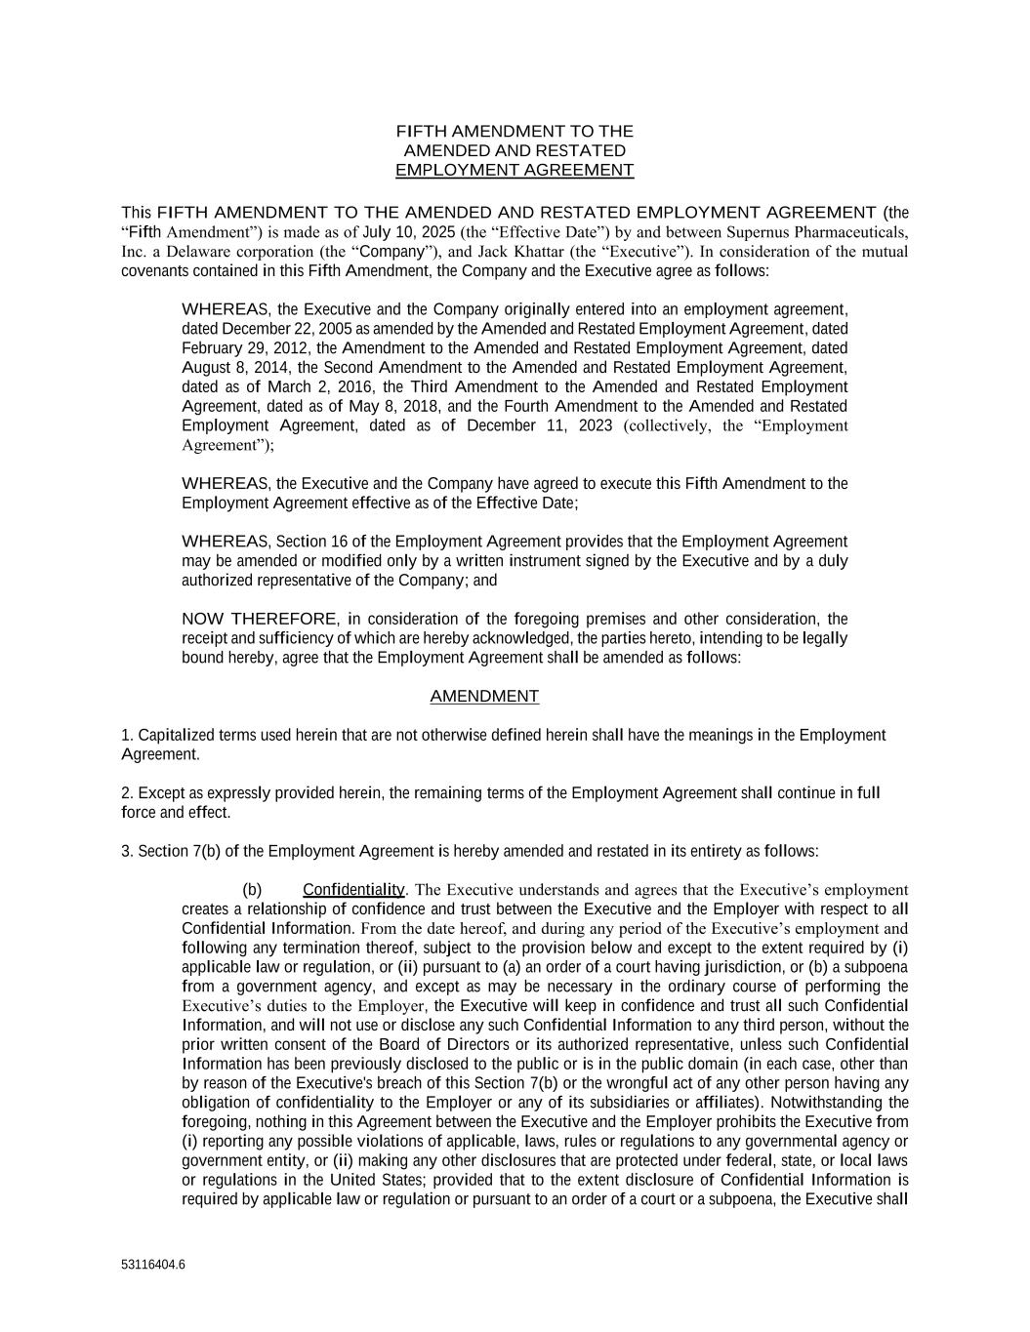
45
53116404.6 FIFTH AMENDMENT TO THE AMENDED AND RESTATED EMPLOYMENT AGREEMENT This FIFTH AMENDMENT TO THE AMENDED AND RESTATED EMPLOYMENT AGREEMENT (the “Fifth Amendment”) is made as of July 10, 2025 (the “Effective Date”) by and between Supernus Pharmaceuticals, Inc. a Delaware corporation (the “Company”), and Jack Khattar (the “Executive”). In consideration of the mutual covenants contained in this Fifth Amendment, the Company and the Executive agree as follows: WHEREAS, the Executive and the Company originally entered into an employment agreement, dated December 22, 2005 as amended by the Amended and Restated Employment Agreement, dated February 29, 2012, the Amendment to the Amended and Restated Employment Agreement, dated August 8, 2014, the Second Amendment to the Amended and Restated Employment Agreement, dated as of March 2, 2016, the Third Amendment to the Amended and Restated Employment Agreement, dated as of May 8, 2018, and the Fourth Amendment to the Amended and Restated Employment Agreement, dated as of December 11, 2023 (collectively, the “Employment Agreement”); WHEREAS, the Executive and the Company have agreed to execute this Fifth Amendment to the Employment Agreement effective as of the Effective Date; WHEREAS, Section 16 of the Employment Agreement provides that the Employment Agreement may be amended or modified only by a written instrument signed by the Executive and by a duly authorized representative of the Company; and NOW THEREFORE, in consideration of the foregoing premises and other consideration, the receipt and sufficiency of which are hereby acknowledged, the parties hereto, intending to be legally bound hereby, agree that the Employment Agreement shall be amended as follows: AMENDMENT 1. Capitalized terms used herein that are not otherwise defined herein shall have the meanings in the Employment Agreement. 2. Except as expressly provided herein, the remaining terms of the Employment Agreement shall continue in full force and effect. 3. Section 7(b) of the Employment Agreement is hereby amended and restated in its entirety as follows: (b) Confidentiality. The Executive understands and agrees that the Executive’s employment creates a relationship of confidence and trust between the Executive and the Employer with respect to all Confidential Information. From the date hereof, and during any period of the Executive’s employment and following any termination thereof, subject to the provision below and except to the extent required by (i) applicable law or regulation, or (ii) pursuant to (a) an order of a court having jurisdiction, or (b) a subpoena from a government agency, and except as may be necessary in the ordinary course of performing the Executive’s duties to the Employer, the Executive will keep in confidence and trust all such Confidential Information, and will not use or disclose any such Confidential Information to any third person, without the prior written consent of the Board of Directors or its authorized representative, unless such Confidential Information has been previously disclosed to the public or is in the public domain (in each case, other than by reason of the Executive's breach of this Section 7(b) or the wrongful act of any other person having any obligation of confidentiality to the Employer or any of its subsidiaries or affiliates). Notwithstanding the foregoing, nothing in this Agreement between the Executive and the Employer prohibits the Executive from (i) reporting any possible violations of applicable, laws, rules or regulations to any governmental agency or government entity, or (ii) making any other disclosures that are protected under federal, state, or local laws or regulations in the United States; provided that to the extent disclosure of Confidential Information is required by applicable law or regulation or pursuant to an order of a court or a subpoena, the Executive shall

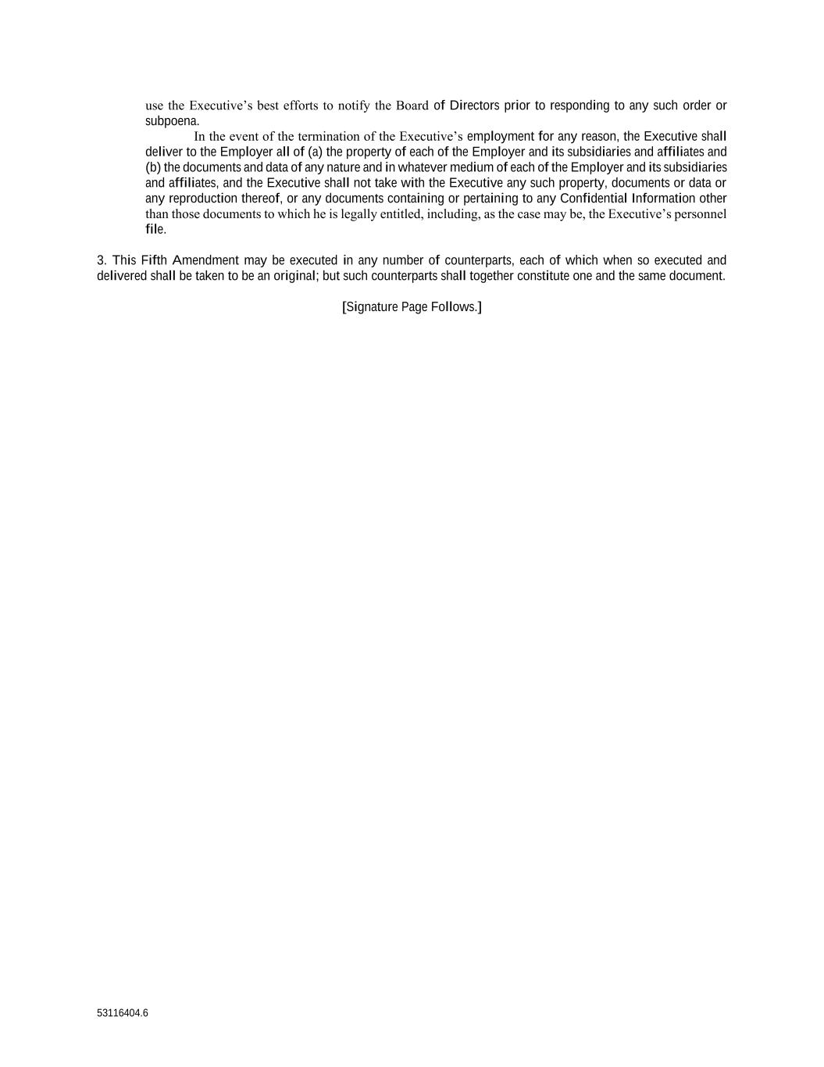
53116404.6 use the Executive’s best efforts to notify the Board of Directors prior to responding to any such order or subpoena. In the event of the termination of the Executive’s employment for any reason, the Executive shall deliver to the Employer all of (a) the property of each of the Employer and its subsidiaries and affiliates and (b) the documents and data of any nature and in whatever medium of each of the Employer and its subsidiaries and affiliates, and the Executive shall not take with the Executive any such property, documents or data or any reproduction thereof, or any documents containing or pertaining to any Confidential Information other than those documents to which he is legally entitled, including, as the case may be, the Executive’s personnel file. 3. This Fifth Amendment may be executed in any number of counterparts, each of which when so executed and delivered shall be taken to be an original; but such counterparts shall together constitute one and the same document. [Signature Page Follows.]

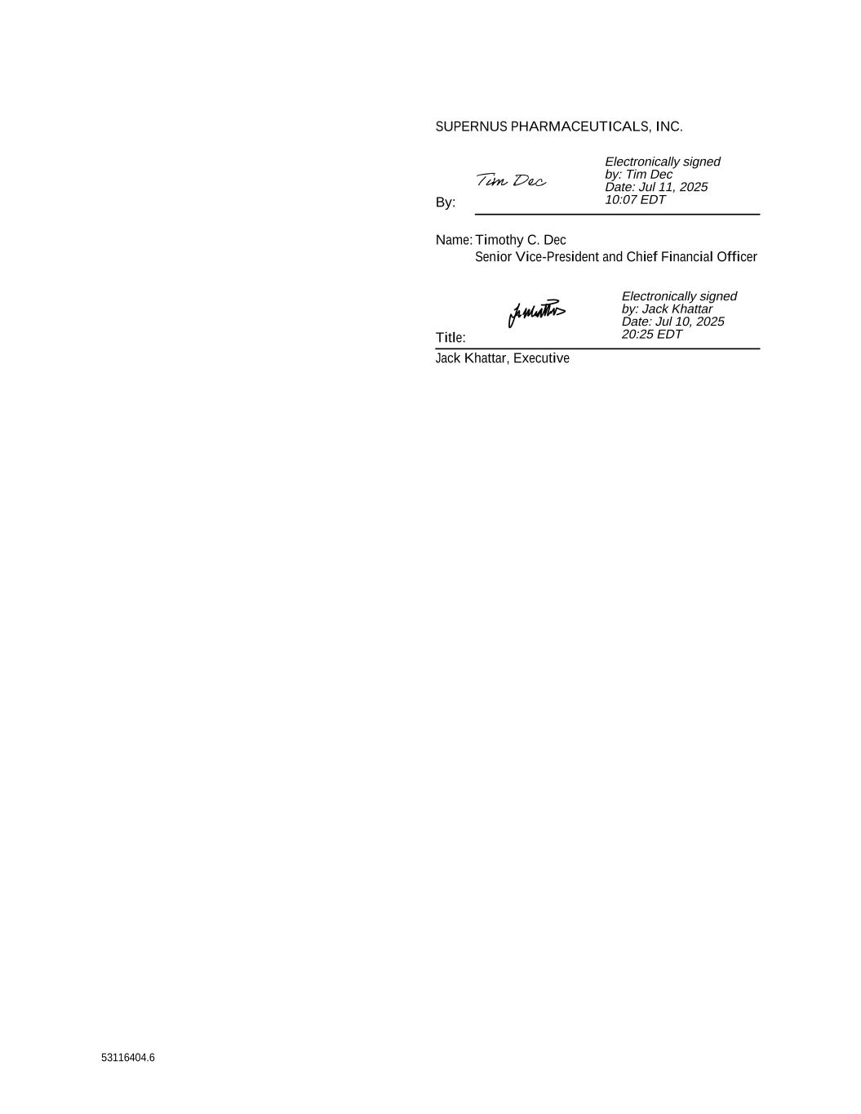
53116404.6 SUPERNUS PHARMACEUTICALS, INC. By: Name: Timothy C. Dec Title: Senior Vice-President and Chief Financial Officer Jack Khattar, Executive Electronically signed by: Jack Khattar Date: Jul 10, 2025 20:25 EDT Electronically signed by: Tim Dec Date: Jul 11, 2025 10:07 EDT

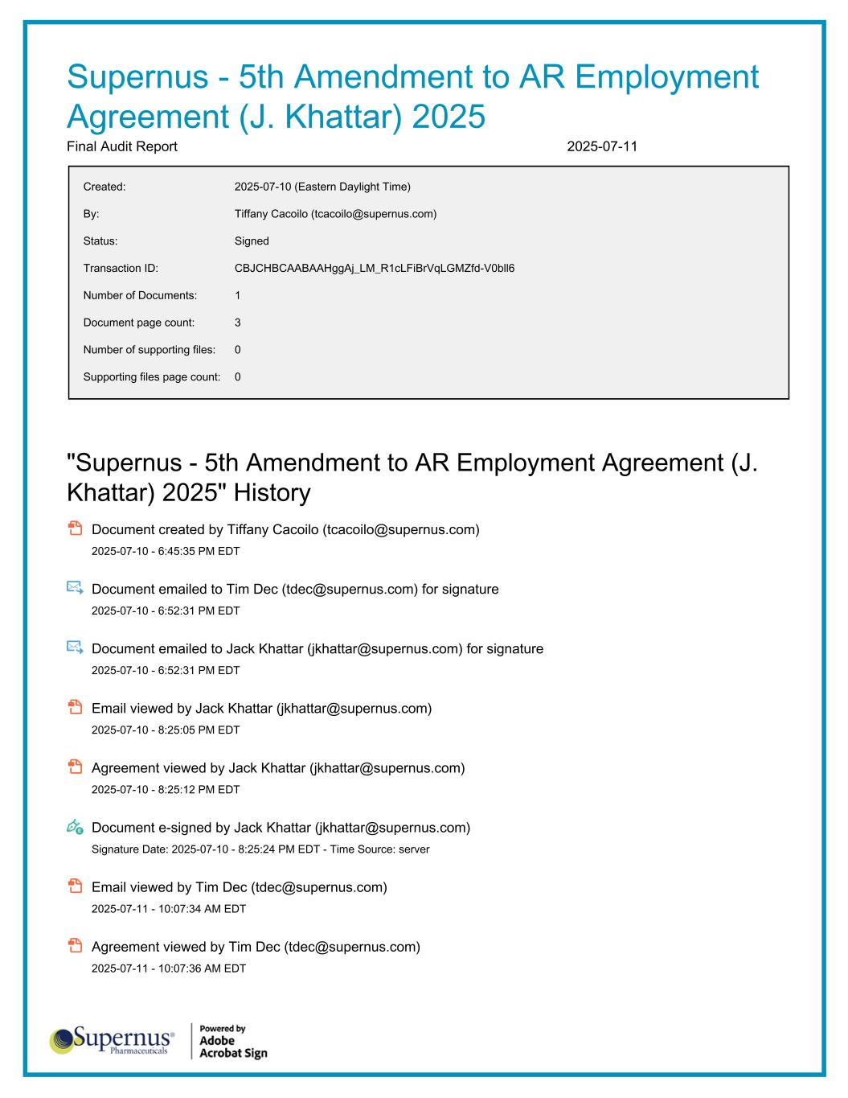
Supernus - 5th Amendment to AR Employment Agreement (J. Khattar) 2025 Final Audit Report 2025-07-11 Created: 2025-07-10 (Eastern Daylight Time) By: Tiffany Cacoilo (tcacoilo@supernus.com) Status: Signed Transaction ID: CBJCHBCAABAAHggAj_LM_R1cLFiBrVqLGMZfd-V0bll6 Number of Documents: 1 Document page count: 3 Number of supporting files: 0 Supporting files page count: 0 "Supernus - 5th Amendment to AR Employment Agreement (J. Khattar) 2025" History Document created by Tiffany Cacoilo (tcacoilo@supernus.com) 2025-07-10 - 6:45:35 PM EDT Document emailed to Tim Dec (tdec@supernus.com) for signature 2025-07-10 - 6:52:31 PM EDT Document emailed to Jack Khattar (jkhattar@supernus.com) for signature 2025-07-10 - 6:52:31 PM EDT Email viewed by Jack Khattar (jkhattar@supernus.com) 2025-07-10 - 8:25:05 PM EDT Agreement viewed by Jack Khattar (jkhattar@supernus.com) 2025-07-10 - 8:25:12 PM EDT Document e-signed by Jack Khattar (jkhattar@supernus.com) Signature Date: 2025-07-10 - 8:25:24 PM EDT - Time Source: server Email viewed by Tim Dec (tdec@supernus.com) 2025-07-11 - 10:07:34 AM EDT Agreement viewed by Tim Dec (tdec@supernus.com) 2025-07-11 - 10:07:36 AM EDT


Document e-signed by Tim Dec (tdec@supernus.com) Signature Date: 2025-07-11 - 10:07:50 AM EDT - Time Source: server Agreement completed. 2025-07-11 - 10:07:50 AM EDT

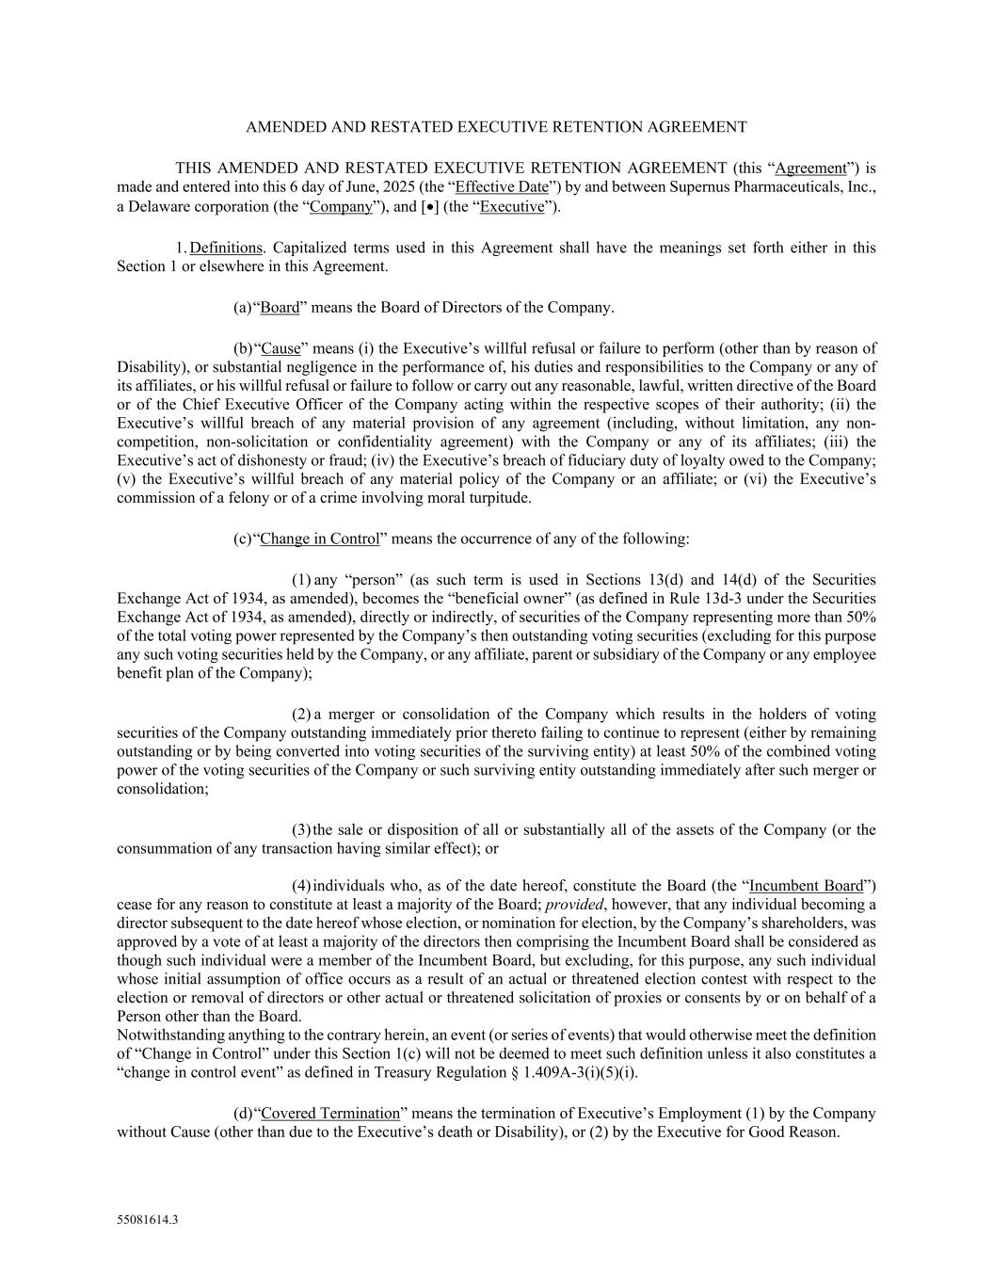
55081614.3 AMENDED AND RESTATED EXECUTIVE RETENTION AGREEMENT THIS AMENDED AND RESTATED EXECUTIVE RETENTION AGREEMENT (this “Agreement”) is made and entered into this 6 day of June, 2025 (the “Effective Date”) by and between Supernus Pharmaceuticals, Inc., a Delaware corporation (the “Company”), and [•] (the “Executive”). 1. Definitions. Capitalized terms used in this Agreement shall have the meanings set forth either in this Section 1 or elsewhere in this Agreement. (a) “Board” means the Board of Directors of the Company. (b) “Cause” means (i) the Executive’s willful refusal or failure to perform (other than by reason of Disability), or substantial negligence in the performance of, his duties and responsibilities to the Company or any of its affiliates, or his willful refusal or failure to follow or carry out any reasonable, lawful, written directive of the Board or of the Chief Executive Officer of the Company acting within the respective scopes of their authority; (ii) the Executive’s willful breach of any material provision of any agreement (including, without limitation, any non- competition, non-solicitation or confidentiality agreement) with the Company or any of its affiliates; (iii) the Executive’s act of dishonesty or fraud; (iv) the Executive’s breach of fiduciary duty of loyalty owed to the Company; (v) the Executive’s willful breach of any material policy of the Company or an affiliate; or (vi) the Executive’s commission of a felony or of a crime involving moral turpitude. (c) “Change in Control” means the occurrence of any of the following: (1) any “person” (as such term is used in Sections 13(d) and 14(d) of the Securities Exchange Act of 1934, as amended), becomes the “beneficial owner” (as defined in Rule 13d-3 under the Securities Exchange Act of 1934, as amended), directly or indirectly, of securities of the Company representing more than 50% of the total voting power represented by the Company’s then outstanding voting securities (excluding for this purpose any such voting securities held by the Company, or any affiliate, parent or subsidiary of the Company or any employee benefit plan of the Company); (2) a merger or consolidation of the Company which results in the holders of voting securities of the Company outstanding immediately prior thereto failing to continue to represent (either by remaining outstanding or by being converted into voting securities of the surviving entity) at least 50% of the combined voting power of the voting securities of the Company or such surviving entity outstanding immediately after such merger or consolidation; (3) the sale or disposition of all or substantially all of the assets of the Company (or the consummation of any transaction having similar effect); or (4) individuals who, as of the date hereof, constitute the Board (the “Incumbent Board”) cease for any reason to constitute at least a majority of the Board; provided, however, that any individual becoming a director subsequent to the date hereof whose election, or nomination for election, by the Company’s shareholders, was approved by a vote of at least a majority of the directors then comprising the Incumbent Board shall be considered as though such individual were a member of the Incumbent Board, but excluding, for this purpose, any such individual whose initial assumption of office occurs as a result of an actual or threatened election contest with respect to the election or removal of directors or other actual or threatened solicitation of proxies or consents by or on behalf of a Person other than the Board. Notwithstanding anything to the contrary herein, an event (or series of events) that would otherwise meet the definition of “Change in Control” under this Section 1(c) will not be deemed to meet such definition unless it also constitutes a “change in control event” as defined in Treasury Regulation § 1.409A-3(i)(5)(i). (d) “Covered Termination” means the termination of Executive’s Employment (1) by the Company without Cause (other than due to the Executive’s death or Disability), or (2) by the Executive for Good Reason.

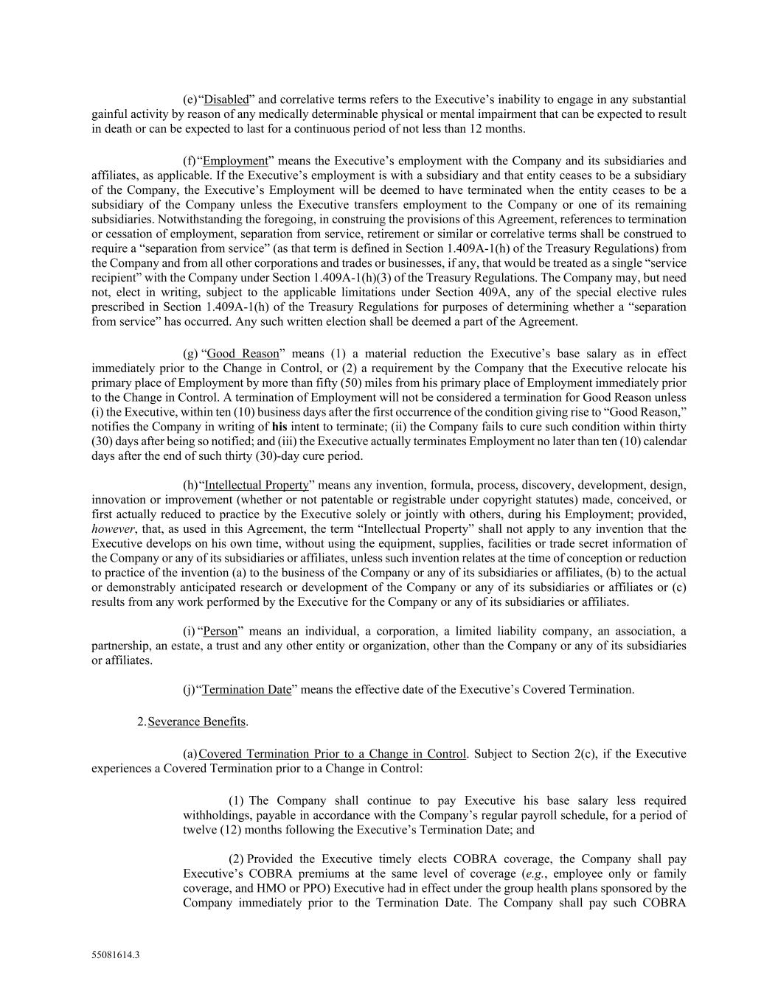
55081614.3 (e) “Disabled” and correlative terms refers to the Executive’s inability to engage in any substantial gainful activity by reason of any medically determinable physical or mental impairment that can be expected to result in death or can be expected to last for a continuous period of not less than 12 months. (f) “Employment” means the Executive’s employment with the Company and its subsidiaries and affiliates, as applicable. If the Executive’s employment is with a subsidiary and that entity ceases to be a subsidiary of the Company, the Executive’s Employment will be deemed to have terminated when the entity ceases to be a subsidiary of the Company unless the Executive transfers employment to the Company or one of its remaining subsidiaries. Notwithstanding the foregoing, in construing the provisions of this Agreement, references to termination or cessation of employment, separation from service, retirement or similar or correlative terms shall be construed to require a “separation from service” (as that term is defined in Section 1.409A-1(h) of the Treasury Regulations) from the Company and from all other corporations and trades or businesses, if any, that would be treated as a single “service recipient” with the Company under Section 1.409A-1(h)(3) of the Treasury Regulations. The Company may, but need not, elect in writing, subject to the applicable limitations under Section 409A, any of the special elective rules prescribed in Section 1.409A-1(h) of the Treasury Regulations for purposes of determining whether a “separation from service” has occurred. Any such written election shall be deemed a part of the Agreement. (g) “Good Reason” means (1) a material reduction the Executive’s base salary as in effect immediately prior to the Change in Control, or (2) a requirement by the Company that the Executive relocate his primary place of Employment by more than fifty (50) miles from his primary place of Employment immediately prior to the Change in Control. A termination of Employment will not be considered a termination for Good Reason unless (i) the Executive, within ten (10) business days after the first occurrence of the condition giving rise to “Good Reason,” notifies the Company in writing of his intent to terminate; (ii) the Company fails to cure such condition within thirty (30) days after being so notified; and (iii) the Executive actually terminates Employment no later than ten (10) calendar days after the end of such thirty (30)-day cure period. (h) “Intellectual Property” means any invention, formula, process, discovery, development, design, innovation or improvement (whether or not patentable or registrable under copyright statutes) made, conceived, or first actually reduced to practice by the Executive solely or jointly with others, during his Employment; provided, however, that, as used in this Agreement, the term “Intellectual Property” shall not apply to any invention that the Executive develops on his own time, without using the equipment, supplies, facilities or trade secret information of the Company or any of its subsidiaries or affiliates, unless such invention relates at the time of conception or reduction to practice of the invention (a) to the business of the Company or any of its subsidiaries or affiliates, (b) to the actual or demonstrably anticipated research or development of the Company or any of its subsidiaries or affiliates or (c) results from any work performed by the Executive for the Company or any of its subsidiaries or affiliates. (i) “Person” means an individual, a corporation, a limited liability company, an association, a partnership, an estate, a trust and any other entity or organization, other than the Company or any of its subsidiaries or affiliates. (j) “Termination Date” means the effective date of the Executive’s Covered Termination. 2. Severance Benefits. (a) Covered Termination Prior to a Change in Control. Subject to Section 2(c), if the Executive experiences a Covered Termination prior to a Change in Control: (1) The Company shall continue to pay Executive his base salary less required withholdings, payable in accordance with the Company’s regular payroll schedule, for a period of twelve (12) months following the Executive’s Termination Date; and (2) Provided the Executive timely elects COBRA coverage, the Company shall pay Executive’s COBRA premiums at the same level of coverage (e.g., employee only or family coverage, and HMO or PPO) Executive had in effect under the group health plans sponsored by the Company immediately prior to the Termination Date. The Company shall pay such COBRA

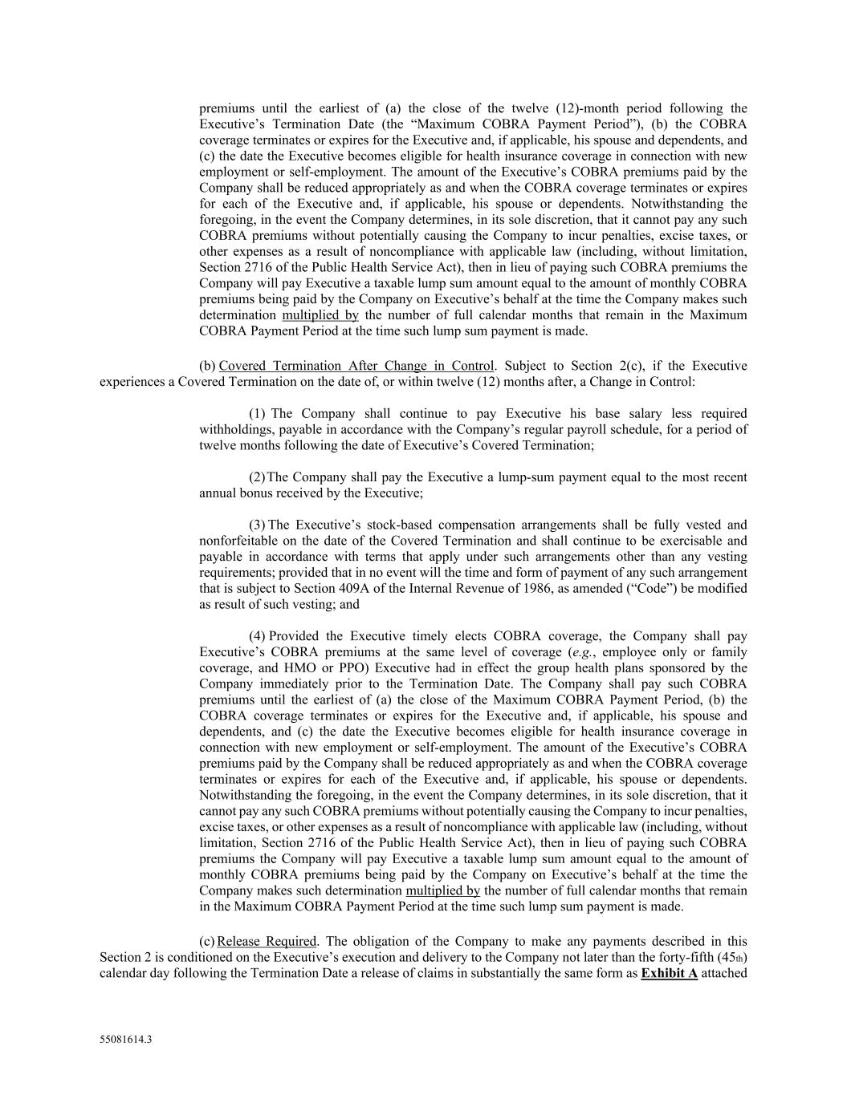
55081614.3 premiums until the earliest of (a) the close of the twelve (12)-month period following the Executive’s Termination Date (the “Maximum COBRA Payment Period”), (b) the COBRA coverage terminates or expires for the Executive and, if applicable, his spouse and dependents, and (c) the date the Executive becomes eligible for health insurance coverage in connection with new employment or self-employment. The amount of the Executive’s COBRA premiums paid by the Company shall be reduced appropriately as and when the COBRA coverage terminates or expires for each of the Executive and, if applicable, his spouse or dependents. Notwithstanding the foregoing, in the event the Company determines, in its sole discretion, that it cannot pay any such COBRA premiums without potentially causing the Company to incur penalties, excise taxes, or other expenses as a result of noncompliance with applicable law (including, without limitation, Section 2716 of the Public Health Service Act), then in lieu of paying such COBRA premiums the Company will pay Executive a taxable lump sum amount equal to the amount of monthly COBRA premiums being paid by the Company on Executive’s behalf at the time the Company makes such determination multiplied by the number of full calendar months that remain in the Maximum COBRA Payment Period at the time such lump sum payment is made. (b) Covered Termination After Change in Control. Subject to Section 2(c), if the Executive experiences a Covered Termination on the date of, or within twelve (12) months after, a Change in Control: (1) The Company shall continue to pay Executive his base salary less required withholdings, payable in accordance with the Company’s regular payroll schedule, for a period of twelve months following the date of Executive’s Covered Termination; (2) The Company shall pay the Executive a lump-sum payment equal to the most recent annual bonus received by the Executive; (3) The Executive’s stock-based compensation arrangements shall be fully vested and nonforfeitable on the date of the Covered Termination and shall continue to be exercisable and payable in accordance with terms that apply under such arrangements other than any vesting requirements; provided that in no event will the time and form of payment of any such arrangement that is subject to Section 409A of the Internal Revenue of 1986, as amended (“Code”) be modified as result of such vesting; and (4) Provided the Executive timely elects COBRA coverage, the Company shall pay Executive’s COBRA premiums at the same level of coverage (e.g., employee only or family coverage, and HMO or PPO) Executive had in effect the group health plans sponsored by the Company immediately prior to the Termination Date. The Company shall pay such COBRA premiums until the earliest of (a) the close of the Maximum COBRA Payment Period, (b) the COBRA coverage terminates or expires for the Executive and, if applicable, his spouse and dependents, and (c) the date the Executive becomes eligible for health insurance coverage in connection with new employment or self-employment. The amount of the Executive’s COBRA premiums paid by the Company shall be reduced appropriately as and when the COBRA coverage terminates or expires for each of the Executive and, if applicable, his spouse or dependents. Notwithstanding the foregoing, in the event the Company determines, in its sole discretion, that it cannot pay any such COBRA premiums without potentially causing the Company to incur penalties, excise taxes, or other expenses as a result of noncompliance with applicable law (including, without limitation, Section 2716 of the Public Health Service Act), then in lieu of paying such COBRA premiums the Company will pay Executive a taxable lump sum amount equal to the amount of monthly COBRA premiums being paid by the Company on Executive’s behalf at the time the Company makes such determination multiplied by the number of full calendar months that remain in the Maximum COBRA Payment Period at the time such lump sum payment is made. (c) Release Required. The obligation of the Company to make any payments described in this Section 2 is conditioned on the Executive’s execution and delivery to the Company not later than the forty-fifth (45th) calendar day following the Termination Date a release of claims in substantially the same form as Exhibit A attached

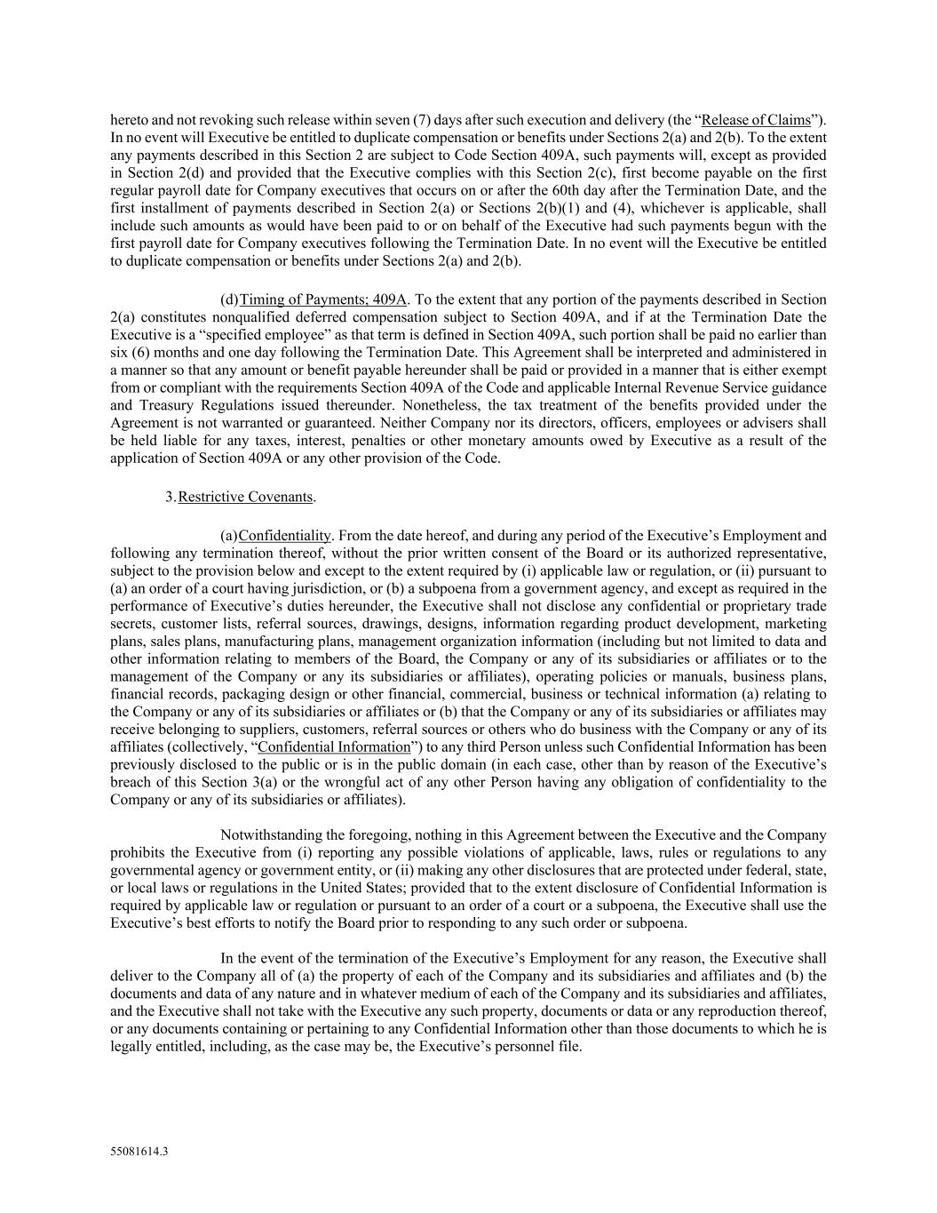
55081614.3 hereto and not revoking such release within seven (7) days after such execution and delivery (the “Release of Claims”). In no event will Executive be entitled to duplicate compensation or benefits under Sections 2(a) and 2(b). To the extent any payments described in this Section 2 are subject to Code Section 409A, such payments will, except as provided in Section 2(d) and provided that the Executive complies with this Section 2(c), first become payable on the first regular payroll date for Company executives that occurs on or after the 60th day after the Termination Date, and the first installment of payments described in Section 2(a) or Sections 2(b)(1) and (4), whichever is applicable, shall include such amounts as would have been paid to or on behalf of the Executive had such payments begun with the first payroll date for Company executives following the Termination Date. In no event will the Executive be entitled to duplicate compensation or benefits under Sections 2(a) and 2(b). (d) Timing of Payments; 409A. To the extent that any portion of the payments described in Section 2(a) constitutes nonqualified deferred compensation subject to Section 409A, and if at the Termination Date the Executive is a “specified employee” as that term is defined in Section 409A, such portion shall be paid no earlier than six (6) months and one day following the Termination Date. This Agreement shall be interpreted and administered in a manner so that any amount or benefit payable hereunder shall be paid or provided in a manner that is either exempt from or compliant with the requirements Section 409A of the Code and applicable Internal Revenue Service guidance and Treasury Regulations issued thereunder. Nonetheless, the tax treatment of the benefits provided under the Agreement is not warranted or guaranteed. Neither Company nor its directors, officers, employees or advisers shall be held liable for any taxes, interest, penalties or other monetary amounts owed by Executive as a result of the application of Section 409A or any other provision of the Code. 3. Restrictive Covenants. (a) Confidentiality. From the date hereof, and during any period of the Executive’s Employment and following any termination thereof, without the prior written consent of the Board or its authorized representative, subject to the provision below and except to the extent required by (i) applicable law or regulation, or (ii) pursuant to (a) an order of a court having jurisdiction, or (b) a subpoena from a government agency, and except as required in the performance of Executive’s duties hereunder, the Executive shall not disclose any confidential or proprietary trade secrets, customer lists, referral sources, drawings, designs, information regarding product development, marketing plans, sales plans, manufacturing plans, management organization information (including but not limited to data and other information relating to members of the Board, the Company or any of its subsidiaries or affiliates or to the management of the Company or any its subsidiaries or affiliates), operating policies or manuals, business plans, financial records, packaging design or other financial, commercial, business or technical information (a) relating to the Company or any of its subsidiaries or affiliates or (b) that the Company or any of its subsidiaries or affiliates may receive belonging to suppliers, customers, referral sources or others who do business with the Company or any of its affiliates (collectively, “Confidential Information”) to any third Person unless such Confidential Information has been previously disclosed to the public or is in the public domain (in each case, other than by reason of the Executive’s breach of this Section 3(a) or the wrongful act of any other Person having any obligation of confidentiality to the Company or any of its subsidiaries or affiliates). Notwithstanding the foregoing, nothing in this Agreement between the Executive and the Company prohibits the Executive from (i) reporting any possible violations of applicable, laws, rules or regulations to any governmental agency or government entity, or (ii) making any other disclosures that are protected under federal, state, or local laws or regulations in the United States; provided that to the extent disclosure of Confidential Information is required by applicable law or regulation or pursuant to an order of a court or a subpoena, the Executive shall use the Executive’s best efforts to notify the Board prior to responding to any such order or subpoena. In the event of the termination of the Executive’s Employment for any reason, the Executive shall deliver to the Company all of (a) the property of each of the Company and its subsidiaries and affiliates and (b) the documents and data of any nature and in whatever medium of each of the Company and its subsidiaries and affiliates, and the Executive shall not take with the Executive any such property, documents or data or any reproduction thereof, or any documents containing or pertaining to any Confidential Information other than those documents to which he is legally entitled, including, as the case may be, the Executive’s personnel file.

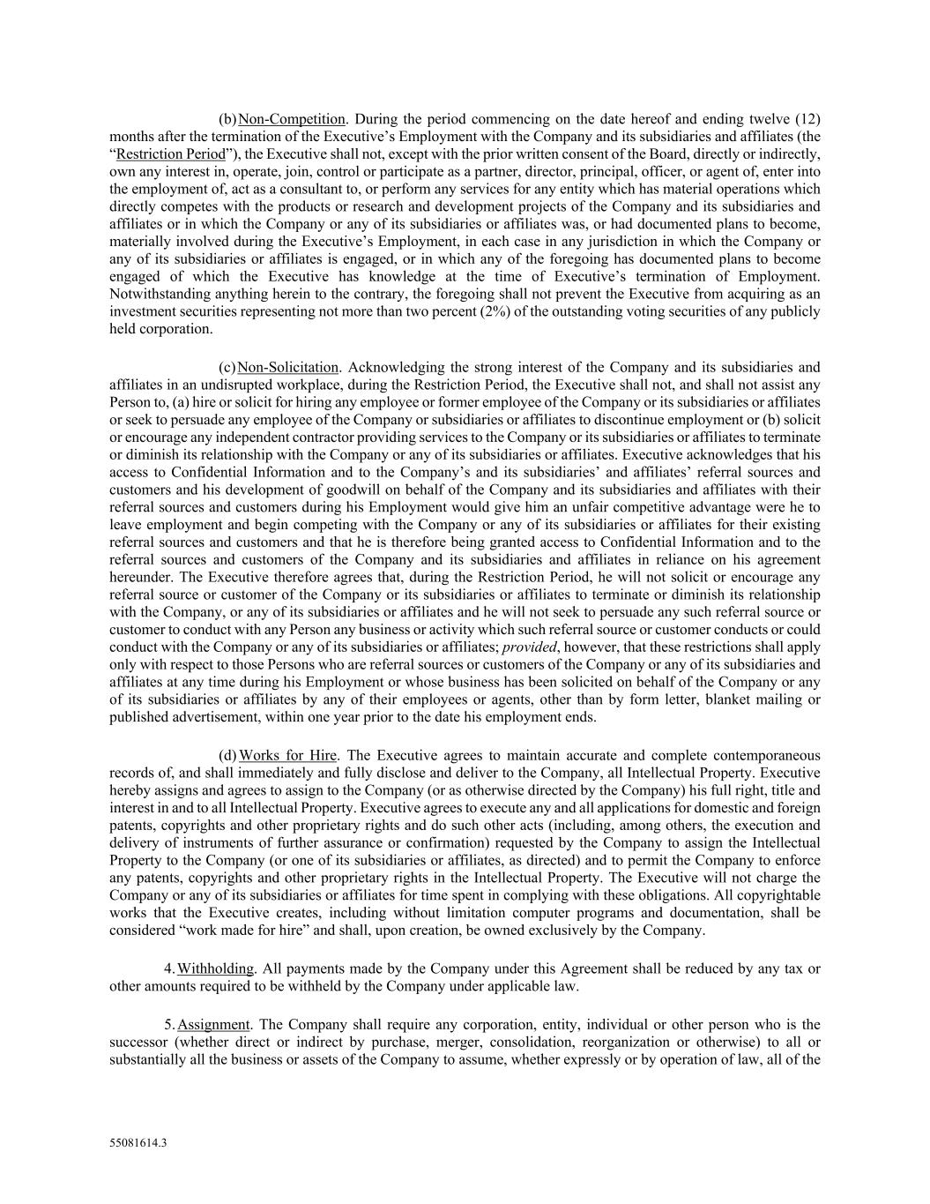
55081614.3 (b) Non-Competition. During the period commencing on the date hereof and ending twelve (12) months after the termination of the Executive’s Employment with the Company and its subsidiaries and affiliates (the “Restriction Period”), the Executive shall not, except with the prior written consent of the Board, directly or indirectly, own any interest in, operate, join, control or participate as a partner, director, principal, officer, or agent of, enter into the employment of, act as a consultant to, or perform any services for any entity which has material operations which directly competes with the products or research and development projects of the Company and its subsidiaries and affiliates or in which the Company or any of its subsidiaries or affiliates was, or had documented plans to become, materially involved during the Executive’s Employment, in each case in any jurisdiction in which the Company or any of its subsidiaries or affiliates is engaged, or in which any of the foregoing has documented plans to become engaged of which the Executive has knowledge at the time of Executive’s termination of Employment. Notwithstanding anything herein to the contrary, the foregoing shall not prevent the Executive from acquiring as an investment securities representing not more than two percent (2%) of the outstanding voting securities of any publicly held corporation. (c) Non-Solicitation. Acknowledging the strong interest of the Company and its subsidiaries and affiliates in an undisrupted workplace, during the Restriction Period, the Executive shall not, and shall not assist any Person to, (a) hire or solicit for hiring any employee or former employee of the Company or its subsidiaries or affiliates or seek to persuade any employee of the Company or subsidiaries or affiliates to discontinue employment or (b) solicit or encourage any independent contractor providing services to the Company or its subsidiaries or affiliates to terminate or diminish its relationship with the Company or any of its subsidiaries or affiliates. Executive acknowledges that his access to Confidential Information and to the Company’s and its subsidiaries’ and affiliates’ referral sources and customers and his development of goodwill on behalf of the Company and its subsidiaries and affiliates with their referral sources and customers during his Employment would give him an unfair competitive advantage were he to leave employment and begin competing with the Company or any of its subsidiaries or affiliates for their existing referral sources and customers and that he is therefore being granted access to Confidential Information and to the referral sources and customers of the Company and its subsidiaries and affiliates in reliance on his agreement hereunder. The Executive therefore agrees that, during the Restriction Period, he will not solicit or encourage any referral source or customer of the Company or its subsidiaries or affiliates to terminate or diminish its relationship with the Company, or any of its subsidiaries or affiliates and he will not seek to persuade any such referral source or customer to conduct with any Person any business or activity which such referral source or customer conducts or could conduct with the Company or any of its subsidiaries or affiliates; provided, however, that these restrictions shall apply only with respect to those Persons who are referral sources or customers of the Company or any of its subsidiaries and affiliates at any time during his Employment or whose business has been solicited on behalf of the Company or any of its subsidiaries or affiliates by any of their employees or agents, other than by form letter, blanket mailing or published advertisement, within one year prior to the date his employment ends. (d) Works for Hire. The Executive agrees to maintain accurate and complete contemporaneous records of, and shall immediately and fully disclose and deliver to the Company, all Intellectual Property. Executive hereby assigns and agrees to assign to the Company (or as otherwise directed by the Company) his full right, title and interest in and to all Intellectual Property. Executive agrees to execute any and all applications for domestic and foreign patents, copyrights and other proprietary rights and do such other acts (including, among others, the execution and delivery of instruments of further assurance or confirmation) requested by the Company to assign the Intellectual Property to the Company (or one of its subsidiaries or affiliates, as directed) and to permit the Company to enforce any patents, copyrights and other proprietary rights in the Intellectual Property. The Executive will not charge the Company or any of its subsidiaries or affiliates for time spent in complying with these obligations. All copyrightable works that the Executive creates, including without limitation computer programs and documentation, shall be considered “work made for hire” and shall, upon creation, be owned exclusively by the Company. 4. Withholding. All payments made by the Company under this Agreement shall be reduced by any tax or other amounts required to be withheld by the Company under applicable law. 5. Assignment. The Company shall require any corporation, entity, individual or other person who is the successor (whether direct or indirect by purchase, merger, consolidation, reorganization or otherwise) to all or substantially all the business or assets of the Company to assume, whether expressly or by operation of law, all of the

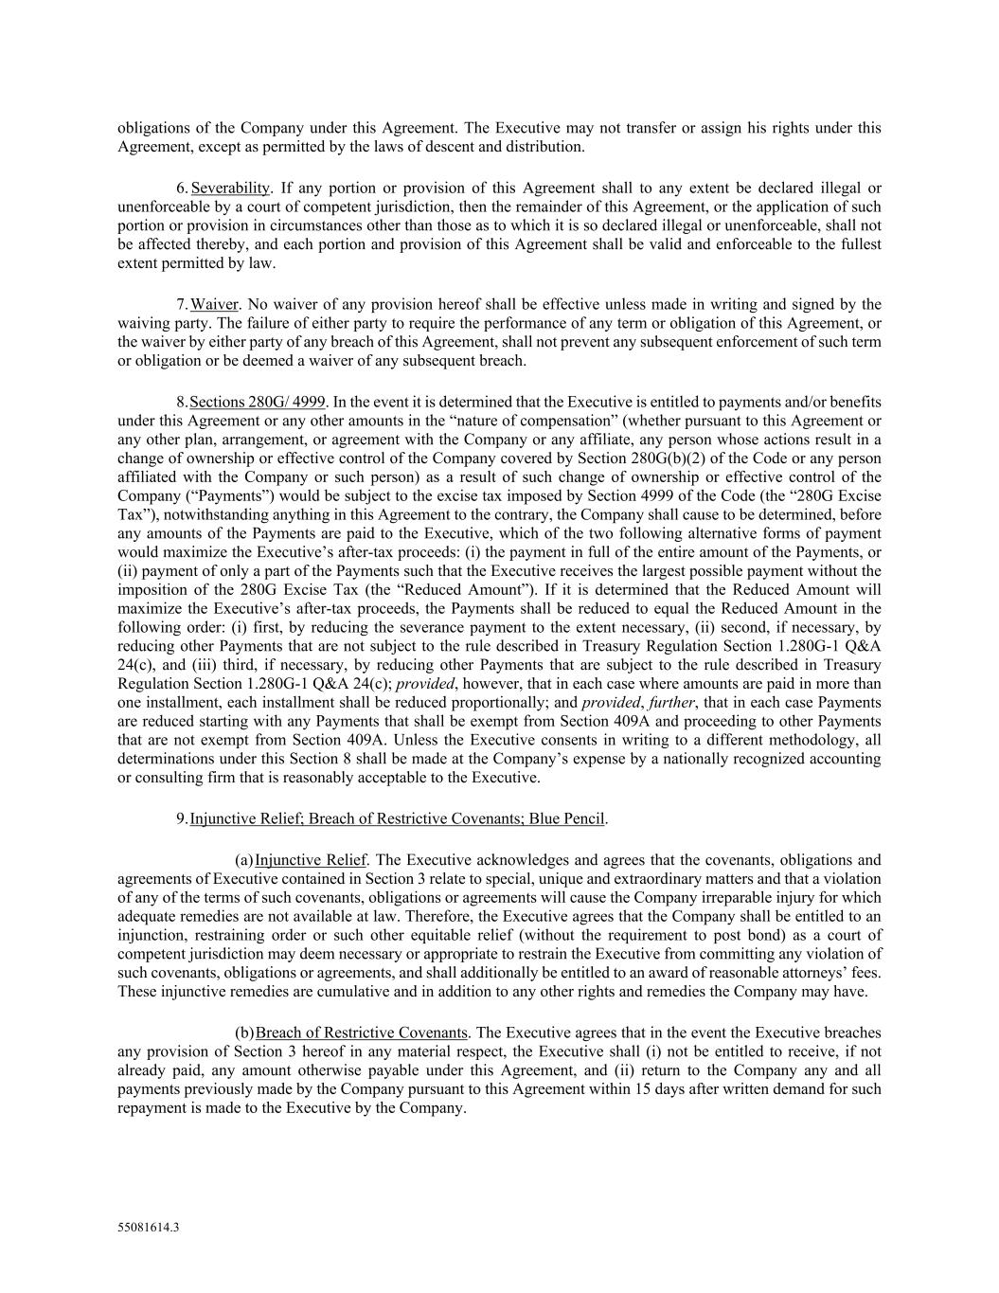
55081614.3 obligations of the Company under this Agreement. The Executive may not transfer or assign his rights under this Agreement, except as permitted by the laws of descent and distribution. 6. Severability. If any portion or provision of this Agreement shall to any extent be declared illegal or unenforceable by a court of competent jurisdiction, then the remainder of this Agreement, or the application of such portion or provision in circumstances other than those as to which it is so declared illegal or unenforceable, shall not be affected thereby, and each portion and provision of this Agreement shall be valid and enforceable to the fullest extent permitted by law. 7. Waiver. No waiver of any provision hereof shall be effective unless made in writing and signed by the waiving party. The failure of either party to require the performance of any term or obligation of this Agreement, or the waiver by either party of any breach of this Agreement, shall not prevent any subsequent enforcement of such term or obligation or be deemed a waiver of any subsequent breach. 8. Sections 280G/ 4999. In the event it is determined that the Executive is entitled to payments and/or benefits under this Agreement or any other amounts in the “nature of compensation” (whether pursuant to this Agreement or any other plan, arrangement, or agreement with the Company or any affiliate, any person whose actions result in a change of ownership or effective control of the Company covered by Section 280G(b)(2) of the Code or any person affiliated with the Company or such person) as a result of such change of ownership or effective control of the Company (“Payments”) would be subject to the excise tax imposed by Section 4999 of the Code (the “280G Excise Tax”), notwithstanding anything in this Agreement to the contrary, the Company shall cause to be determined, before any amounts of the Payments are paid to the Executive, which of the two following alternative forms of payment would maximize the Executive’s after-tax proceeds: (i) the payment in full of the entire amount of the Payments, or (ii) payment of only a part of the Payments such that the Executive receives the largest possible payment without the imposition of the 280G Excise Tax (the “Reduced Amount”). If it is determined that the Reduced Amount will maximize the Executive’s after-tax proceeds, the Payments shall be reduced to equal the Reduced Amount in the following order: (i) first, by reducing the severance payment to the extent necessary, (ii) second, if necessary, by reducing other Payments that are not subject to the rule described in Treasury Regulation Section 1.280G-1 Q&A 24(c), and (iii) third, if necessary, by reducing other Payments that are subject to the rule described in Treasury Regulation Section 1.280G-1 Q&A 24(c); provided, however, that in each case where amounts are paid in more than one installment, each installment shall be reduced proportionally; and provided, further, that in each case Payments are reduced starting with any Payments that shall be exempt from Section 409A and proceeding to other Payments that are not exempt from Section 409A. Unless the Executive consents in writing to a different methodology, all determinations under this Section 8 shall be made at the Company’s expense by a nationally recognized accounting or consulting firm that is reasonably acceptable to the Executive. 9. Injunctive Relief; Breach of Restrictive Covenants; Blue Pencil. (a) Injunctive Relief. The Executive acknowledges and agrees that the covenants, obligations and agreements of Executive contained in Section 3 relate to special, unique and extraordinary matters and that a violation of any of the terms of such covenants, obligations or agreements will cause the Company irreparable injury for which adequate remedies are not available at law. Therefore, the Executive agrees that the Company shall be entitled to an injunction, restraining order or such other equitable relief (without the requirement to post bond) as a court of competent jurisdiction may deem necessary or appropriate to restrain the Executive from committing any violation of such covenants, obligations or agreements, and shall additionally be entitled to an award of reasonable attorneys’ fees. These injunctive remedies are cumulative and in addition to any other rights and remedies the Company may have. (b) Breach of Restrictive Covenants. The Executive agrees that in the event the Executive breaches any provision of Section 3 hereof in any material respect, the Executive shall (i) not be entitled to receive, if not already paid, any amount otherwise payable under this Agreement, and (ii) return to the Company any and all payments previously made by the Company pursuant to this Agreement within 15 days after written demand for such repayment is made to the Executive by the Company.

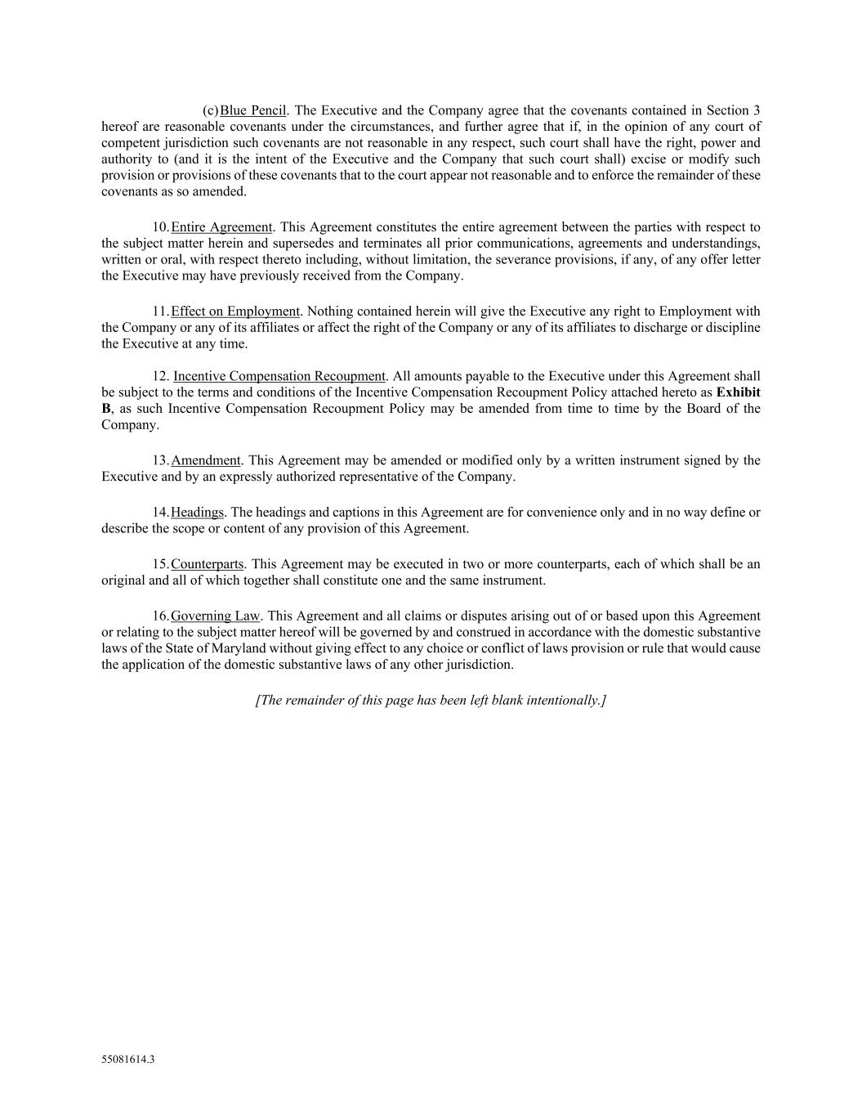
55081614.3 (c) Blue Pencil. The Executive and the Company agree that the covenants contained in Section 3 hereof are reasonable covenants under the circumstances, and further agree that if, in the opinion of any court of competent jurisdiction such covenants are not reasonable in any respect, such court shall have the right, power and authority to (and it is the intent of the Executive and the Company that such court shall) excise or modify such provision or provisions of these covenants that to the court appear not reasonable and to enforce the remainder of these covenants as so amended. 10. Entire Agreement. This Agreement constitutes the entire agreement between the parties with respect to the subject matter herein and supersedes and terminates all prior communications, agreements and understandings, written or oral, with respect thereto including, without limitation, the severance provisions, if any, of any offer letter the Executive may have previously received from the Company. 11. Effect on Employment. Nothing contained herein will give the Executive any right to Employment with the Company or any of its affiliates or affect the right of the Company or any of its affiliates to discharge or discipline the Executive at any time. 12. Incentive Compensation Recoupment. All amounts payable to the Executive under this Agreement shall be subject to the terms and conditions of the Incentive Compensation Recoupment Policy attached hereto as Exhibit B, as such Incentive Compensation Recoupment Policy may be amended from time to time by the Board of the Company. 13. Amendment. This Agreement may be amended or modified only by a written instrument signed by the Executive and by an expressly authorized representative of the Company. 14. Headings. The headings and captions in this Agreement are for convenience only and in no way define or describe the scope or content of any provision of this Agreement. 15. Counterparts. This Agreement may be executed in two or more counterparts, each of which shall be an original and all of which together shall constitute one and the same instrument. 16. Governing Law. This Agreement and all claims or disputes arising out of or based upon this Agreement or relating to the subject matter hereof will be governed by and construed in accordance with the domestic substantive laws of the State of Maryland without giving effect to any choice or conflict of laws provision or rule that would cause the application of the domestic substantive laws of any other jurisdiction. [The remainder of this page has been left blank intentionally.]


55081614.3 IN WITNESS WHEREOF, this Agreement has been executed as a sealed instrument by the Company, by its duly authorized representative, and by the Executive, as of the date first above written. THE EXECUTIVE: THE COMPANY: By: By: Name: Name: Title: Title:

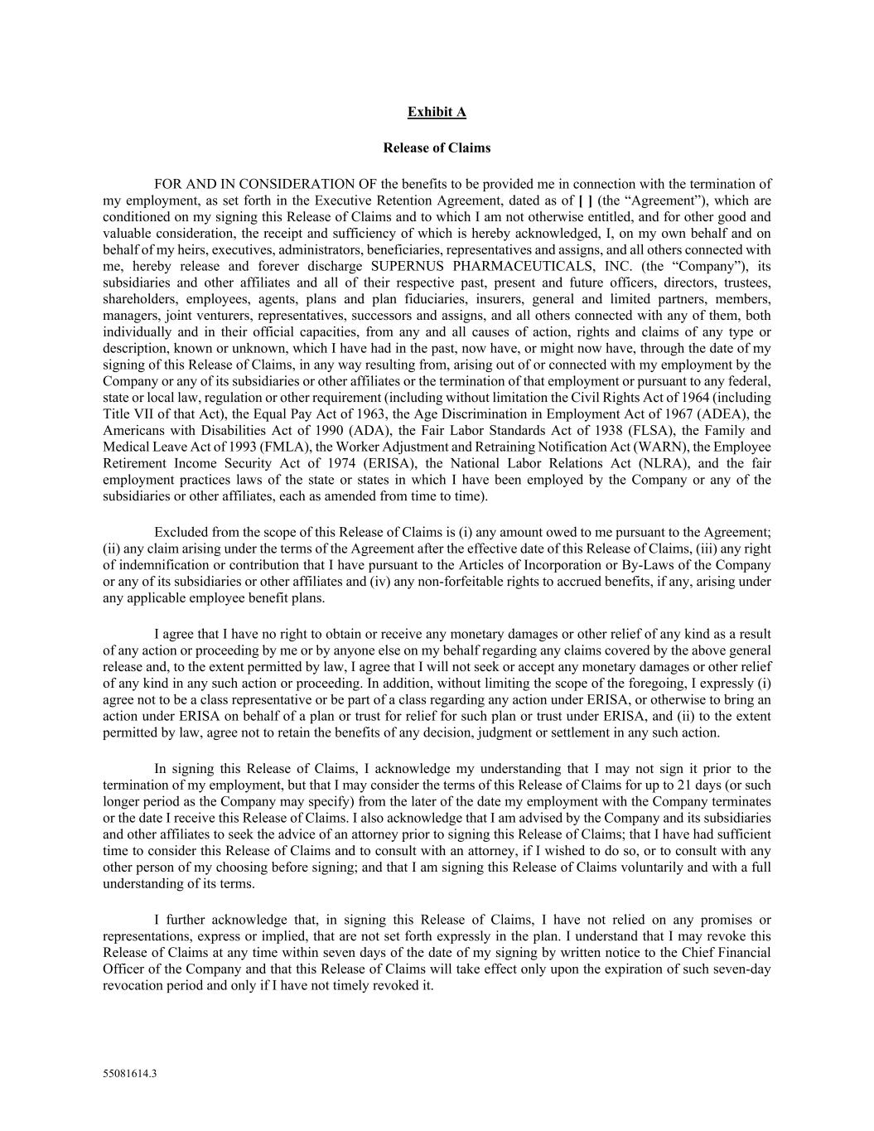
55081614.3 Exhibit A Release of Claims FOR AND IN CONSIDERATION OF the benefits to be provided me in connection with the termination of my employment, as set forth in the Executive Retention Agreement, dated as of [ ] (the “Agreement”), which are conditioned on my signing this Release of Claims and to which I am not otherwise entitled, and for other good and valuable consideration, the receipt and sufficiency of which is hereby acknowledged, I, on my own behalf and on behalf of my heirs, executives, administrators, beneficiaries, representatives and assigns, and all others connected with me, hereby release and forever discharge SUPERNUS PHARMACEUTICALS, INC. (the “Company”), its subsidiaries and other affiliates and all of their respective past, present and future officers, directors, trustees, shareholders, employees, agents, plans and plan fiduciaries, insurers, general and limited partners, members, managers, joint venturers, representatives, successors and assigns, and all others connected with any of them, both individually and in their official capacities, from any and all causes of action, rights and claims of any type or description, known or unknown, which I have had in the past, now have, or might now have, through the date of my signing of this Release of Claims, in any way resulting from, arising out of or connected with my employment by the Company or any of its subsidiaries or other affiliates or the termination of that employment or pursuant to any federal, state or local law, regulation or other requirement (including without limitation the Civil Rights Act of 1964 (including Title VII of that Act), the Equal Pay Act of 1963, the Age Discrimination in Employment Act of 1967 (ADEA), the Americans with Disabilities Act of 1990 (ADA), the Fair Labor Standards Act of 1938 (FLSA), the Family and Medical Leave Act of 1993 (FMLA), the Worker Adjustment and Retraining Notification Act (WARN), the Employee Retirement Income Security Act of 1974 (ERISA), the National Labor Relations Act (NLRA), and the fair employment practices laws of the state or states in which I have been employed by the Company or any of the subsidiaries or other affiliates, each as amended from time to time). Excluded from the scope of this Release of Claims is (i) any amount owed to me pursuant to the Agreement; (ii) any claim arising under the terms of the Agreement after the effective date of this Release of Claims, (iii) any right of indemnification or contribution that I have pursuant to the Articles of Incorporation or By-Laws of the Company or any of its subsidiaries or other affiliates and (iv) any non-forfeitable rights to accrued benefits, if any, arising under any applicable employee benefit plans. I agree that I have no right to obtain or receive any monetary damages or other relief of any kind as a result of any action or proceeding by me or by anyone else on my behalf regarding any claims covered by the above general release and, to the extent permitted by law, I agree that I will not seek or accept any monetary damages or other relief of any kind in any such action or proceeding. In addition, without limiting the scope of the foregoing, I expressly (i) agree not to be a class representative or be part of a class regarding any action under ERISA, or otherwise to bring an action under ERISA on behalf of a plan or trust for relief for such plan or trust under ERISA, and (ii) to the extent permitted by law, agree not to retain the benefits of any decision, judgment or settlement in any such action. In signing this Release of Claims, I acknowledge my understanding that I may not sign it prior to the termination of my employment, but that I may consider the terms of this Release of Claims for up to 21 days (or such longer period as the Company may specify) from the later of the date my employment with the Company terminates or the date I receive this Release of Claims. I also acknowledge that I am advised by the Company and its subsidiaries and other affiliates to seek the advice of an attorney prior to signing this Release of Claims; that I have had sufficient time to consider this Release of Claims and to consult with an attorney, if I wished to do so, or to consult with any other person of my choosing before signing; and that I am signing this Release of Claims voluntarily and with a full understanding of its terms. I further acknowledge that, in signing this Release of Claims, I have not relied on any promises or representations, express or implied, that are not set forth expressly in the plan. I understand that I may revoke this Release of Claims at any time within seven days of the date of my signing by written notice to the Chief Financial Officer of the Company and that this Release of Claims will take effect only upon the expiration of such seven-day revocation period and only if I have not timely revoked it.


55081614.3 Intending to be legally bound, I have signed this Release of Claims under seal as of the date written below. Signature: Name (please print): Date Signed:

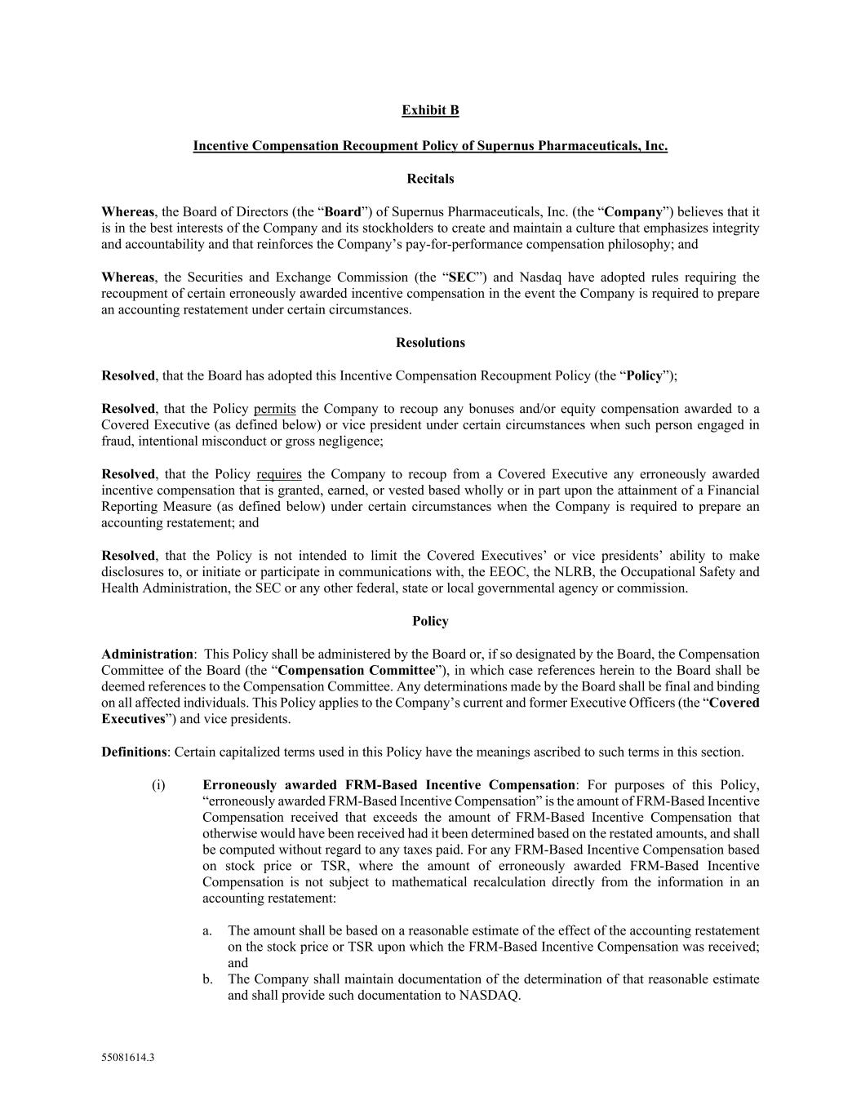
55081614.3 Exhibit B Incentive Compensation Recoupment Policy of Supernus Pharmaceuticals, Inc. Recitals Whereas, the Board of Directors (the “Board”) of Supernus Pharmaceuticals, Inc. (the “Company”) believes that it is in the best interests of the Company and its stockholders to create and maintain a culture that emphasizes integrity and accountability and that reinforces the Company’s pay-for-performance compensation philosophy; and Whereas, the Securities and Exchange Commission (the “SEC”) and Nasdaq have adopted rules requiring the recoupment of certain erroneously awarded incentive compensation in the event the Company is required to prepare an accounting restatement under certain circumstances. Resolutions Resolved, that the Board has adopted this Incentive Compensation Recoupment Policy (the “Policy”); Resolved, that the Policy permits the Company to recoup any bonuses and/or equity compensation awarded to a Covered Executive (as defined below) or vice president under certain circumstances when such person engaged in fraud, intentional misconduct or gross negligence; Resolved, that the Policy requires the Company to recoup from a Covered Executive any erroneously awarded incentive compensation that is granted, earned, or vested based wholly or in part upon the attainment of a Financial Reporting Measure (as defined below) under certain circumstances when the Company is required to prepare an accounting restatement; and Resolved, that the Policy is not intended to limit the Covered Executives’ or vice presidents’ ability to make disclosures to, or initiate or participate in communications with, the EEOC, the NLRB, the Occupational Safety and Health Administration, the SEC or any other federal, state or local governmental agency or commission. Policy Administration: This Policy shall be administered by the Board or, if so designated by the Board, the Compensation Committee of the Board (the “Compensation Committee”), in which case references herein to the Board shall be deemed references to the Compensation Committee. Any determinations made by the Board shall be final and binding on all affected individuals. This Policy applies to the Company’s current and former Executive Officers (the “Covered Executives”) and vice presidents. Definitions: Certain capitalized terms used in this Policy have the meanings ascribed to such terms in this section. (i) Erroneously awarded FRM-Based Incentive Compensation: For purposes of this Policy, “erroneously awarded FRM-Based Incentive Compensation” is the amount of FRM-Based Incentive Compensation received that exceeds the amount of FRM-Based Incentive Compensation that otherwise would have been received had it been determined based on the restated amounts, and shall be computed without regard to any taxes paid. For any FRM-Based Incentive Compensation based on stock price or TSR, where the amount of erroneously awarded FRM-Based Incentive Compensation is not subject to mathematical recalculation directly from the information in an accounting restatement: a. The amount shall be based on a reasonable estimate of the effect of the accounting restatement on the stock price or TSR upon which the FRM-Based Incentive Compensation was received; and b. The Company shall maintain documentation of the determination of that reasonable estimate and shall provide such documentation to NASDAQ.

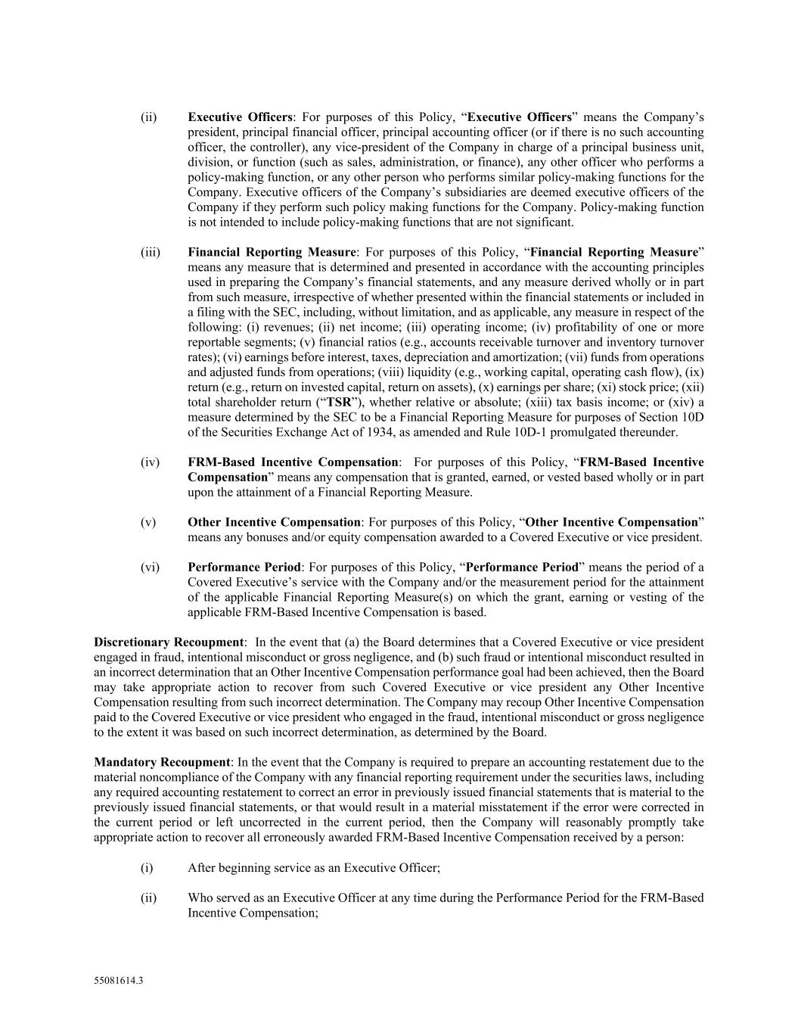
55081614.3 (ii) Executive Officers: For purposes of this Policy, “Executive Officers” means the Company’s president, principal financial officer, principal accounting officer (or if there is no such accounting officer, the controller), any vice-president of the Company in charge of a principal business unit, division, or function (such as sales, administration, or finance), any other officer who performs a policy-making function, or any other person who performs similar policy-making functions for the Company. Executive officers of the Company’s subsidiaries are deemed executive officers of the Company if they perform such policy making functions for the Company. Policy-making function is not intended to include policy-making functions that are not significant. (iii) Financial Reporting Measure: For purposes of this Policy, “Financial Reporting Measure” means any measure that is determined and presented in accordance with the accounting principles used in preparing the Company’s financial statements, and any measure derived wholly or in part from such measure, irrespective of whether presented within the financial statements or included in a filing with the SEC, including, without limitation, and as applicable, any measure in respect of the following: (i) revenues; (ii) net income; (iii) operating income; (iv) profitability of one or more reportable segments; (v) financial ratios (e.g., accounts receivable turnover and inventory turnover rates); (vi) earnings before interest, taxes, depreciation and amortization; (vii) funds from operations and adjusted funds from operations; (viii) liquidity (e.g., working capital, operating cash flow), (ix) return (e.g., return on invested capital, return on assets), (x) earnings per share; (xi) stock price; (xii) total shareholder return (“TSR”), whether relative or absolute; (xiii) tax basis income; or (xiv) a measure determined by the SEC to be a Financial Reporting Measure for purposes of Section 10D of the Securities Exchange Act of 1934, as amended and Rule 10D-1 promulgated thereunder. (iv) FRM-Based Incentive Compensation: For purposes of this Policy, “FRM-Based Incentive Compensation” means any compensation that is granted, earned, or vested based wholly or in part upon the attainment of a Financial Reporting Measure. (v) Other Incentive Compensation: For purposes of this Policy, “Other Incentive Compensation” means any bonuses and/or equity compensation awarded to a Covered Executive or vice president. (vi) Performance Period: For purposes of this Policy, “Performance Period” means the period of a Covered Executive’s service with the Company and/or the measurement period for the attainment of the applicable Financial Reporting Measure(s) on which the grant, earning or vesting of the applicable FRM-Based Incentive Compensation is based. Discretionary Recoupment: In the event that (a) the Board determines that a Covered Executive or vice president engaged in fraud, intentional misconduct or gross negligence, and (b) such fraud or intentional misconduct resulted in an incorrect determination that an Other Incentive Compensation performance goal had been achieved, then the Board may take appropriate action to recover from such Covered Executive or vice president any Other Incentive Compensation resulting from such incorrect determination. The Company may recoup Other Incentive Compensation paid to the Covered Executive or vice president who engaged in the fraud, intentional misconduct or gross negligence to the extent it was based on such incorrect determination, as determined by the Board. Mandatory Recoupment: In the event that the Company is required to prepare an accounting restatement due to the material noncompliance of the Company with any financial reporting requirement under the securities laws, including any required accounting restatement to correct an error in previously issued financial statements that is material to the previously issued financial statements, or that would result in a material misstatement if the error were corrected in the current period or left uncorrected in the current period, then the Company will reasonably promptly take appropriate action to recover all erroneously awarded FRM-Based Incentive Compensation received by a person: (i) After beginning service as an Executive Officer; (ii) Who served as an Executive Officer at any time during the Performance Period for the FRM-Based Incentive Compensation;

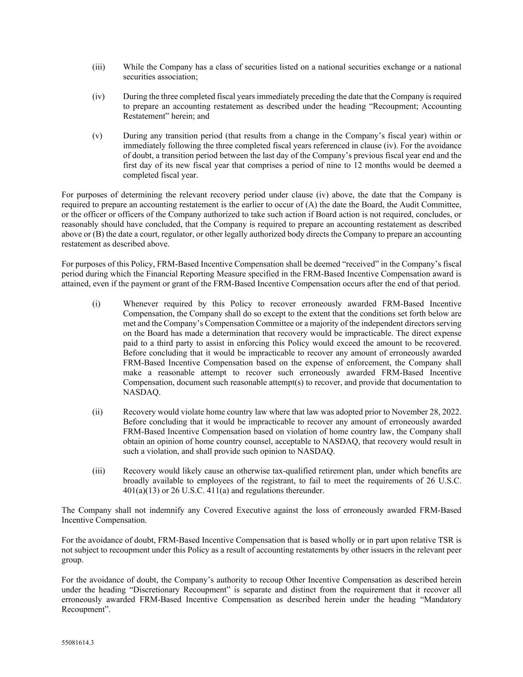
55081614.3 (iii) While the Company has a class of securities listed on a national securities exchange or a national securities association; (iv) During the three completed fiscal years immediately preceding the date that the Company is required to prepare an accounting restatement as described under the heading “Recoupment; Accounting Restatement” herein; and (v) During any transition period (that results from a change in the Company’s fiscal year) within or immediately following the three completed fiscal years referenced in clause (iv). For the avoidance of doubt, a transition period between the last day of the Company’s previous fiscal year end and the first day of its new fiscal year that comprises a period of nine to 12 months would be deemed a completed fiscal year. For purposes of determining the relevant recovery period under clause (iv) above, the date that the Company is required to prepare an accounting restatement is the earlier to occur of (A) the date the Board, the Audit Committee, or the officer or officers of the Company authorized to take such action if Board action is not required, concludes, or reasonably should have concluded, that the Company is required to prepare an accounting restatement as described above or (B) the date a court, regulator, or other legally authorized body directs the Company to prepare an accounting restatement as described above. For purposes of this Policy, FRM-Based Incentive Compensation shall be deemed “received” in the Company’s fiscal period during which the Financial Reporting Measure specified in the FRM-Based Incentive Compensation award is attained, even if the payment or grant of the FRM-Based Incentive Compensation occurs after the end of that period. (i) Whenever required by this Policy to recover erroneously awarded FRM-Based Incentive Compensation, the Company shall do so except to the extent that the conditions set forth below are met and the Company’s Compensation Committee or a majority of the independent directors serving on the Board has made a determination that recovery would be impracticable. The direct expense paid to a third party to assist in enforcing this Policy would exceed the amount to be recovered. Before concluding that it would be impracticable to recover any amount of erroneously awarded FRM-Based Incentive Compensation based on the expense of enforcement, the Company shall make a reasonable attempt to recover such erroneously awarded FRM-Based Incentive Compensation, document such reasonable attempt(s) to recover, and provide that documentation to NASDAQ. (ii) Recovery would violate home country law where that law was adopted prior to November 28, 2022. Before concluding that it would be impracticable to recover any amount of erroneously awarded FRM-Based Incentive Compensation based on violation of home country law, the Company shall obtain an opinion of home country counsel, acceptable to NASDAQ, that recovery would result in such a violation, and shall provide such opinion to NASDAQ. (iii) Recovery would likely cause an otherwise tax-qualified retirement plan, under which benefits are broadly available to employees of the registrant, to fail to meet the requirements of 26 U.S.C. 401(a)(13) or 26 U.S.C. 411(a) and regulations thereunder. The Company shall not indemnify any Covered Executive against the loss of erroneously awarded FRM-Based Incentive Compensation. For the avoidance of doubt, FRM-Based Incentive Compensation that is based wholly or in part upon relative TSR is not subject to recoupment under this Policy as a result of accounting restatements by other issuers in the relevant peer group. For the avoidance of doubt, the Company’s authority to recoup Other Incentive Compensation as described herein under the heading “Discretionary Recoupment” is separate and distinct from the requirement that it recover all erroneously awarded FRM-Based Incentive Compensation as described herein under the heading “Mandatory Recoupment”.

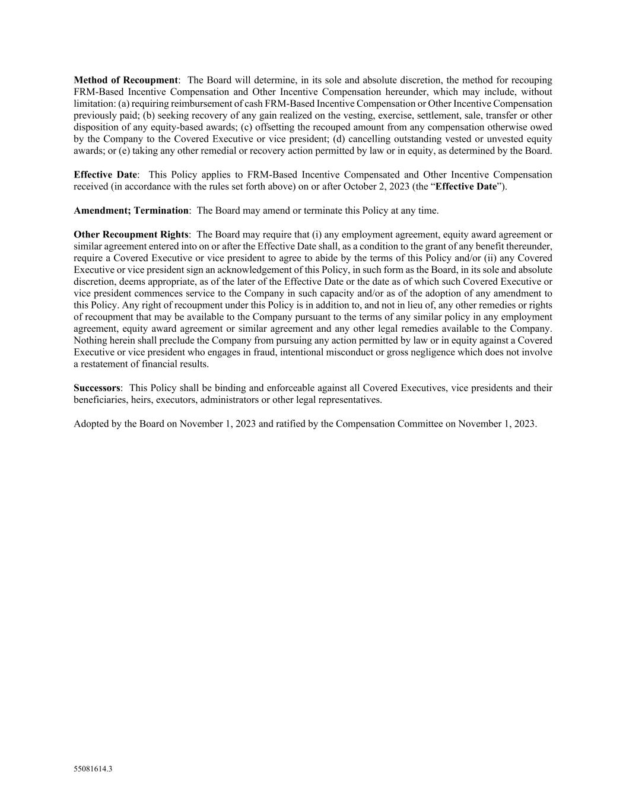
55081614.3 Method of Recoupment: The Board will determine, in its sole and absolute discretion, the method for recouping FRM-Based Incentive Compensation and Other Incentive Compensation hereunder, which may include, without limitation: (a) requiring reimbursement of cash FRM-Based Incentive Compensation or Other Incentive Compensation previously paid; (b) seeking recovery of any gain realized on the vesting, exercise, settlement, sale, transfer or other disposition of any equity-based awards; (c) offsetting the recouped amount from any compensation otherwise owed by the Company to the Covered Executive or vice president; (d) cancelling outstanding vested or unvested equity awards; or (e) taking any other remedial or recovery action permitted by law or in equity, as determined by the Board. Effective Date: This Policy applies to FRM-Based Incentive Compensated and Other Incentive Compensation received (in accordance with the rules set forth above) on or after October 2, 2023 (the “Effective Date”). Amendment; Termination: The Board may amend or terminate this Policy at any time. Other Recoupment Rights: The Board may require that (i) any employment agreement, equity award agreement or similar agreement entered into on or after the Effective Date shall, as a condition to the grant of any benefit thereunder, require a Covered Executive or vice president to agree to abide by the terms of this Policy and/or (ii) any Covered Executive or vice president sign an acknowledgement of this Policy, in such form as the Board, in its sole and absolute discretion, deems appropriate, as of the later of the Effective Date or the date as of which such Covered Executive or vice president commences service to the Company in such capacity and/or as of the adoption of any amendment to this Policy. Any right of recoupment under this Policy is in addition to, and not in lieu of, any other remedies or rights of recoupment that may be available to the Company pursuant to the terms of any similar policy in any employment agreement, equity award agreement or similar agreement and any other legal remedies available to the Company. Nothing herein shall preclude the Company from pursuing any action permitted by law or in equity against a Covered Executive or vice president who engages in fraud, intentional misconduct or gross negligence which does not involve a restatement of financial results. Successors: This Policy shall be binding and enforceable against all Covered Executives, vice presidents and their beneficiaries, heirs, executors, administrators or other legal representatives. Adopted by the Board on November 1, 2023 and ratified by the Compensation Committee on November 1, 2023.

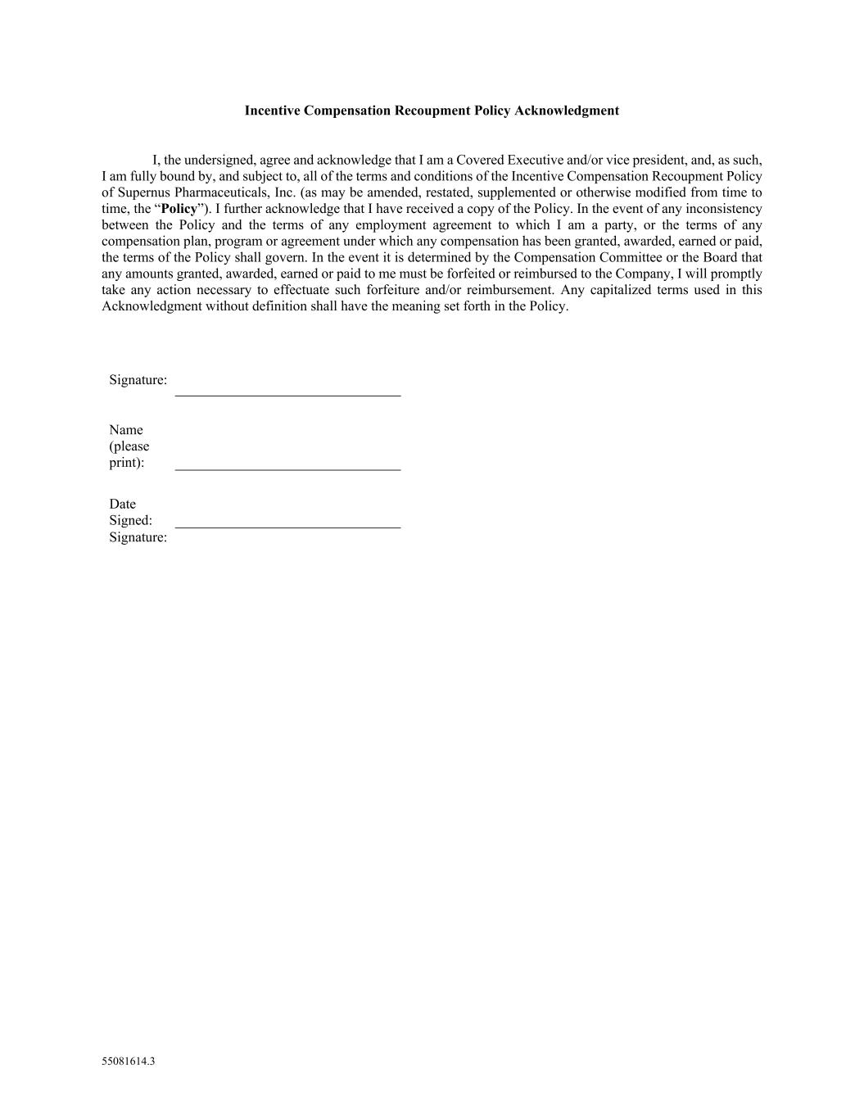
55081614.3 Incentive Compensation Recoupment Policy Acknowledgment I, the undersigned, agree and acknowledge that I am a Covered Executive and/or vice president, and, as such, I am fully bound by, and subject to, all of the terms and conditions of the Incentive Compensation Recoupment Policy of Supernus Pharmaceuticals, Inc. (as may be amended, restated, supplemented or otherwise modified from time to time, the “Policy”). I further acknowledge that I have received a copy of the Policy. In the event of any inconsistency between the Policy and the terms of any employment agreement to which I am a party, or the terms of any compensation plan, program or agreement under which any compensation has been granted, awarded, earned or paid, the terms of the Policy shall govern. In the event it is determined by the Compensation Committee or the Board that any amounts granted, awarded, earned or paid to me must be forfeited or reimbursed to the Company, I will promptly take any action necessary to effectuate such forfeiture and/or reimbursement. Any capitalized terms used in this Acknowledgment without definition shall have the meaning set forth in the Policy. Signature: Name (please print): Date Signed: Signature:

EXHIBIT 31.1
CERTIFICATION
I, Jack A. Khattar, certify that:
1.I have reviewed this Quarterly Report on Form 10-Q of Supernus Pharmaceuticals, Inc.;
2.Based on my knowledge, this report does not contain any untrue statement of a material fact or omit to state a material fact necessary to make the statements made, in light of the circumstances under which such statements were made, not misleading with respect to the period covered by this report;
3.Based on my knowledge, the financial statements, and other financial information included in this report, fairly present in all material respects the financial condition, results of operations and cash flows of the registrant as of, and for, the periods presented in this report;
4.The registrant’s other certifying officer and I are responsible for establishing and maintaining disclosure controls and procedures (as defined in Exchange Act Rules 13a-15(e) and 15d-15(e)) and internal control over financial reporting (as defined in Exchange Act Rules 13a-15(f) and 15d-15(f)) for the registrant and have:
(a)designed such disclosure controls and procedures, or caused such disclosure controls and procedures to be designed under our supervision, to ensure that material information relating to the registrant, including its consolidated subsidiaries, is made known to us by others within those entities, particularly during the period in which this report is being prepared;
(b)designed such internal control over financial reporting, or caused such internal control over financial reporting to be designed under our supervision, to provide reasonable assurance regarding the reliability of financial reporting and the preparation of financial statements for external purposes in accordance with generally accepted accounting principles;
(c)evaluated the effectiveness of the registrant’s disclosure controls and procedures and presented in this report our conclusions about the effectiveness of the disclosure controls and procedures, as of the end of the period covered by this report based on such evaluation; and
(d)disclosed in this report any change in the registrant’s internal control over financial reporting that occurred during the registrant’s most recent fiscal quarter (the registrant’s fourth fiscal quarter in the case of an annual report) that has materially affected, or is reasonably likely to materially affect, the registrant’s internal control over financial reporting; and
5.The registrant’s other certifying officer and I have disclosed, based on our most recent evaluation of internal control over financial reporting, to the registrant’s auditors and the audit committee of the registrant’s board of directors (or persons performing the equivalent functions):
(a)all significant deficiencies and material weaknesses in the design or operation of internal control over financial reporting which are reasonably likely to adversely affect the registrant’s ability to record, process, summarize and report financial information; and
(b)any fraud, whether or not material, that involves management or other employees who have a significant role in the registrant’s internal control over financial reporting.
Date: August 5, 2025 |  |  | By: |  |  | /s/ Jack A. Khattar
Jack A. Khattar
President and Chief Executive Officer

EXHIBIT 31.2
CERTIFICATION
I, Timothy C. Dec, certify that:
1.I have reviewed this Quarterly Report on Form 10-Q of Supernus Pharmaceuticals, Inc.;
2.Based on my knowledge, this report does not contain any untrue statement of a material fact or omit to state a material fact necessary to make the statements made, in light of the circumstances under which such statements were made, not misleading with respect to the period covered by this report;
3.Based on my knowledge, the financial statements, and other financial information included in this report, fairly present in all material respects the financial condition, results of operations and cash flows of the registrant as of, and for, the periods presented in this report;
4.The registrant’s other certifying officer and I are responsible for establishing and maintaining disclosure controls and procedures (as defined in Exchange Act Rules 13a-15(e) and 15d-15(e)) and internal control over financial reporting (as defined in Exchange Act Rules 13a-15(f) and 15d-15(f)) for the registrant and have:
(a)designed such disclosure controls and procedures, or caused such disclosure controls and procedures to be designed under our supervision, to ensure that material information relating to the registrant, including its consolidated subsidiaries, is made known to us by others within those entities, particularly during the period in which this report is being prepared;
(b)designed such internal control over financial reporting, or caused such internal control over financial reporting to be designed under our supervision, to provide reasonable assurance regarding the reliability of financial reporting and the preparation of financial statements for external purposes in accordance with generally accepted accounting principles;
(c)evaluated the effectiveness of the registrant’s disclosure controls and procedures and presented in this report our conclusions about the effectiveness of the disclosure controls and procedures, as of the end of the period covered by this report based on such evaluation; and
(d)disclosed in this report any change in the registrant’s internal control over financial reporting that occurred during the registrant’s most recent fiscal quarter (the registrant’s fourth fiscal quarter in the case of an annual report) that has materially affected, or is reasonably likely to materially affect, the registrant’s internal control over financial reporting; and
5.The registrant’s other certifying officer and I have disclosed, based on our most recent evaluation of internal control over financial reporting, to the registrant’s auditors and the audit committee of the registrant’s board of directors (or persons performing the equivalent functions):
(a)all significant deficiencies and material weaknesses in the design or operation of internal control over financial reporting which are reasonably likely to adversely affect the registrant’s ability to record, process, summarize and report financial information; and
(b)any fraud, whether or not material, that involves management or other employees who have a significant role in the registrant’s internal control over financial reporting.
Date: August 5, 2025 |  |  | By: |  |  | /s/ Timothy C. Dec
 |  |  |  |  |  | Timothy C. Dec
 |  |  |  |  |  | Senior Vice President and Chief Financial Officer

EXHIBIT 32.1
SUPERNUS PHARMACEUTICALS, INC.
CERTIFICATION PURSUANT TO
18 U.S.C. sec. 1350,
AS ADOPTED PURSUANT TO
SECTION 906 OF THE SARBANES-OXLEY ACT OF 2002
In connection with the Quarterly Report of Supernus Pharmaceuticals, Inc. (the “Company”) on Form 10-Q for the period ended June 30, 2025 as filed with the Securities and Exchange Commission on the date hereof (the “Report”), I, Jack A. Khattar, President and Chief Executive Officer of the Company, certify, pursuant to 18 U.S.C. sec. 1350, as adopted pursuant to Section 906 of the Sarbanes-Oxley Act of 2002, that:
(1)The Report fully complies with the requirements of section 13(a) or 15(d) of the Securities Exchange Act of 1934; and
(2)The information contained in the Report fairly presents, in all material respects, the financial condition and results of operations of the Company.
Date: August 5, 2025 |  |  | By: |  |  | /s/ Jack A. Khattar
Jack A. Khattar
President and Chief Executive Officer

EXHIBIT 32.2
SUPERNUS PHARMACEUTICALS, INC.
CERTIFICATION PURSUANT TO
18 U.S.C. sec. 1350,
AS ADOPTED PURSUANT TO
SECTION 906 OF THE SARBANES-OXLEY ACT OF 2002
In connection with the Quarterly Report of Supernus Pharmaceuticals, Inc. (the “Company”) on Form 10-Q for the period ended June 30, 2025 as filed with the Securities and Exchange Commission on the date hereof (the “Report”), I, Timothy C. Dec, Senior Vice President and Chief Financial Officer of the Company, certify, pursuant to 18 U.S.C. sec. 1350, as adopted pursuant to Section 906 of the Sarbanes-Oxley Act of 2002, that:
(1)The Report fully complies with the requirements of section 13(a) or 15(d) of the Securities Exchange Act of 1934; and
(2)The information contained in the Report fairly presents, in all material respects, the financial condition and results of operations of the Company.
Date: August 5, 2025 |  |  | By: |  |  | /s/ Timothy C. Dec
Timothy C. Dec
Senior Vice President and Chief Financial Officer

