UNITED STATES

SECURITIES AND EXCHANGE COMMISSION
Washington, D.C. 20549

FORM 8-K

CURRENT REPORT

Pursuant to Section 13 or 15(d) of the Securities Exchange Act of 1934

Date of Report (Date of earliest event reported): February 8, 2023

Supernus Pharmaceuticals, Inc.

Delaware

(State or other jurisdiction of incorporation or organization)

9715 Key West Ave

(Address of Principal Executive Offices)

(Exact name of registrant as specified in its charter)

001-35518 20-2590184

(Commission File Number) (I.R.S. Employer Identification No.)

Rockville MD 20850

(Zip Code)

Registrant’s telephone number, including area code: (301) 838-2500

Not Applicable

(Former name or former address, if changed since last report.)

Securities registered pursuant to Section 12(b) of the Exchange Act
 | Title of each class |  | Trading Symbol |  |  | Name of each exchange on which registered
Common Stock, $0.001 par value per share |  |  |  | SUPN |  |  | The Nasdaq Stock Market LLC

Check the appropriate box below if the Form 8-K filing is intended to simultaneously satisfy the filing obligation of the registrant under any of the following provisions (see General Instruction A.2. below):

- Written communications pursuant to Rule 425 under the Securities Act (17 CFR 230.425)

- Soliciting material pursuant to Rule 14a-12 under the Exchange Act (17 CFR 240.14a-12)

- Pre-commencement communications pursuant to Rule 14d-2(b) under the Exchange Act (17 CFR 240.14d-2(b))

- Pre-commencement communications pursuant to Rule 13e-4(c) under the Exchange Act (17 CFR 240.13e-4(c))

Indicate by check mark whether the registrant is an emerging growth company as defined in Rule 405 of the Securities Act of 1933 (§230.405 of this chapter) or Rule 12b-2 of the Securities Exchange Act of 1934 (§240.12b-2 of this chapter). ☐

If an emerging growth company, indicate by check mark if the registrant has elected not to use the extended transition period for complying with any new or revised financial accounting standards provided pursuant to Section 13(a) of the Exchange Act. ☐

Item 1.01. Entry into a Material Definitive Agreement.

On February 8, 2023, Supernus Pharmaceuticals, Inc. (the “Company”) entered into a credit line agreement (the “Credit Line”) with UBS Bank USA (“UBS”). The Credit Line provides for a revolving line of credit of up to $150,000,000.00, which can be drawn at any time and will be used for general corporate purposes. Any fixed rate borrowing will bear interest at a fixed interest rate, equal to the sum of (i) the UBS Fixed Funding Rate (as defined in the Credit Line) plus (ii) the applicable Percentage Spread established in the Credit Line. Any variable rate borrowing will bear interest at a variable interest rate, equal to the sum of (i) the UBS Variable Rate (as defined in the Credit Line) plus (ii) the applicable Percentage Spread established in the Credit Line.

The Credit Line is secured by a first priority lien and security interest in the following assets and rights of the Company: (i) each account of the Company at UBS Financial Services Inc. (the “Collateral Account”); (ii) any and all money, credit balances, certificated and uncertificated securities, security entitlements, commodity contracts, deposits, certificates of deposit, instruments, documents, partnership interests, limited liability company interests, general intangibles, financial assets and other investment property now or in the future credited to or carried, held or maintained in the Collateral Account; (iii) any and all over-the-counter options, futures, foreign exchange, swap or similar contracts between the Company, on the one hand, and either UBS Financial Services Inc. or any of its affiliates, on the other hand;

- any and all accounts of the Company at UBS or any of its affiliates; (v) any and all goods, assets or other property in the possession, custody or control of UBS or any of its agents or custodians, including, without limitation, gold and other precious metals (whether in the form of coins, bars or otherwise); (vi) any and all supporting obligations, general intangibles and other rights ancillary or attributable to, or arising in any way in connection with, any of the foregoing; and (vii) any and all interest, dividends, distributions and other proceeds of any of the foregoing, including proceeds of proceeds (collectively, the “Collateral”); provided, however, clauses (iv) and
- of above will not be effective with respect to the Company (and, such assets will not be “Collateral” for the purposes of the Credit Line) if and for so long as the Company simultaneously has a “purpose” and a “non-purpose” loan or loans outstanding with UBS (as such terms are used under Federal Reserve Regulation U). Company’s money market and marketable securities held in its managed investment account with UBS. (the “Collateral”). The Company may be required to post additional collateral if the value of the Collateral declines below the required collateral maintenance requirements.

Upon certain customary events of default, all amounts due under the Credit Line (the “Credit Line Obligations”) will become immediately due and payable without demand, and UBS has the right, in its discretion, to liquidate, transfer, withdraw or sell all or any part of the Collateral and apply the proceeds to the repay any borrowings pursuant to the Credit Line.

The Company has the right to repay any variable rate advance under the Credit Line at any time, in whole or in part, without penalty. The Company may repay any fixed rate advance in whole, but may not repay any fixed rate advance in part. In its discretion and without cause, UBS has the right at any time to demand full or partial payment of amounts borrowed pursuant to the Credit Line and terminate the Credit Line.

The foregoing description of the Credit Line does not purport to be complete and is qualified in its entirety by reference to the Credit Line, which is filed as Exhibit 10.1 hereto and which is incorporated herein by reference. The Credit Line has been filed to provide information to investors regarding its terms. It is not intended to provide any other factual information about the Company, its business, or the actual conduct of its business. None of the Company’s stockholders or any other third parties should rely on the representations, warranties and covenants or any descriptions thereof as characterizations of the actual state of facts or conditions of the Company or any of its subsidiaries or affiliates. The Credit Line contains representations and warranties that are the product of negotiations among the parties thereto and that the parties made to, and solely for the benefit of, each other as of specified dates. The representations and warranties may have been made for the purpose of allocating contractual risk between the parties to the agreements instead of establishing these matters as facts and may be subject to standards of materiality applicable to the contracting parties that differ from those applicable to investors.

2

Item 2.03 Creation of a Direct Financial Obligation or an Obligation under an Off-Balance Sheet Arrangement of a Registrant.

The information set forth under Item 1.01, “Entry into a Material Definitive Agreement,” is incorporated herein by reference.

Item 8.01 Other Events.

On February 14, 2023, the Company issued a press release announcing that it had entered into the Credit Line. A copy of this press release is furnished as Exhibit 99.1 hereto and is incorporated herein by reference.

This Current Report on Form 8-K contains “forward-looking statements” that do not convey historical information, but relate to predicted or potential future events, such as statements of our plans, strategies and intentions. These statements can often be identified by the use of forward-looking terminology such as “believe,” “expect,” “intend,” “may,” “will,” “should,” or “anticipate” or similar terminology. All statements other than statements of historical facts included in this Current Report on Form 8-K are forward-looking statements. All forward-looking statements speak only as of the date of this Current Report on Form 8-K. Except for the Company's ongoing obligations to disclose material information under the federal securities laws, the Company undertakes no obligation to update or revise any forward-looking statements, whether as a result of new information, future events or otherwise. In addition to the risks and uncertainties of ordinary business operations and conditions in the general economy and the markets in which the Company competes, the forward-looking statements of the Company contained in this Current Report on Form 8-K are also subject to various risks and uncertainties, including those set forth in Item 1A, “Risk Factors,” in the Company's Annual Report on Form 10-K for the fiscal year ended December 31, 2021, and other risk factors set forth from time to time in the Company’s filings with the Securities and Exchange Commission made pursuant to Section 13 or 15(d) of the Securities Exchange Act of 1934, as amended.

Item 9.01 Financial Statements and Exhibits.

- Exhibits

Exhibit 10.1† — Credit Line Agreement between UBS Bank USA and Supernus Pharmaceuticals, Inc. dated as of February 8, 2023.

Exhibit 99.1 - Press Release Dated February 14, 2023 filed as an Exhibit pursuant to Item 8.01 hereof.

Exhibit 104 — The cover page from this Current Report on Form 8-K, formatted in Inline XBRL.

- Certain portions of this exhibit that constitute confidential information have been omitted in accordance with Regulation S-K, Item 601(b)(10)(iv) because it (i) is not material and (ii) would be competitively harmful if publicly disclosed.

3

SIGNATURES

Pursuant to the requirements of the Securities Exchange Act of 1934, the registrant has duly caused this report to be signed on its behalf by the undersigned hereunto duly authorized.

 | SUPERNUS PHARMACEUTICALS, INC.
DATED: February 14, 2023 | By: /s/ Timothy C. Dec
 |  | Timothy C. Dec
 |  | Senior Vice President and Chief Financial Officer
 | 4

Exhibit 10.1

CERTAIN CONFIDENTIAL INFORMATION IDENTIFIED IN THIS DOCUMENT, MARKED BY [*], HAS BEEN EXCLUDED FROM THE EXHIBIT BECAUSE IT IS BOTH (I) NOT MATERIAL AND (II) WOULD BE COMPETITIVELY HARMFUL IF PUBLICLY DISCLOSED.
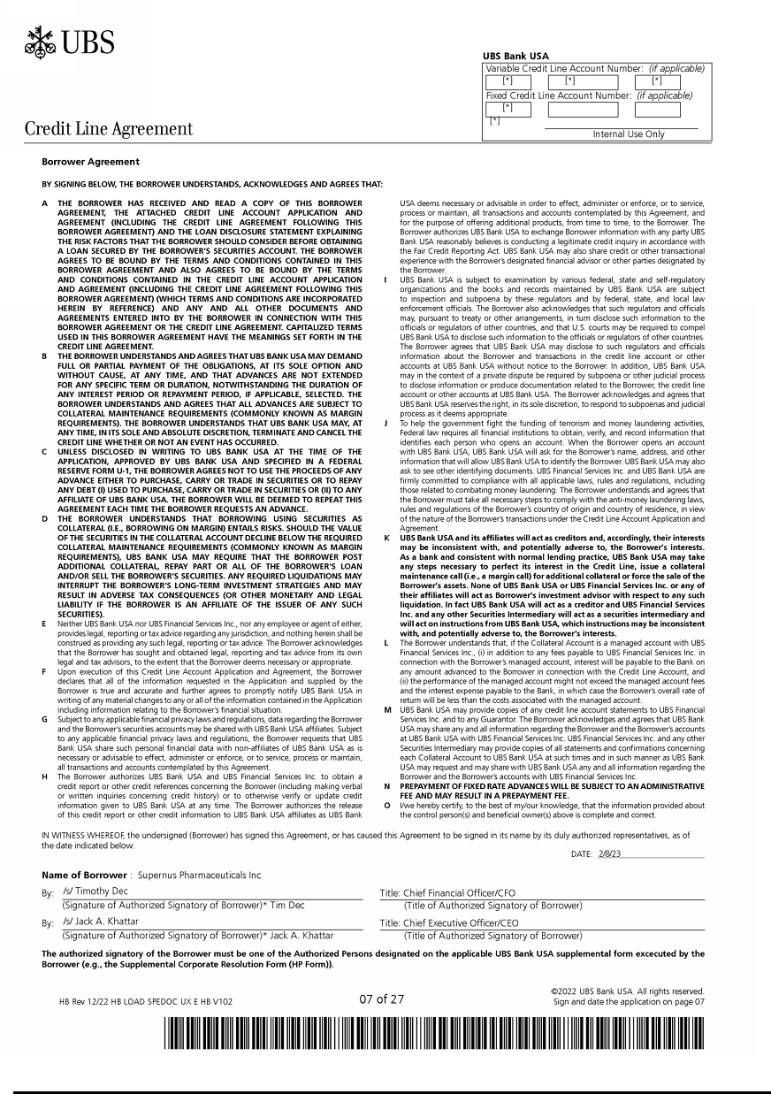

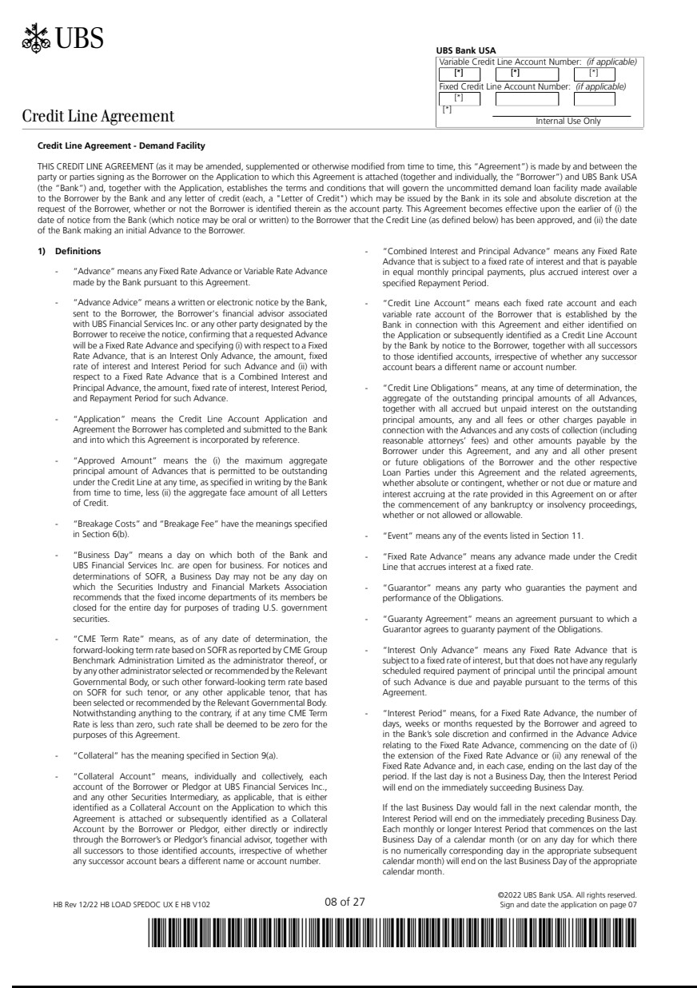

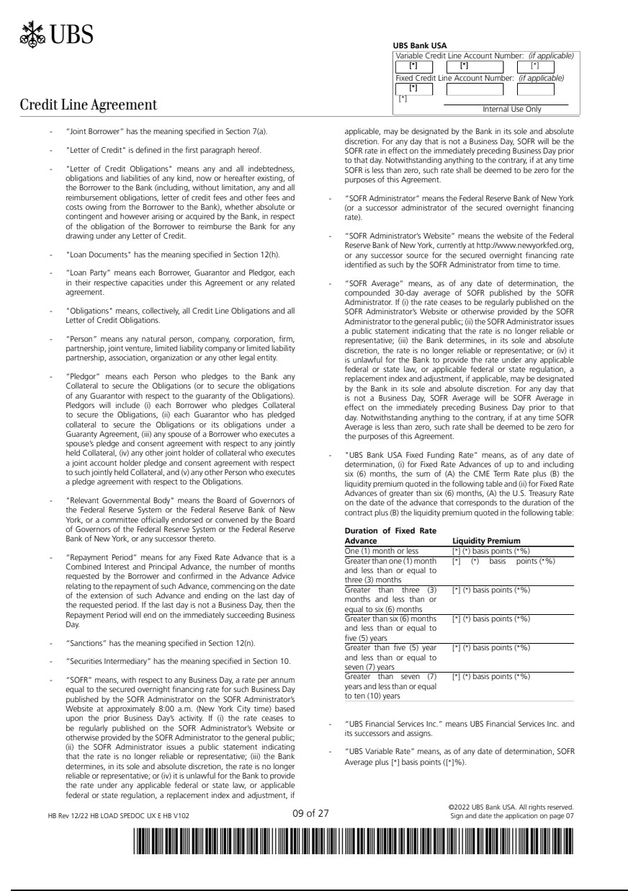

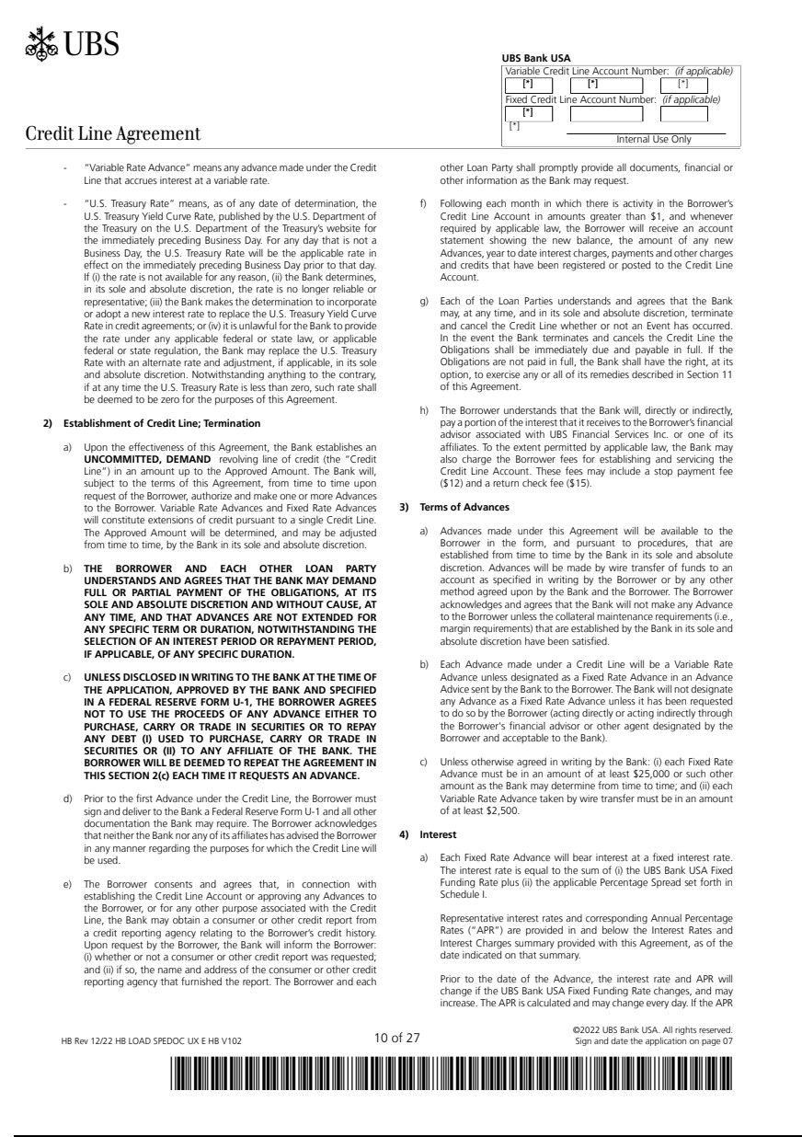

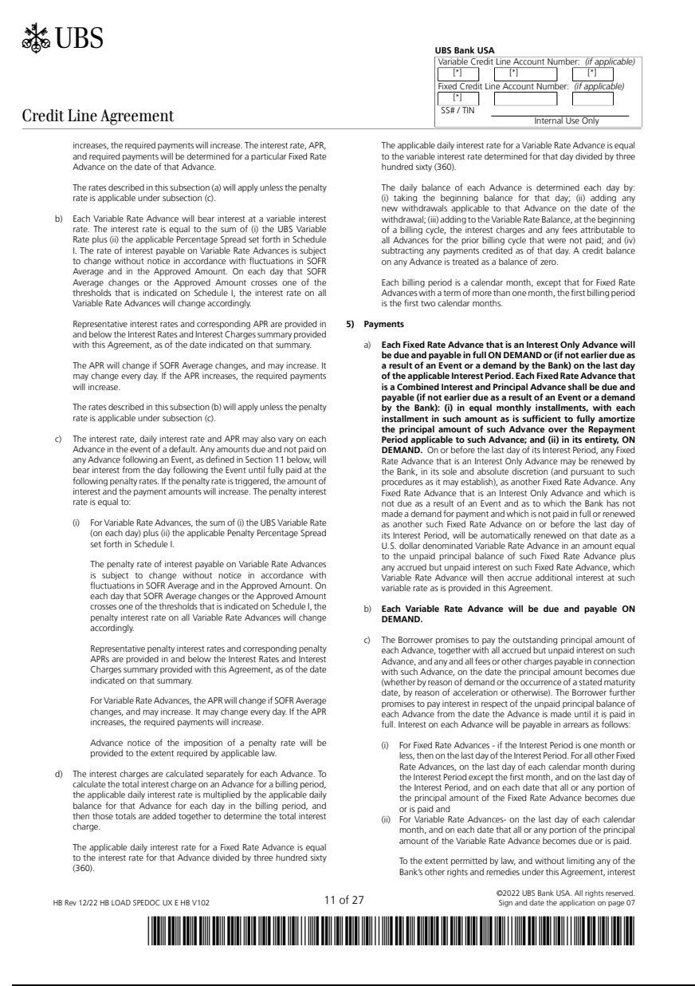

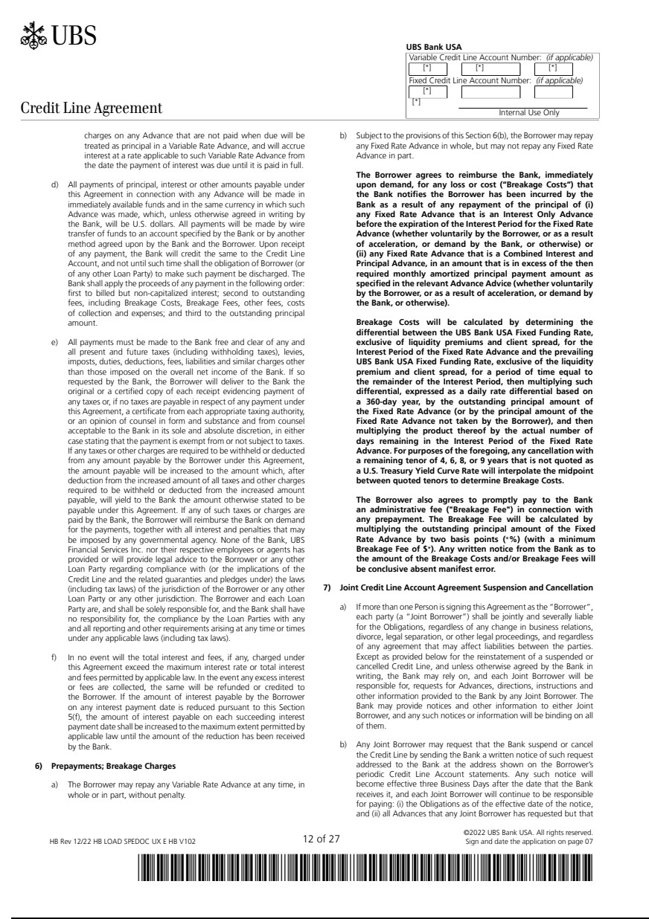

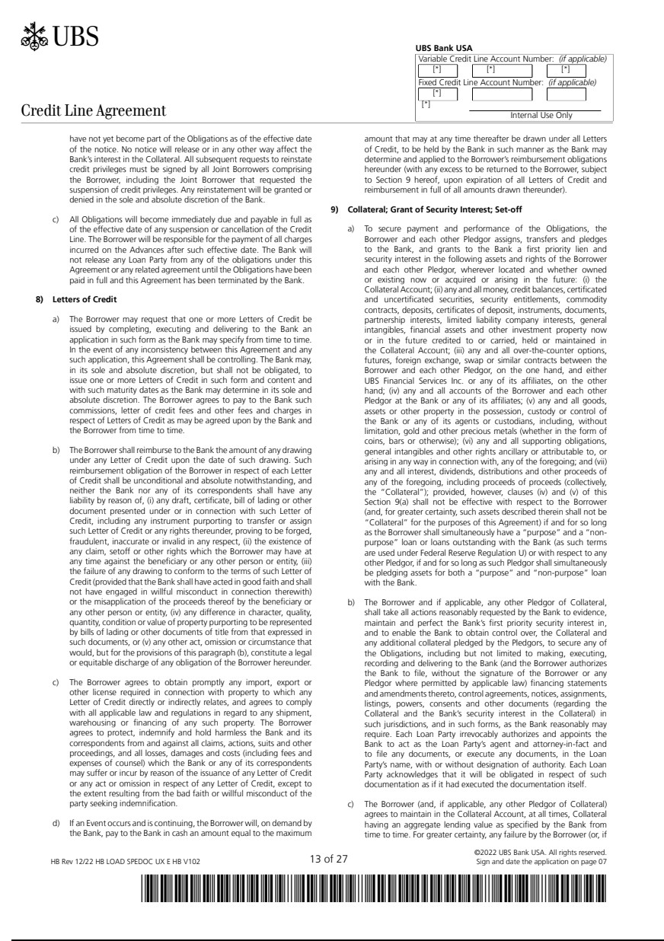

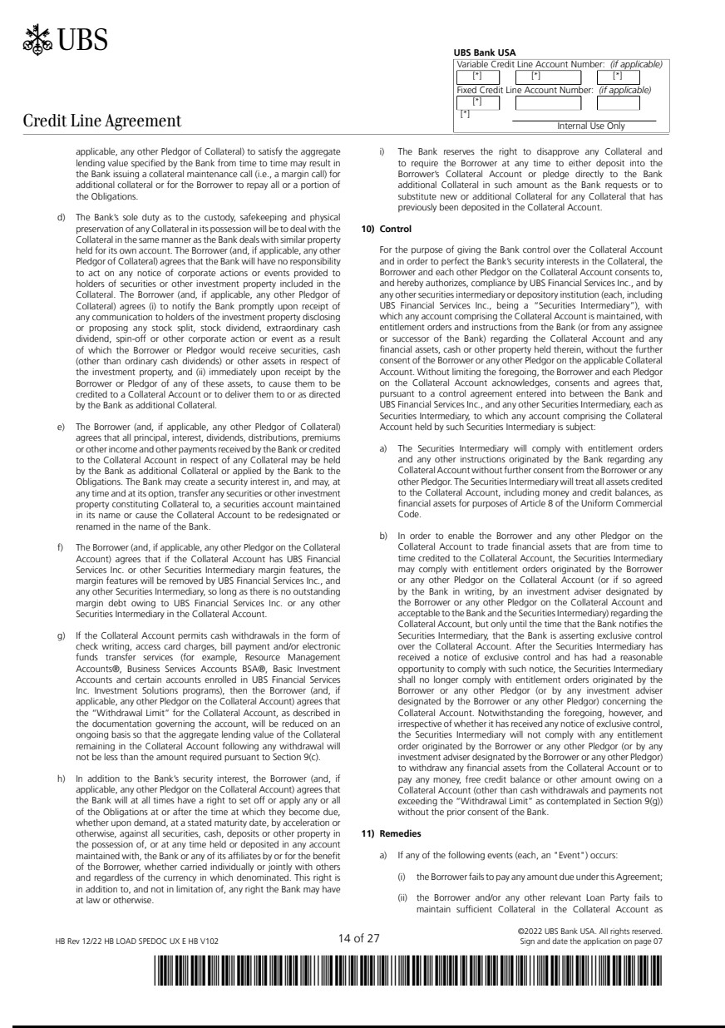

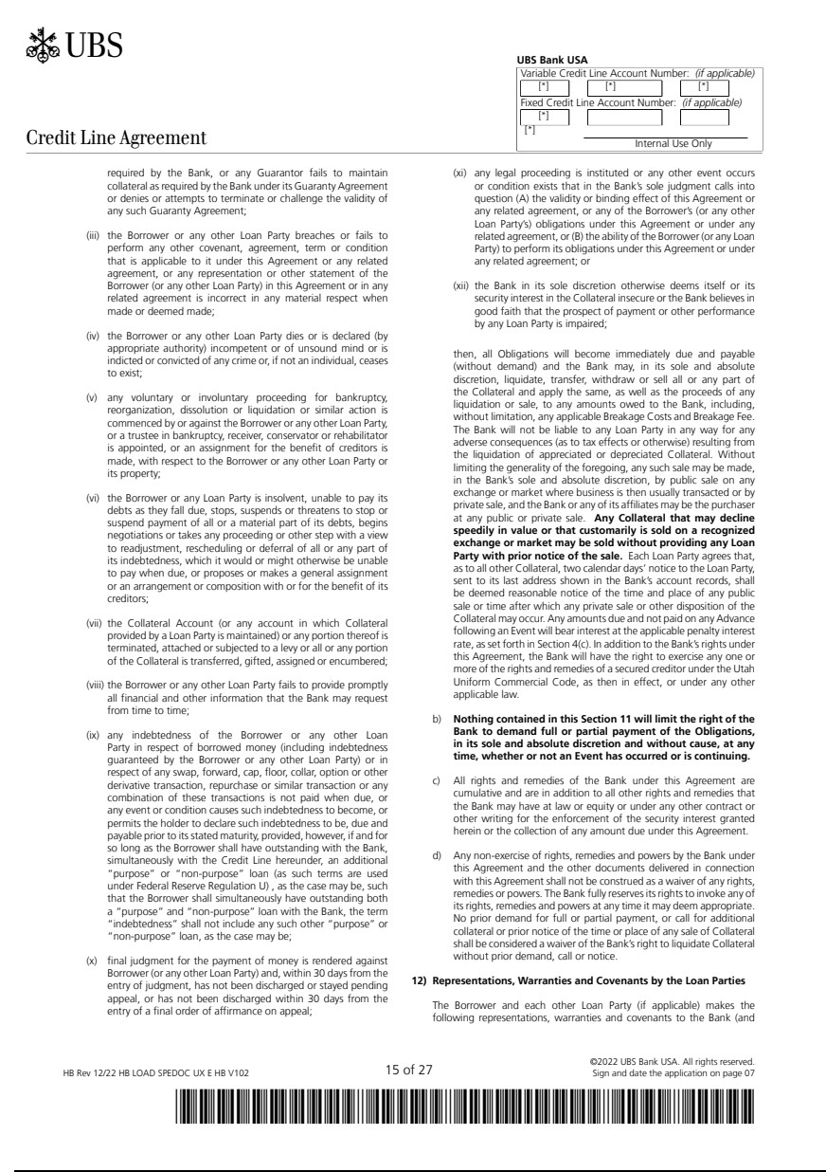

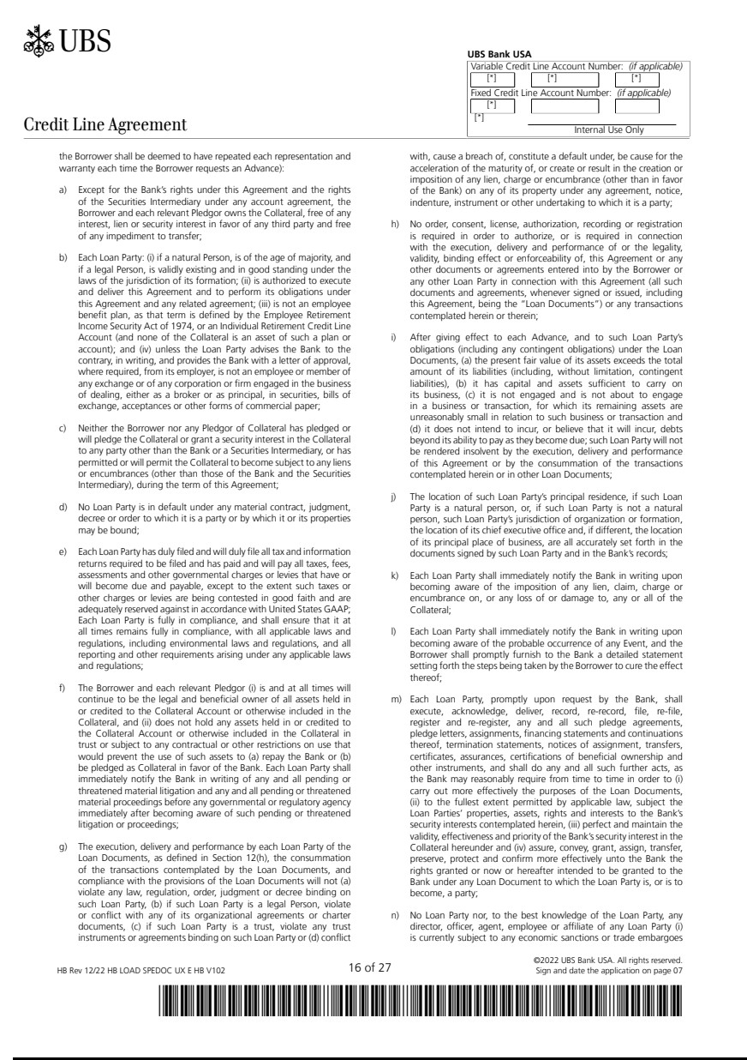

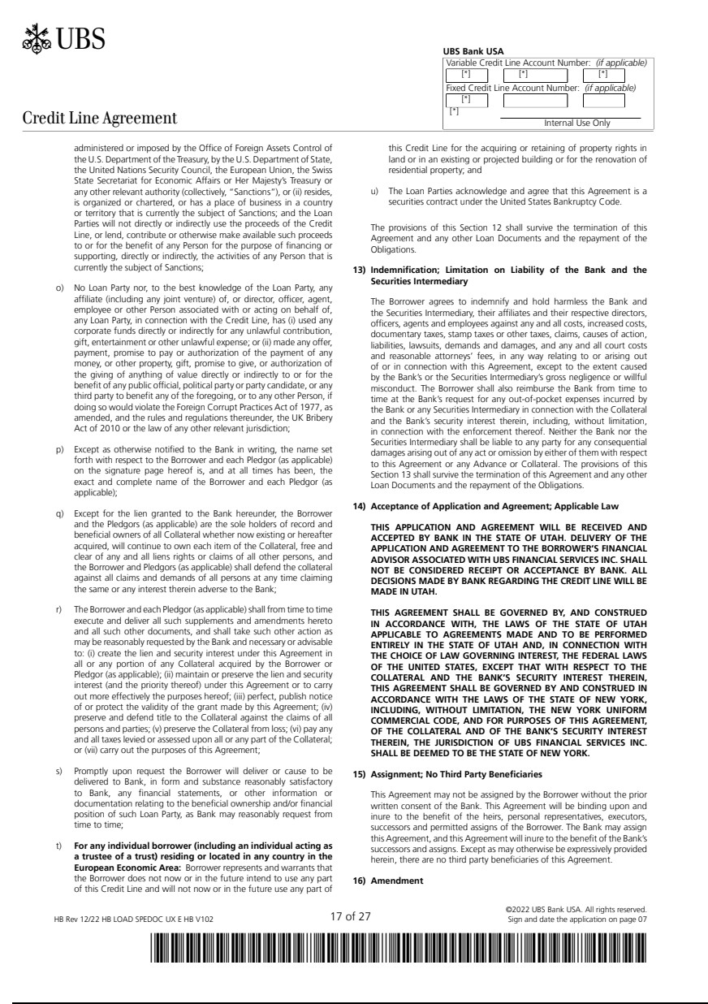

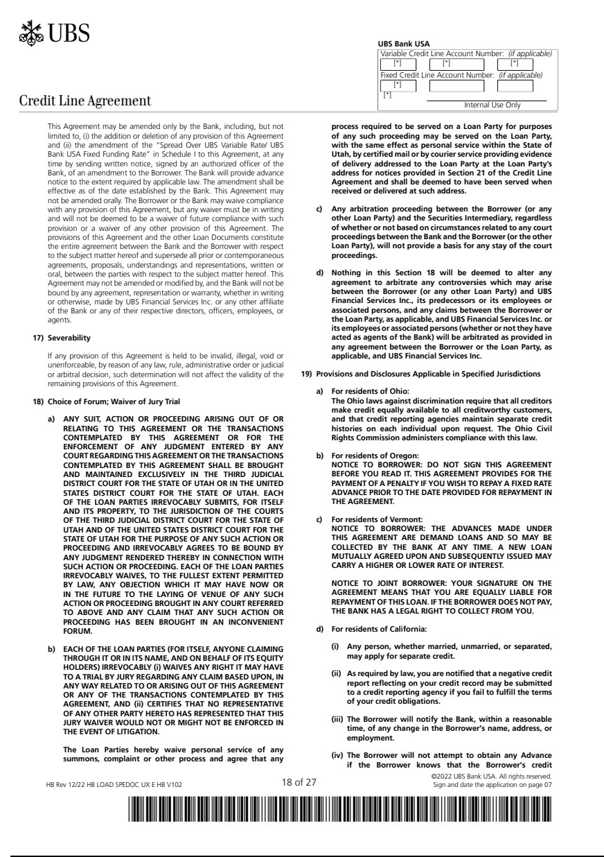

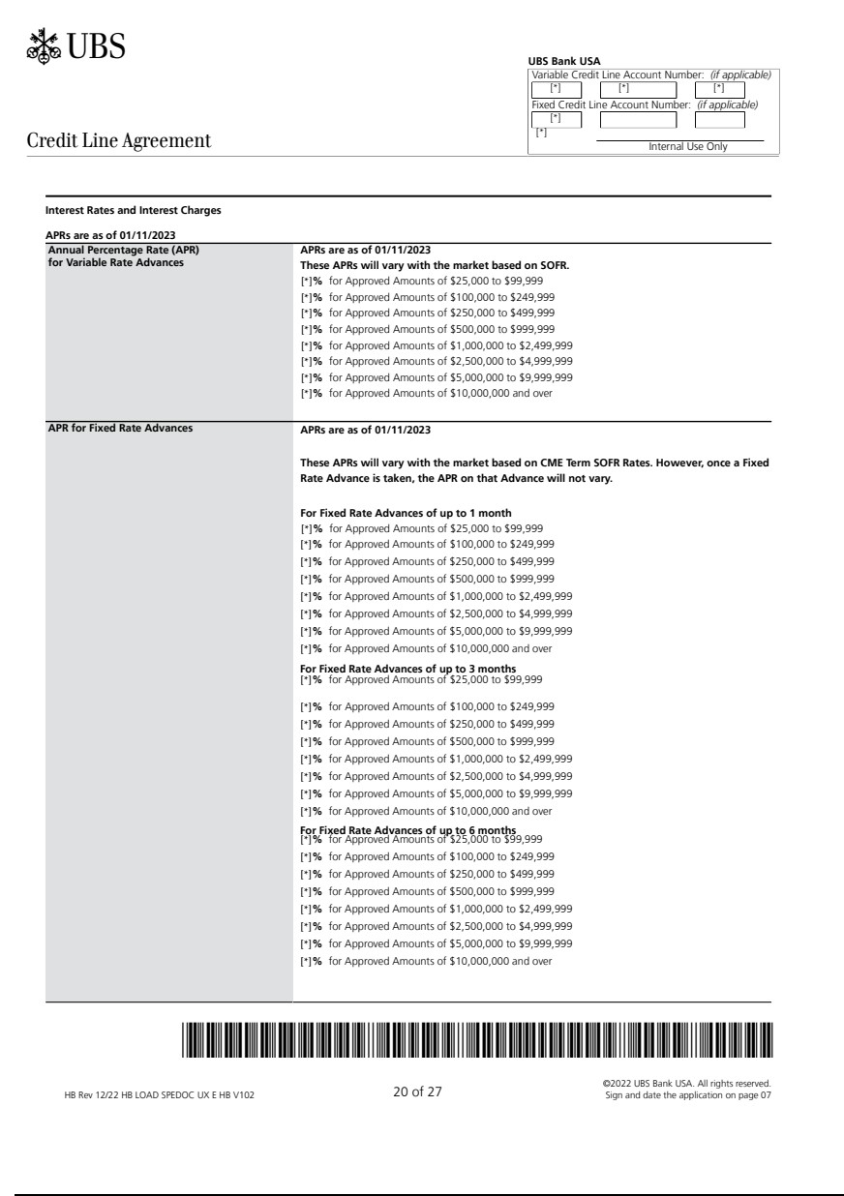

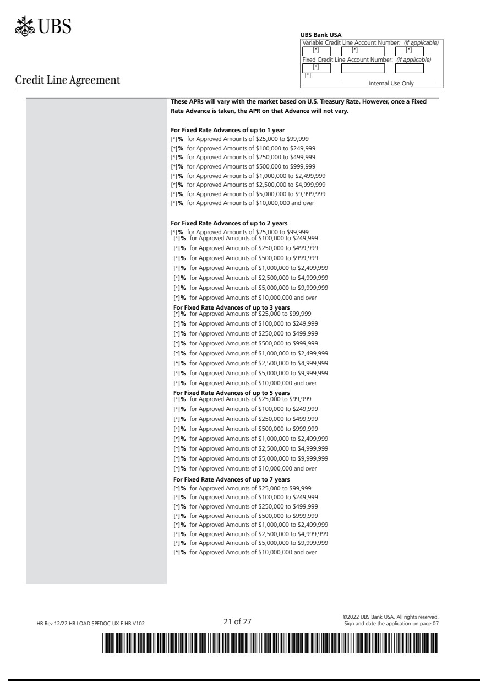

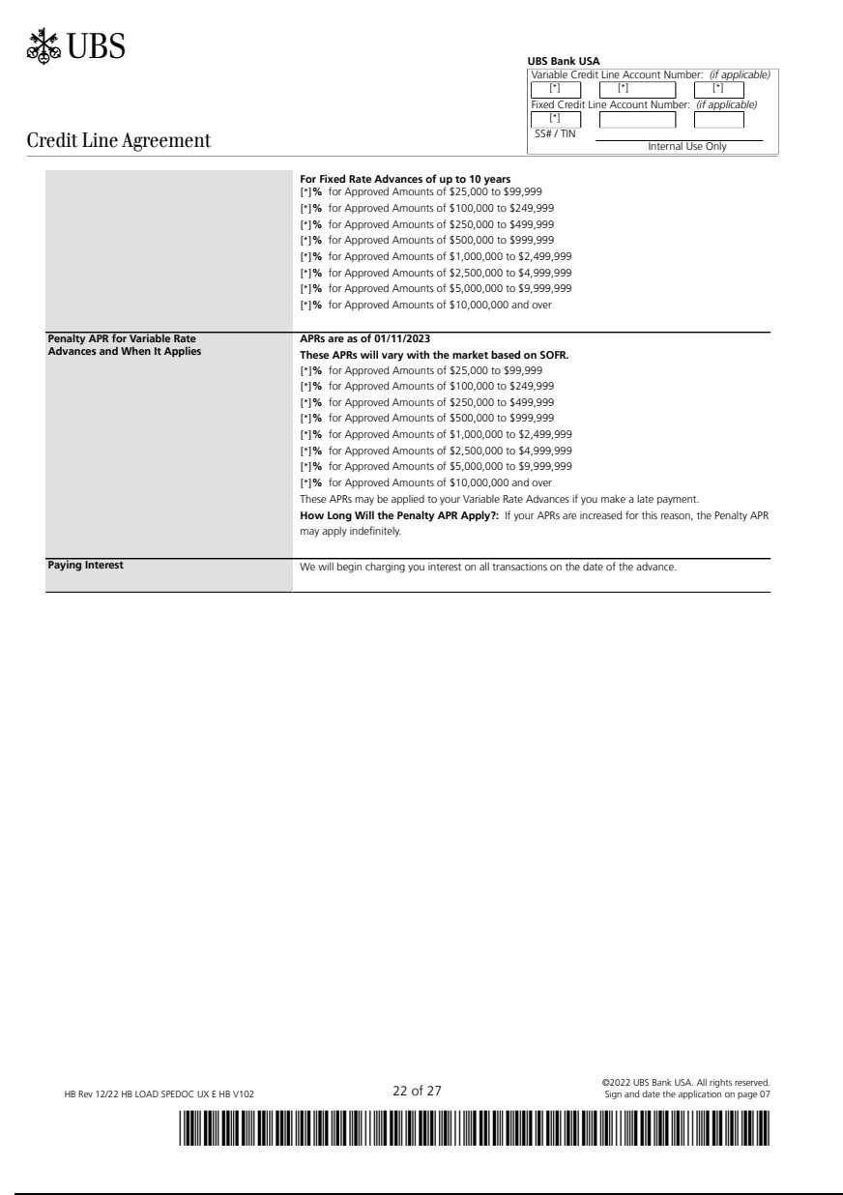

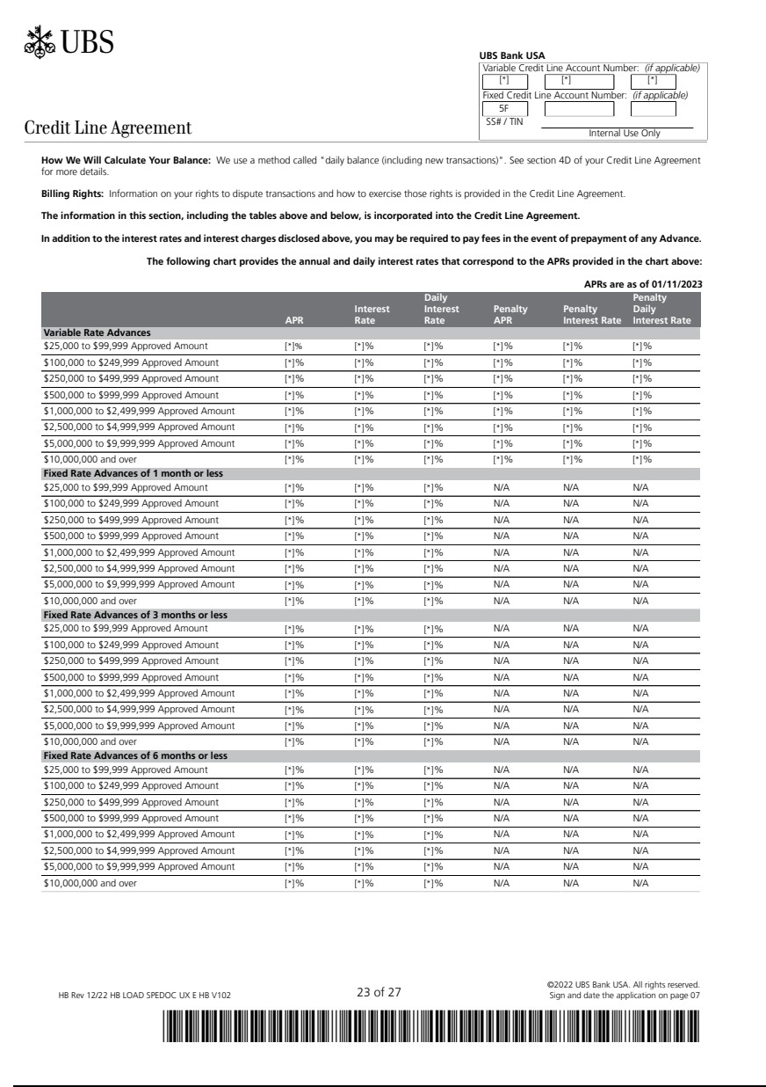

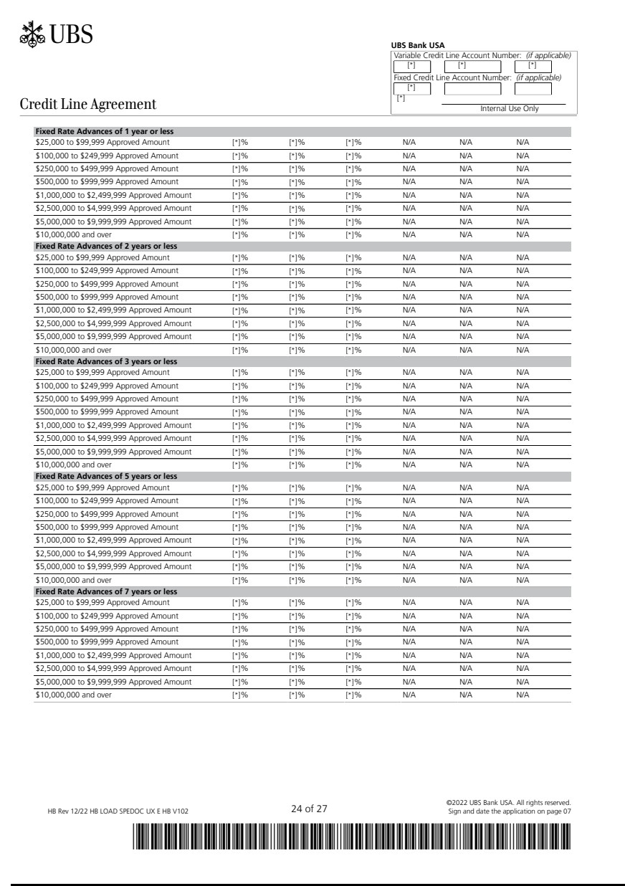

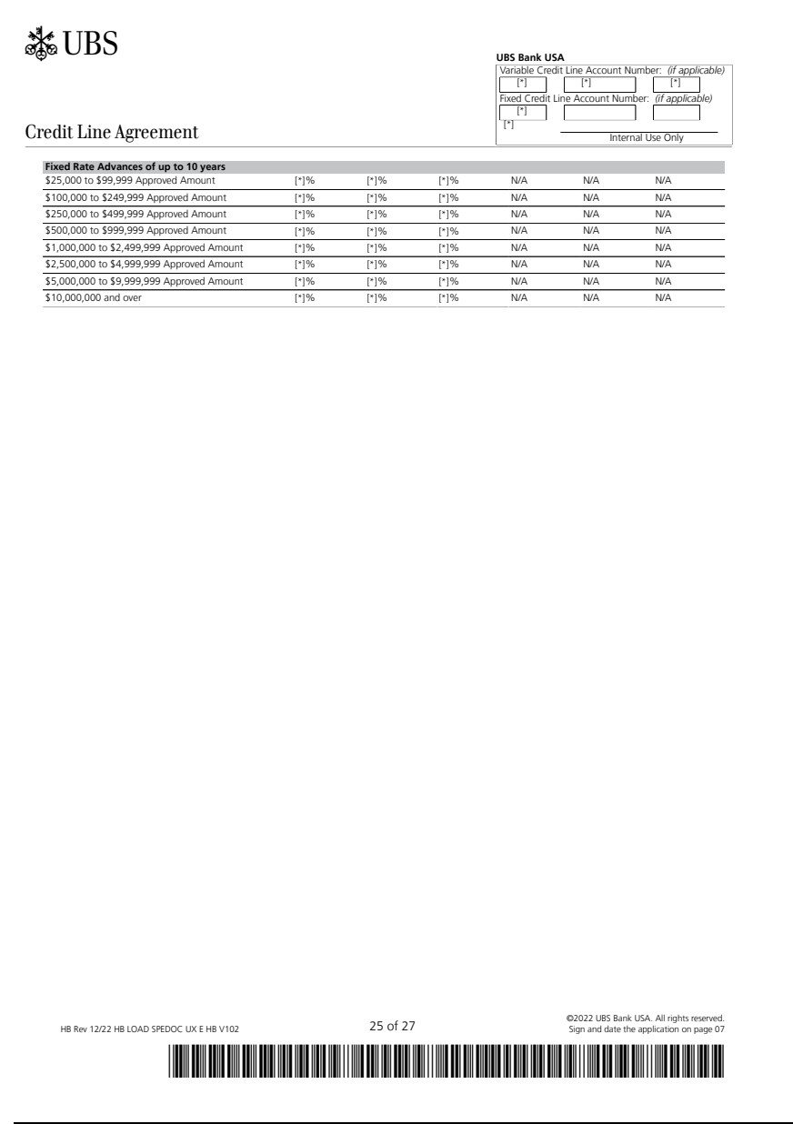

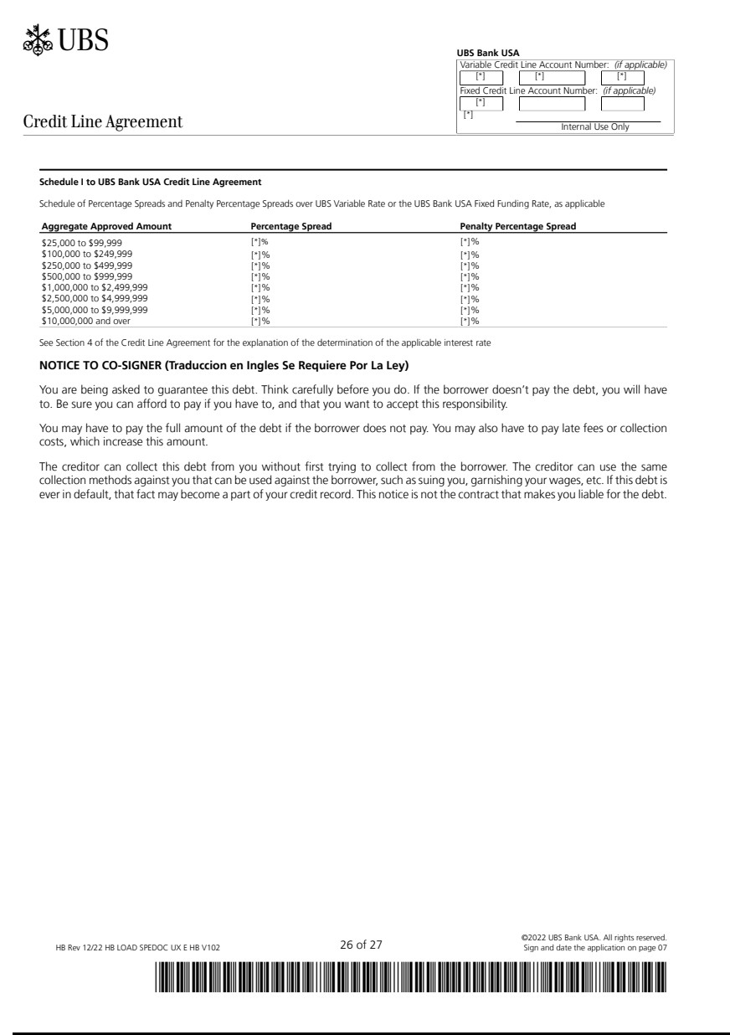

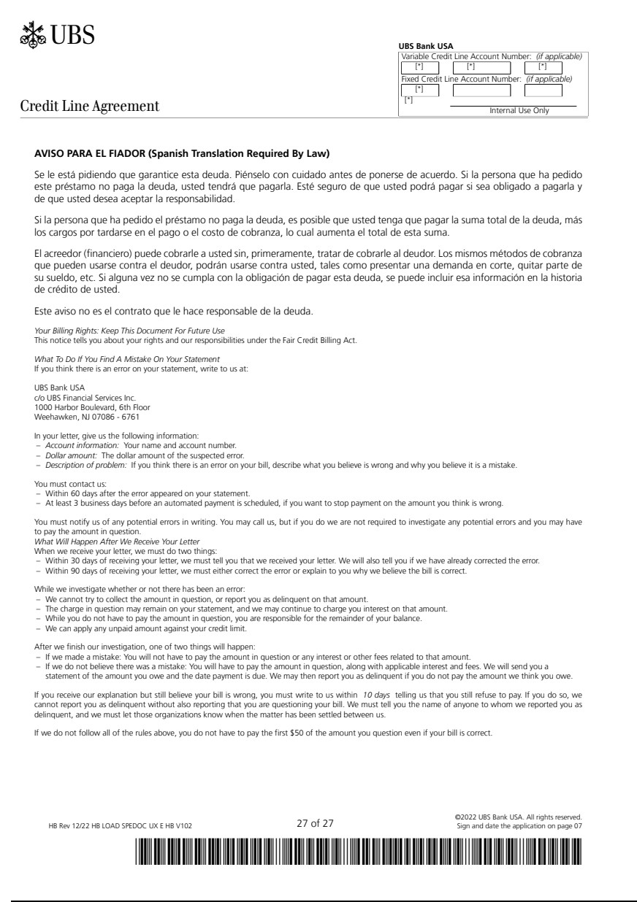

Exhibit 99.1
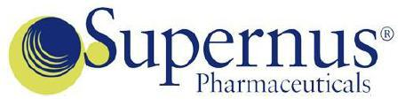

Supernus Enters Into $150 Million Credit Facility

ROCKVILLE, MD, February 14, 2023 – Supernus Pharmaceuticals, Inc. (Nasdaq: SUPN), a biopharmaceutical company focused on developing and commercializing products for the treatment of central nervous system (CNS) diseases, today announced it entered into a credit line agreement (the “Credit Line”) with UBS Bank USA (“UBS”) providing the Company an uncommitted demand secured line of credit of up to $150 million, which can be drawn at any time.

Any fixed rate borrowing will bear interest at a fixed interest rate, equal to the sum of the UBS Fixed Funding Rate plus the applicable Percentage Spread established in the Credit Line. Any variable rate borrowing will bear interest at a variable interest rate, equal to the sum of the UBS Variable Rate plus the applicable Percentage Spread established in the Credit Line.

“We are pleased to further enhance the strength and flexibility of our balance sheet with this line of credit,” said Jack Khattar, President and CEO.

About Supernus Pharmaceuticals, Inc.

Supernus Pharmaceuticals is a biopharmaceutical company focused on developing and commercializing products for the treatment of central nervous system (CNS) diseases.

Our diverse neuroscience portfolio includes approved treatments for epilepsy, migraine, ADHD, hypomobility in PD, cervical dystonia, chronic sialorrhea, dyskinesia in PD patients receiving levodopa-based therapy, and drug-induced extrapyramidal reactions in adult patients. We are developing a broad range of novel CNS product candidates including new potential treatments for hypomobility in PD, epilepsy, depression, and other CNS disorders.

For more information, please visit www.supernus.com.

Forward-Looking Statements

This press release includes forward-looking statements within the meaning of the Private Securities Litigation Reform Act of 1995. These statements do not convey historical information but relate to predicted or potential future events that are based upon management's current expectations. These statements are subject to risks and uncertainties that could cause actual results to differ materially from those expressed or implied by such statements. In addition to the factors mentioned in this press release, such risks and uncertainties include, but are not limited to, the Company’s ability to sustain and increase its profitability; the Company’s ability to raise sufficient capital to fully implement its corporate strategy; the implementation of the Company’s corporate strategy; the Company’s future financial performance and projected expenditures; the Company’s ability to increase the number of prescriptions written for each of its products; the Company’s ability to increase its net revenue; the Company’s ability to commercialize its products including Qelbree; the Company’s ability to enter into future collaborations with pharmaceutical companies and academic institutions or to obtain funding from government agencies; the Company’s product research and development activities, including the timing and progress of the Company’s clinical trials, and projected expenditures; the Company’s ability to receive, and the timing of any receipt of, regulatory approvals to develop and commercialize the Company’s product candidates; the Company’s ability to protect its intellectual property and operate its business without infringing upon the intellectual property rights of others; the Company’s expectations regarding federal, state and foreign regulatory requirements; the therapeutic benefits, effectiveness and safety of the Company’s product candidates; the accuracy of the Company’s estimates of the size and characteristics of the markets that may be addressed by its product candidates; the Company’s ability to increase its manufacturing capabilities for its products and product candidates; the Company’s projected markets and growth in markets; the Company’s product formulations and patient needs and potential funding sources; the Company’s staffing needs; the Company’s ability to increase the number of prescriptions written for each of its products and the products of Adamas; the Company’s ability to increase its net revenue from its products and the products of Adamas; and other risk factors set forth from time to time in the Company’s filings with the Securities and Exchange Commission made pursuant to Section 13 or 15(d) of the Securities Exchange Act of 1934, as amended. The Company undertakes no obligation to update the information in this press release to reflect events or circumstances after the date hereof or to reflect the occurrence of anticipated or unanticipated events.

1

CONTACTS:

Jack A. Khattar, President and CEO

Timothy C. Dec, Senior Vice President and CFO

Supernus Pharmaceuticals, Inc.

Tel: (301) 838-2591

or

INVESTOR CONTACT:

Peter Vozzo

ICR Westwicke

Office: (443) 213-0505

Mobile: (443) 377-4767

Email: peter.vozzo@westwicke.com

2

