UNITED STATES
SECURITIES AND EXCHANGE COMMISSION
Washington, D.C. 20549

SCHEDULE 14A

PROXY STATEMENT PURSUANT TO SECTION 14(a) OF THE
SECURITIES EXCHANGE ACT OF 1934

FILED BY THE REGISTRANT ☒

FILED BY A PARTY OTHER THAN THE REGISTRANT ☐

Check the appropriate box:

 | ☐ | Preliminary Proxy Statement

 | ☐ | Confidential, for Use of the Commission Only (as permitted by Rule 14a-6(e)(2))

 | ☐ | Definitive Proxy Statement

 | ☒ | Definitive Additional Materials

 | ☐ | Soliciting Material under §240.14a-12

SUPERNUS PHARMACEUTICALS, INC.

(Name of the Registrant as Specified In Its Charter)

(Name of Person(s) Filing Proxy Statement, if other than the Registrant)

Payment of Filing Fee (Check the appropriate box):

 | ☒ | No fee required.

 | ☐ | Fee paid previously with preliminary materials.

 | ☐ | Fee computed on table in exhibit required by Item 25(b) per Exchange Act Rules 14a6(i)(1) and 0-11.

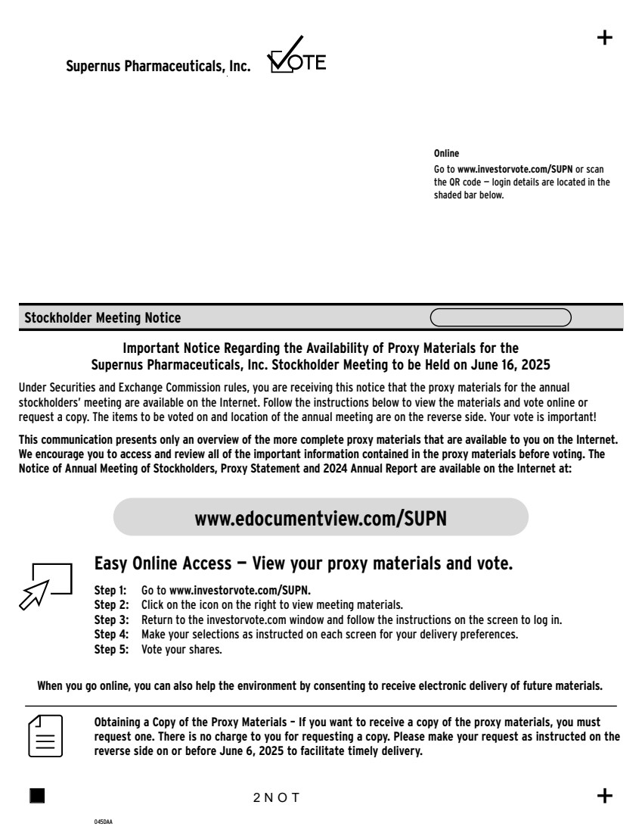 | www.edocumentview.com/SUPN Step 1: Go to www.investorvote.com/SUPN. Step 2: Click on the icon on the right to view meeting materials. Step 3: Return to the investorvote.com window and follow the instructions on the screen to log in. Online Go to www.investorvote.com/SUPN or scan the QR code — login details are located in the shaded bar below. Stockholder Meeting Notice 045DAA Important Notice Regarding the Availability of Proxy Materials for the Supernus Pharmaceuticals, Inc. Stockholder Meeting to be Held on June 16, 2025 Under Securities and Exchange Commission rules, you are receiving this notice that the proxy materials for the annual stockholders’ meeting are available on the Internet. Follow the instructions below to view the materials and vote online or request a copy. The items to be voted on and location of the annual meeting are on the reverse side. Your vote is important! This communication presents only an overview of the more complete proxy materials that are available to you on the Internet. We encourage you to access and review all of the important information contained in the proxy materials before voting. The Notice of Annual Meeting of Stockholders, Proxy Statement and 2024 Annual Report are available on the Internet at: Obtaining a Copy of the Proxy Materials – If you want to receive a copy of the proxy materials, you must request one. There is no charge to you for requesting a copy. Please make your request as instructed on the reverse side on or before June 6, 2025 to facilitate timely delivery. 2NOT Easy Online Access — View your proxy materials and vote. When you go online, you can also help the environment by consenting to receive electronic delivery of future materials. Supernus Pharmaceuticals, Inc. Step 4: Make your selections as instructed on each screen for your delivery preferences. Step 5: Vote your shares.
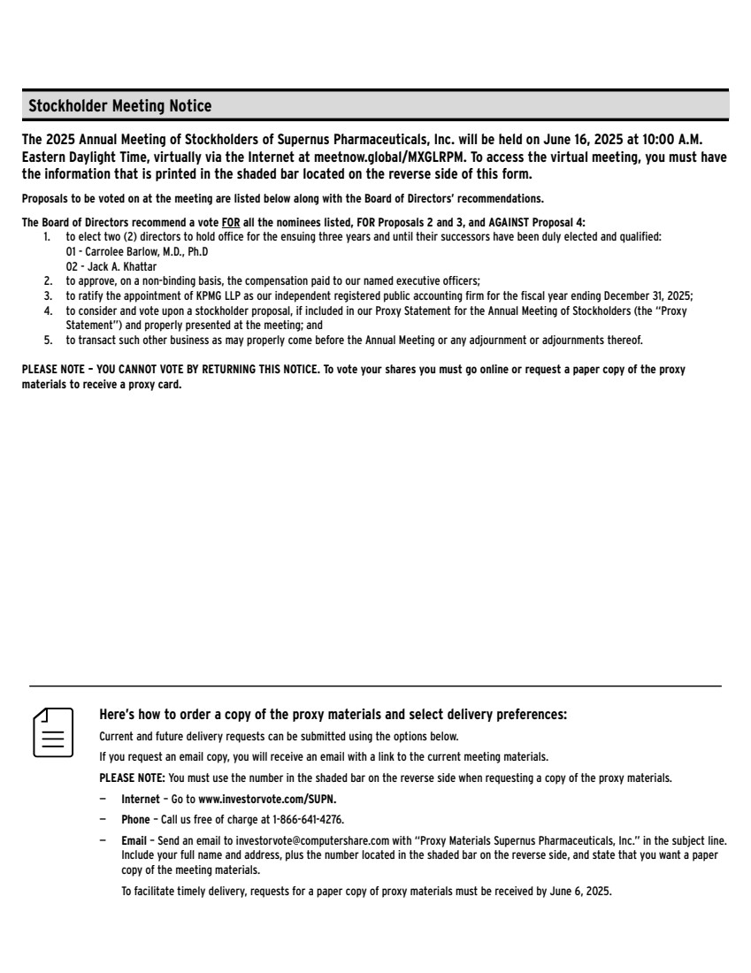 | Here’s how to order a copy of the proxy materials and select delivery preferences: Current and future delivery requests can be submitted using the options below. If you request an email copy, you will receive an email with a link to the current meeting materials. PLEASE NOTE: You must use the number in the shaded bar on the reverse side when requesting a copy of the proxy materials. — Internet – Go to www.investorvote.com/SUPN. — Phone – Call us free of charge at 1-866-641-4276. — Email – Send an email to investorvote@computershare.com with “Proxy Materials Supernus Pharmaceuticals, Inc.” in the subject line. Include your full name and address, plus the number located in the shaded bar on the reverse side, and state that you want a paper copy of the meeting materials. To facilitate timely delivery, requests for a paper copy of proxy materials must be received by June 6, 2025. The 2025 Annual Meeting of Stockholders of Supernus Pharmaceuticals, Inc. will be held on June 16, 2025 at 10:00 A.M. Eastern Daylight Time, virtually via the Internet at meetnow.global/MXGLRPM. To access the virtual meeting, you must have the information that is printed in the shaded bar located on the reverse side of this form. Proposals to be voted on at the meeting are listed below along with the Board of Directors’ recommendations. The Board of Directors recommend a vote FOR all the nominees listed, FOR Proposals 2 and 3, and AGAINST Proposal 4: 1. to elect two (2) directors to hold office for the ensuing three years and until their successors have been duly elected and qualified: 01 - Carrolee Barlow, M.D., Ph.D 02 - Jack A. Khattar 2. to approve, on a non-binding basis, the compensation paid to our named executive officers; 3. to ratify the appointment of KPMG LLP as our independent registered public accounting firm for the fiscal year ending December 31, 2025; 4. to consider and vote upon a stockholder proposal, if included in our Proxy Statement for the Annual Meeting of Stockholders (the “Proxy Statement”) and properly presented at the meeting; and 5. to transact such other business as may properly come before the Annual Meeting or any adjournment or adjournments thereof. PLEASE NOTE – YOU CANNOT VOTE BY RETURNING THIS NOTICE. To vote your shares you must go online or request a paper copy of the proxy materials to receive a proxy card. Stockholder Meeting Notice

