UNITED STATES
SECURITIES AND EXCHANGE COMMISSION
Washington, D.C. 20549

FORM 8-K

CURRENT REPORT
Pursuant to Section 13 or 15(d) of the Securities Exchange Act of 1934

Date of Report (Date of earliest event reported): August 3, 2026

Supernus Pharmaceuticals, Inc.
(Exact name of registrant as specified in its charter)

Delaware | 001-35518 | 20-2590184
(State or other jurisdiction of  incorporation or organization) | (Commission File Number) | (I.R.S. Employer Identification No.)

9715 Key West Ave | Rockville | MD | 20850
(Address of Principal Executive Offices) |  |  | (Zip Code)

Registrant’s telephone number, including area code: (301) 838-2500

Not Applicable
(Former name or former address, if changed since last report.)

Securities registered pursuant to Section 12(b) of the Exchange Act

Title of each class | Trading Symbol | Name of each exchange on which registered
Common Stock, $0.001 par value per share | SUPN | The Nasdaq Stock Market LLC

Check the appropriate box below if the Form 8-K filing is intended to simultaneously satisfy the filing obligation of the registrant under any of the following provisions (see General Instruction A.2. below):

☒ Written communications pursuant to Rule 425 under the Securities Act (17 CFR 230.425)

☒ Soliciting material pursuant to Rule 14a-12 under the Exchange Act (17 CFR 240.14a-12)

☐ Pre-commencement communications pursuant to Rule 14d-2(b) under the Exchange Act (17 CFR 240.14d-2(b))

☐ Pre-commencement communications pursuant to Rule 13e-4(c) under the Exchange Act (17 CFR 240.13e-4(c))

Indicate by check mark whether the registrant is an emerging growth company as defined in Rule 405 of the Securities Act of 1933 (§230.405 of this chapter) or Rule 12b-2 of the Securities Exchange Act of 1934 (§240.12b-2 of this chapter). ☐

If an emerging growth company, indicate by check mark if the registrant has elected not to use the extended transition period for complying with any new or revised financial accounting standards provided pursuant to Section 13(a) of the Exchange Act. ☐

Item 8.01 | Other Events.

On August 3, 2026, Supernus Pharmaceuticals, Inc. (the “Company”) published a post relating to the proposed merger of equals of the Company and Indivior Pharmaceuticals Inc. (“Indivior”) on the Company’s LinkedIn account. In addition, on August 3, 2026, the Company distributed to its employees communications relating to the proposed merger, consisting of an email to Company employees from Jack A. Khattar, the Company’s President and Chief Executive Officer, and a presentation used at a Company employee meeting. Copies of the LinkedIn post, the employee email and the employee presentation are filed as Exhibit 99.1, Exhibit 99.2 and Exhibit 99.3 hereto, respectively, and are incorporated herein by reference.

Important Additional Information and Where to Find It

In connection with the proposed transaction, Indivior intends to file with the SEC a registration statement on Form S-4, which will include a document that serves as a prospectus of Indivior and a joint proxy statement of Indivior and Supernus (the “joint proxy statement/prospectus”). Each party also plans to file other relevant documents with the SEC regarding the proposed transaction. INVESTORS AND SECURITY HOLDERS ARE URGED TO READ THE JOINT PROXY STATEMENT/PROSPECTUS AND OTHER RELEVANT DOCUMENTS FILED WITH THE SEC WHEN THEY BECOME AVAILABLE, BECAUSE THEY WILL CONTAIN IMPORTANT INFORMATION ABOUT THE PROPOSED TRANSACTION. A definitive joint proxy statement/prospectus will be sent to Indivior’s stockholders and Supernus’ stockholders. Investors and securityholders may obtain a free copy of the joint proxy statement/prospectus (if and when it becomes available) and other relevant documents filed by Indivior and Supernus with the SEC at the SEC’s website at www.sec.gov. Copies of the documents filed by Indivior with the SEC will be available free of charge on Indivior’s website at www.indivior.com or by contacting Indivior’s Investor Relations at InvestorRelations@indivior.com. Copies of the documents filed by Supernus with the SEC will be available free of charge on Supernus’ website at www.supernus.com.

No Offer or Solicitation

This report and the information contained herein is for informational purposes only and does not constitute an offer to sell or the solicitation of an offer to buy or exchange any securities, or a solicitation of any vote or approval, nor shall there be any sale of securities in any jurisdiction in which such offer, solicitation or sale would be unlawful prior to registration or qualification under the securities laws of any such jurisdiction. This report does not constitute a prospectus or prospectus equivalent document. No offer of securities shall be made except by means of a prospectus meeting the requirements of Section 10 of the Securities Act of 1933, as amended.

Participants in the Solicitation

Indivior and Supernus and their respective directors, executive officers and other members of management and employees may be deemed to be participants in the solicitation of proxies in respect of the proposed transaction. Information about directors and executive officers of Indivior is available in the Indivior proxy statement for its 2026 Annual Meeting, which was filed with the SEC on March 27, 2026. Information about directors and executive officers of Supernus is available in the Supernus proxy statement for its 2026 Annual Meeting, which was filed with the SEC on April 30, 2026. Other information regarding the participants in the proxy solicitation and a description of their direct and indirect interests, by security holdings or otherwise, will be contained in the joint proxy statement/prospectus and other relevant materials filed with the SEC regarding the proposed transaction when they become available. Investors should read the joint proxy statement/prospectus carefully when it becomes available before making any voting or investment decisions. Investors may obtain free copies of these documents from Indivior and Supernus as indicated above.

2

Forward-Looking Statements

This report contains forward-looking statements within the meaning of the U.S. Private Securities Litigation Reform Act of 1995 and other federal securities laws. From time to time, oral or written forward-looking statements may also be included in other information released to the public. These forward-looking statements are intended to provide Supernus’s and Indivior’s respective management’s current expectations or plans for our future operating and financial performance, based on assumptions currently believed to be valid. Words such as “anticipate,” “believe,” “estimate,” “expect,” “intend,” “plan,” “project,” “may,” “will,” “would,” “could,” “should,” and similar expressions are intended to identify forward-looking statements, although not all forward-looking statements contain these words. All forward-looking statements involve risks, uncertainties and other factors that may cause actual results to differ materially from those expressed or implied in the forward-looking statements. These statements, including statements regarding the proposed merger of equals of Supernus and Indivior, the expected timing of the closing, and the anticipated benefits and prospects of the combined company, are based on management’s current expectations and are subject to risks and uncertainties that could cause actual results to differ materially, including, among others: the risk that the proposed merger may not be completed in a timely manner or at all; the failure to obtain the required approvals of Supernus' or Indivior’s stockholders; the failure or delay in obtaining required regulatory approvals, or the imposition of conditions in connection therewith; the failure to satisfy the other conditions to closing; the possibility that a competing or superior acquisition proposal is made; the fact that the exchange ratio is fixed and will not be adjusted for changes in the market price of Supernus or Indivior shares; the effect of the announcement, pendency or completion of the transaction on the market price of Supernus and Indivior shares; the effect of the additional indebtedness incurred to fund the Special Dividend on the combined company; the effects of business disruption resulting from the announcement or pendency of the transaction; the diversion of management’s attention and resources from ongoing business operations; the effect of the transaction on the parties’ ability to retain and hire key personnel and to maintain relationships with customers, suppliers and other business partners; restrictions during the pendency of the transaction that may limit the parties’ ability to pursue business opportunities or strategic transactions; the risk that the anticipated benefits, synergies and cost savings may not be realized within the expected timeframe or at all; the difficulties and costs of integrating the two businesses; significant transaction costs and/or unknown or inestimable liabilities; the risk that the merger does not qualify for its intended treatment as a tax-free reorganization; the occurrence of any event that could give rise to termination of the merger agreement, including in circumstances requiring payment of a termination fee; the risk of stockholder litigation in connection with the transaction; the impact of macroeconomic and market conditions, including economic downturns, international conflict, trade disputes and tariffs; and the other risks identified in Supernus' and Indivior’s filings with the SEC and in the joint proxy statement/prospectus when it becomes available. There can be no assurance that the proposed merger will in fact be consummated in the manner described or at all. These forward-looking statements speak only as of the date of this report and neither Supernus nor Indivior undertakes any obligation to update any forward-looking statement, except as required by applicable law.

Item 9.01 | Financial Statements and Exhibits.

 | (d) | Exhibits

Exhibit 99.1 - LinkedIn post published by Supernus Pharmaceuticals, Inc., dated August 3, 2026.
Exhibit 99.2 - Email to employees of Supernus Pharmaceuticals, Inc. from Jack A. Khattar, dated August 3, 2026.
Exhibit 99.3 - Employee presentation of Supernus Pharmaceuticals, Inc., dated August 3, 2026.
Exhibit 104 - The cover page from this Current Report on Form 8-K, formatted in Inline XBRL.

3

SIGNATURES

Pursuant to the requirements of the Securities Exchange Act of 1934, the registrant has duly caused this report to be signed on its behalf by the undersigned hereunto duly authorized.

 | SUPERNUS PHARMACEUTICALS, INC.
DATED: August 3, 2026 | By: | /s/ Timothy C. Dec
 |  | Timothy C. Dec
 |  | Senior Vice President and Chief Financial Officer

4

Exhibit 99.1

Filed by: Supernus Pharmaceuticals, Inc.
Pursuant to Rule 425 under the Securities Act of 1933
and deemed filed pursuant to Rule 14a-12 under the Securities Exchange Act of 1934
Subject Company: Supernus Pharmaceuticals, Inc.
Commission File No. 001-35518
Date: August 3, 2026

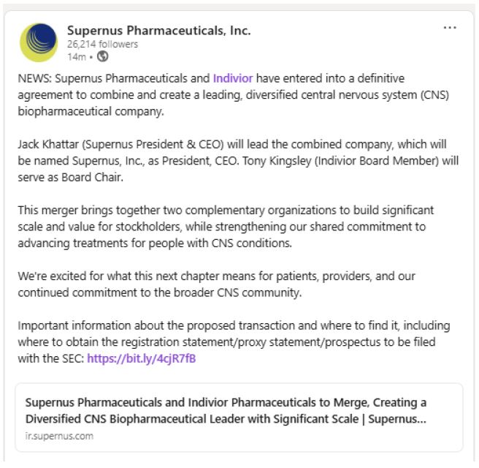

Exhibit 99.2

Filed by: Supernus Pharmaceuticals, Inc.
Pursuant to Rule 425 under the Securities Act of 1933
and deemed filed pursuant to Rule 14a-12 under the Securities Exchange Act of 1934
Subject Company: Supernus Pharmaceuticals, Inc.
Commission File No.: 001-35518
Date: August 3, 2026

 | August, 3, 2026

For Internal Use Only, Do Not Forward

Dear Colleagues,

Today, we announced that Supernus and Indivior have entered into an agreement to combine our companies in an all-stock merger of equals to create a leading U.S. biopharma company focused on improving the lives of people living with central nervous system (CNS) diseases. Bringing these two organizations together is intended to deliver greater value to the patients, communities, and shareholders we serve.

Why We are Combining

 | • | A differentiated commercial portfolio: Together, the combined company brings leading, durable, differentiated, patent-protected franchises that provide a platform for growth.

 | • | Four established commercial franchises across CNS and behavioral health: The combined company will have four separate, established businesses — SUBLOCADE® in opioid use disorder, Qelbree® in ADHD, Zurzuvae® in postpartum depression, and Onapgo® and GOCOVRI® in Parkinson's disease.

 | • | Pipeline and R&D capabilities: Innovative pipeline in epilepsy, depression, and ADHD as well as R&D capabilities that will create a broader innovation engine, with more potential paths forward across addiction, psychiatry, and neurology.

 | • | A strong financial profile: The combined company has financial strength and flexibility to pursue business development opportunities that neither Indivior nor Supernus could contemplate on their own today.

As part of this transaction, I will serve as Chief Executive Officer, and the Supernus leadership team will be part of the expanded leadership team at the combined company.

What Happens Next

 | • | This afternoon there will be an all-employee meeting at 1 p.m. A calendar invitation will be sent shortly.

 | • | Business continues as usual until closing. We will remain separate companies until the transaction closes, which is expected to happen in Q4 2026. That means we continue to operate as we do today, and we do not coordinate commercially or share competitively sensitive information. Do not speak externally about the transaction unless designated to do so and refrain from any social media posts, LinkedIn commentary, blog posts, or public statements about the deal.

 | • | Please do not reach out to Indivior counterparts about integration, commercial matters, or day-to-day business. Integration planning will happen through a structured process that Legal, and the integration team will lead. If you receive an inbound outreach, please route it to your manager.

 | • | Your focus should remain on serving patients, customers, and our 2026 priorities.

 | • | We are growing our commitment to patients. The combined company strengthens our ability to improve the lives of people suffering from central nervous system diseases through a broader platform and stronger innovation engine.

Thank you for your continued focus, professionalism, and commitment to the people who depend on us.

I look forward to providing more information at 1pm.

Jack

---

Forward Looking Statements

This presentation, and any related oral statements made by representatives of Supernus or Indivior in connection with it, contain forward-looking statements within the meaning of the Private Securities Litigation Reform Act of 1995 and other federal securities laws. Words such as “anticipate,” “believe,” “estimate,” “expect,” “intend,” “plan,” “project,” “may,” “will,” “would,” “could,” “should,” and similar expressions are intended to identify forward-looking statements, although not all forward-looking statements contain these words. These statements, including statements regarding the proposed merger of equals of Supernus and Indivior, the expected timing of the closing, and the anticipated benefits and prospects of the combined company, are based on management’s current expectations and are subject to risks and uncertainties that could cause actual results to differ materially, including, among others: the risk that the proposed merger may not be completed in a timely manner or at all; the failure to obtain the required approvals of Supernus‘s or Indivior’s stockholders; the failure or delay in obtaining required regulatory approvals, or the imposition of conditions in connection therewith; the failure to satisfy the other conditions to closing; the possibility that a competing or superior acquisition proposal is made; the fact that the exchange ratio is fixed and will not be adjusted for changes in the market price of Supernus or Indivior shares; the effect of the announcement, pendency or completion of the transaction on the market price of Supernus and Indivior shares; the risk that the financing for the Special Dividend is not obtained on the anticipated terms or at all, and the effect of the additional indebtedness incurred to fund the Special Dividend on the combined company; the effects of business disruption resulting from the announcement or pendency of the transaction; the diversion of management’s attention and resources from ongoing business operations; the effect of the transaction on the parties’ ability to retain and hire key personnel and to maintain relationships with customers, suppliers and other business partners; restrictions during the pendency of the transaction that may limit the parties’ ability to pursue business opportunities or strategic transactions; the risk that the anticipated benefits, synergies and cost savings may not be realized within the expected timeframe or at all; the difficulties and costs of integrating the two businesses; significant transaction costs and/or unknown or inestimable liabilities; the risk that the merger does not qualify for its intended treatment as a tax-free reorganization; the risk that the Indivior shares to be issued in the merger are not approved for listing on Nasdaq; the occurrence of any event that could give rise to termination of the merger agreement, including in circumstances requiring payment of a termination fee; the risk of stockholder litigation in connection with the transaction; the impact of macroeconomic and market conditions, including economic downturns, international conflict, trade disputes and tariffs; and the other risks identified in Supernus’s and Indivior’s filings with the SEC and in the joint proxy statement/prospectus when it becomes available. These forward-looking statements speak only as of the date of this presentation and neither Supernus nor Indivior undertakes any obligation to update any forward-looking statement, except as required by applicable law. This presentation also contains non-GAAP financial measures, including Adjusted EBITDA, Adjusted EBITDA margin and run-rate cost synergies, which are not calculated in accordance with GAAP, should be considered in addition to and not as substitutes for the most directly comparable GAAP measures, and may not be comparable to similarly titled measures used by other companies

Additional Information

No Offer or Solicitation

This communication is for informational purposes only and does not constitute an offer to sell or the solicitation of an offer to buy or exchange any securities, or a solicitation of any vote or approval, nor shall there be any sale of securities in any jurisdiction in which such offer, solicitation or sale would be unlawful prior to registration or qualification under the securities laws of any such jurisdiction. This communication does not constitute a prospectus or prospectus equivalent document. No offer of securities shall be made except by means of a prospectus meeting the requirements of Section 10 of the Securities Act of 1933, as amended.

Additional Information and Where to Find It

In connection with the proposed transaction, Indivior intends to file with the SEC a registration statement on Form S-4, which will include a document that serves as a prospectus of Indivior and a joint proxy statement of Indivior and Supernus (the “joint proxy statement/prospectus”). Each party also plans to file other relevant documents with the SEC regarding the proposed transaction. INVESTORS AND SECURITY HOLDERS ARE URGED TO READ THE JOINT PROXY STATEMENT/PROSPECTUS AND OTHER RELEVANT DOCUMENTS FILED WITH THE SEC WHEN THEY BECOME AVAILABLE, BECAUSE THEY WILL CONTAIN IMPORTANT INFORMATION ABOUT THE PROPOSED TRANSACTION. A definitive joint proxy statement/prospectus will be sent to Indivior’s stockholders and Supernus’ stockholders. Investors and securityholders may obtain a free copy of the joint proxy statement/prospectus (if and when it becomes available) and other relevant documents filed by Indivior and Supernus with the SEC at the SEC’s website at www.sec.gov. Copies of the documents filed by Indivior with the SEC will be available free of charge on Indivior’s website at www.indivior.com or by contacting Indivior’s Investor Relations at InvestorRelations@indivior.com. Copies of the documents filed by Supernus with the SEC will be available free of charge on Supernus’ website at www.supernus.com

Participants in The Solicitation

Indivior and Supernus and their respective directors, executive officers and other members of management and employees may be deemed to be participants in the solicitation of proxies in respect of the proposed transaction. Information about directors and executive officers of Indivior is available in the Indivior proxy statement for its 2026 Annual Meeting, which was filed with the SEC on March 27, 2026. Information about directors and executive officers of Supernus is available in the Supernus proxy statement for its 2026 Annual Meeting, which was filed with the SEC on April 30, 2026. Other information regarding the participants in the proxy solicitation and a description of their direct and indirect interests, by security holdings or otherwise, will be contained in the joint proxy statement/prospectus and other relevant materials filed with the SEC regarding the proposed transaction when they become available. Investors should read the joint proxy statement/prospectus carefully when it becomes available before making any voting or investment decisions. Investors may obtain free copies of these documents from Indivior and Supernus as indicated above.

Exhibit 99.3

Filed by: Supernus Pharmaceuticals, Inc.
Pursuant to Rule 425 under the Securities Act of 1933
and deemed filed pursuant to Rule 14a-12 under the Securities Exchange Act of 1934
Subject Company: Supernus Pharmaceuticals, Inc.
Commission File No. 001-35518
Date: August 3, 2026

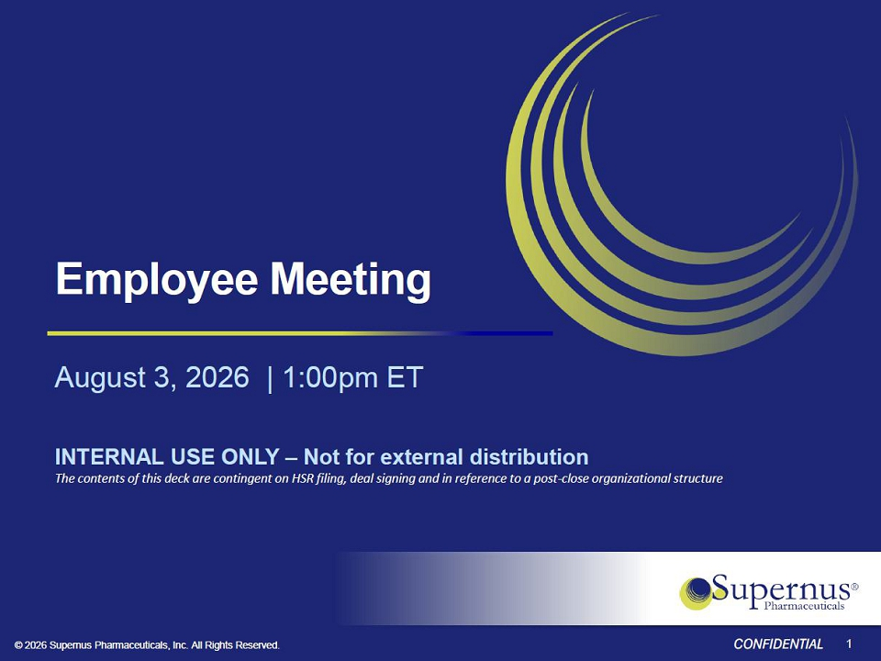
© 2026 Supernus Pharmaceuticals, Inc. All Rights Reserved. CONFIDENTIAL Employee Meeting August 3, 2026 | 1:00pm ET INTERNAL USE ONLY – Not for external distribution The contents of this deck are contingent on HSR filing, deal signing and in reference to a post - close organizational structure 1 Filed by: Supernus Pharmaceuticals, Inc. Pursuant to Rule 425 under the Securities Act of 1933 and deemed filed pursuant to Rule 14a - 12 under the Securities Exchange Act of 1934 Subject Company: Supernus Pharmaceuticals, Inc. Commission File No. 001 - 35518 Date: August 3, 2026

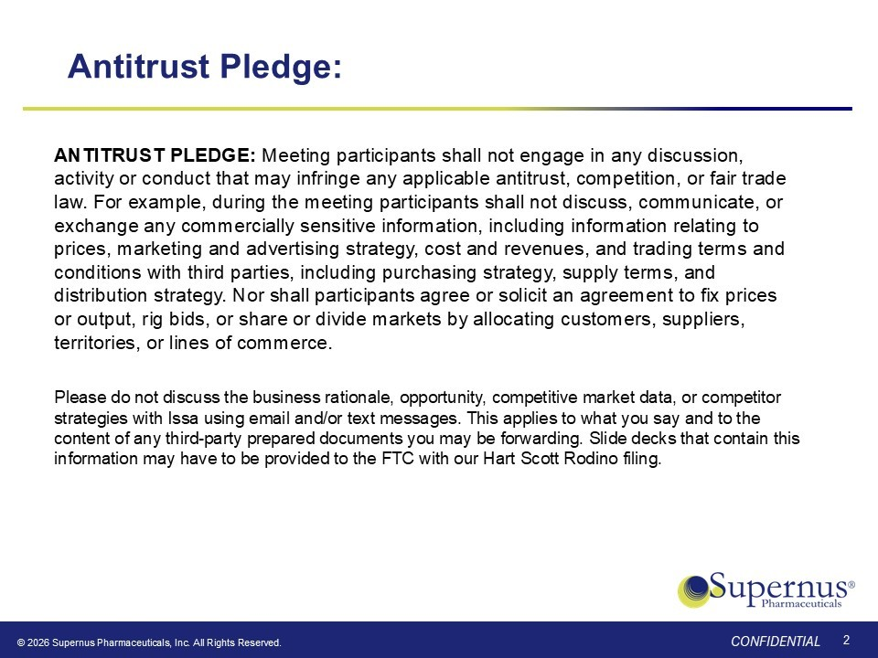
© 2026 Supernus Pharmaceuticals, Inc. All Rights Reserved. CONFIDENTIAL CONFIDENTIAL Antitrust Pledge: ANTITRUST PLEDGE: Meeting participants shall not engage in any discussion, activity or conduct that may infringe any applicable antitrust, competition, or fair trade law. For example, during the meeting participants shall not discuss, communicate, or exchange any commercially sensitive information, including information relating to prices, marketing and advertising strategy, cost and revenues, and trading terms and conditions with third parties, including purchasing strategy, supply terms, and distribution strategy. Nor shall participants agree or solicit an agreement to fix prices or output, rig bids, or share or divide markets by allocating customers, suppliers, territories, or lines of commerce. Please do not discuss the business rationale, opportunity, competitive market data, or competitor strategies with Issa using email and/or text messages. This applies to what you say and to the content of any third - party prepared documents you may be forwarding. Slide decks that contain this information may have to be provided to the FTC with our Hart Scott Rodino filing . 2 © 2026 Supernus Pharmaceuticals, Inc. All Rights Reserved. CONFIDENTIAL

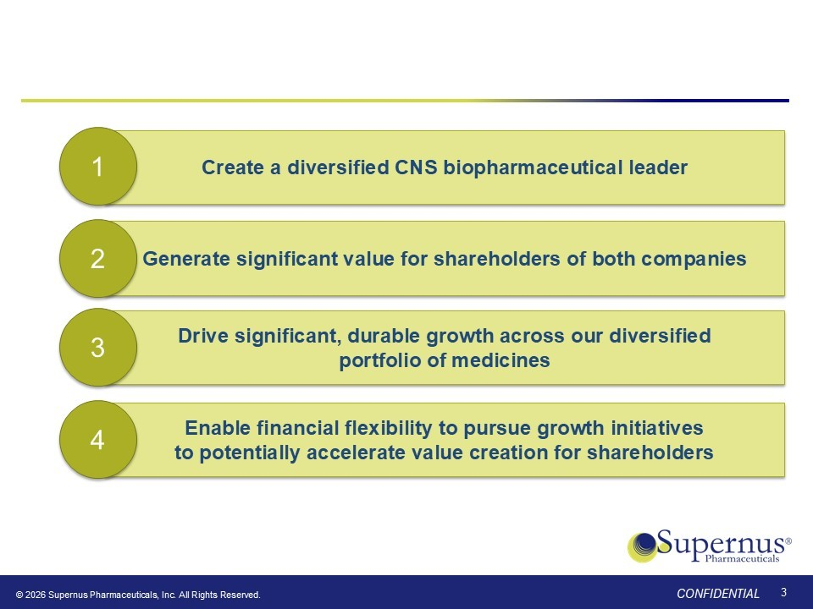
Create a diversified CNS biopharmaceutical leader 1 Generate significant value for shareholders of both companies 2 Drive significant, durable growth across our diversified portfolio of medicines 3 Enable financial flexibility to pursue growth initiatives to potentially accelerate value creation for shareholders 4 3 © 2026 Supernus Pharmaceuticals, Inc. All Rights Reserved. CONFIDENTIAL

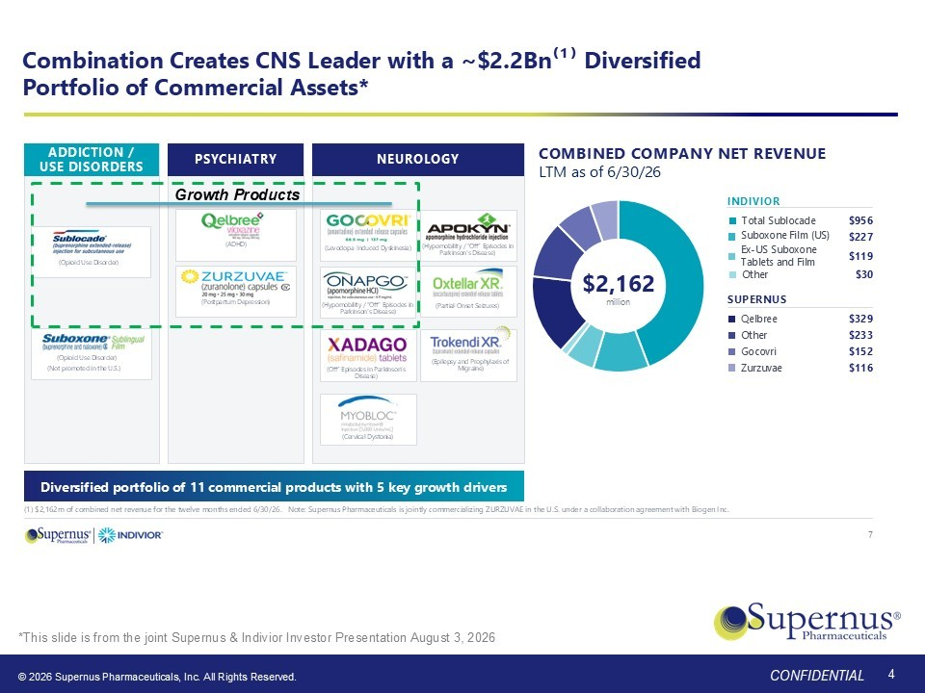
Combination Creates CNS Leader with a ~$2.2Bn⁽¹⁾ Diversified Portfolio of Commercial Assets* G ADDICTION / USE DISORDERS PSYCHIATRY NEUROLOGY COMBINED COMPANY NET REVENUE LTM as of 6/30/26 $2,162 million INDIVIOR Total Sublocade $956 Suboxone Film (US) $227 Ex - US Suboxone Tablets and Film $119 Other $30 SUPERNUS Qelbree $329 Other $233 Gocovri $152 Zurzuvae $116 Diversified portfolio of 11 commercial products with 5 key growth drivers (1) $2,162m of combined net revenue for the twelve months ended 6/30/26. Note: Supernus Pharmaceuticals is jointly commerci ali zing ZURZUVAE in the U.S. under a collaboration agreement with Biogen Inc. (Opioid Use Disorder) (Opioid Use Disorder) (ADHD) (Postpartum Depression) (Levodopa - Induced Dyskinesia) (Hypomobility / “Off” Episodes in Parkinson’s Disease) (Cervical Dystonia) (“Off” Episodes in PD) (Partial - Onset Seizures) (Epilepsy and Prophylaxis of Migraine) 7 Growth Products (Not promoted in the U.S.) (Off” Episodes in Parkinson’s Disease) (Hypomobility / “Off” Episodes in Parkinson’s Disease) 4 © 2026 Supernus Pharmaceuticals, Inc. All Rights Reserved. CONFIDENTIAL *This slide is from the joint Supernus & Indivior Investor Presentation August 3, 2026

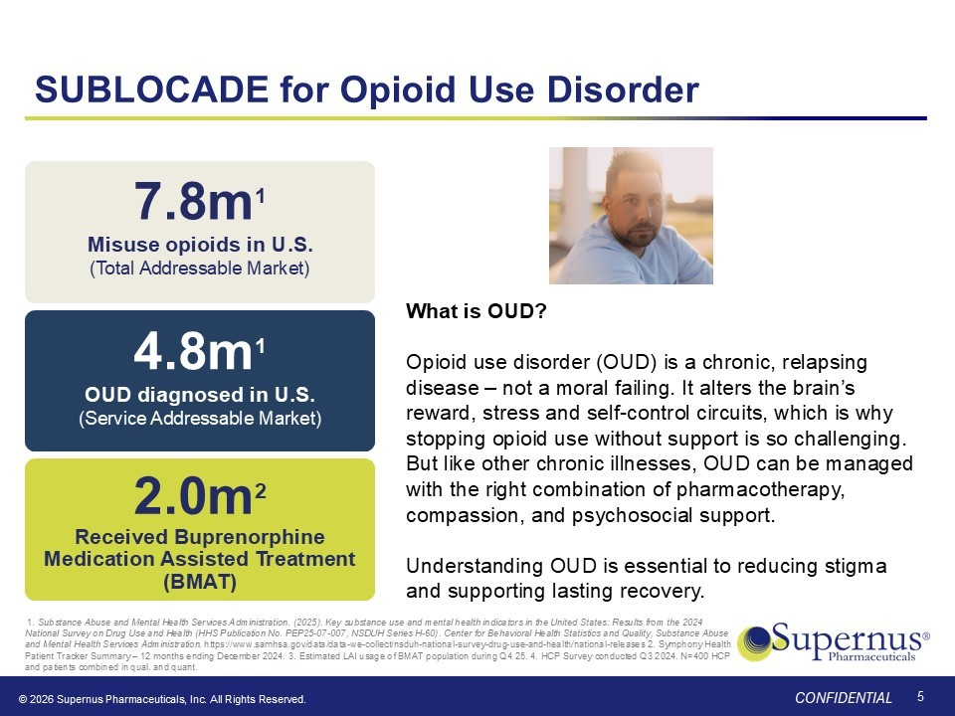
© 2026 Supernus Pharmaceuticals, Inc. All Rights Reserved. CONFIDENTIAL SUBLOCADE for Opioid Use Disorder 5 7.8m 1 Misuse opioids in U.S. (Total Addressable Market) 4.8m 1 OUD diagnosed in U.S. (Service Addressable Market) 2.0m 2 Received Buprenorphine Medication Assisted Treatment (BMAT) 1. Substance Abuse and Mental Health Services Administration. (2025). Key substance use and mental health indicators in the Unit ed States: Results from the 2024 National Survey on Drug Use and Health (HHS Publication No. PEP25 - 07 - 007, NSDUH Series H - 60). Center for Behavioral Health Stati stics and Quality, Substance Abuse and Mental Health Services Administration . https://www.samhsa.gov/data/data - we - collect/nsduh - national - survey - drug - use - and - health/national - releases 2. Symphony Health Patient Tracker Summary – 12 months ending December 2024. 3. Estimated LAI usage of BMAT population during Q4 25. 4. HCP Survey conducted Q3 2024. N=400 HCP and patients combined in qual. and quant. What is OUD? Opioid use disorder (OUD) is a chronic, relapsing disease – not a moral failing. It alters the brain’s reward, stress and self - control circuits, which is why stopping opioid use without support is so challenging. But like other chronic illnesses, OUD can be managed with the right combination of pharmacotherapy, compassion, and psychosocial support. Understanding OUD is essential to reducing stigma and supporting lasting recovery.

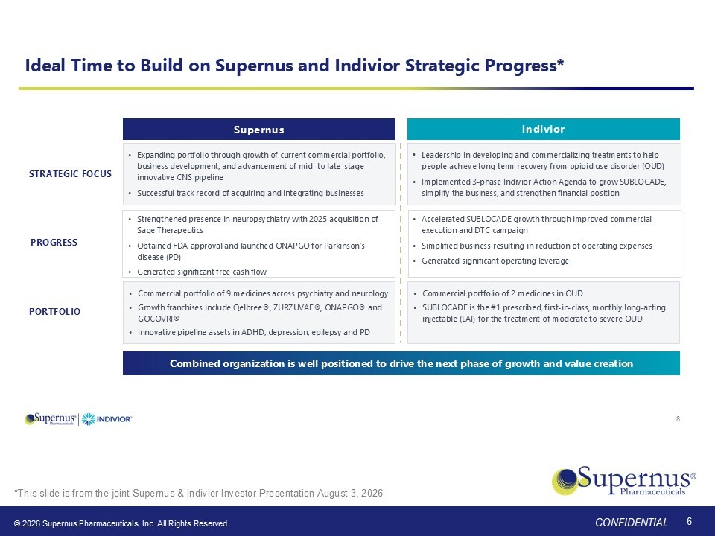
© 2026 Supernus Pharmaceuticals, Inc. All Rights Reserved. CONFIDENTIAL Ideal Time to Build on Supernus and Indivior Strategic Progress* Supernus Indivior STRATEGIC FOCUS • Expanding portfolio through growth of current commercial portfolio, business development, and advancement of mid - to late - stage innovative CNS pipeline • Successful track record of acquiring and integrating businesses • Leadership in developing and commercializing treatments to help people achieve long - term recovery from opioid use disorder (OUD) • Implemented 3 - phase Indivior Action Agenda to grow SUBLOCADE, simplify the business, and strengthen financial position PROGRESS • Strengthened presence in neuropsychiatry with 2025 acquisition of Sage Therapeutics • Obtained FDA approval and launched ONAPGO for Parkinson’s disease (PD) • Generated significant free cash flow • Accelerated SUBLOCADE growth through improved commercial execution and DTC campaign • Simplified business resulting in reduction of operating expenses • Generated significant operating leverage Combined organization is well positioned to drive the next phase of growth and value creation 8 PORTFOLIO • Commercial portfolio of 9 medicines across psychiatry and neurology • Growth franchises include Qelbree®, ZURZUVAE®, ONAPGO® and GOCOVRI® • Innovative pipeline assets in ADHD, depression, epilepsy and PD • Commercial portfolio of 2 medicines in OUD • SUBLOCADE is the #1 prescribed, first - in - class, monthly long - acting injectable (LAI) for the treatment of moderate to severe OUD 6 © 2026 Supernus Pharmaceuticals, Inc. All Rights Reserved. CONFIDENTIAL *This slide is from the joint Supernus & Indivior Investor Presentation August 3, 2026

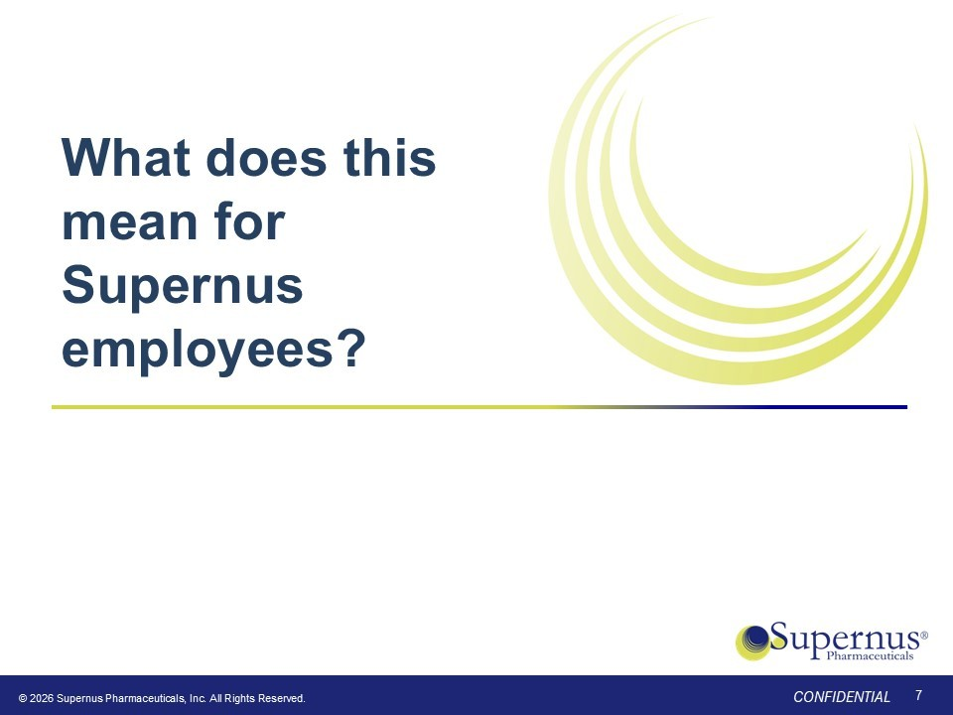
What does this mean for Supernus employees? 7 © 2026 Supernus Pharmaceuticals, Inc. All Rights Reserved. CONFIDENTIAL

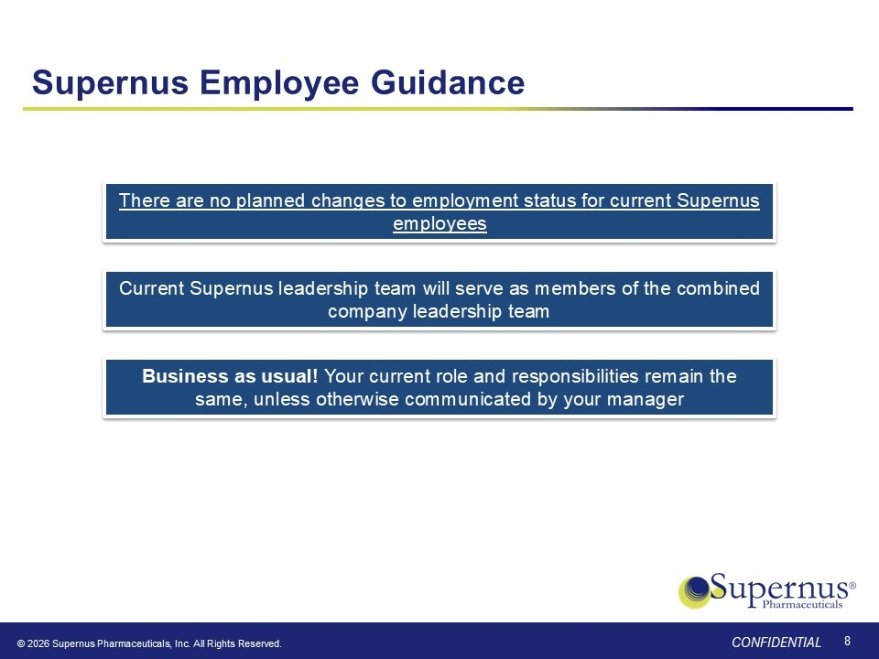
© 2026 Supernus Pharmaceuticals, Inc. All Rights Reserved. CONFIDENTIAL Supernus Employee Guidance Business as usual! Your current role and responsibilities remain the same, unless otherwise communicated by your manager There are no planned changes to employment status for current Supernus employees Current Supernus leadership team will serve as members of the combined company leadership team 8

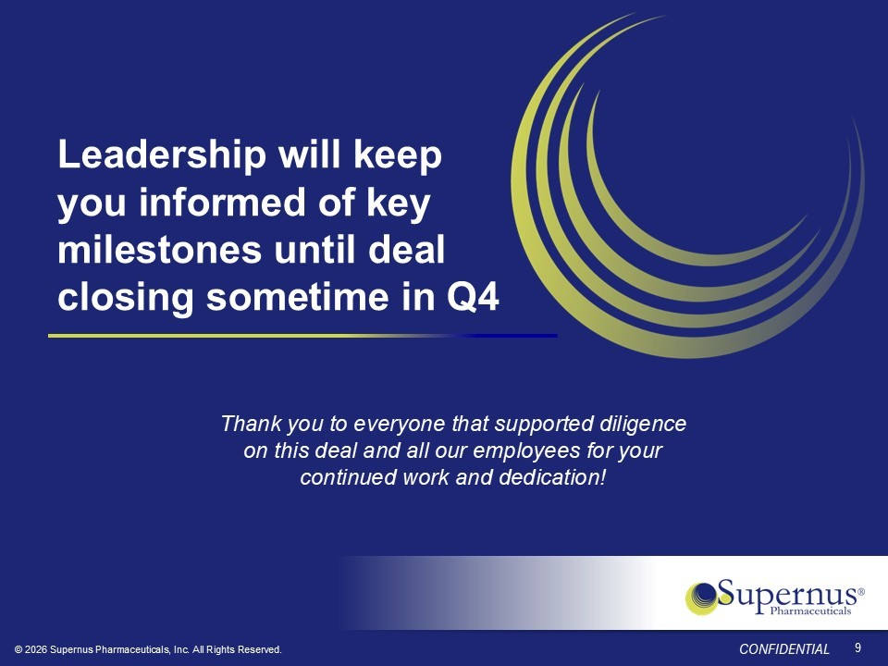
© 2026 Supernus Pharmaceuticals, Inc. All Rights Reserved. CONFIDENTIAL Leadership will keep you informed of key milestones until deal closing sometime in Q4 9 Thank you to everyone that supported diligence on this deal and all our employees for your continued work and dedication!

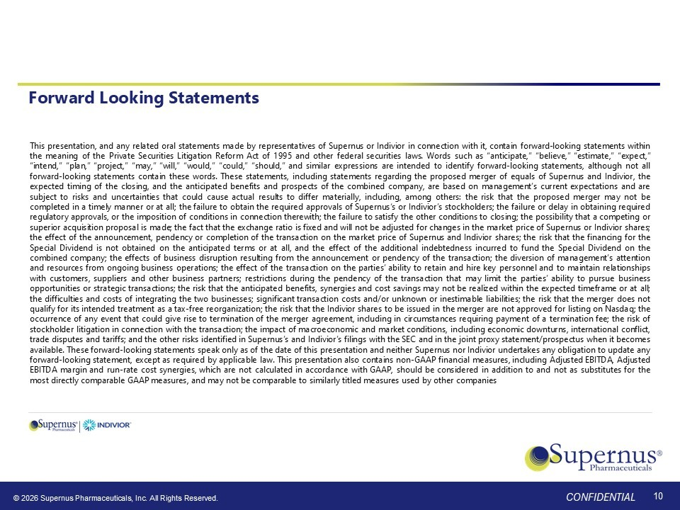
© 2026 Supernus Pharmaceuticals, Inc. All Rights Reserved. CONFIDENTIAL Forward Looking Statements This presentation, and any related oral statements made by representatives of Supernus or Indivior in connection with it, contain forward - looking statements within the meaning of the Private Securities Litigation Reform Act of 1995 and other federal securities laws . Words such as “anticipate,” “believe,” “estimate,” “expect,” “intend,” “plan,” “project,” “may,” “will,” “would,” “could,” “should,” and similar expressions are intended to identify forward - looking statements, although not all forward - looking statements contain these words . These statements, including statements regarding the proposed merger of equals of Supernus and Indivior, the expected timing of the closing, and the anticipated benefits and prospects of the combined company, are based on management’s current expectations and are subject to risks and uncertainties that could cause actual results to differ materially, including, among others : the risk that the proposed merger may not be completed in a timely manner or at all ; the failure to obtain the required approvals of Supernus‘s or Indivior’s stockholders ; the failure or delay in obtaining required regulatory approvals, or the imposition of conditions in connection therewith ; the failure to satisfy the other conditions to closing ; the possibility that a competing or superior acquisition proposal is made ; the fact that the exchange ratio is fixed and will not be adjusted for changes in the market price of Supernus or Indivior shares ; the effect of the announcement, pendency or completion of the transaction on the market price of Supernus and Indivior shares ; the risk that the financing for the Special Dividend is not obtained on the anticipated terms or at all, and the effect of the additional indebtedness incurred to fund the Special Dividend on the combined company ; the effects of business disruption resulting from the announcement or pendency of the transaction ; the diversion of management’s attention and resources from ongoing business operations ; the effect of the transaction on the parties’ ability to retain and hire key personnel and to maintain relationships with customers, suppliers and other business partners ; restrictions during the pendency of the transaction that may limit the parties’ ability to pursue business opportunities or strategic transactions ; the risk that the anticipated benefits, synergies and cost savings may not be realized within the expected timeframe or at all ; the difficulties and costs of integrating the two businesses ; significant transaction costs and/or unknown or inestimable liabilities ; the risk that the merger does not qualify for its intended treatment as a tax - free reorganization ; the risk that the Indivior shares to be issued in the merger are not approved for listing on Nasdaq ; the occurrence of any event that could give rise to termination of the merger agreement, including in circumstances requiring payment of a termination fee ; the risk of stockholder litigation in connection with the transaction ; the impact of macroeconomic and market conditions, including economic downturns, international conflict, trade disputes and tariffs ; and the other risks identified in Supernus’s and Indivior’s filings with the SEC and in the joint proxy statement/prospectus when it becomes available . These forward - looking statements speak only as of the date of this presentation and neither Supernus nor Indivior undertakes any obligation to update any forward - looking statement, except as required by applicable law . This presentation also contains non - GAAP financial measures, including Adjusted EBITDA, Adjusted EBITDA margin and run - rate cost synergies, which are not calculated in accordance with GAAP, should be considered in addition to and not as substitutes for the most directly comparable GAAP measures, and may not be comparable to similarly titled measures used by other companies 10

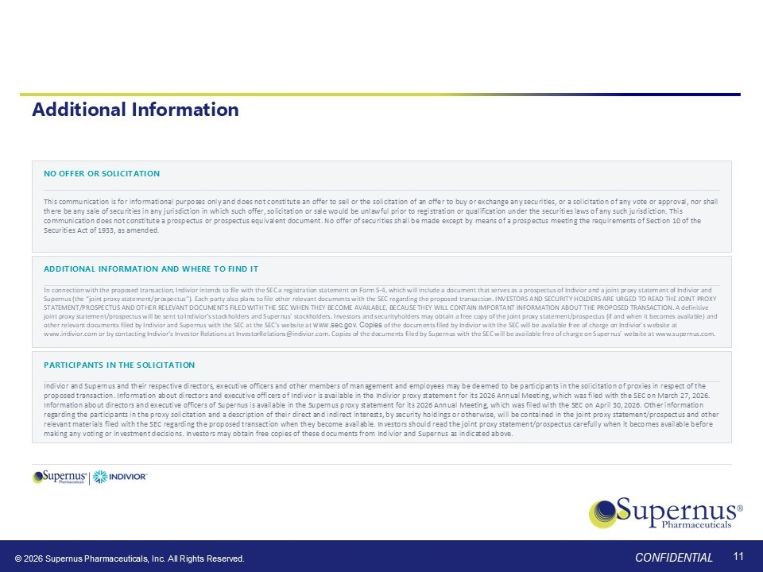
© 2026 Supernus Pharmaceuticals, Inc. All Rights Reserved. CONFIDENTIAL Additional Information NO OFFER OR SOLICITATION This communication is for informational purposes only and does not constitute an offer to sell or the solicitation of an offe r t o buy or exchange any securities, or a solicitation of any vote or approval, nor shall there be any sale of securities in any jurisdiction in which such offer, solicitation or sale would be unlawful prior to regi str ation or qualification under the securities laws of any such jurisdiction. This communication does not constitute a prospectus or prospectus equivalent document. No offer of securities shall be made except by means of a prospectus meeting the requirements of Section 10 of the Securities Act of 1933, as amended . ADDITIONAL INFORMATION AND WHERE TO FIND IT I n connection with the proposed transaction, Indivior intends to file with the SEC a registration statement on Form S - 4, which wi ll include a document that serves as a prospectus of Indivior and a joint proxy statement of Indivior and Supernus (the “joint proxy statement/prospectus”). Each party also plans to file other relevant documents with the SEC regard ing the proposed transaction. INVESTORS AND SECURITY HOLDERS ARE URGED TO READ THE JOINT PROXY STATEMENT/PROSPECTUS AND OTHER RELEVANT DOCUMENTS FILED WITH THE SEC WHEN THEY BECOME AVAILABLE, BECAUSE THEY WILL CONTAIN IM POR TANT INFORMATION ABOUT THE PROPOSED TRANSACTION. A definitive joint proxy statement/prospectus will be sent to Indivior’s stockholders and Supernus’ stockholders. Investors and securityho lde rs may obtain a free copy of the joint proxy statement/prospectus (if and when it becomes available) and other relevant documents filed by Indivior and Supernus with the SEC at the SEC’s website at www.sec.gov . Copies of the documents filed by Indivior with the SEC will be available free of charge on Indivior’s website at www.indivior.com or by contacting Indivior’s Investor Relations at InvestorRelations@indivior.com. Copies of the documents fi led by Supernus with the SEC will be available free of charge on Supernus’ website at www.supernus.com . PARTICIPANTS IN THE SOLICITATION Indivior and Supernus and their respective directors, executive officers and other members of management and employees may be de emed to be participants in the solicitation of proxies in respect of the proposed transaction. Information about directors and executive officers of Indivior is available in the Indivior proxy state men t for its 2026 Annual Meeting, which was filed with the SEC on March 27, 2026. Information about directors and executive officers of Supernus is available in the Supernus proxy statement for its 2026 Annu al Meeting, which was filed with the SEC on April 30, 2026. Other information regarding the participants in the proxy solicitation and a description of their direct and indirect interests, by security ho ldi ngs or otherwise, will be contained in the joint proxy statement/prospectus and other relevant materials filed with the SEC regarding the proposed transaction when they become available. Investors should read th e j oint proxy statement/prospectus carefully when it becomes available before making any voting or investment decisions. Investors may obtain free copies of these documents from Indivior and Supernus as ind icated above. 11

