UNITED STATES
SECURITIES AND EXCHANGE COMMISSION
Washington, D.C. 20549

FORM 8-K

CURRENT REPORT
Pursuant to Section 13 or 15(d) of the Securities Exchange Act of 1934

Date of Report (Date of earliest event reported): August 3, 2026

Supernus Pharmaceuticals, Inc.
(Exact name of registrant as specified in its charter)

Delaware | 001-35518 | 20-2590184
(State or other jurisdiction of  incorporation or organization) | (Commission File Number) | (I.R.S. Employer Identification No.)

9715 Key West Ave | Rockville | MD | 20850
(Address of Principal Executive Offices) |  |  | (Zip Code)

Registrant’s telephone number, including area code: (301) 838-2500

Not Applicable
(Former name or former address, if changed since last report.)

Securities registered pursuant to Section 12(b) of the Exchange Act

Title of each class | Trading Symbol | Name of each exchange on which registered
Common Stock, $0.001 par value per share | SUPN | The Nasdaq Stock Market LLC

Check the appropriate box below if the Form 8-K filing is intended to simultaneously satisfy the filing obligation of the registrant under any of the following provisions (see General Instruction A.2. below):

☒ Written communications pursuant to Rule 425 under the Securities Act (17 CFR 230.425)

☒ Soliciting material pursuant to Rule 14a-12 under the Exchange Act (17 CFR 240.14a-12)

☐ Pre-commencement communications pursuant to Rule 14d-2(b) under the Exchange Act (17 CFR 240.14d-2(b))

☐ Pre-commencement communications pursuant to Rule 13e-4(c) under the Exchange Act (17 CFR 240.13e-4(c))

Indicate by check mark whether the registrant is an emerging growth company as defined in Rule 405 of the Securities Act of 1933 (§230.405 of this chapter) or Rule 12b-2 of the Securities Exchange Act of 1934 (§240.12b-2 of this chapter). ☐

If an emerging growth company, indicate by check mark if the registrant has elected not to use the extended transition period for complying with any new or revised financial accounting standards provided pursuant to Section 13(a) of the Exchange Act. ☐

Item 8.01 | Other Events.

As previously announced, on August 3, 2026, Supernus Pharmaceuticals, Inc. (the “Company”) and Indivior Pharmaceuticals Inc. (“Indivior”) are hosting a conference call and webcast at 8:30 a.m., Eastern Time, to present information regarding the proposed merger of the Company and Indivior. The Company intends to display the slides filed as Exhibit 99.1 hereto during the presentation.

Important Additional Information and Where to Find It

In connection with the proposed transaction, Indivior intends to file with the SEC a registration statement on Form S-4, which will include a document that serves as a prospectus of Indivior and a joint proxy statement of Indivior and Supernus (the “joint proxy statement/prospectus”). Each party also plans to file other relevant documents with the SEC regarding the proposed transaction. INVESTORS AND SECURITY HOLDERS ARE URGED TO READ THE JOINT PROXY STATEMENT/PROSPECTUS AND OTHER RELEVANT DOCUMENTS FILED WITH THE SEC WHEN THEY BECOME AVAILABLE, BECAUSE THEY WILL CONTAIN IMPORTANT INFORMATION ABOUT THE PROPOSED TRANSACTION. A definitive joint proxy statement/prospectus will be sent to Indivior’s stockholders and Supernus’ stockholders. Investors and securityholders may obtain a free copy of the joint proxy statement/prospectus (if and when it becomes available) and other relevant documents filed by Indivior and Supernus with the SEC at the SEC’s website at www.sec.gov. Copies of the documents filed by Indivior with the SEC will be available free of charge on Indivior’s website at www.indivior.com or by contacting Indivior’s Investor Relations at InvestorRelations@indivior.com. Copies of the documents filed by Supernus with the SEC will be available free of charge on Supernus’ website at www.supernus.com.

No Offer or Solicitation

This report and the information contained herein is for informational purposes only and does not constitute an offer to sell or the solicitation of an offer to buy or exchange any securities, or a solicitation of any vote or approval, nor shall there be any sale of securities in any jurisdiction in which such offer, solicitation or sale would be unlawful prior to registration or qualification under the securities laws of any such jurisdiction. This report does not constitute a prospectus or prospectus equivalent document. No offer of securities shall be made except by means of a prospectus meeting the requirements of Section 10 of the Securities Act of 1933, as amended.

Participants in the Solicitation

Indivior and Supernus and their respective directors, executive officers and other members of management and employees may be deemed to be participants in the solicitation of proxies in respect of the proposed transaction. Information about directors and executive officers of Indivior is available in the Indivior proxy statement for its 2026 Annual Meeting, which was filed with the SEC on March 27, 2026. Information about directors and executive officers of Supernus is available in the Supernus proxy statement for its 2026 Annual Meeting, which was filed with the SEC on April 30, 2026. Other information regarding the participants in the proxy solicitation and a description of their direct and indirect interests, by security holdings or otherwise, will be contained in the joint proxy statement/prospectus and other relevant materials filed with the SEC regarding the proposed transaction when they become available. Investors should read the joint proxy statement/prospectus carefully when it becomes available before making any voting or investment decisions. Investors may obtain free copies of these documents from Indivior and Supernus as indicated above.

2

Forward-Looking Statements

This report contains forward-looking statements within the meaning of the U.S. Private Securities Litigation Reform Act of 1995 and other federal securities laws. From time to time, oral or written forward-looking statements may also be included in other information released to the public. These forward-looking statements are intended to provide Supernus’s and Indivior’s respective management’s current expectations or plans for our future operating and financial performance, based on assumptions currently believed to be valid. Words such as “anticipate,” “believe,” “estimate,” “expect,” “intend,” “plan,” “project,” “may,” “will,” “would,” “could,” “should,” and similar expressions are intended to identify forward-looking statements, although not all forward-looking statements contain these words. All forward-looking statements involve risks, uncertainties and other factors that may cause actual results to differ materially from those expressed or implied in the forward-looking statements. These statements, including statements regarding the proposed merger of equals of Supernus and Indivior, the expected timing of the closing, and the anticipated benefits and prospects of the combined company, are based on management’s current expectations and are subject to risks and uncertainties that could cause actual results to differ materially, including, among others: the risk that the proposed merger may not be completed in a timely manner or at all; the failure to obtain the required approvals of Supernus' or Indivior’s stockholders; the failure or delay in obtaining required regulatory approvals, or the imposition of conditions in connection therewith; the failure to satisfy the other conditions to closing; the possibility that a competing or superior acquisition proposal is made; the fact that the exchange ratio is fixed and will not be adjusted for changes in the market price of Supernus or Indivior shares; the effect of the announcement, pendency or completion of the transaction on the market price of Supernus and Indivior shares; the effect of the additional indebtedness incurred to fund the Special Dividend on the combined company; the effects of business disruption resulting from the announcement or pendency of the transaction; the diversion of management’s attention and resources from ongoing business operations; the effect of the transaction on the parties’ ability to retain and hire key personnel and to maintain relationships with customers, suppliers and other business partners; restrictions during the pendency of the transaction that may limit the parties’ ability to pursue business opportunities or strategic transactions; the risk that the anticipated benefits, synergies and cost savings may not be realized within the expected timeframe or at all; the difficulties and costs of integrating the two businesses; significant transaction costs and/or unknown or inestimable liabilities; the risk that the merger does not qualify for its intended treatment as a tax-free reorganization; the occurrence of any event that could give rise to termination of the merger agreement, including in circumstances requiring payment of a termination fee; the risk of stockholder litigation in connection with the transaction; the impact of macroeconomic and market conditions, including economic downturns, international conflict, trade disputes and tariffs; and the other risks identified in Supernus' and Indivior’s filings with the SEC and in the joint proxy statement/prospectus when it becomes available. There can be no assurance that the proposed merger will in fact be consummated in the manner described or at all. These forward-looking statements speak only as of the date of this report and neither Supernus nor Indivior undertakes any obligation to update any forward-looking statement, except as required by applicable law.

Item 9.01 | Financial Statements and Exhibits.

 | (d) | Exhibits

Exhibit 99.1 - Investor Presentation, dated August 3, 2026.
Exhibit 104 - The cover page from this Current Report on Form 8-K, formatted in Inline XBRL.

3

SIGNATURES

Pursuant to the requirements of the Securities Exchange Act of 1934, the registrant has duly caused this report to be signed on its behalf by the undersigned hereunto duly authorized.

 | SUPERNUS PHARMACEUTICALS, INC.
DATED: August 3, 2026 | By: | /s/ Timothy C. Dec
 |  | Timothy C. Dec
 |  | Senior Vice President and Chief Financial Officer

4
Exhibit 99.1

Filed by: Supernus Pharmaceuticals, Inc.
Pursuant to Rule 425 under the Securities Act of 1933
and deemed filed pursuant to Rule 14a-12
under the Securities Exchange Act of 1934
Subject Company: Supernus Pharmaceuticals, Inc.
Commission File No.: 001-35518
Date: August 3, 2026

 | 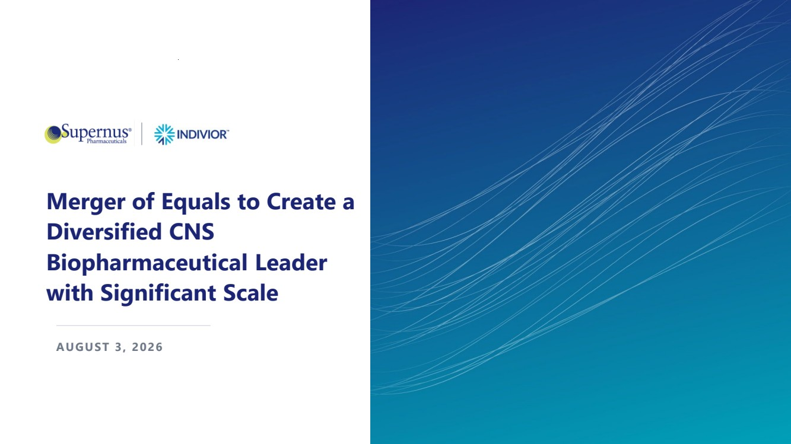 | Merger of Equals to Create a Diversified CNS Biopharmaceutical Leader with Significant Scale AUGUST 3, 2026
 | 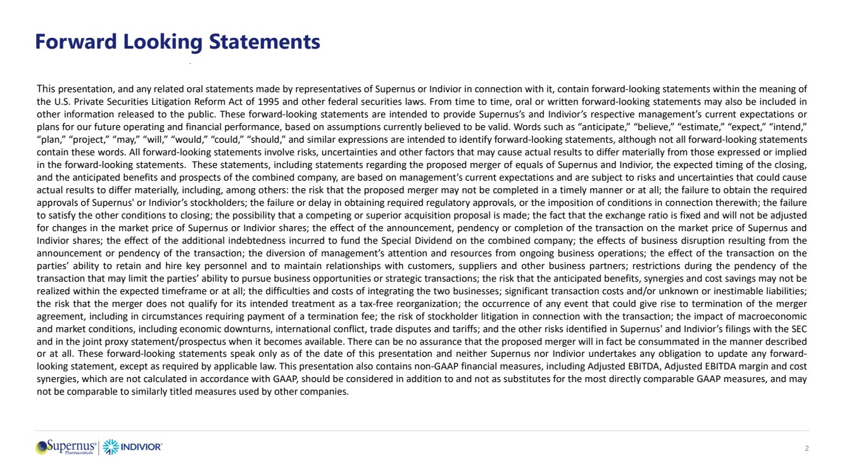 | Forward Looking Statements This presentation, and any related oral statements made by representatives of Supernus or Indivior in connection with it, contain forward-looking statements within the meaning of the U.S. Private Securities Litigation Reform Act of 1995 and other federal securities laws. From time to time, oral or written forward-looking statements may also be included in other information released to the public. These forward-looking statements are intended to provide Supernus’s and Indivior’s respective management’s current expectations or plans for our future operating and financial performance, based on assumptions currently believed to be valid. Words such as “anticipate,” “believe,” “estimate,” “expect,” “intend,” “plan,” “project,” “may,” “will,” “would,” “could,” “should,” and similar expressions are intended to identify forward-looking statements, although not all forward-looking statements contain these words. All forward-looking statements involve risks, uncertainties and other factors that may cause actual results to differ materially from those expressed or implied in the forward-looking statements. These statements, including statements regarding the proposed merger of equals of Supernus and Indivior, the expected timing of the closing, and the anticipated benefits and prospects of the combined company, are based on management’s current expectations and are subject to risks and uncertainties that could cause actual results to differ materially, including, among others: the risk that the proposed merger may not be completed in a timely manner or at all; the failure to obtain the required approvals of Supernus' or Indivior’s stockholders; the failure or delay in obtaining required regulatory approvals, or the imposition of conditions in connection therewith; the failure to satisfy the other conditions to closing; the possibility that a competing or superior acquisition proposal is made; the fact that the exchange ratio is fixed and will not be adjusted for changes in the market price of Supernus or Indivior shares; the effect of the announcement, pendency or completion of the transaction on the market price of Supernus and Indivior shares; the effect of the additional indebtedness incurred to fund the Special Dividend on the combined company; the effects of business disruption resulting from the announcement or pendency of the transaction; the diversion of management’s attention and resources from ongoing business operations; the effect of the transaction on the parties’ ability to retain and hire key personnel and to maintain relationships with customers, suppliers and other business partners; restrictions during the pendency of the transaction that may limit the parties’ ability to pursue business opportunities or strategic transactions; the risk that the anticipated benefits, synergies and cost savings may not be realized within the expected timeframe or at all; the difficulties and costs of integrating the two businesses; significant transaction costs and/or unknown or inestimable liabilities; the risk that the merger does not qualify for its intended treatment as a tax-free reorganization; the occurrence of any event that could give rise to termination of the merger agreement, including in circumstances requiring payment of a termination fee; the risk of stockholder litigation in connection with the transaction; the impact of macroeconomic and market conditions, including economic downturns, international conflict, trade disputes and tariffs; and the other risks identified in Supernus' and Indivior’s filings with the SEC and in the joint proxy statement/prospectus when it becomes available. There can be no assurance that the proposed merger will in fact be consummated in the manner described or at all. These forward-looking statements speak only as of the date of this presentation and neither Supernus nor Indivior undertakes any obligation to update any forward-looking statement, except as required by applicable law. This presentation also contains non-GAAP financial measures, including Adjusted EBITDA, Adjusted EBITDA margin and cost synergies, which are not calculated in accordance with GAAP, should be considered in addition to and not as substitutes for the most directly comparable GAAP measures, and may not be comparable to similarly titled measures used by other companies. 2
 | 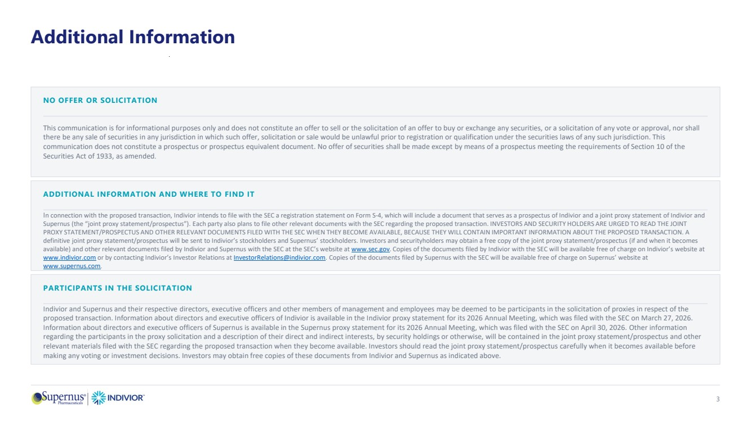 | Additional Information 3 NO OFFER OR SOLICITATION This communication is for informational purposes only and does not constitute an offer to sell or the solicitation of an offer to buy or exchange any securities, or a solicitation of any vote or approval, nor shall there be any sale of securities in any jurisdiction in which such offer, solicitation or sale would be unlawful prior to registration or qualification under the securities laws of any such jurisdiction. This communication does not constitute a prospectus or prospectus equivalent document. No offer of securities shall be made except by means of a prospectus meeting the requirements of Section 10 of the Securities Act of 1933, as amended. ADDITIONAL INFORMATION AND WHERE TO FIND IT In connection with the proposed transaction, Indivior intends to file with the SEC a registration statement on Form S-4, which will include a document that serves as a prospectus of Indivior and a joint proxy statement of Indivior and Supernus (the “joint proxy statement/prospectus”). Each party also plans to file other relevant documents with the SEC regarding the proposed transaction. INVESTORS AND SECURITY HOLDERS ARE URGED TO READ THE JOINT PROXY STATEMENT/PROSPECTUS AND OTHER RELEVANT DOCUMENTS FILED WITH THE SEC WHEN THEY BECOME AVAILABLE, BECAUSE THEY WILL CONTAIN IMPORTANT INFORMATION ABOUT THE PROPOSED TRANSACTION. A definitive joint proxy statement/prospectus will be sent to Indivior’s stockholders and Supernus’ stockholders. Investors and securityholders may obtain a free copy of the joint proxy statement/prospectus (if and when it becomes available) and other relevant documents filed by Indivior and Supernus with the SEC at the SEC’s website at www.sec.gov. Copies of the documents filed by Indivior with the SEC will be available free of charge on Indivior’s website at www.indivior.com or by contacting Indivior’s Investor Relations at InvestorRelations@indivior.com. Copies of the documents filed by Supernus with the SEC will be available free of charge on Supernus’ website at www.supernus.com. PARTICIPANTS IN THE SOLICITATION Indivior and Supernus and their respective directors, executive officers and other members of management and employees may be deemed to be participants in the solicitation of proxies in respect of the proposed transaction. Information about directors and executive officers of Indivior is available in the Indivior proxy statement for its 2026 Annual Meeting, which was filed with the SEC on March 27, 2026. Information about directors and executive officers of Supernus is available in the Supernus proxy statement for its 2026 Annual Meeting, which was filed with the SEC on April 30, 2026. Other information regarding the participants in the proxy solicitation and a description of their direct and indirect interests, by security holdings or otherwise, will be contained in the joint proxy statement/prospectus and other relevant materials filed with the SEC regarding the proposed transaction when they become available. Investors should read the joint proxy statement/prospectus carefully when it becomes available before making any voting or investment decisions. Investors may obtain free copies of these documents from Indivior and Supernus as indicated above.
 | 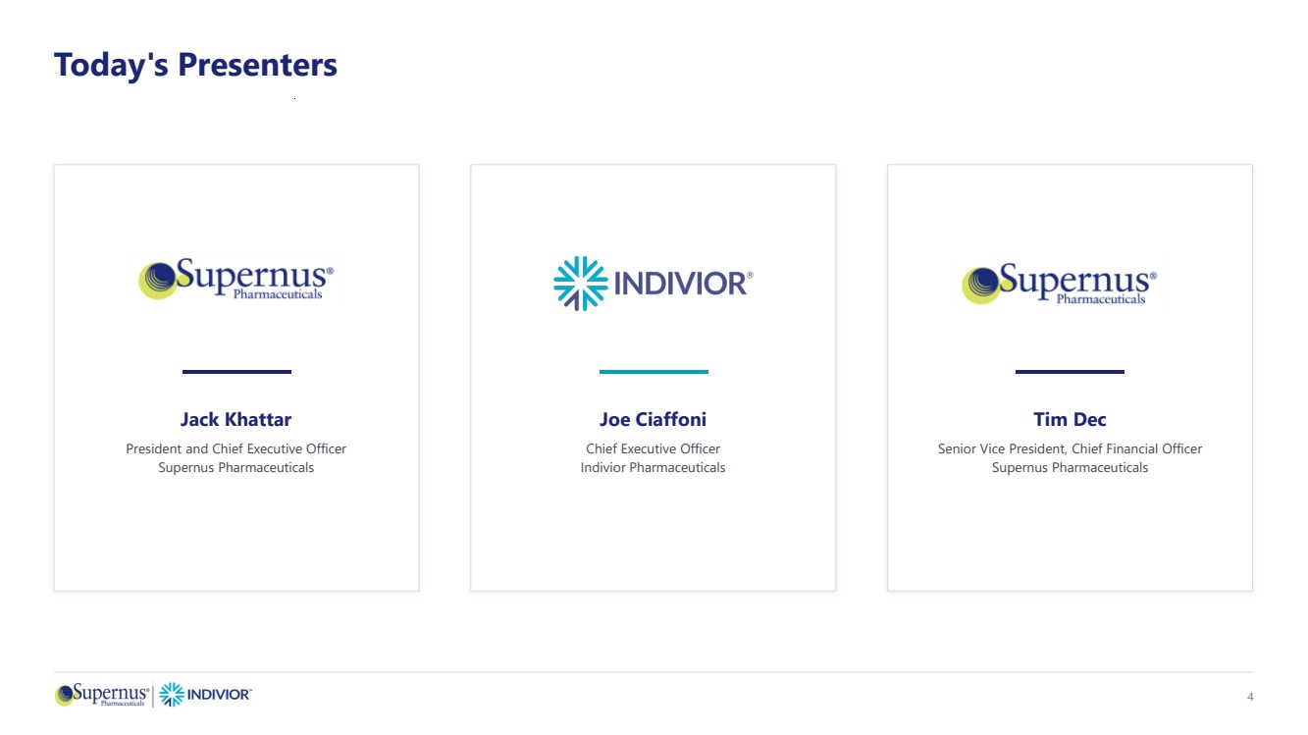 | Today's Presenters Jack Khattar President and Chief Executive Officer Supernus Pharmaceuticals Joe Ciaffoni Chief Executive Officer Indivior Pharmaceuticals Tim Dec Senior Vice President, Chief Financial Officer Supernus Pharmaceuticals 4
 | 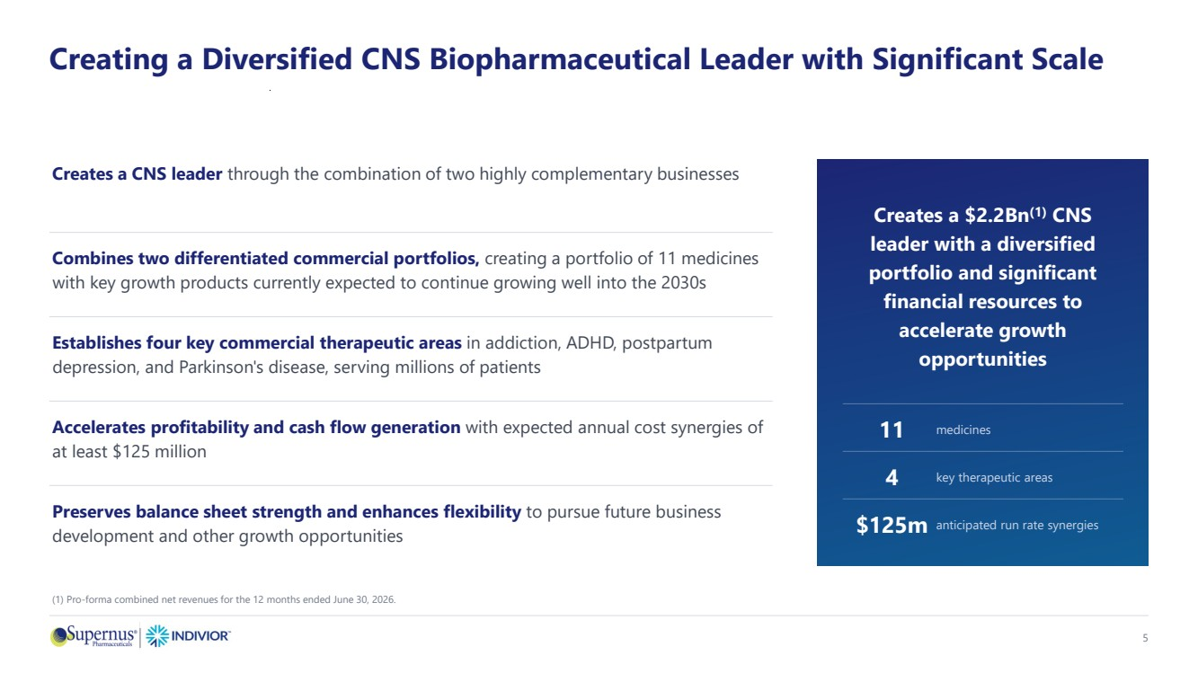 | Creating a Diversified CNS Biopharmaceutical Leader with Significant Scale Creates a CNS leader through the combination of two highly complementary businesses Combines two differentiated commercial portfolios, creating a portfolio of 11 medicines with key growth products currently expected to continue growing well into the 2030s Establishes four key commercial therapeutic areas in addiction, ADHD, postpartum depression, and Parkinson's disease, serving millions of patients Accelerates profitability and cash flow generation with expected annual cost synergies of at least $125 million Preserves balance sheet strength and enhances flexibility to pursue future business development and other growth opportunities Creates a $2.2Bn(1) CNS leader with a diversified portfolio and significant financial resources to accelerate growth opportunities 11 medicines 4 key therapeutic areas $125m anticipated run rate synergies 5 (1) Pro-forma combined net revenues for the 12 months ended June 30, 2026.
 | 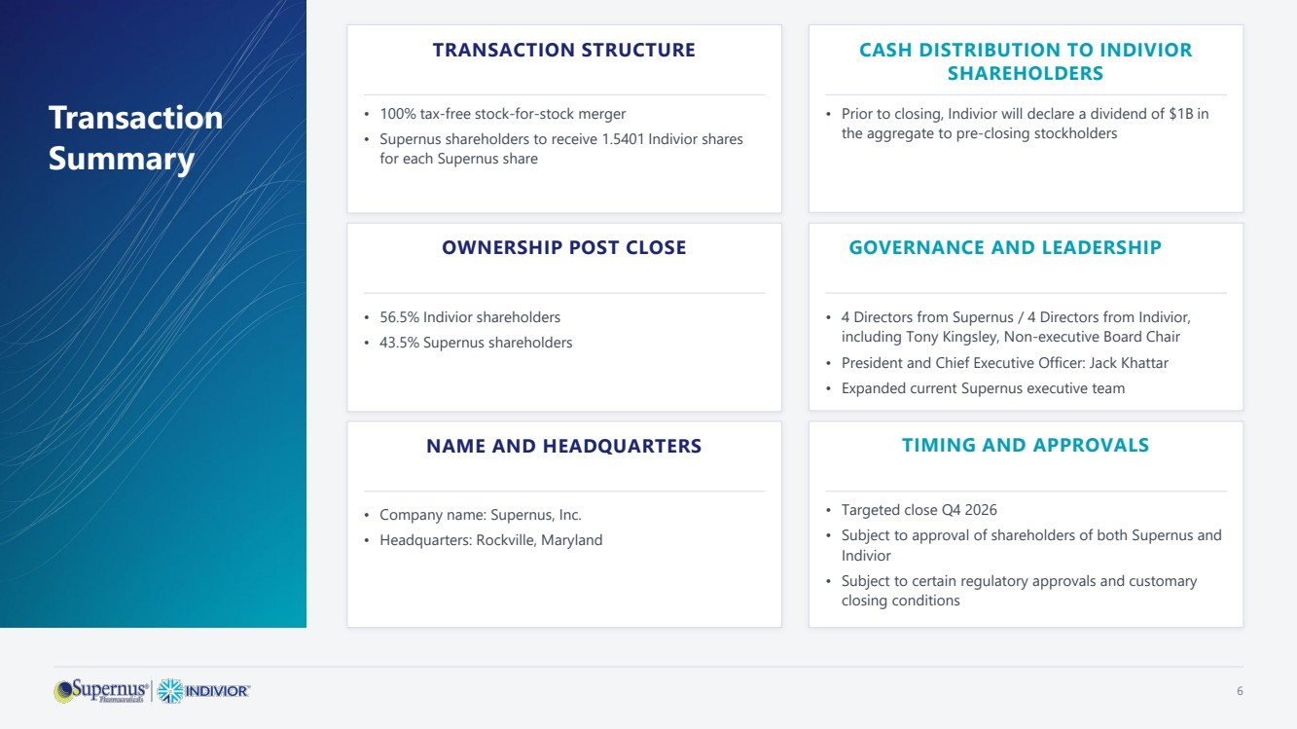 | Transaction Summary TRANSACTION STRUCTURE • 100% tax-free stock-for-stock merger • Supernus shareholders to receive 1.5401 Indivior shares for each Supernus share CASH DISTRIBUTION TO INDIVIOR SHAREHOLDERS • Prior to closing, Indivior will declare a dividend of $1B in the aggregate to pre-closing stockholders OWNERSHIP POST CLOSE • 56.5% Indivior shareholders • 43.5% Supernus shareholders GOVERNANCE AND LEADERSHIP • 4 Directors from Supernus / 4 Directors from Indivior, including Tony Kingsley, Non-executive Board Chair • President and Chief Executive Officer: Jack Khattar • Expanded current Supernus executive team NAME AND HEADQUARTERS • Company name: Supernus, Inc. • Headquarters: Rockville, Maryland TIMING AND APPROVALS • Targeted close Q4 2026 • Subject to approval of shareholders of both Supernus and Indivior • Subject to certain regulatory approvals and customary closing conditions 6
 | 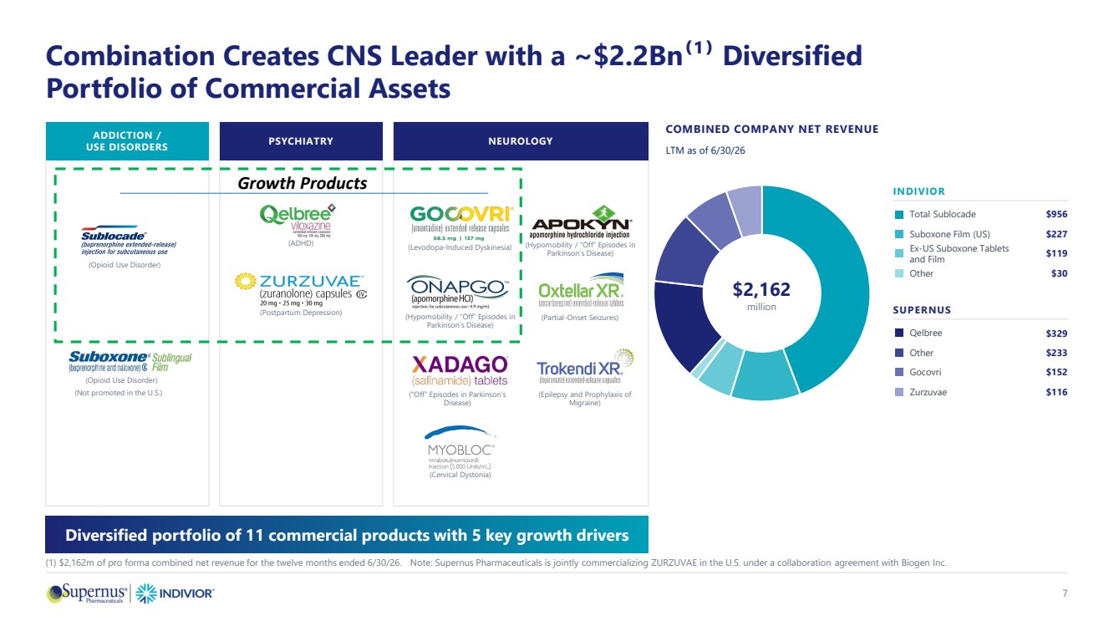 | (Epilepsy and Prophylaxis of Migraine) Combination Creates CNS Leader with a ~$2.2Bn⁽¹⁾ Diversified Portfolio of Commercial Assets G ADDICTION / USE DISORDERS PSYCHIATRY NEUROLOGY COMBINED COMPANY NET REVENUE LTM as of 6/30/26 $2,162 million INDIVIOR Total Sublocade $956 Suboxone Film (US) $227 Ex-US Suboxone Tablets and Film $119 Other $30 SUPERNUS Qelbree $329 Other $233 Gocovri $152 Zurzuvae $116 Diversified portfolio of 11 commercial products with 5 key growth drivers (1) $2,162m of pro forma combined net revenue for the twelve months ended 6/30/26. Note: Supernus Pharmaceuticals is jointly commercializing ZURZUVAE in the U.S. under a collaboration agreement with Biogen Inc. (Opioid Use Disorder) (Opioid Use Disorder) (ADHD) (Postpartum Depression) (Levodopa-Induced Dyskinesia) (Hypomobility / “Off” Episodes in Parkinson’s Disease) (Cervical Dystonia) (Partial-Onset Seizures) 7 Growth Products (Not promoted in the U.S.) ("Off” Episodes in Parkinson’s Disease) (Hypomobility / “Off” Episodes in Parkinson’s Disease)
 | 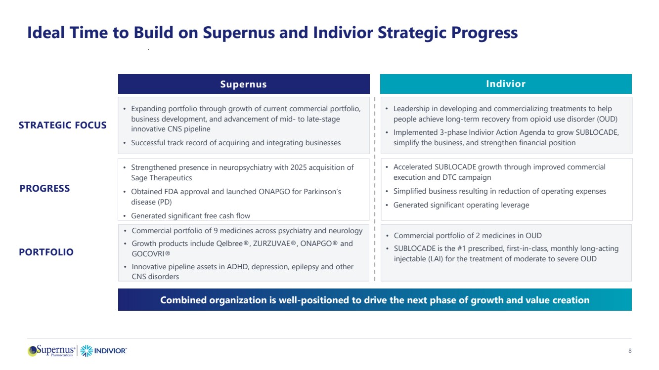 | Ideal Time to Build on Supernus and Indivior Strategic Progress Supernus Indivior STRATEGIC FOCUS • Expanding portfolio through growth of current commercial portfolio, business development, and advancement of mid- to late-stage innovative CNS pipeline • Successful track record of acquiring and integrating businesses • Leadership in developing and commercializing treatments to help people achieve long-term recovery from opioid use disorder (OUD) • Implemented 3-phase Indivior Action Agenda to grow SUBLOCADE, simplify the business, and strengthen financial position PROGRESS • Strengthened presence in neuropsychiatry with 2025 acquisition of Sage Therapeutics • Obtained FDA approval and launched ONAPGO for Parkinson’s disease (PD) • Generated significant free cash flow • Accelerated SUBLOCADE growth through improved commercial execution and DTC campaign • Simplified business resulting in reduction of operating expenses • Generated significant operating leverage Combined organization is well-positioned to drive the next phase of growth and value creation 8 PORTFOLIO • Commercial portfolio of 9 medicines across psychiatry and neurology • Growth products include Qelbree®, ZURZUVAE®, ONAPGO® and GOCOVRI® • Innovative pipeline assets in ADHD, depression, epilepsy and other CNS disorders • Commercial portfolio of 2 medicines in OUD • SUBLOCADE is the #1 prescribed, first-in-class, monthly long-acting injectable (LAI) for the treatment of moderate to severe OUD
 | 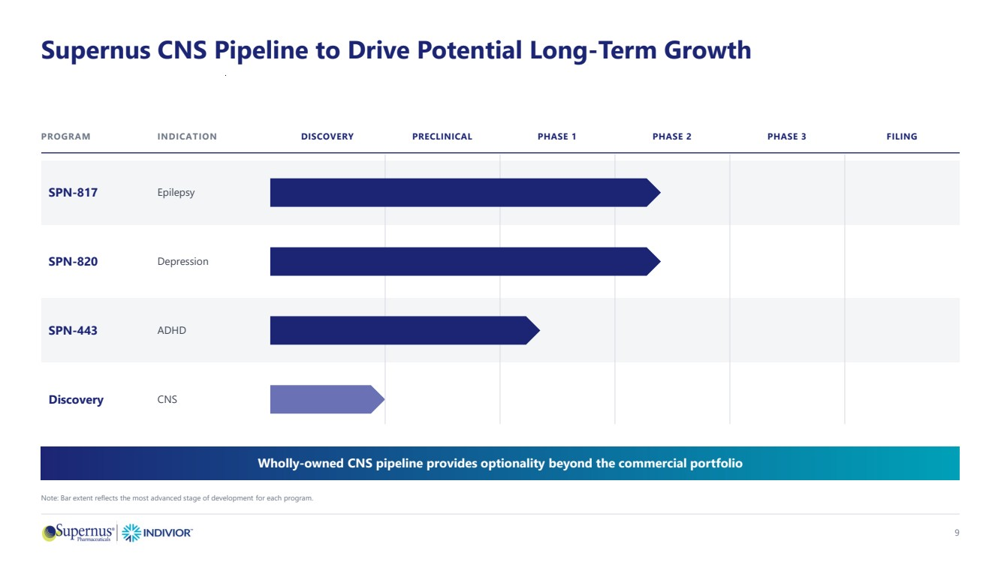 | Supernus CNS Pipeline to Drive Potential Long-Term Growth PROGRAM INDICATION DISCOVERY PRECLINICAL PHASE 1 PHASE 2 PHASE 3 FILING SPN-817 Epilepsy SPN-820 Depression SPN-443 ADHD Discovery CNS Wholly-owned CNS pipeline provides optionality beyond the commercial portfolio Note: Bar extent reflects the most advanced stage of development for each program. 9
 | 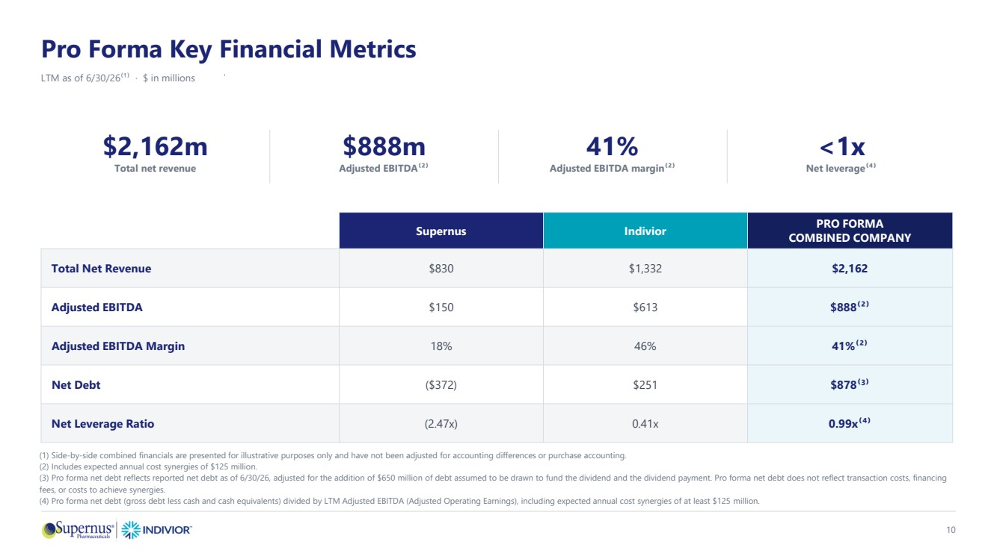 | Pro Forma Key Financial Metrics LTM as of 6/30/26⁽¹⁾ · $ in millions $2,162m Total net revenue $888m Adjusted EBITDA⁽²⁾ 41% Adjusted EBITDA margin⁽²⁾ <1x Net leverage⁽⁴⁾ Supernus Indivior PRO FORMA COMBINED COMPANY Total Net Revenue $830 $1,332 $2,162 Adjusted EBITDA $150 $613 $888⁽²⁾ Adjusted EBITDA Margin 18% 46% 41%⁽²⁾ Net Debt ($372) $251 $878⁽3⁾ Net Leverage Ratio (2.47x) 0.41x 0.99x⁽⁴⁾ (1) Side-by-side combined financials are presented for illustrative purposes only and have not been adjusted for accounting differences or purchase accounting. (2) Includes expected annual cost synergies of $125 million. (3) Pro forma net debt reflects reported net debt as of 6/30/26, adjusted for the addition of $650 million of debt assumed to be drawn to fund the dividend and the dividend payment. Pro forma net debt does not reflect transaction costs, financing fees, or costs to achieve synergies. (4) Pro forma net debt (gross debt less cash and cash equivalents) divided by LTM Adjusted EBITDA (Adjusted Operating Earnings), including expected annual cost synergies of at least $125 million. 10
 | 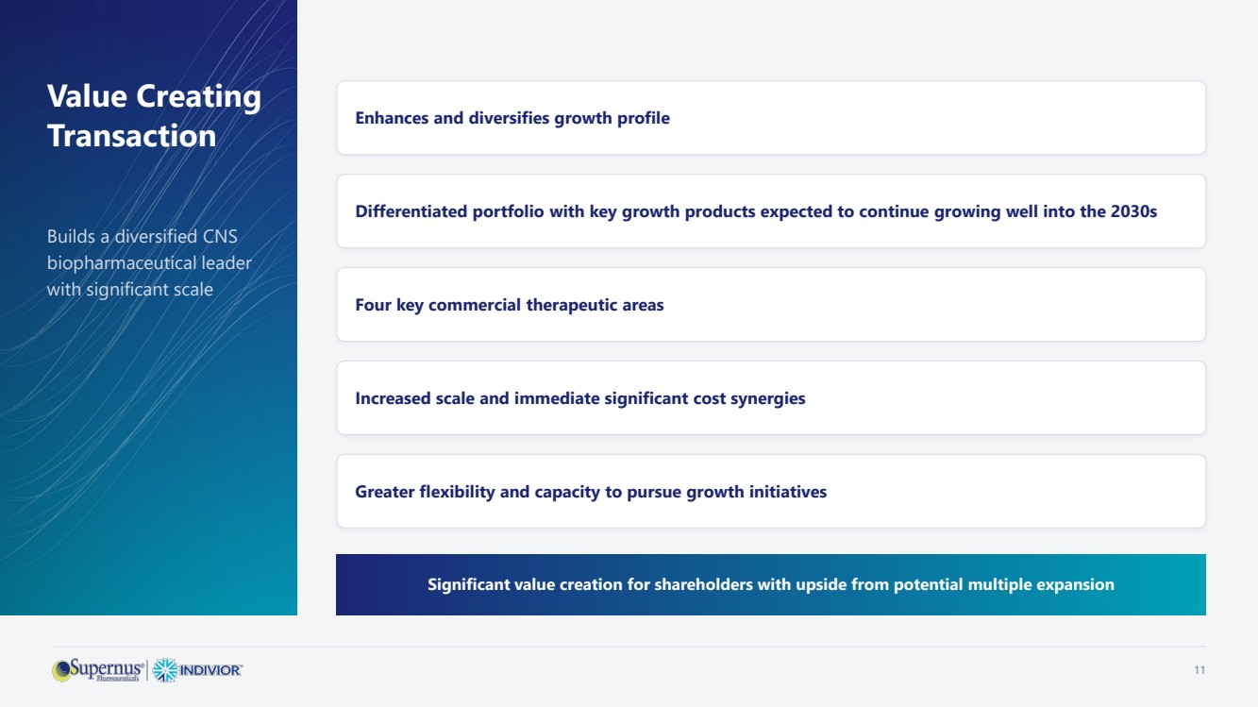 | Value Creating Transaction Builds a diversified CNS biopharmaceutical leader with significant scale Enhances and diversifies growth profile Differentiated portfolio with key growth products expected to continue growing well into the 2030s Four key commercial therapeutic areas Increased scale and immediate significant cost synergies Greater flexibility and capacity to pursue growth initiatives Significant value creation for shareholders with upside from potential multiple expansion 11
 | 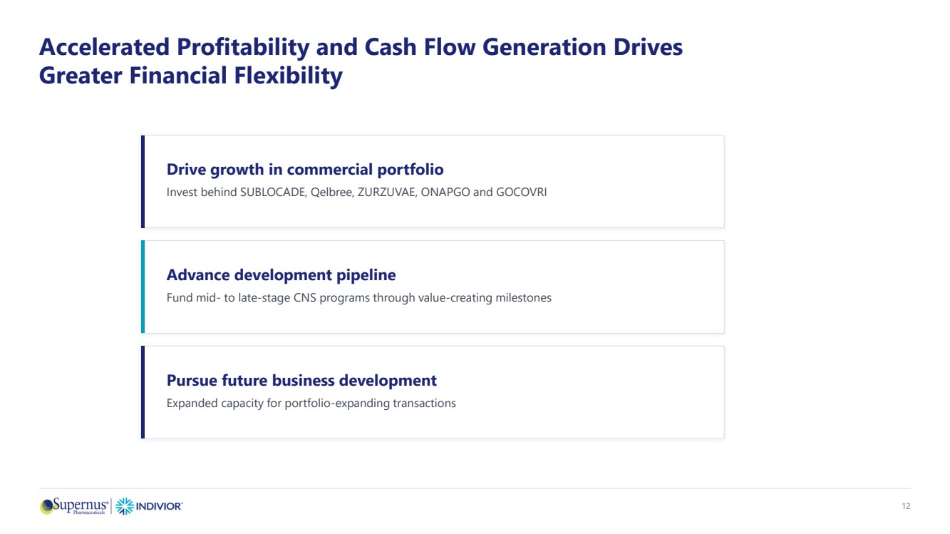 | Accelerated Profitability and Cash Flow Generation Drives Greater Financial Flexibility Drive growth in commercial portfolio Invest behind SUBLOCADE, Qelbree, ZURZUVAE, ONAPGO and GOCOVRI Advance development pipeline Fund mid- to late-stage CNS programs through value-creating milestones Pursue future business development Expanded capacity for portfolio-expanding transactions 12
 |  | Q&A

